

Kungliga Tekniska Högskolan

SH2703 - Nuclear Reactor Technology

Master program in Nuclear Energy Engineering

ESBWR

*Economic Simplified Boiling Water Reactor*

Group 31

Jeevan George

Mikael Flodin

# Abstract

This report outlines the project work done as partial fulfillment of the requirements in the course SH2702 in Nuclear Reactor Technology. The report involves an overview of the ESBWR general features and safety features along with calculations of various core averaged thermal hydraulic characteristics using core parameters of GE Hitachi’s ESBWR. The report is divided into four sections based on the six tasks assigned. The first section provides an outline of the ESBWR while the next three sections contain calculations of the selected core characteristics. Section 1 discusses the general design specifications of the ESBWR, the operational principles of the power plant, and describes the safety features of the power plant. Section 2 includes results such as axial pressure drop distribution, axial coolant enthalpy distribution, axial coolant temperature distribution, axial void fraction distribution, and flow characteristics of the core. Section 3 includes the result of the calculation of CHF margins in a hot channel and the MCPR ratio. Section 4 provides the result of the calculation of maximum cladding and fuel pellet temperature and it was found that the maximum temperature occurred in the fuel element is well below recommended safety limits.

i

# Contents

1. Introduction 1
   1. General design specification . . . . . . . . . . . . . . . . . . . . . 1
   2. Operational principles of ESBWR . . . . . . . . . . . . . . . . . . 2
   3. Safety features of ESBWR . . . . . . . . . . . . . . . . . . . . . . 3
      1. Gravity Driven Core Cooling System (GDCS) . . . . . . . . 3
      2. Automatic Depressurisation System (ADS) . . . . . . . . . 5
      3. Passive Containment Cooling System (PCCS) . . . . . . . . 6
2. Calculation of selected core parameters 8
   1. Axial pressure drop distribution . . . . . . . . . . . . . . . . . . . . 9
      1. Model . . . . . . . . . . . . . . . . . . . . . . . . . . . . . 9
      2. Result . . . . . . . . . . . . . . . . . . . . . . . . . . . . . 9
   2. Axial coolant enthalpy distribution . . . . . . . . . . . . . . . . . . 9
      1. Model . . . . . . . . . . . . . . . . . . . . . . . . . . . . . 9
      2. Result . . . . . . . . . . . . . . . . . . . . . . . . . . . . . 9
   3. Axial coolant temperature distribution . . . . . . . . . . . . . . . . 10
      1. Model . . . . . . . . . . . . . . . . . . . . . . . . . . . . . 10
      2. Result . . . . . . . . . . . . . . . . . . . . . . . . . . . . . 10
   4. Axial void fraction distribution . . . . . . . . . . . . . . . . . . . . 10
      1. Model . . . . . . . . . . . . . . . . . . . . . . . . . . . . . 10
      2. Result . . . . . . . . . . . . . . . . . . . . . . . . . . . . . 10
   5. Flow characteristic of the core . . . . . . . . . . . . . . . . . . . . 11
      1. Result . . . . . . . . . . . . . . . . . . . . . . . . . . . . . 11
3. Calculation of CHF Margins in the hot channel 14
   1. Model . . . . . . . . . . . . . . . . . . . . . . . . . . . . . . . . . 14
   2. Result . . . . . . . . . . . . . . . . . . . . . . . . . . . . . . . . . 14
4. Calculation of the maximum cladding and fuel pellet temperature 16
   1. Methodology . . . . . . . . . . . . . . . . . . . . . . . . . . . . . 16
   2. Results . . . . . . . . . . . . . . . . . . . . . . . . . . . . . . . . . 17

ii

# Introduction

Nuclear energy is an important source of energy in the energy mix of many countries worldwide. Currently, there are 423 nuclear power reactors in operation in 32 countries with a total net installed capacity of 378754 MW. Another 56 power reactors are under construction. The majority of all of these reactors are light water-cooled reactors [1].

The General Electric Economic Simplified Boiling Water Reactor (ESBWR) is one such design that offers numerous safety features to ensure the protection of the public, the environment, and plant personnel. The ESBWR is designed to have the absolute lowest core damage frequency of any advanced reactor design in the industry, with a power of 1*.*7×108 per year. This means that the likelihood of a severe accident is extremely low [2]. Additionally, the ESBWR is designed to produce nearly zero greenhouse gas emissions during operation, making it a sustainable option for power generation.

Aside from the increased safety measures, the ESBWR also has economic benefits compared to earlier reactors [2]. Because of the simplified design, many components have been removed as they are no longer necessary, which reduces costs for maintenance. The ESBWR also requires significantly fewer plant personnel than other Generation III/III+ plants. It is projected to have the lowest operating, maintenance and staffing costs per MWh of any current reactor technology [3][4].

## General design specification

The ESBWR is a type of boiling water reactor with a rated power of 4500 MWth and an electrical power output of 1535 MW. The power plant’s design life is 60 years and it uses light water as the coolant. The ESBWR has 1132 fuel assemblies in the core, each with a 10x10 square lattice configuration, and with sintered UO2 as a fuel. The ESBWR features an active core height of 3.048 m and an equivalent core diameter of 5.88 m. Some other relevant plant features are:

* Average linear heat rate: 15.1 kW/m
* Core coolant inlet temperature 276.2 deg. C
* Pressure of reactor vessel: 7.17 MPa
* Height of Primary containment: 35.4 m
* Diameter of the primary containment: 40 m
* Shape of the primary containment: Cylindrical

From an idea of simplification in design and operation, the Economic Simplified Boiling Water Rector (ESBWR) design was born. It is the latest step in the evolution of the boiling water reactor, featuring a higher vessel than its predecessor - the Simplified Boiling Water Reactor - which employed the same principles of simplification but was considered to be an economically unviable option.

Particularly interesting about the ESBWR is that it uses natural circulation to provide core flow. Natural circulation occurs because of the density difference between the water in the vessel and the steam/water mixture inside the shroud and chimney [5], as can be visualised in Figure 1.

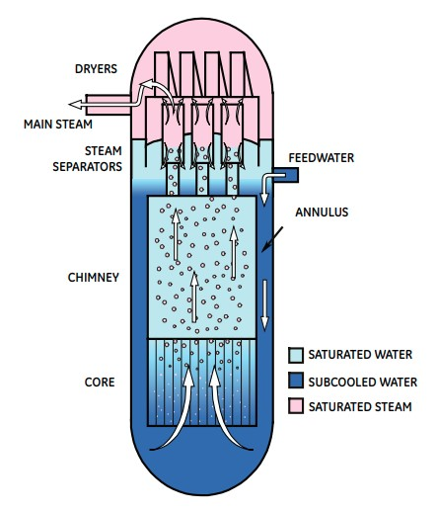

Figure 1: Natural flow in core [2].

## Operational principles of ESBWR

The startup procedure for ESBWR follows the established process at Dodewaard. The Dodewaard plant operated through 22 cycles for 30 years with no problems during startup [2]. Because of the size, the ESBWR will not be operated in a load-follow mode. However, changes in core power can be readily accomplished through the movement of the fine motion control rod drives (FMCRD). During the De-aeration Period, the reactor coolant is de-aerated by using mechanical vacuum pumps to create a vacuum on the main condenser and reactor vessel while the steam drain lines are open. The coolant is heated up to a temperature between 80ºC and 90ºC using auxiliary and decay heat, and the reactor pressure is reduced to approximately 50 kPa to 60 kPa. After de-aeration, control rods are withdrawn to achieve criticality, and the Main Steam Isolation Valves (MSIVs) are either left open or closed. The Startup Period begins when groups of control rods are pulled to criticality, and fission power is used to heat the reactor water while keeping the water level close to the top of the separators but below the steam lines. Steaming at the free surface starts to pressurize the reactor vessel, but the core region remains subcooled due to the large static head in the chimney and separators. As the reactor heats up and pressurizes, the RWCU/SDC system heat exchangers are used to control the downcomer temperature, enhance coolant flow, and reduce lower plenum stratification. The MSIVs are reopened when the pressure reaches 6.3 MPa, and subsequently, the turbine bypass valves are used to control pressure. The reactor power is increased, and preparations are made to start the turbine.[2].

## Safety features of ESBWR

The ESBWR design features many passive safety systems, which are shown in Figure 2. The working principles of few of these systems are described in the further sections.

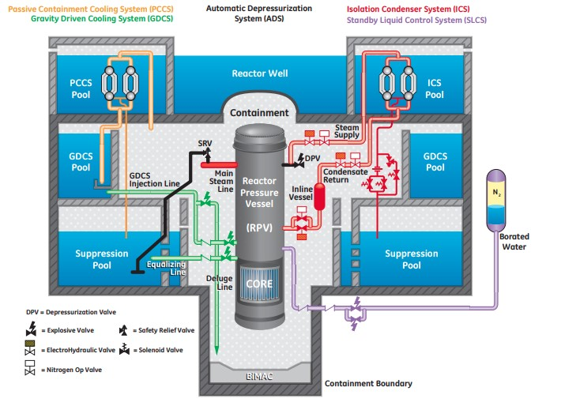

Figure 2: Overview of reactor safety systems [2].

### Gravity Driven Core Cooling System (GDCS)

The GDCS is composed of a pool with four mechanical trains. Each train contains three independent sub-systems: a short-term cooling system for the injection of water in the reactor pressure vessel (RPV), a long-term cooling system to equalise the water level in RPV with the suppression pool and a deluge line to flood the lower drywell of the reactor in the case of a core meltdown (see Fig. 3).

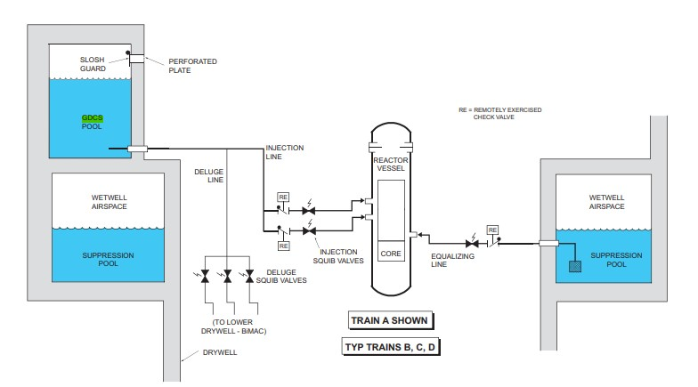

Figure 3: GDCS Schematic [2].

The injection of each of those sub-systems is controlled by a squib valve. The squib valve is an explosive actuated valve. This implies that it does not require external power to be opened, and also that once opened, it cannot be naturally closed (see Fig. 4). It allows a continuous flow of water in the PRV in case of a Loss of Coolant Accident (LOCA). Moreover, the trains are designed in a Venturi tube shape to prevent a quick emptying of the GDCS pool in case of break in one the lines upstream from the valve.

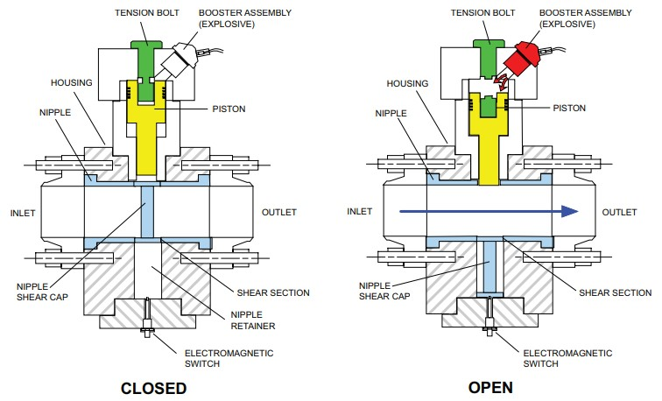

Figure 4: Conceptual design of the squib valve [2].

The injection lines in the RPV also contain a check valve. Its role is to prevent a too large counter-flow after the opening of the squib valve. Indeed, if the pressure inside the RPV is higher than the pressure in the GDCS pool outlet line plus its gravity head, a counter-flow can occur and remove even more coolant from the RPV. The aim the check valve is to mitigate this phenomenon until the pressure in the RPV has sufficiently dropped. It then opens fully to allow water from the GDCS pool to flood the RPV.

### Automatic Depressurisation System (ADS)

The ADS is initiated when an RPV low water level signal is maintained for 10 seconds or if a high drywell pressure signal is maintained for one hour. During ADS initiation, each safety release valve (SRV) or depressurisation valve (DPV) receives initiation signals from 3 safety-releated logic divisions and also the nonsafety-release Diverse Protective System. This triple redundancy meets the single failure safety criteria. SRVs are controlled by a pneumatic system that can be activated automatically or manually and DPVs are squib valves (see section 1.3.1). The ADS can also be manually inhibited with switches in the control room in case of an anticipated transient without scram event.

### Passive Containment Cooling System (PCCS)

The role of the PCCS is to maintain the pressure in the containment building within the dedicated limits. It contains 6 independent loops, each of them has a two-module condenser with a heat transfer capacity of 7.8 MWth. This system can maintain the pressure in the facility below the limit for at least 72 hours without any intervention in case of a LOCA and for longer if its vent fans are activated and the IC/PCC pool is refilled (see Fig. 8). This pool is the coolant of the condensers.

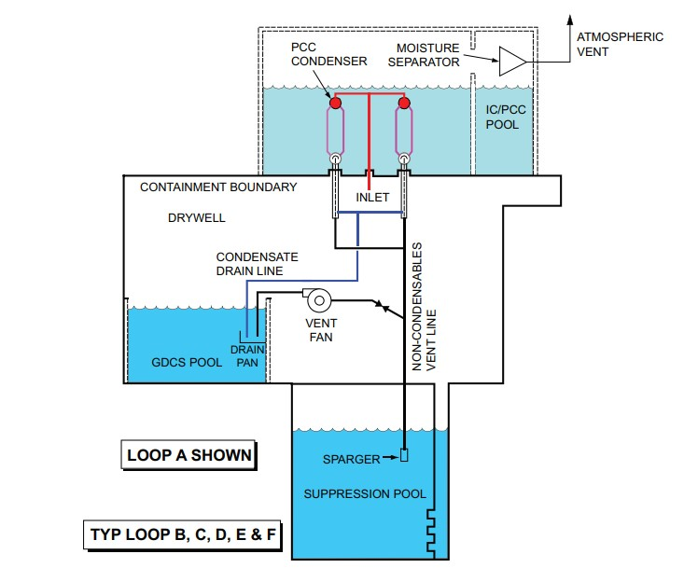

Figure 5: PCCS Schematic [2].

The steam enters the PCCS from an inlet located above the drywell and is directed to the condenser. Condensated water is directed to the GDCS pool and non-condensable gas are evacuated from the condenser by the non-condensables vent line. The is necessary to maintain a sufficient efficiency of the condenser. 72 hours after the beginning of a LOCA, the vent fans have to be activated by the operator to assure that the heat transfer capacity of the condensers in the PCCS is still sufficient.

Those fans are powered by a diesel generator.

The whole design of the PCCS makes it entirely passive for at least the first 72 hours of a LOCA. After those 72 hours, excess heat accumulated in the IC/PCC pool has to be evacuated by atmospheric release of the excess of steam. Since the water in the IC/PCC pool is never mixed with the contaminated steam coming from the drywell, the steam in the IC/PCC pool is non radioactive and can be safely released in the atmosphere. However, fluid is lost during this operation and thus the IC/PCC pool has to be refilled by the Makeup Water System (active system).

# Calculation of selected core parameters

In this section we present some key core parameters of ESBWR in Tab. (1). The majority of these parameters are found in [2]. Some of them, however, are not available in the open literature, and in those cases we make qualified assumptions regarding the parameter based on the best knowledge and/or engineering judgement. Based on these parameters, we estimate a number of core-averaged thermal-hydraulic characteristics and present them as plots (parameter versus axial distance from the core inlet): The axial pressure drop distribution, the axial coolant enthalpy distribution, the axial coolant temperature distribution, the axial void fraction distribution, and the flow characteristic of the core. In all calculations, we assume that the spatial core power distribution can be modelled as:

*q*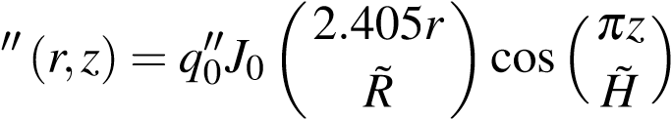 (1)

where *q*′′0 is the heat flux at the core center *r* = *z* = 0, *J*0 is the Bessel function of the first kind and zero order, and where *R*˜ and *H*˜ are the extrapolated radius and the extrapolated height of the core, respectively. We furthermore assume a reflected core, where *R/R*˜ = *H/H*˜ = 5*/*6.

|  |  |
| --- | --- |
| Table 1: Key core parameters |  |
| Parameter | Value |
| Total core heat output | 4500 MW |
| Total heat output in fuel pellets | 4253 MW |
| Nominal system pressure | 7.17 MPa |
| Total core mass flow rate | 9570 kg/s |
| Effective fuel cooling mass flow rate | 8135 kg/s |
| Number of fuel assemblies | 1132 |
| Active fuel height | 3.048 m |
| Channel lateral dimensions | 14 cm x 14 cm |
| Lattice pitch | 12.95 mm |
| Number of fuel rods per assembly | 92/78 |
| Outside fuel rod diameter | 10.26 mm |
| Clad thickness | 0.75 mm |
| Fuel pellet diameter | 8.76 mm |
| Number of spacers | 6 |
| Clad and channel wall roughness | 0.50 *µ*m |

## Axial pressure drop distribution

### Model

For the axial pressure drop distribution, we apply a two-phase flow model accounting for: friction, gravity, acceleration, and local losses. In the latter, we include inlet orifices. Inlet orifices are used to stabilize flow through the core and to avoid hydrodynamic instabilities. We adjust the local loss coefficient at fuel assembly inlets to get 50 % of the total pressure drop in the core.

2.1.2 Result

The axial pressure drop distribution is displayed in Fig. (6a).

## Axial coolant enthalpy distribution

### Model

The enthalpy distribution, for a non-uniform axial power distribution, can be modelled by the differential equation:

*dil* (*z*)

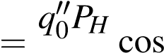 *, dz W H*˜

where *PH* is the hydraulic perimeter of the channel, and *W* is the coolant mass flux.

The solution of the differential equation is given by:

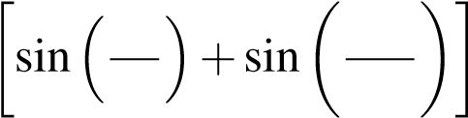*q*′′*P il* (*z*)= 0 *H H*˜ *π*˜*z πH*˜*H* +*ili.*

*W π H*

This model is valid if we use the same numerical inputs to Eq. (1) throughout the core. However, in the case of ESBWR, each fuel assembly contain 14 of 92 partial length rods, with a 2/3 length. To account for this, we adjust *q*′′ with a factor 78/92 for *z* ≥ 0*.*5 m. In addition, inlet subcooling is applied with 10 K.

2.2.2 Result

The axial coolant enthalpy distribution is displayed in Fig. (6b).

## Axial coolant temperature distribution

### Model

The coolant temperature distribution is modeled similarly to the enthalpy distribution, and the solution of the differential equation is given by:

*q*′′ *P*

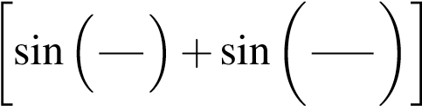 *Tlb* (*z*)= *W*0 *cHp Hπ*˜ *πH*˜*z πH*˜*H* +*Tlbi.*

This model is valid whenever *T < T*sat. However, in BWR’s the coolant temperature reach saturation temperature close to the inlet, from which two-phase flow takes over. Thus, in the region where *z* ≥ *z*ONB, we model the temperature distribution through the XSteam(′Tsatp-function with the axial pressure distribution,

*p*(*z*)= *p*0 −∆*p*, as input.

2.3.2 Result

The axial coolant temperature distribution is displayed in Fig. (6c).

## Axial void fraction distribution

### Model

In this section we apply the Homogeneous Equilibrium Model (HEM) to calculate the coolant equilibrium quality throughout the channel and the corresponding void fraction. The equilibrium quality is defined as:

*i*(*z*)−*if xe* ≡ *,*

*ifg*

where *i*(*z*) is the axial coolant enthalpy distribution calculated in Section 2.2. The void fraction, for a given equilibrium quality, is in HEM given by:

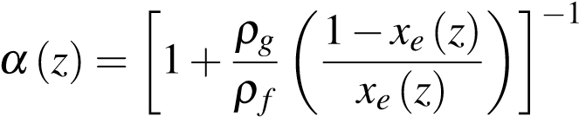 for 0 *< xe <* 1*,*

which is valid whenever 0 *< xe <* 1. For *xe* ≤ 0, *α*(*z*)= 0, and for *xe* ≥ 1, *α*(*z*)= 1. The liquid and vapor densities are calculated through the XSteam-function for the given core temperature and pressure.

2.4.2 Result

The axial void fraction distribution is displayed in Fig. (6d).

## Flow characteristic of the core

### Result

The flow characteristic of the core is displayed in Fig. (7). The plot show the core pressure drop versus mass flux, for a core power equal to 0 %, 50 %, 100 % and 150 % of the nominal power, with flow varying from 1 % to 150 % of the core nominal flow.

**2**

**0**

**-2**

**-60**

**-50**

**-40**

**-30**

**-20**

**-10**

**0**

**p [kPa]**

**0**

**-2**

**2**

**1000**

**1200**

**1400**

**1600**

**1800**

**2000**

**2200**

**H [kJ/kg]**

**a)**

**b)**

**z [m] z [m]**

**278**

**280**

**282**

**284**

**286**

**288**

**T [deg. C]**

**0.2**

**0.4**

**0.6**

**0.8**

**1**

**V**

**c**

**)**

**d)**

**276 0**

#### -2 0 2 -2 0 2 z [m] z [m]

Figure 6:

1. Axial pressure drop distribution.
2. Axial coolant enthalpy distribution.
3. Axial coolant temperature distribution.
4. Axial void fraction distribution.

**1**

**1.5**

**0**

**0.5**

**-180**

**-160**

**-140**

**-120**

**-100**

**-80**

**-60**

**-40**

**-20**

**0**

**p**

**tot**

**[kPa]**

**P**

**0.0**

**th**

**P**

**0.5**

**th**

**P**

**1.0**

**th**

**1.5**

**P**

**th**

**% of core nominal flow**

Figure 7: Flow characteristic of the core for different choices of power output.

# Calculation of CHF Margins in the hot channel

CHF (Critical Heat Flux) is one of the factors that limit the maximum thermal power in the core. In this section, the CHF margin is estimated, and more specifically the dryout type of CHF given by the Minimum Critical Power Ratio (MCPR). For this purpose we investigate the hot channel, assuming that the actual power of the channel is given by Eq. (1). Next, we gradually increase the power keeping all other parameters constant, until CHF condition is achieved. The MCPR is defined as:

*q*cr

MCPR = *,*

*q*nom

where *q*cr is the calculated critical power in hot channel, and *q*nom is the nominal power. In addition to the MCPR, we present as plots some core-averaged thermalhydraulic characteristics for the hot channel covering: the axial pressure drop distribution, the axial coolant enthalpy distribution, the axial coolant temperature distribution, and the axial void fraction distribution.

## Model

As a model for the critical quality, we use the Levitan-Lantsman correlation. This model takes the core pressure, the coolant flux, and the hydraulic diameter of the hot channel as input and return the critical quality, *x*cr, of the channel. Dryout occurs for all *z* for which *x*e ≥ *x*cr.

## Result

We calculate the Minimal Critical Power Ratio to MCPR = 1.43. The plots, showing the axial distributions for both nominal and critical power, are displayed in Figs. (8a) to (8d).

**2**

**0**

**-2**

**-70**

**-60**

**-50**

**-40**

**-30**

**-20**

**-10**

**0**

**p [kPa]**

**P**

**nom**

**1.43**

**P**

**nom**

**0**

**-2**

**2**

**1000**

**1200**

**1400**

**1600**

**1800**

**2000**

**2200**

**2400**

**2600**

**H [kJ/kg]**

**P**

**nom**

**1**

**.4**

**3**

**P**

**nom**

**b**

**)**

**a)**

**z [m] z [m]**

**0.2**

**0.4**

**0.6**

**0.8**

**1**

**V**

**P**

**nom**

**P**

**1.43**

**nom**

**270**

**275**

**280**

**285**

**290**

**T [deg. C]**

**1.4**

**3**

**P**

**nom**

**P**

**nom**

**)**

**c**

**d)**

**265 0**

### **-2 0 2 -2 0 2 z [m] z [m]**

Figure 8:

1. Axial pressure drop distribution at nominal and critical power.
2. Axial coolant enthalpy distribution at nominal and critical power.
3. Axial coolant temperature distribution at nominal and critical power.
4. Axial void fraction distribution at nominal and critical power.

# Calculation of the maximum cladding and fuel pellet temperature

This section presents the maximum values of cladding and fuel pellet temperatures achieved during the reactor operation. The temperatures for both the clad and the fuel pellet obtained were well below the maximum allowed limits. This section further describes the correlations used in our calculations which are valid for actual reactors.

## Methodology

Clad-coolant Heat transfer in channels with both single-phase flows and two-phase flows were taken into account. In the single-phase region, when *zin < z < zonb*, the clad surface temperature *Tco* of the heated wall and the liquid bulk temperature *Tlb* are related to each other as:

*Tco* ≡ *Tlb* =∆*Tlb* (2)

where, ∆*Tlb* is the temperature difference between the surface of the heated wall and the bulk liquid. The heat transfer coefficient, h can be calculated by calculating the Nusselt number using the Dittus-Boelter correlation, which is given as :

*Nu* ≡ 0*.*023×*Re*0*.*8 ×*Pr*0*.*4 (3)

where, the Nusselt number values can be obtained from the equation :

*Nu* ≡ *h*×*Dh* ÷*λ* . Here, *Dh* is the hydraulic diameter and *λ* is the thermal conductivity. For two-phase flows, the Chen correlation was used to calculate the heat transfer coefficients.

Now that the heat transfer coefficients and the cladding outer wall temperature are measured, we use simplifications in the conduction equations to find out the temperature gradients in the reactor fuel element. These are:

* Heat conduction in the z-direction (axial) can be neglected.
* In fuel regions *q*′′′ ≡ *q*′′′(*z*)
* In gas gap and clad regions *q*′′′ ≡ 0

Using the above simplifications and the heat conduction equations, the various plots obtained are presented in the results section.

## Results

The following plots show the temperature distribution in the fuel element. A single fuel element consists of the fuel pellet, the gas gap filled with helium, and the cladding. The goal is to ensure that The maximum temperature achieved in the fuel elements is less than the safety limits during the operation of the reactor. From the analysis, it was found that the maximum temperature in the fuel pellet was around 1125 °C and 330 °C in the cladding, both of which are well below the melting points and recommended safety limits. In the results displayed, the radial fuel pellet temperature distribution and the radial temperature distribution in the cladding are displayed from the respective outer surface to the inner surface.

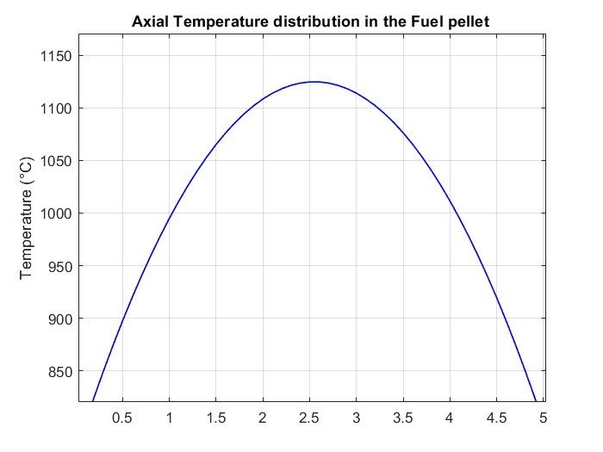

Figure 9: Axial Temperature Distribution in the fuel

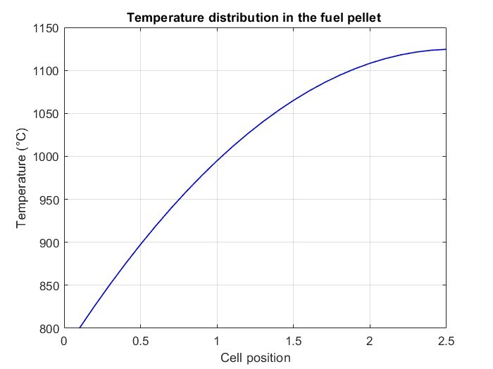

Figure 10: Radial Fuel Temperature Distribution

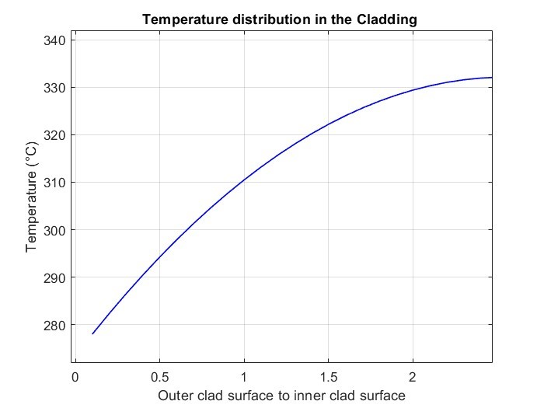

Figure 11: Clad Temperature Distribution

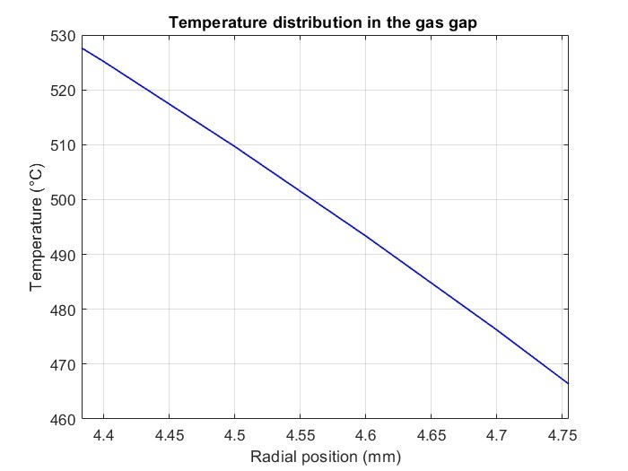

Figure 12: Temperature Distribution in the Gas Gap

# References

1. IAEA. *PRIS online database*. Vienna, 2023. URL: [https://pris.iaea.org/ PRIS/home.aspx.](https://pris.iaea.org/PRIS/home.aspx)
2. GE Hitachi Nuclear Energy. *The ESBWR Plant General Description*. Wilmington, 2011. URL: [https://nuclear.gepower.com/content/dam/ gepower-nuclear/global/en_US/documents/ESBWR_General%5C% 20Description%5C%20Book.pdf.](https://nuclear.gepower.com/content/dam/gepower-nuclear/global/en_US/documents/ESBWR_General%5C%20Description%5C%20Book.pdf)
3. Nuclear Energy Agency. *GE Hitachi’s ABWR and ESBWR: Safer, Simpler, Smarter*. Paris, 2020. URL: [https://www.oecd-nea.org/jcms/pl_30617/ ge-hitachi-s-abwr-and-esbwr-safer-simpler-smarter?details= true.](https://www.oecd-nea.org/jcms/pl_30617/ge-hitachi-s-abwr-and-esbwr-safer-simpler-smarter?details=true)
4. GE Hitachi Nuclear Energy. *ESBWR Nuclear Power Plant*. Wilmington, 2015.

URL: [https://nuclear.gepower.com/build-a-plant/products/ nuclear-power-plants-overview/esbwr.](https://nuclear.gepower.com/build-a-plant/products/nuclear-power-plants-overview/esbwr)

1. Office of New Reactors. *Final Safety Evaluation Report Related to the Certification of the Economic Simplified Boiling-Water Reactor Standard Design Volume 1 (Chapters 1 – 3)*. Washington, 2014. URL: [https://www.nrc.gov/ docs/ML1409/ML14099A519.pdf.](https://www.nrc.gov/docs/ML1409/ML14099A519.pdf)