Introduction:
This report will present the results of an exercise using the SERPENT Monte Carlo code to study the convergence of the fission source and the multiplication factor for a large critical cube filled with a homogeneous fissile material submerged in a large water pool. The purpose of the exercise was to run a series of test criticality simulations, varying the neutron batch size, to determine the optimal neutron batch size for the system.
This experimental setup was designed as a $5m × 5m × 5m$ cube filled with homogenous fissile material and submerged in water. The cells used were enriched uranium, water, and the outside. Materials used included enriched UO2 and heavy water. Thermal scattering data for light and heavy water was also used, with a reflective boundary condition. Two detectors were utilized, one in the fuel and one in the moderator.

Approach to criticality:
To conduct a Monte Carlo simulation using SERPENT, we converted our script to the Unix format by typing "dos2unix <Win format of input file>" into the Unix server. We then executed the file and adjust parameters accordingly to achieve criticality. Initially, the reactor was subcritical, so we added a reflective boundary condition to reduce neutron leakage, used heavy water as a moderator due to its lower absorption/scattering cross-section, and increased the enrichment of the fuel until a criticality between 0.999 and 1.001 was reached. The enrichment level resulting in criticality became our reference simulation.

Source convergence optimization:
In this report, I present the optimization of source convergence by finding the right balance between batch size and the number of active and inactive cycles. To achieve this, I increased the batch size to benefit the simulation while ensuring enough processes enabled the source to converge. I also reduced the batch size to allow for more cycles and avoid accuracy losses due to the source's bias and the k value propagated through the cycles. The plots on the following slides show the outputs resulting from the above simulation intent.

Simulations:
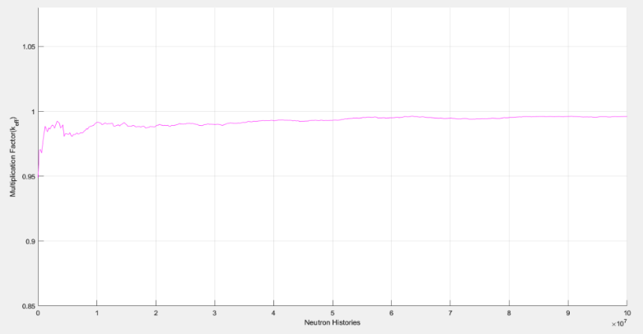
Fig1: Multiplication factor based on a total number of simulated neutron histories when the active cycle is 500.
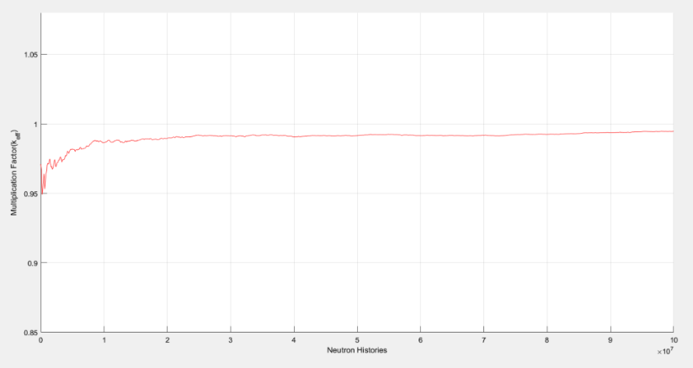
Fig2: Multiplication factor based on a total number of simulated neutron histories when the active cycle is 1000.

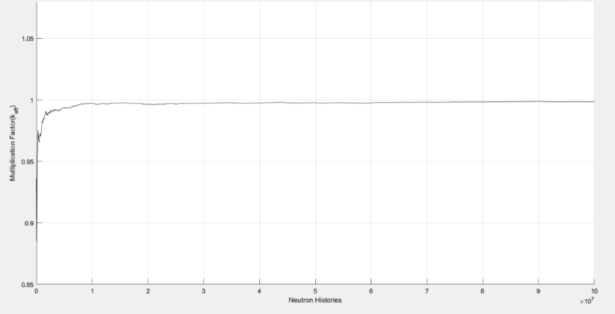
Fig3: Multiplication factor based on a total number of simulated neutron histories when the active cycle is 5000.
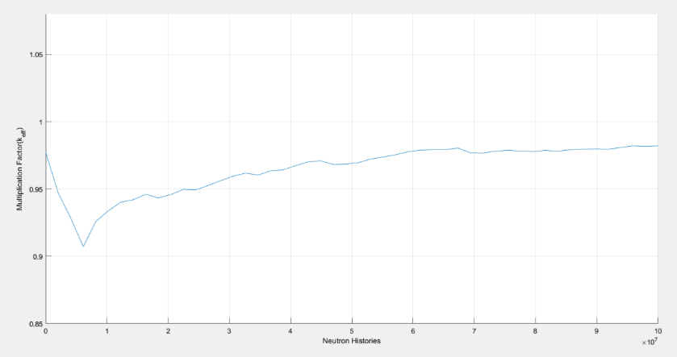
Fig4: Multiplication factor based on a total number of simulated neutron histories when the active cycle is 50.
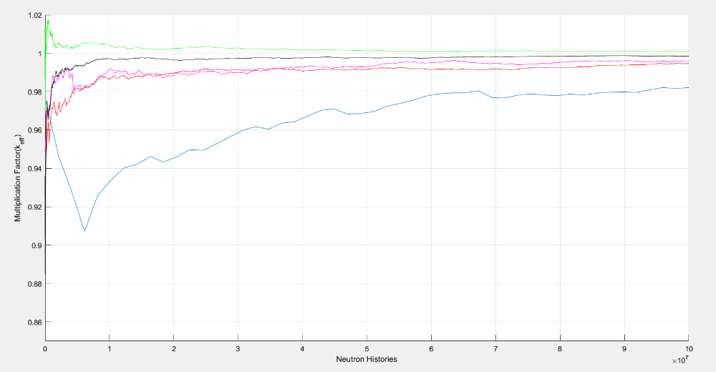
Fig5: Multiplication factor based on the total number of simulated neutron histories with a different number of cycles.

Discussions:
In a Monte Carlo simulation context, large batch sizes can sometimes lead to system divergence, as shown in the observed significant errors in Figure 4. On the other hand, using small batch sizes can help the system converge, as seen in Figure 5, where many cycles lead to convergence.
However, a small batch size can also lead to increased statistical uncertainty in the results, as seen in the difference between the expected multiplication factor and the calculated one in Figure 3. The most efficient multiplication factor was observed to be 0.99842, suggesting a trade-off between computational efficiency and the accuracy of the simulation results. In general, finding the optimal batch size is a matter of balancing the computational efficiency and the accuracy of the simulation results.

Reference:
[1] Jaakko Leppänen. Serpent –a Continuous-energy Monte Carlo Reactor Physics Burnup Calculation Code. User’s Manual.
[2] http://serpent.vtt.fi/mediawiki/index.php/Main_Page
[3] Simulation is carried out in Serpent and plots are done on Matlab.

