- 49 BWRs with a total net electrical capacity of 49.6 GWe in worldwide operation in 2023
- 12 BWRs with a capacity of 12.3 GWe suspended the operation
- 2 BWRs with a capacity of 2.65 GWe are under construction
- 52 BWRs are permanently shut down with a capacity of 49.6 GWe

BWRs are an endangered system (they disappear)—most BWRs shut down in Japan after Fukushima.
4 types of advanced BWRs recently under design:
- ABWR-II –Advanced Boiling Water Reactor II (GE-Hitachi)
- ESBWR –Economic Simplified Boiling Water Reactor (GE-Hitachi)
- KERNA (AREVA)
- RMWR –Reduced-Moderation Water Reactor (JAEA) –with potential for breeding thanks to hard neutron spectrum

BWRs are simplified to reduce capital costs, but there is a trade-off as phenomena become more complex.
Reduced moderation water reactor:
- It can be used for breeding as it has a harder neutron spectrum.
- There has yet to be a significant interest in breeding.

ABWR was Introduced in 1991
- Experience in BWR operation
- Modular construction techniques
- Safety improvements (reduced core damage frequency)
- Design life 60 years
- No external Recirculation Loops (Reactor Internal Pumps)

Several types of reactor vessels exist:
- The pressure vessel (in PWR, BWR, and GCR)
- In CANDU calandria is a reactor vessel
- In RBMK –a steel shell containing the reactor core and graphite

Reactor vessels differ in shape and orientation:
- cylindrical or spherical (Magnox)
- vertical or horizontal (CANDU or PWR)

ABWR -Reactor Pressure Vessel
- Diameter 7.1 m,
- Height 21m
- Pressure 7 MPa
- Saturation temperature 286ºC (Good margin for clad temperature 550ºC)
- Steam separation at the top (Not possible to get CR from the top)
- ABWR RPV forged ring (forge to work heated metal by hammering or pressing it into shape)
- Manufacturing by forging rings:
  - Plates to rings
  - Rings to shell

- ABWR shell, bottom head:
Bottom head manufactured by forging from one piece - penetrations machined for motors, CRGTs IGTs

Functions of Reactor Pressure Vessel (RPV):
- houses reactor core (fuel)
- serves as a fission product barrier
- provides volume for water to keep the reactor core cooled
- Thermal sleeves: their function is to eliminate the risk of thermal fatigue at the inlet of (relatively) cold feedwater to RPV
  - Saturation temperature 286ºC
  - Feedwater 215ºC
  - 71ºC difference,
  - thermal fatigue, cracks that can destroy steel elements in a year.
  - Flow into a Sparger then to downcomer

- Safety and performance elements all in one vessel
- Internal parts are more complex than PWR
  - PWR is one through circulation
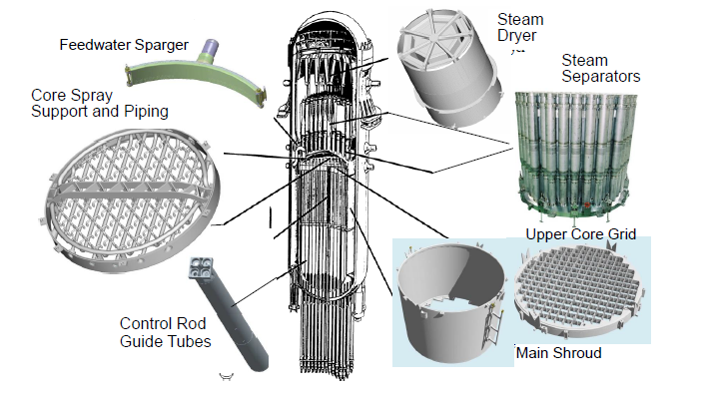
  - BWR has an internal circulation
- Feedwater flows into a Sparger, then into the downcomer
- Core spray support and piping (Used for core cooling)
- Core shroud
  - Is not separating the flow of hot and cold coolant
  - The fuel canisters separate flow
- Control rods (CR)
  - Cross inside canister
  - Boron is not used because water boils

The reactor core is the nuclear reactor’s central part, having fuel, moderator (in thermal reactors), coolant, and reactivity/power control elements.

The core is characterized by the following:
- assembly geometry (square, hexagonal, cylindrical)
- fuel form (rods, pellets, plates)
- fuel material (U metal, UO2, UO2/PuO2, UO2/ThO2, UO2/MOX)
- refueling type (on-load, off-load)
- moderator material (light water, heavy water, carbon, none)
- fuel-clad material (magnesium alloys, stainless steel, zirconium alloys, advanced and composite materials, so-called accident tolerant fuel ATF)
- average fuel enrichment
- refueling frequency (12, 18, 24 months)
- active core diameter and height
- number of fissile fuel assemblies/bundles
- number of fertile fuel assemblies
- fuel and moderator weight
- average core power density (ratio of the thermal power and the volume of the core; W/m3)
- average fuel power density (ratio of the core thermal power and the volume of the fuel; W/m3)
- average fuel-specific power (ratio of the core thermal power and the fuel mass; W/kgU)
- fuel linear heat generation rate (thermal power per linear unit of fuel rod; W/m)

Main components of a BWR fuel assembly
  - 1. Top tie plate,
  - 2. Fuel rods,
  - 3. Channel,
  - 4. Water cross,
  - 5. Spacer grid,
  - 6. Bottom tie plate

