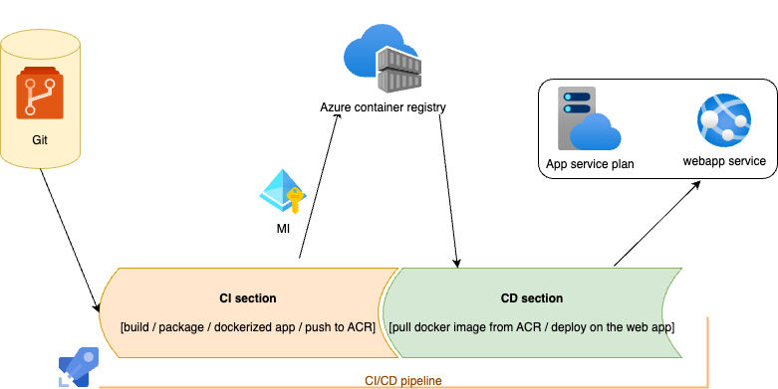

**Sequence of setup environment**

| **Task** | **How/why** | **Link** |
| --- | --- | --- |
| **Create Source code** | | |
| Create Git repo | In Azure devops repo | <https://famahmoudi64@dev.azure.com/famahmoudi64/SampleProjects/_git/ABN-HelloApp> |
| Create java app | With java spring boot | src |
| Create Dockerfile | To dockerized app | <https://dev.azure.com/famahmoudi64/SampleProjects/_git/ABN-HelloApp?path=/Dockerfile> |
| **Create Azure Resources** | | |
| Create App Service plan |  | <https://dev.azure.com/famahmoudi64/SampleProjects/_build?definitionId=3> |
| Create Web app service |  | <https://dev.azure.com/famahmoudi64/SampleProjects/_build?definitionId=6> |
| Create ACR | To push/pull Docker image | <https://dev.azure.com/famahmoudi64/SampleProjects/_build?definitionId=9> |
| Create Managed Identity | To access to ACR |  |
| Create Alerts | To define the rule and do action | <https://dev.azure.com/famahmoudi64/SampleProjects/_build?definitionId=8> |
| Create Action Group |  |  |
| **Create pipelines** | | |
| CI pipeline |  | <https://dev.azure.com/famahmoudi64/SampleProjects/_build?definitionId=1> |
| CD pipeline |  | <https://dev.azure.com/famahmoudi64/SampleProjects/_build?definitionId=11> |
| CICD pipeline | I can mix ci and cd in a single pipeline (as template) |  |
| web service pipeline |  | <https://dev.azure.com/famahmoudi64/SampleProjects/_build?definitionId=6> |
| ACR pipeline |  | <https://dev.azure.com/famahmoudi64/SampleProjects/_build?definitionId=9> |
| start pipeline |  | <https://dev.azure.com/famahmoudi64/SampleProjects/_build?definitionId=3> |
| stop pipeline |  | <https://dev.azure.com/famahmoudi64/SampleProjects/_build?definitionId=4> |
| alert pipeline |  | <https://dev.azure.com/famahmoudi64/SampleProjects/_build?definitionId=8> |
| action group pipeline |  |  |