* Go to <https://github.com/> and create your account
* Go to https://github.com/fametrano/bitbook and press *Fork*
* Go to msysgit.github.io and download the program;
* Run the .*exe* file;
* Follow the installation Wizard selecting this options:
  + Use git from git bash only, checkout windows style, commit unix style line endings
* Run Git Bash
* Run the following commands:
  + $ git config --global user.name "*your Name*"
  + $ git config --global user.email *yourEmail*@*example.com*
* Run $ git config –list to see the modified settings
* Run the following command (you have to use the username that you use in github.com):

$ git clone https://github.com/*username*/bitbook

* Close Git Bash
* Right click on your bitbook folder and select “Git Bash”

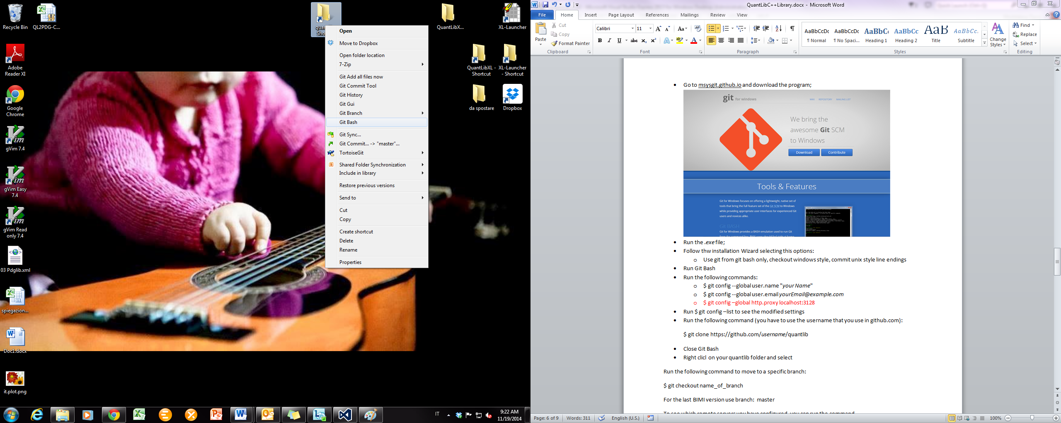

* Run the following command to move to a specific branch:

$ git checkout *branchname*

For the last version use *masteriI* as branchname

* To see which remote servers you have configured, you can run the command

$ git remote –v

* To add a remote server you can run the command

$ git remote add *remote_server_shortname* *remote_server_url*

(for example: $ git remote add ferdinando https://github.com/fametrano/bitbook)

* You can use the command

$ git pull remote_server_shortname *branchname*

to automatically fetch and then merge a remote branch into your current branch

(for example: $ git pull ferdinando master)