 Data Flow Diagram and AI Connectivity: SPERT® Suite at [ORGANIZATION]
Template · Fill-in template: data flows per tier, Connect AI snapshot contents and tools, and the organization's own controls · spertsuite.com/approval-kit
SPERT® Suite Approval Kit v1.0.0 (Release) · Content reviewed 2026-10-25 · Built 2026-10-26
Prepared by: [PROJECT MANAGER NAME] for [REVIEWING TEAM] · Request reference: [REQUEST ID] · Date: [DATE]
Reviewed against: SPERT® Scheduler 0.79.26, SPERT® Story Map 0.53.14, SPERT® Forecaster 0.47.4, SPERT® CFD 0.15.23, GanttApp™ 0.29.8, MyScrumBudget™ 0.44.4; shared backend spert-landing 2.7.2 (commit 52b7fbf), whose Connect AI tool definitions were read for the appendix; Connect AI server 1.14.1; Privacy Policy v1.4 and AI Privacy Notice v2.3 (both effective 2026-10-26). Review date: 2026-10-25.
This document supports an approval process. It is not legal, compliance or security advice, and it makes no commitments on the operator's behalf beyond those in the published legal documents.
For the project manager. Sections 1 to 5 describe SPERT® Suite and need no editing beyond the placeholders. Sections 6 and 7 describe [ORGANIZATION]'s side: fill them in with your service desk or [REVIEWING TEAM]. Delete the tier sections you are not requesting. The Architecture Overview explains each flow in more detail. Delete this box before you send it.

1. Scope
Item | Value
Apps in scope | [APPS REQUESTED]
Tiers in scope | [TIERS REQUESTED]
Connect AI modes in scope (tier 3) | [NONE / WRITE ONLY / WRITE AND READ]
Approved AI platform and account type (tier 3) | [AI PLATFORM]
Highest data classification | [DATA CLASSIFICATION]

2. Components
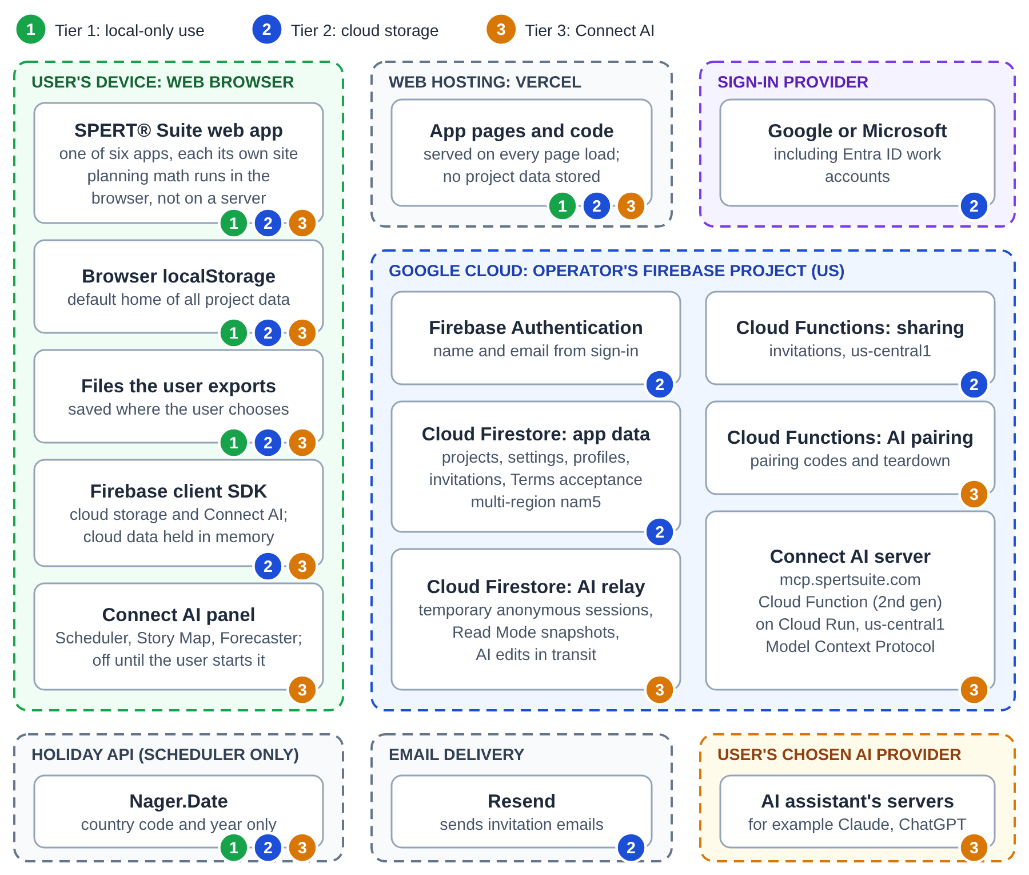
Figure 1. SPERT® Suite components. The numbered marks on each box show the tier or tiers that use it.
Each app is a web page served by Vercel that runs in the user's browser. The optional features share one Google Firebase project: Firebase Authentication, Cloud Firestore (saved projects and the Connect AI relay) and Cloud Functions (sharing invitations, Connect AI pairing, and the Connect AI server). Invitation emails go through Resend.

3. Tier 1: local-only use (the default)
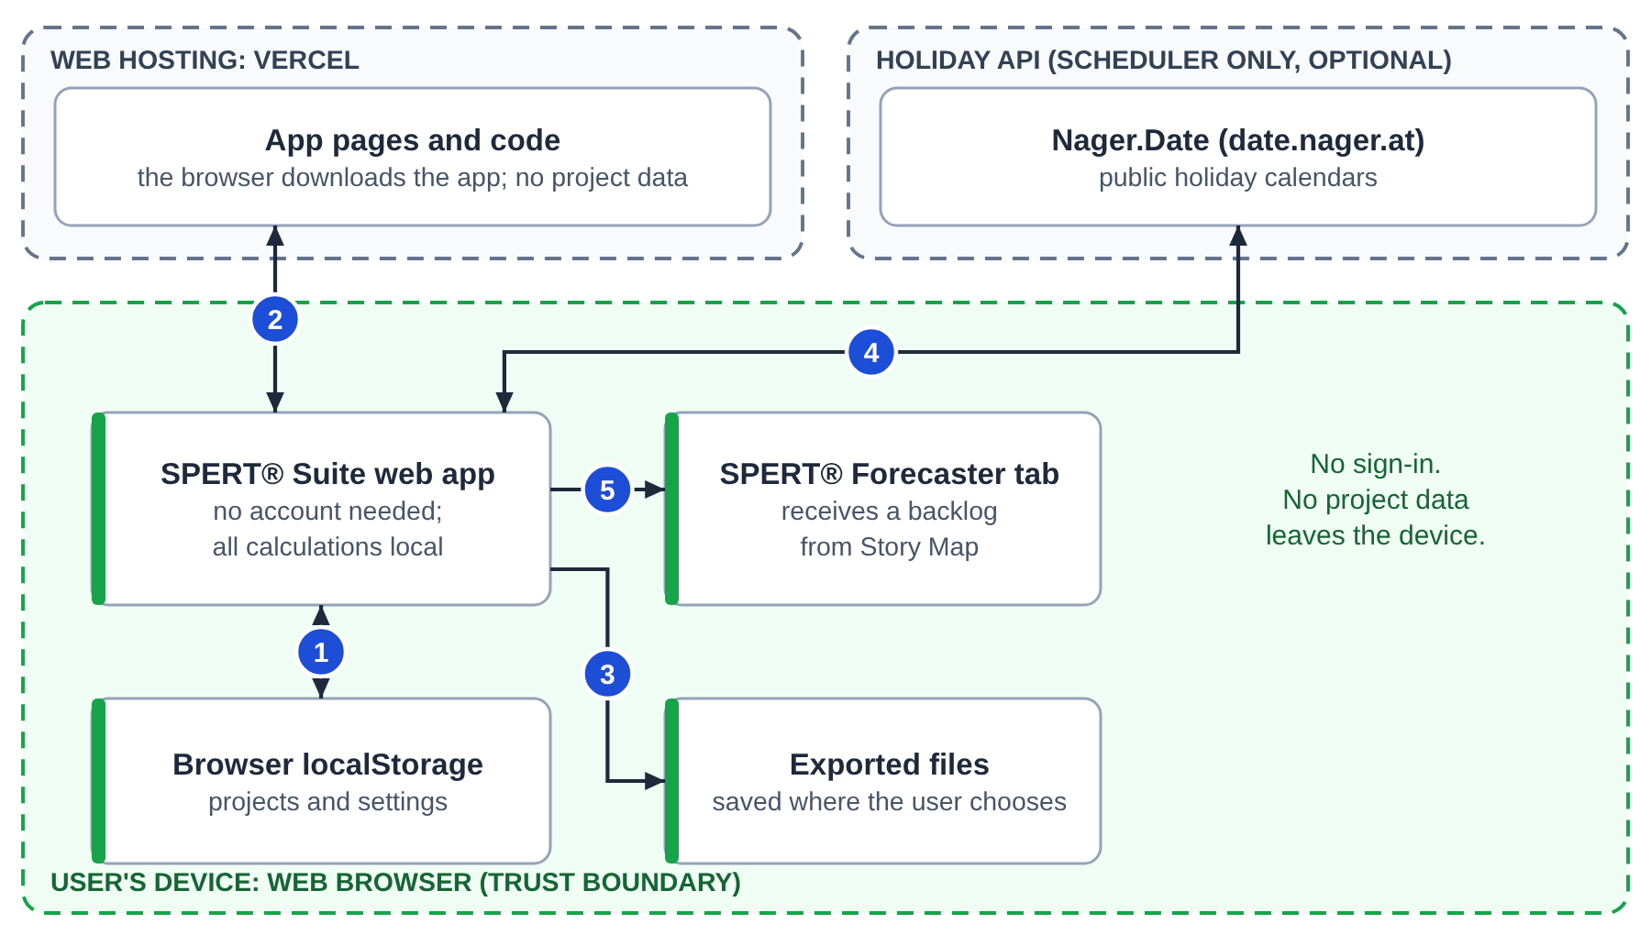
Figure 2. Tier 1 data flows. Nothing in this tier sends project data off the device.
# | From and to | What travels | When
1 | App and browser storage | Projects and settings, on the device | Always
2 | Vercel to browser | Pages and code; Vercel receives IP address and browser type (Privacy §1) | Every page load
3 | App to the user's files | Export files | When the user exports
4 | SPERT® Scheduler to Nager.Date | Country list on opening the Calendar page; country code and year when loading holidays; the service also sees the IP address (Privacy §1) | Calendar page only
5 | SPERT® Story Map to a SPERT® Forecaster tab | A backlog, passed between two open browser tabs, not through a server | Only when the user sends one

4. Tier 2: cloud storage and sharing
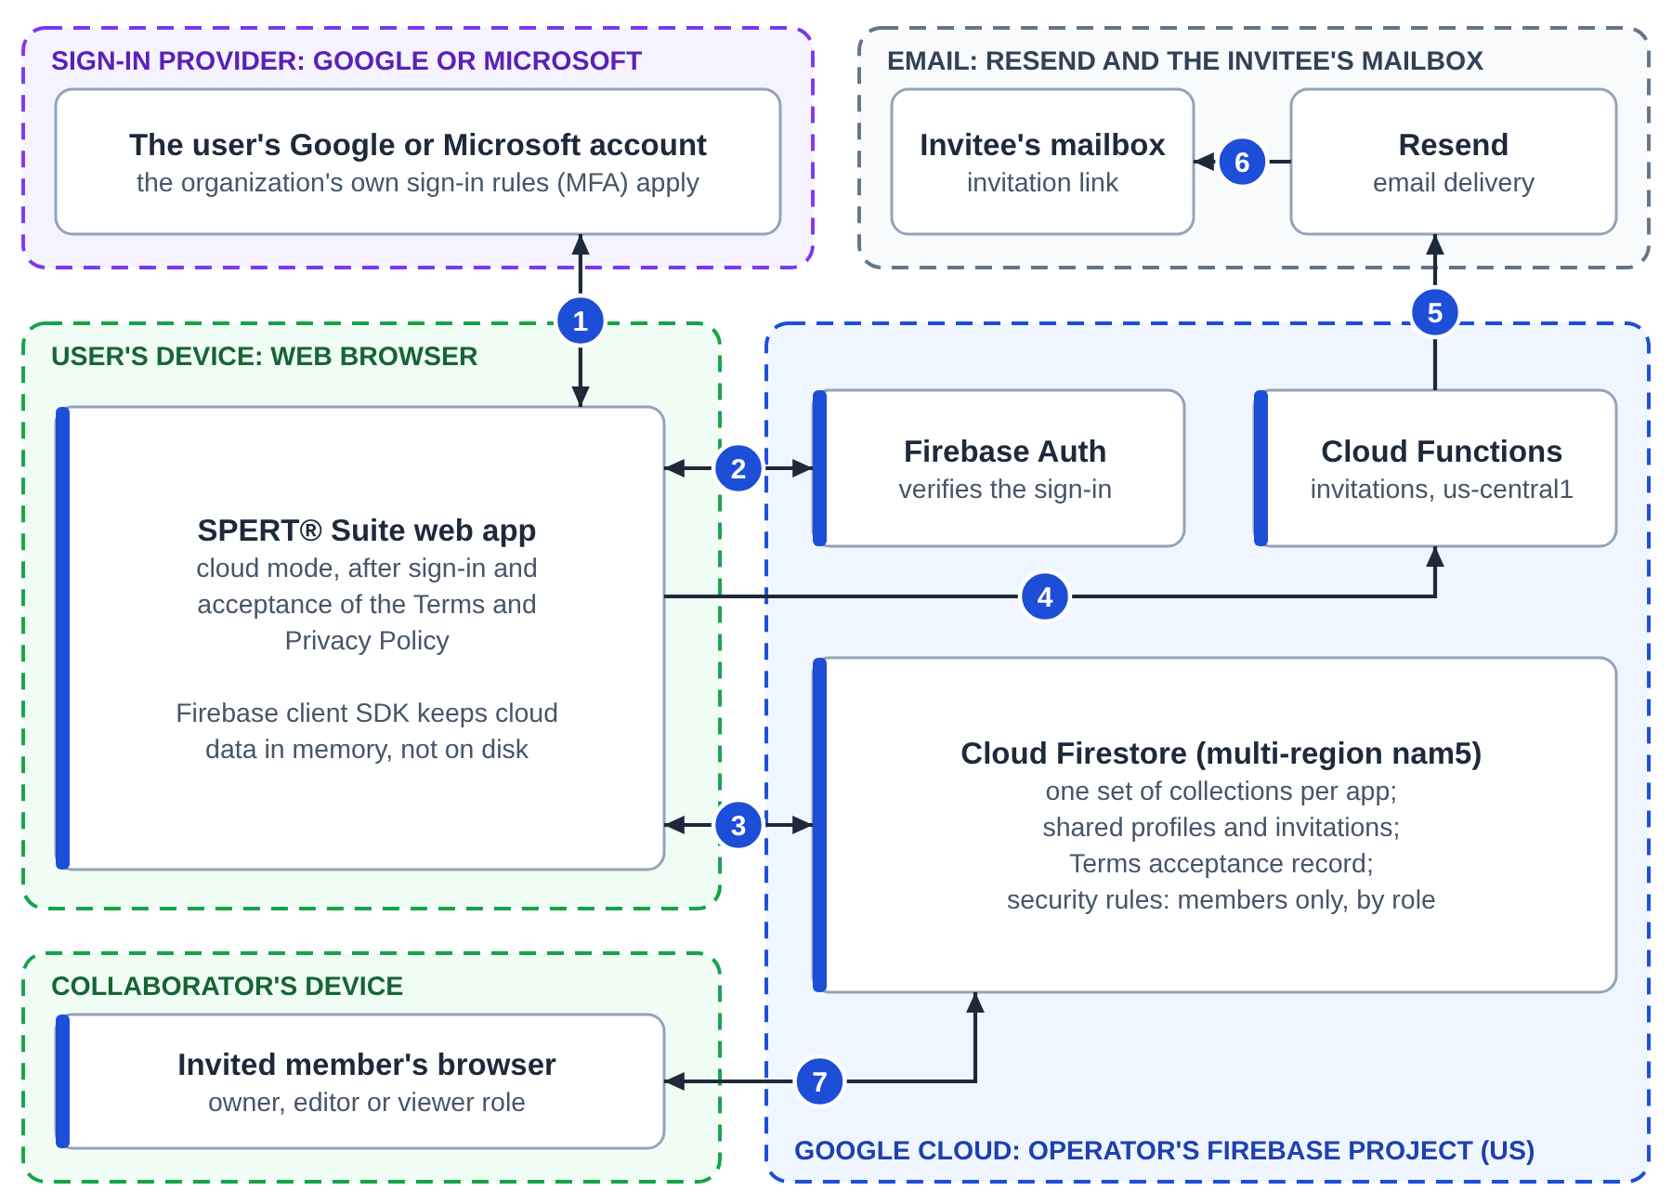
Figure 3. Tier 2 data flows. Cloud storage needs sign-in and acceptance of the Terms and Privacy Policy.
# | From and to | What travels
1 | Browser and the sign-in provider | Google or Microsoft sign-in, including [ORGANIZATION]'s work accounts. No password reaches SPERT® Suite
2 | Browser and Firebase Authentication | The sign-in result; the operator receives name and email (Privacy §2.1)
3 | Browser and Cloud Firestore (US, nam5) | Projects, settings, a shared profile (name, email) and the Terms acceptance record, checked by security rules
4 | Browser to Cloud Functions (us-central1) | A sharing invitation: invitee email, role, project id and name
5 | Cloud Functions to Resend | The invitation email
6 | Resend to the invitee | An email with a link to the project
7 | Collaborator's browser and Firestore | The shared project, within the role granted

5. Tier 3: Connect AI
Connect AI is offered only in SPERT® Scheduler and SPERT® Story Map (Write Mode required, Read Mode optional) and SPERT® Forecaster (Read Mode only) (AI Privacy Notice §2.3).
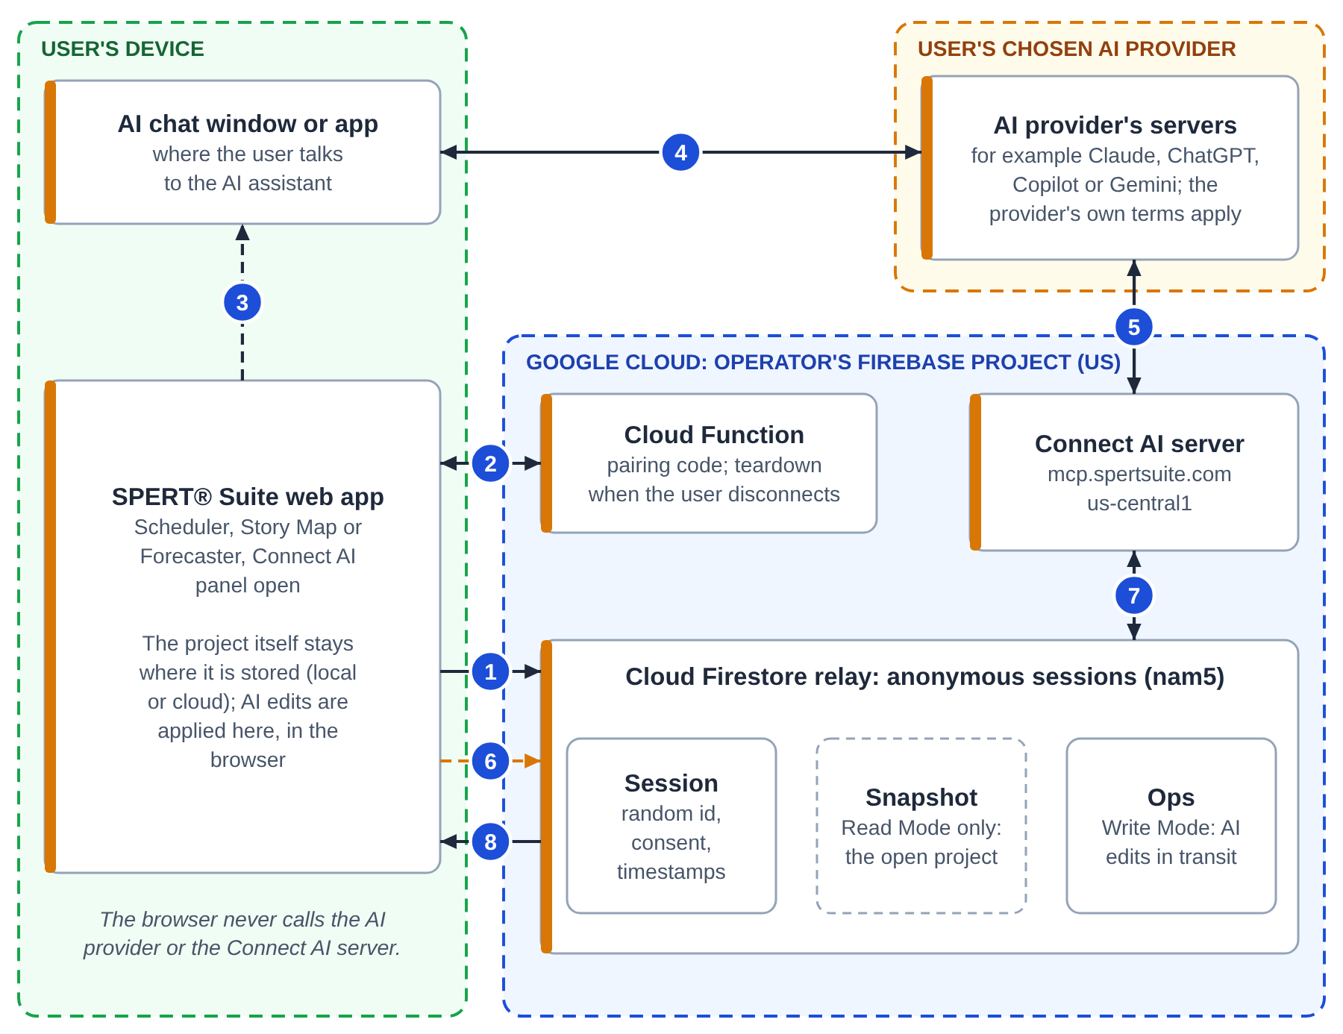
Figure 4. Tier 3 data flows. The orange dashed flow happens only when the user turns Read Mode on.
# | From and to | What travels
1 | Browser to the relay (Firestore) | A session record with a random identifier, consent and activity timestamps
2 | Browser and a Cloud Function | A pairing-code request (one word plus 10 digits, valid 15 minutes, single use); at the end, a teardown request
3 | User, from app to AI chat | The pairing code, copied by hand
4 | AI chat and the AI provider | Everything the user types, and the replies. This happens whatever SPERT® Suite's settings are
5 | AI provider's servers and the Connect AI server | MCP tool calls over HTTPS to https://mcp.spertsuite.com (a Google Cloud Function in us-central1), and tool results, including the snapshot in Read Mode
6 | Browser to the relay (Read Mode only) | A snapshot of the one open project, refreshed after edits, "regardless of your storage setting" (AI Privacy Notice §2.2)
7 | Connect AI server and the relay | The server reads the snapshot (Read Mode) and writes the AI's edits (Write Mode)
8 | Relay to browser | The AI's edits, applied to the open project

What a Read Mode snapshot contains
Each app builds its snapshot field by field from the open project. None includes other projects, the owner, members, sharing settings or email addresses.
App | Included | Notes
SPERT® Scheduler | Project name and id; every scenario; activity names, three-point estimates, status, computed dates and critical-path flags; milestones; dependencies; free text: activity notes, descriptions, checklist and deliverable items | Calendars and holiday data excluded. Free text is dropped first if the snapshot would exceed about 700 KB
SPERT® Story Map | Project name, id and description; the size scale; releases (name and order only); themes, backbones and ribs with names, categories, sizes and release allocations; free text: rib descriptions and notes | Release target dates excluded; recorded sprint progress appears only as a "locked" flag. Notes are dropped first if the snapshot would exceed about 900 KB
SPERT® Forecaster | Project name, unit of measure, sprint cadence and dates; up to the 60 most recent sprints (dates, completed amount, backlog); velocity and scope-change statistics; milestones (name, size, status); productivity adjustments with a free-text reason; forecast settings and percentile results | Raw simulation trials and charts excluded. Text fields are capped (names 200 characters, reasons 500)

Sources: each app's snapshot builder at the versions above (src/app/api/ai-snapshot-service.ts in SPERT® Scheduler, src/lib/aiSnapshot.ts in SPERT® Story Map, src/features/connect-ai/lib/build-snapshot.ts in SPERT® Forecaster).

Retention
The relay copy is deleted when the user disconnects or turns Read Mode off, or seven days after the session's last activity, including requests from the AI assistant; backups may keep copies up to 98 days (AI Privacy Notice §2.2, §4). Signing out ends the session on the server in all three apps (since SPERT® Scheduler 0.79.25, SPERT® Story Map 0.53.13 and SPERT® Forecaster 0.47.3); if the server cannot be reached at that moment, for example when offline, the app tells the user and keeps retrying. Disconnecting also ends the session on the server, but if the server cannot be reached, SPERT® Scheduler and SPERT® Story Map do not tell the user. Until a later attempt succeeds, the relay data stays until the session expires seven days after the session's last activity, including requests from the AI assistant; because each AI request extends the session, one that an AI keeps using does not expire. In SPERT® Scheduler a session is bound to the project it was opened for; in SPERT® Story Map it follows the user to whichever project is open, and the snapshot is replaced (AI Privacy Notice §2.2), so users should disconnect before opening a project the AI should not see or change. The AI provider's own terms govern anything it received (Privacy Policy §4.5).

What the AI can change
App | Tools | Can overwrite existing content | Can delete
SPERT® Scheduler | 25 (1 read, 24 write) | Yes: names, estimates, descriptions (an empty value clears one), milestones, dependency settings, checklist state, activity order | Dependency links only; can also unassign a milestone. No tool deletes an activity, milestone, scenario or project
SPERT® Story Map | 21 (1 read, 20 write) | Yes: names, descriptions, categories, notes (an empty value clears one), sizes, release allocations, location in the map | No entity deletes; tools can remove release allocations
SPERT® Forecaster | 3 (all read) | No | No

Each session is bound to one app, and the server refuses tool calls meant for another app. Browsers cannot write AI edits into the relay or read a snapshot back out of it (Firestore rules). The full tool list is in the appendix.

6. The organization's side
Fill this in with your service desk or [REVIEWING TEAM]. It records the controls [ORGANIZATION] already has around the flows above.
Element | The organization's arrangement
User devices | [MANAGED / UNMANAGED], [DISK ENCRYPTION], [WHO MAY USE THEM]
Browsers and profiles | [APPROVED BROWSERS], [ONE PROFILE PER PERSON, YES / NO]
Network and web filtering | [PROXY OR FILTER]. Allow *.spertsuite.com, and for tier 2 the Google Firebase endpoints
Identity provider (tier 2) | [TENANT], [MFA], [CONDITIONAL ACCESS], [USER CONSENT TO THIRD-PARTY APPS, ALLOWED / BLOCKED]
Data loss prevention | [DLP CONTROLS THAT APPLY TO BROWSER STORAGE, EXPORTS OR AI CHAT]
AI platform (tier 3) | [AI PLATFORM]; account type [ACCOUNT TYPE]; custom connectors [ALLOWED / RESTRICTED / BLOCKED]
Export storage | [WHERE EXPORTED FILES MUST BE SAVED]
Acceptable-use rule | [POLICY REFERENCE]

Restricting custom connectors in [AI PLATFORM], where available, stops Connect AI. Blocking the Connect AI server (mcp.spertsuite.com) on [ORGANIZATION]'s network does not work, because the AI provider's servers call it (flow 5), not the user's device. Starting Connect AI does need the user's browser to call SPERT® Suite's pairing function (flow 2) at us-central1-spert-suite.cloudfunctions.net/generatePairingCode, so blocking that path, or that whole host (which also stops sharing invitations), may stop Connect AI from starting. This is untested, so [ORGANIZATION]'s IT team should test any block it relies on.

7. Trust boundaries and controls
Boundary | What crosses it | SPERT® Suite control | Organization's control
Device and Vercel | Page requests, app code | HTTPS | [CONTROL]
Device and sign-in provider (tier 2) | Sign-in | Provider's sign-in only; no passwords | [MFA, CONDITIONAL ACCESS]
Device and the operator's Google Cloud (tiers 2, 3) | Cloud projects, profiles, invitations; relay records and snapshots | HTTPS; Firebase Authentication; Firestore security rules | [CONTROL]
AI provider and the Connect AI server (tier 3) | Tool calls and results, including snapshots in Read Mode | HTTPS; single-use pairing code; session identifier; rate limit | [AI PLATFORM CONNECTOR CONTROLS]
Device and AI provider (tier 3) | Everything typed into the AI chat | None: outside SPERT® Suite | [AI PLATFORM ACCOUNT CONTROLS]
Device and Nager.Date (SPERT® Scheduler, optional) | Country code and year | HTTPS; responses checked | [CONTROL]

Reviewer notes
- "Local-only has an exception." Correct, and the legal documents say so: Connect AI Read Mode uploads the open project whatever the storage setting (Privacy Policy §1; AI Privacy Notice §2.2). If [ORGANIZATION] approves tier 1 only, Connect AI is out of scope and the exception does not arise in approved use; there is no technical switch that enforces that, so it rests on policy.
- "Data leaving the environment." Figures 2 to 4 show every flow. Only flows 4 and 5 in tier 1 leave the device, and neither carries project data.
- "Audit and logging." None of these flows produces a log [ORGANIZATION] can see. Google Cloud keeps operational request logs for 30 days for the operator only (Privacy Policy §2.3).
- "Open source, no vendor review." The flows here were traced in the public source at the versions listed; no independent party has verified them.
- Scope and limits. Not verified: live security headers, deployed logging settings, and any AI provider's handling of data.

Appendix: Connect AI tools
From the Connect AI server's tool definitions (spert-landing, functions/src/mcp/tools/, at commit c54e8da). "Destructive" means the tool can overwrite or remove existing content. Two shared tools, resolve_session_code and get_session_info, change no project content.
SPERT® Forecaster (3, read-only): forecaster_get_project (needs Read Mode), forecaster_explain_method, forecaster_get_glossary.
SPERT® Scheduler (25):
Tool | Effect | Destructive?
scheduler_get_project | Read the project (Read Mode) | No
scheduler_create_activity, scheduler_bulk_create_activities | Add activities | No
scheduler_create_milestone, scheduler_bulk_create_milestones | Add milestones | No
scheduler_add_checklist_items, scheduler_add_deliverable_items | Add items | No
scheduler_append_activity_note, scheduler_bulk_append_notes | Append to notes | No
scheduler_create_dependency, scheduler_bulk_create_dependencies | Add dependency links (needs Read Mode) | No
scheduler_bulk_import | Add activities, milestones, assignments and links in one call | No
scheduler_assign_milestone, scheduler_bulk_assign_milestones | Assign activities to a milestone | Changes an assignment
scheduler_rename_activity | Replace an activity name | Overwrite
scheduler_update_activity_estimate | Replace an estimate, confidence and distribution | Overwrite
scheduler_set_activity_description | Replace a description; an empty value clears it | Overwrite or clear
scheduler_bulk_update_activities | Replace names, estimates and descriptions in bulk | Overwrite or clear
scheduler_update_milestone | Replace a milestone name and target date | Overwrite
scheduler_unassign_milestone | Remove an activity's milestone assignment | Remove link
scheduler_update_dependency | Replace a link's lag and type | Overwrite
scheduler_remove_dependency | Delete a dependency link | Delete
scheduler_toggle_checklist_item, scheduler_toggle_deliverable_item | Change completed state | Overwrite (state)
scheduler_reorder_activities | Reorder activities, which can move dates | Overwrite (order, dates)

SPERT® Story Map (21):
Tool | Effect | Destructive?
storymap_get_project | Read the project (Read Mode) | No
storymap_bulk_import | Add themes, backbones and ribs | No
storymap_create_theme, storymap_create_backbone, storymap_create_rib, storymap_create_release, storymap_bulk_create_releases | Add items | No
storymap_append_rib_note, storymap_bulk_append_rib_notes | Append to notes | No
storymap_size_rib, storymap_bulk_size | Size unsized ribs only | No
storymap_allocate_rib, storymap_bulk_allocate | Allocate a rib to a release | Changes an allocation
storymap_update_theme | Rename a theme | Overwrite
storymap_update_backbone | Replace a name or description; an empty value clears it | Overwrite or clear
storymap_update_rib | Replace a name, description, category or notes; can override or clear a size | Overwrite or clear
storymap_bulk_update_ribs | Replace descriptions, categories or notes in bulk | Overwrite or clear
storymap_unassign_rib, storymap_bulk_unassign | Remove release allocations | Remove links
storymap_move_rib, storymap_bulk_move_ribs | Move ribs to another backbone and replace their allocation | Overwrite (location, allocation)

