**Practical No 1**

1. Develop a JAVA program for multi-client chat server.

# ChatServer.java

package multiclient;

import java.net.ServerSocket;

import java.net.Socket;

public class ChatServer {

int port;

ServerSocket serverSocket;

Socket socket;

public ChatServer(int port) {

super();

this.port = port;

}

public void listen() {

try {

serverSocket = new ServerSocket(port);

System.out.println("Listening on ip:" + serverSocket.getInetAddress().getHostAddress() + " and port:" + port);

while(true)

{

socket = serverSocket.accept();

System.out.println("Client Accepted " + socket); ServRequest sr=new ServRequest(socket,this); sr.start();

}

} catch (Exception e) {

System.out.println(e.getMessage());

}

}

public static void main(String[] args) {

// TODO Auto-generated method stub ChatServer cs = new ChatServer(5000);

cs.listen();

}

}

# ChatClient.java

package multiclient;

import java.io.BufferedReader; import java.io.DataInputStream; import java.io.DataOutputStream; import java.io.InputStreamReader; import java.net.InetAddress;

import java.net.Socket;

public class ChatClient {

Socket socket;

int port;

public ChatClient(int port) {

super();

this.port = port;

}

public void request() {

try {

InetAddress host = InetAddress.getLocalHost();

socket = new Socket(host.getHostName(), port);

DataOutputStream dos = new DataOutputStream(socket.getOutputStream());

DataInputStream dis = new DataInputStream(socket.getInputStream());

System.out.println("Connected");

BufferedReader keyRead = new BufferedReader(new

InputStreamReader(System.in));

String line = "";

while(!line.equals("bye")) { line = keyRead.readLine();

dos.writeUTF(line);

dos.flush();

line = dis.readUTF();

System.out.println("Server reply - " + line);

} keyRead.close(); dos.close();

socket.close();

}

catch(Exception e) {

System.out.println(e.getMessage());

}

}

public static void main(String[] ar) {

ChatClient cc = new ChatClient(5000); cc.request();

}

}

# ServRequest.java

package multiclient;

import java.io.BufferedInputStream; import java.io.BufferedOutputStream; import java.io.BufferedReader; import java.io.DataInputStream; import java.io.DataOutputStream; import java.io.InputStreamReader; import java.net.Socket;

public class ServRequest extends Thread{ private Socket socket; @SuppressWarnings("unused")

private ChatServer chatServer;

public ServRequest(Socket socket, ChatServer chatServer) {

this.socket=socket;

this.chatServer=chatServer;

}

public void run()

{

try {

DataInputStream dis = new DataInputStream(new

BufferedInputStream(socket.getInputStream()));

DataOutputStream dos = new DataOutputStream(new

BufferedOutputStream(socket.getOutputStream()));

BufferedReader keyRead = new BufferedReader(new InputStreamReader(System.in)); boolean done = false;

while (!done) {

String line = dis.readUTF();

System.out.println(" Client Msg - "+ line + "\n");

done = line.equals("bye"); line = keyRead.readLine(); dos.writeUTF(line);

dos.flush();

} dis.close();

socket.close();

}

catch(Exception e)

{

System.out.println(e.getMessage());

}

}

}

**Output:**

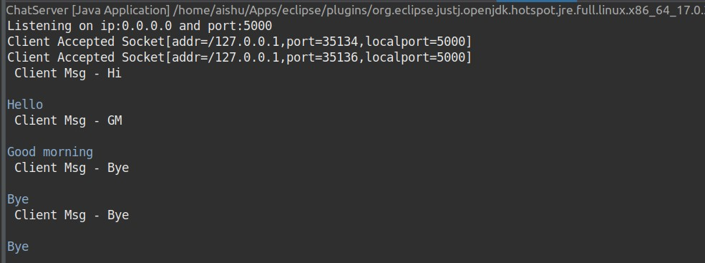

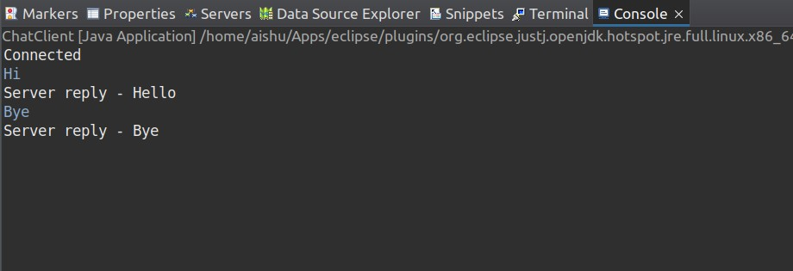

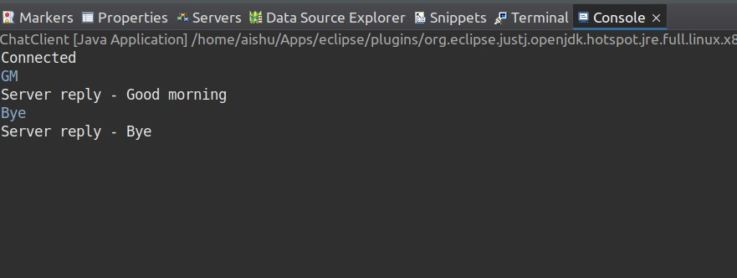

2. Write a java program to implement mutual exclusion using Token ring algorithm.

# UDPChatClient2.java

package tokenring;

import java.io.BufferedReader; import java.io.InputStreamReader; import java.net.DatagramPacket; import java.net.DatagramSocket;

import java.net.InetAddress;

public class UDPChatClient {

DatagramSocket udpClientSocket; int port;

public UDPChatClient(int port) { this.port = port;

}

public void sendReq() {

InetAddress serverAddress;

String in;

try {

udpClientSocket = new DatagramSocket(); InetAddress host = InetAddress.getLocalHost();

serverAddress = InetAddress.getByName(host.getHostName());

BufferedReader keyRead = new BufferedReader(new InputStreamReader(System.in)); System.out.println("UDP Client-1 started at " + InetAddress.getLocalHost());

while (true) {

System.out.println("Enter message for server: "); in = keyRead.readLine();

DatagramPacket sndPacket = new DatagramPacket(in.getBytes(), in.getBytes().length, serverAddress, port); udpClientSocket.send(sndPacket);

if(in.equalsIgnoreCase("bye")) break;

byte[] buf = new byte[1024];

DatagramPacket recPacket = new DatagramPacket(buf, buf.length); udpClientSocket.receive(recPacket);

String msg = new String(recPacket.getData()).trim();

System.out.println("Message from " + recPacket.getAddress().getHostAddress() + ": " + msg);

}

}

catch(Exception e) {

System.out.println(e.getMessage());

}

finally {

udpClientSocket.close();

}

}

public static void main(String[] args) {

UDPChatClient sender = new UDPChatClient(5000); sender.sendReq();

}

}

# UDPChatSrv.java

package tokenring;

import java.io.BufferedReader; import java.io.InputStreamReader; import java.net.DatagramPacket; import java.net.DatagramSocket;

import java.net.InetAddress;

public class UDPChatSrv { public DatagramSocket udpSrvSocket;

public int port;

String in;

public UDPChatSrv(int port) { this.port = port;

}

private void listen() { try {

udpSrvSocket = new DatagramSocket(port); BufferedReader keyRead = new BufferedReader(new

InputStreamReader(System.in));

String msg;

int [] clientPortA = new int[2]; InetAddress clientAddress;

int clientPort, clientCnt = 0; int tokenTo = -1, currentClient = -1; DatagramPacket recPacket, sndPacket;

System.out.println("Server started at " + InetAddress.getLocalHost());

while (true) {

byte[] buf = new byte[1024]; //System.out.println("while @server"); recPacket = new DatagramPacket(buf, buf.length); // blocks until a packet is received udpSrvSocket.receive(recPacket); msg = new String(recPacket.getData()).trim(); clientAddress = recPacket.getAddress(); clientPort = recPacket.getPort();

boolean clientPortPresent = false; int i; for(i = 0; i < clientPortA.length; i++) { if(clientPortA[i] == clientPort) { clientPortPresent = true;

currentClient = i; break;

}

}

if(clientPortPresent == false) { clientPortA[clientCnt] = clientPort; currentClient = clientCnt;

clientCnt++;

}

//System.out.println("Message from client " + currentClient + ": " + msg);

if(tokenTo == -1 && clientCnt == 1) {

tokenTo = 0; //Assign token to 1st client in d list

System.out.println("send Message :- Token assigned to client " + currentClient);

in = "Token assigned";

sndPacket = new DatagramPacket(in.getBytes(), in.getBytes().length, clientAddress, clientPortA[currentClient]); udpSrvSocket.send(sndPacket);

}

//1. token is wth 0th client in d list => clientCnt=1 //2. client send msg token => either he wants it or return it.

//3. if he wants chk who has d token n reply accordingly

//3.1 if token is wth 1 n 2 wants then deny

//3.2 token msg arrived at server, current client n tokenTo are same

//3.2 so remove token frm current n assign it to nxt

//4. if he returns it then assign it nxt in list

if(msg.contains("token")) { if(tokenTo == currentClient) { if(clientPortA.length == tokenTo) tokenTo = 0; else tokenTo++;

System.out.println("send Message :- Token assigned to client " + currentClient);

//in = keyRead.readLine(); in = "Token assigned";

sndPacket = new DatagramPacket(in.getBytes(), in.getBytes().length, clientAddress, clientPortA[tokenTo]);

udpSrvSocket.send(sndPacket);

} else {

System.out.println("send Message :- ");

//in = keyRead.readLine();

in = "Token is with Client - " + tokenTo +". Wait for your turn.";

sndPacket = new DatagramPacket(in.getBytes(), in.getBytes().length, clientAddress, clientPortA[currentClient]);

udpSrvSocket.send(sndPacket);

}

} else {

if(currentClient == tokenTo) {

System.out.println("send Message :- ");

in = keyRead.readLine(); //in = "Token assigned";

sndPacket = new DatagramPacket(in.getBytes(), in.getBytes().length, clientAddress, clientPortA[currentClient]);

udpSrvSocket.send(sndPacket);

} else{

System.out.println("send Message :- ");

//in = keyRead.readLine();

in = "Token is with Client - " + tokenTo +". Wait for your turn.";

sndPacket = new DatagramPacket(in.getBytes(), in.getBytes().length, clientAddress, clientPortA[currentClient]);

udpSrvSocket.send(sndPacket);

}

}

/*if(msg.equalsIgnoreCase("bye"))

clientCnt--;

*/

}

}

catch(Exception e) {

System.out.println(e.getMessage());

}

finally {

udpSrvSocket.close();

}

}

public static void main(String[] args) {

UDPChatSrv client = new UDPChatSrv(5000); client.listen();

}

}

**Output:**

