**Practical No. 2**

**1. Write a java program to implement a Server calculator using RPC concept.**

**Client.java** import java.io.BufferedReader; import java.io.InputStreamReader; import java.net.DatagramPacket; import java.net.DatagramSocket; import java.net.InetAddress; import java.util.Scanner;

public class Client {

DatagramSocket udpSocket;

InetAddress serverAddress;

int port;

Scanner scanner;

public Client(int port) { this.port = port;

}

public void sendReq() {

String in; try {

udpSocket = new DatagramSocket();

InetAddress host = InetAddress.getLocalHost();

serverAddress = InetAddress.getByName(host.getHostName());

BufferedReader keyRead = new BufferedReader(new InputStreamReader(System.in));

System.out.println("UDP Client started at " + InetAddress.getLocalHost());

String paramlist="";

System.out.println("EnterMethod:\n1.Addition:\n2.Subtraction\n3.Multiplication\n4.Devision");

in = keyRead.readLine(); paramlist=paramlist+in+"-";

System.out.println("Enter Number 1:"); in = keyRead.readLine(); paramlist=paramlist+in+"-";

System.out.println("Enter Number 2:"); in = keyRead.readLine(); paramlist=paramlist+in;

DatagramPacket p = new DatagramPacket(paramlist.getBytes(), paramlist.getBytes().length, serverAddress, port); udpSocket.send(p);

}

catch(Exception e) {

System.out.println(e.getMessage());

}

}

public static void main(String[] args) { Client sender = new Client(5000); sender.sendReq();

}

}

**Output:**

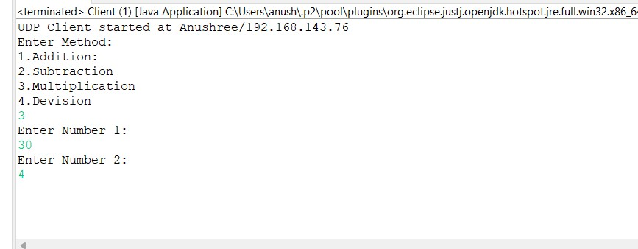

**Server.java** import java.net.DatagramPacket; import java.net.DatagramSocket; import java.net.InetAddress; import java.util.StringTokenizer;

public class Server {

private DatagramSocket udpSocket;

private int port;

public Server(int port) { this.port = port;

}

public static int addition(int num1,int num2)

{

return num1+num2;

}

public static int substraction(int num1,int num2)

{

return num1-num2;

}

public static int multiplication(int num1,int num2)

{

return num1*num2;

}

public static int division(int num1,int num2)

{

return num1/num2;

}

private void listen() {

try {

DatagramSocket udpSocket = new DatagramSocket(port);

System.out.println("Server started at " + InetAddress.getLocalHost());

String msg;

byte[] buf = new byte[1024];

DatagramPacket packet = new DatagramPacket(buf, buf.length);

// blocks until a packet is received udpSocket.receive(packet); msg = new String(packet.getData()).trim();

StringTokenizer str=new StringTokenizer(msg,"-"); int mthNo=Integer.parseInt(str.nextToken()); int num1=Integer.parseInt(str.nextToken()); int num2=Integer.parseInt(str.nextToken()); int result; if(mthNo==1) {

result=addition(num1,num2); msg="Addition:"+result;

} if(mthNo==2) {

result=substraction(num1,num2); msg="substraction:"+result;

} if(mthNo==3) {

result=multiplication(num1,num2); msg="multiplication:"+result;

}

if(mthNo==4)

{

result=division(num1,num2); msg="division:"+result;

}

System.out.println("Message from " + packet.getAddress().getHostAddress() + ": " + msg);

}

catch(Exception e) {

System.out.println(e.getMessage());

}

finally {

//udpSocket.close();

}

}

public static void main(String[] args) { Server client = new Server(5000);

client.listen();

}

}

**Output:**

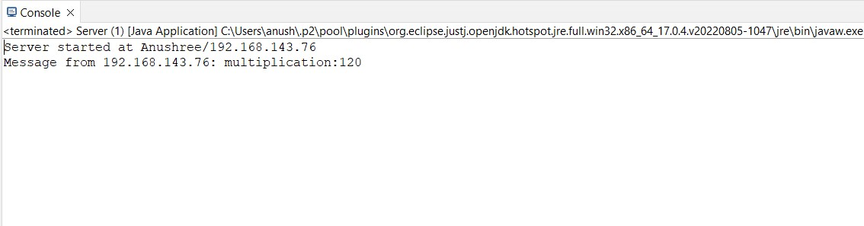

**2. Write a java to implement a Date Time Server using RPC concept.**

**RPC_Client.java**

**import** java.io.BufferedReader; **import** java.io.InputStreamReader; **import** java.net.DatagramPacket; **import** java.net.DatagramSocket; **import** java.net.InetAddress; **import** java.time.LocalDateTime; **import** java.util.Scanner;

**public** **class** RPC_Client {

DatagramSocket udpSocket; InetAddress serverAddress; **int** port;

Scanner scanner;

**public** RPC_Client(**int** port) { **this**.port = port;

}

**public** **void** sendReq() {

String in; **try** {

udpSocket = **new** DatagramSocket();

InetAddress host = InetAddress.*getLocalHost*();

serverAddress = InetAddress.*getByName*(host.getHostName());

BufferedReader keyRead = **new** BufferedReader(**new**

InputStreamReader(System.***in***));

System.***out***.println("UDP Client started at " +

InetAddress.*getLocalHost*());

String paramlist="";

DatagramPacket p = **new** DatagramPacket(paramlist.getBytes(), paramlist.getBytes().length, serverAddress, port); udpSocket.send(p);

}

**catch**(Exception e) {

System.***out***.println(e.getMessage());

}

}

**public** **static** **void** main(String[] args) { RPC_Client sender = **new** RPC_Client(5000); sender.sendReq();

}

}

**Output:**

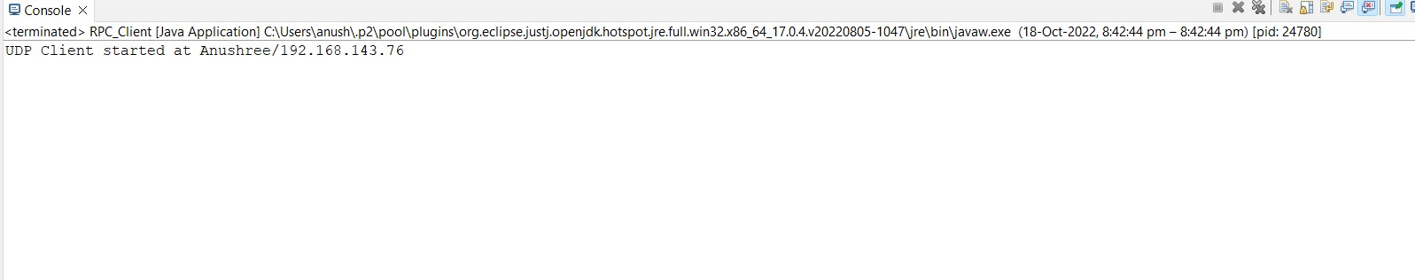

**RPC_Server.java**

**import** java.net.DatagramPacket; **import** java.net.DatagramSocket; **import** java.net.InetAddress; **import** java.time.LocalDateTime;

**public** **class** RPC_Server { **private** DatagramSocket udpSocket;

**private** **int** port;

**public** RPC_Server(**int** port) { **this**.port = port;

}

**public** **static** LocalDateTime date()

{

**return** java.time.LocalDateTime.*now*();

}

**private** **void** listen() {

**try** {

DatagramSocket udpSocket = **new** DatagramSocket(port);

System.***out***.println("Server started at " +

InetAddress.*getLocalHost*());

LocalDateTime msg;

**byte**[] buf = **new** **byte**[1024];

DatagramPacket packet = **new** DatagramPacket(buf, buf.length);

// blocks until a packet is received udpSocket.receive(packet);

msg=*date*();

System.***out***.println("Message from " +

packet.getAddress().getHostAddress() + ": " + msg);

}

**catch**(Exception e) {

System.***out***.println(e.getMessage());

} **finally** {

//udpSocket.close();

}

}

**public** **static** **void** main(String[] args) { Server client = **new** Server(5000); client.listen();

}

}

**Output:**

