**Remote Method Invocation**

**Exercise:**

**1. Design a Graphical User Interface (GUI) based calculator. (scientific or standard). Operations should be performed using both mouse and keyboard.**

**Calculator.java**

package mypackage;

import java.rmi.Remote;

import java.rmi.RemoteException;

public interface Calculator extends Remote{

public void calculate() throws RemoteException;

}

**Main.java**

package mypackage;

import java.rmi.RemoteException;

import java.rmi.server.UnicastRemoteObject;

public class Main extends UnicastRemoteObject implements Calculator{

protected Main() throws RemoteException {

super();

}

private static final long serialVersionUID = 1L;

@Override

public void calculate() throws RemoteException {

new calculator();

}

}

**calculator.java**

package mypackage;

import java.awt.event.*;

import java.awt.*;

import javax.swing.*;

public class calculator extends JFrame implements ActionListener

{

JButton b10,b11,b12,b13,b14,b15;

JButton b[]=new JButton[10];

int i,r,n1,n2;

JTextField res;

char op;

public calculator()

{

super("calulator");

setLayout(new BorderLayout());

JPanel p=new JPanel();

p.setLayout(new GridLayout(4,4));

for(int i=0;i<=9;i++)

{

b[i]=new JButton(i+"");

p.add(b[i]);

b[i].addActionListener(this);

}

b10=new JButton("+");

p.add(b10);

b10.addActionListener(this);

b11=new JButton("-");

p.add(b11);

b11.addActionListener(this);

b12=new JButton("*");

p.add(b12);

b12.addActionListener(this);

b13=new JButton("/");

p.add(b13);

b13.addActionListener(this);

b14=new JButton("=");

p.add(b14);

b14.addActionListener(this);

b15=new JButton("C");

p.add(b15);

b15.addActionListener(this);

res=new JTextField(10);

add(p,BorderLayout.CENTER);

add(res,BorderLayout.NORTH);

setVisible(true);

setSize(200,200);

}

public void actionPerformed(ActionEvent ae)

{

JButton pb=(JButton)ae.getSource();

if(pb==b15)

{

r=n1=n2=0;

res.setText("");

}

else

if(pb==b14)

{

n2=Integer.parseInt(res.getText());

eval();

res.setText(""+r);

}

else

{

boolean opf=false;

if(pb==b10)

{ op='+';

opf=true;

}

if(pb==b11)

{ op='-';opf=true;}

if(pb==b12)

{ op='*';opf=true;}

if(pb==b13)

{ op='/';opf=true;}

if(opf==false)

{

for(i=0;i<10;i++)

{

if(pb==b[i])

{

String t=res.getText();

t+=i;

res.setText(t);

}

}

}

else

{

n1=Integer.parseInt(res.getText());

res.setText(""); }}

}

int eval()

{

switch(op)

{

case '+': r=n1+n2; break;

case '-': r=n1-n2; break;

case '*': r=n1*n2; break;

case '/': r=n1/n2; break;

}

return 0;

}}

**Server.java**

package mypackage;

import java.rmi.Naming;

import java.rmi.registry.LocateRegistry;

public class Server {

public static void main(String[] args) {

try

{

Calculator cal=new Main();

LocateRegistry.createRegistry(1900);

Naming.rebind("rmi://localhost:1900/calculator", cal);

}

catch(Exception ex)

{

System.out.println(ex);

}

}

}

**Client.java**

package mypackage;

import java.rmi.Naming;

public class Client {

public static void main(String[] args) {

try

{

Calculator access=(Calculator)Naming.*lookup*("rmi://localhost:1900/calculator");

access.calculate();

}

catch(Exception ex)

{

System.***out***.println(ex);

}

}

}

**Output:**

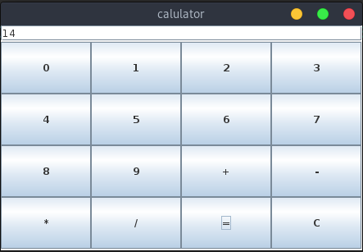

**2. Retrieve day, time and date function from server to client. This program should display server day, date and time.**

**Dater.java**

package datetime;

import java.rmi.Remote;

import java.rmi.RemoteException;

import java.sql.Date;

import java.time.LocalDateTime;

public interface Dater extends Remote {

public LocalDateTime getDate() throws RemoteException;

}

**Main.java**

package datetime;

import java.rmi.RemoteException;

import java.rmi.server.UnicastRemoteObject;

import java.sql.Date;

import java.time.LocalDate;

import java.time.LocalDateTime;

public class Main extends UnicastRemoteObject implements Dater{

Main() throws RemoteException

{

super();

}

@Override

public LocalDateTime getDate() throws RemoteException {

return java.time.LocalDateTime.now();

}

}

**Server.java**

package datetime;

import java.rmi.Naming;

import java.rmi.registry.LocateRegistry;

public class Server {

public static void main(String[] args) {

try

{

Dater dt=new Main();

LocateRegistry.*createRegistry*(1900);

Naming.*rebind*("rmi://localhost:1900/datedisplay", dt);

}

catch(Exception ex)

{

System.***out***.println(ex);

}

}

}

**Client.java**

package datetime;

import java.rmi.Naming;

import java.sql.Date;

import java.time.LocalDateTime;

public class Client {

public static void main(String[] args) {

LocalDateTime answer;

try

{

Dater access=(Dater)Naming.lookup("rmi://localhost:1900/datedisplay");

answer=access.getDate();

System.out.println(answer);

}

catch(Exception ex)

{

System.out.println(ex);

}

}

}

**Output:**

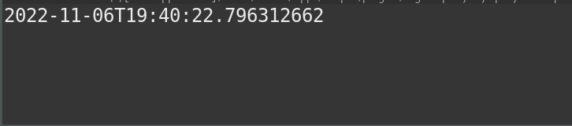

**3. Equation solver. The client should provide an equation to the server through an interface. The server will solve the expression given by the client. (a-b)2 = a2 –2ab + b2;**

**If a = 5 and b = 2 then return value = 52 – 2*5*2 + 22 = 9.**

**Equator.java**

package mypackage;

import java.rmi.Remote;

import java.rmi.RemoteException;

public interface Equator extends Remote{

public int getEquation(int a,int b) throws RemoteException;

}

**Main.java**

package mypackage;

import java.rmi.RemoteException;

import java.rmi.server.UnicastRemoteObject;

public class Main extends UnicastRemoteObject implements Equator{

protected Main() throws RemoteException {

super();

}

private static final long serialVersionUID = 1L;

@Override

public int getEquation(int a, int b) throws RemoteException {

int result=((a*a)-(2*a*b)+(b*b));

return result;

}

}

**Server.java**

package mypackage;

import java.rmi.Naming;

import java.rmi.registry.LocateRegistry;

public class Server {

public static void main(String[] args) {

try

{

Equator eq=new Main();

LocateRegistry.createRegistry(1900);

Naming.rebind("rmi://localhost:1900/equationsolver", eq);

}

catch(Exception ex)

{

System.out.println(ex);

}

}

}

**Client.java**

package mypackage;

import java.rmi.Naming;

public class Client {

public static void main(String[] args) {

try

{

Equator access=(Equator)Naming.*lookup*("rmi://localhost:1900/equationsolver");

int answer=access.getEquation(5, 3);

System.***out***.println("(a-b)2= "+answer);

}

catch(Exception ex)

{

System.***out***.println(ex);

}

}

}

**Output:**

