**Implementation**

1. Create a test class with @BeforeClass/@AfterClass, @BeforeMethod/@AfterMethod annotations and execute it using a testng.xml

**Code:**

package practical11;

import org.testng.annotations.AfterClass;

import org.testng.annotations.AfterMethod;

import org.testng.annotations.BeforeClass;

import org.testng.annotations.BeforeMethod;

import org.testng.annotations.Test;

public class Q1 {

@BeforeClass

public void beforeClassMethod(){

System.err.println("This is before class method");}

@AfterClass

public void afterClassMethod() {

System.err.println("This is after Class Method");}

@BeforeMethod

public void beforeMethod() {

System.err.println("This is before Method");}

@AfterMethod

public void afterMethod() {

System.err.println("This is After Method");}

@Test

public void firstMethod() {

System.out.println("First method of Q1");

}}

**Output:-**

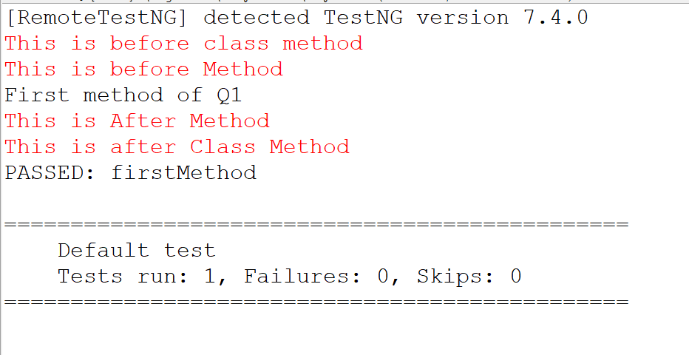

1. Create and execute a TestNG class using test annotation on class. The class contains two public methods and one private method.

**Code:**

package practical11;

import org.testng.annotations.Test;

@Test

public class Q2 {

public void publicMethod() {

System.out.println("This is Public Method");

}

private void privateMethod() {

System.out.println("This is private Method"); }

}

**XML:**

<suite name="Practical_11_Q1">

<test name="Q1">

<classes>

<class name="practical11.Q2"/>

</classes>

</test>

</suite>

**Output:**

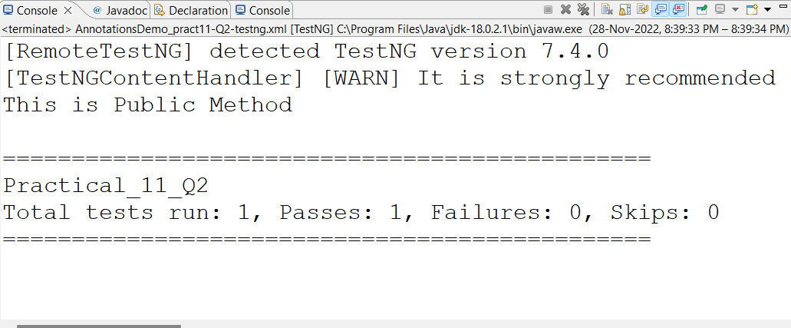

1. Create TestNG class containing three test methods using test annotation out of which any two methods are enabled and remaining method is disabled. Use appropriate attributes of test annotation.

**Code:**

package beforeafter;

import org.testng.annotations.Test;

public class test {

@Test

public void testMethodOne() {

System.out.println("First Test Method");}

@Test(enabled=false)

public void testMethodTwo() {

System.out.println("Second Test Method");}

@Test

private void testMethodThird() {

System.out.println("Third Test Method");

}}

**XML:**

<suite name="Test Suite" verbose="1">

<test name="First Test">

<classes>

<class name="beforeafter.test"/>

</classes>

</test>

</suite>

**Output:**

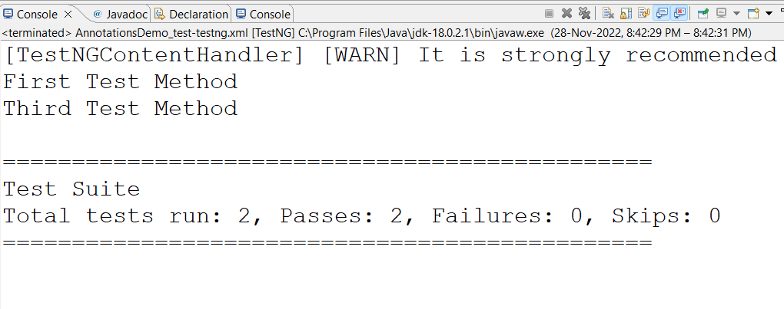

1. Create a test class with @BeforeSuite/@AfterSuite, @BeforeTest/@AfterTest annotations and execute it using a testng.xml.

**Code:**

package practical11;

import org.testng.annotations.AfterSuite;

import org.testng.annotations.AfterTest;

import org.testng.annotations.BeforeGroups;

import org.testng.annotations.BeforeSuite;

import org.testng.annotations.BeforeTest;

import org.testng.annotations.Test;

public class Q3 {

@BeforeSuite

public void beforeSuite() {

System.err.println("This is before suite method");}

@AfterSuite

public void afterSuite() {

System.err.println("This is before suite method"); }

@BeforeTest

public void beforeTest() {

System.err.println("This is before Test method");}

@AfterTest

public void afterTest() {

System.err.println("This is after Test method");

}

@Test

public void firstMethod() {

System.out.println("In Method");

}}

**XML:**

<suite name="Practical_11_Q3">

<test name="Q3">

<classes>

<class name="practical11.Q3"/>

</classes>

</test>

</suite>

**Output:**

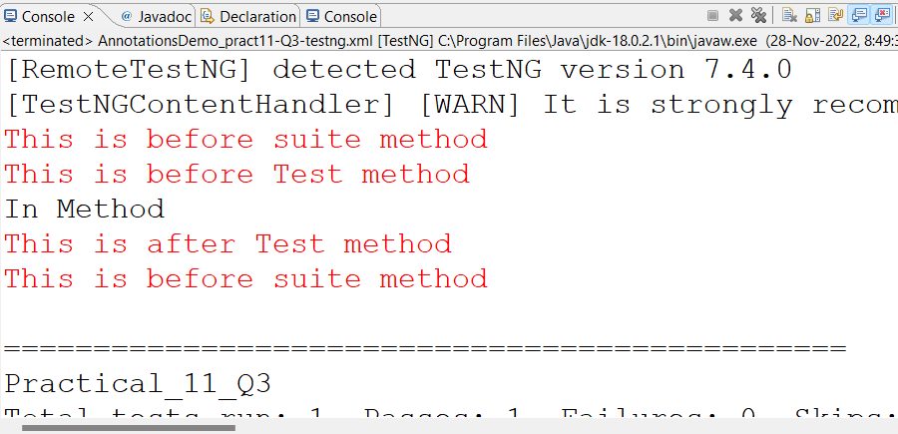

1. Create a test class that contains four test methods. Two of which should belong to one group and the remaining two to another group. Create testing.xml file to execute tests in a particular group.

**Code:**

package beforeafter;

import org.testng.annotations.Test;

public class GroupsTestDemo {

@Test(groups ={"test-group"})

public void testMethodOne() {

System.out.println("Test method one belongs to test-group"); }

@Test(groups= {"new-group"})

public void testMethodTwo() {

System.err.println("Test method two belongs to new group");}

@Test(groups = {"test-group"})

public void testMethodThird() {

System.out.println("Test method third belongs to test-group");}

@Test(groups= {"new-group"})

public void testMethodFourth() {

System.err.println("Test method Fourth belongs to new-group");

}}

**XML:**

<suite name="groupt test suite">

<test name=" Group Testing">

<groups>

<run>

<include name="test-group"/>

<include name="new-group"/>

</run>

</groups>

<classes>

<class name="beforeafter.GroupsTestDemo"/>

</classes>

</test>

</suite>

**Output:**

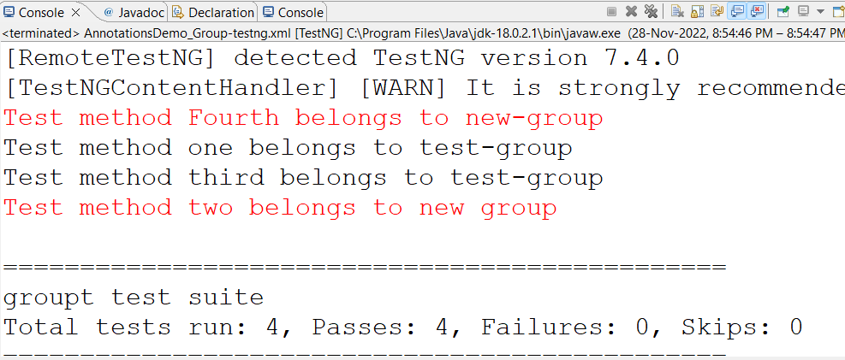

1. Write a test class containing test method that calculates the average marks that awarded by two reviewers prints whether writer is shortlisted if average is >4. The marks are passed as parameters whose values are passed from testing.xml at test level.

**Code:**

package beforeafter;

import org.testng.annotations.Parameters;

import org.testng.annotations.Test;

public class ParameterizationDemo {

@Test

@Parameters({"Reviewer1","Reviewer2"})

public void check_if_shortLiisted(int marks1,int marks2) {

float average=(marks1+marks2)/2;

System.out.println("Average achieve by reviewer "+average);

if(average > 4)

System.out.println("Reviewer is ShortListed");

else

System.out.println("Reviewer is not ShortListed");

}}

**XML:**

<suite name="parameterized" verbose="1">

<parameter name="Reviewer1" value="4"/>

<parameter name="Reviewer2" value="9"/>

<test name="Parameterized Test">

<parameter name="Reviewer1" value="4"/>

<parameter name="Reviewer2" value="1"/>

<classes>

<class name="beforeafter.ParameterizationDemo"/>

</classes>

</test>

</suite>

**Output:**

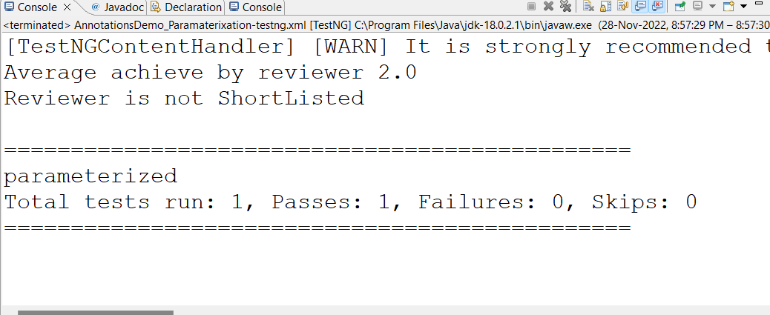

1. Write a test class containing test method that prints the value of parameters which are passed from data provider.

**Code:**

package beforeafter;

import org.testng.annotations.DataProvider;

import org.testng.annotations.Test;

public class DataProviderDemo {

@DataProvider(name="dataProvider")

public Object[][] dataProviderMethod() {

return new Object[][] {{"data one"},{"data two"}};

}

@Test(dataProvider="dataProvider")

public void testMethod(String data) {

System.out.println("Data is :"+data);

}}

**XML:**

<suite name="Test Suite">

<test name="Data provider Test">

<classes>

<class name="beforeafter.DataProviderDemo"/>

</classes>

</test>

</suite>

**Output:**

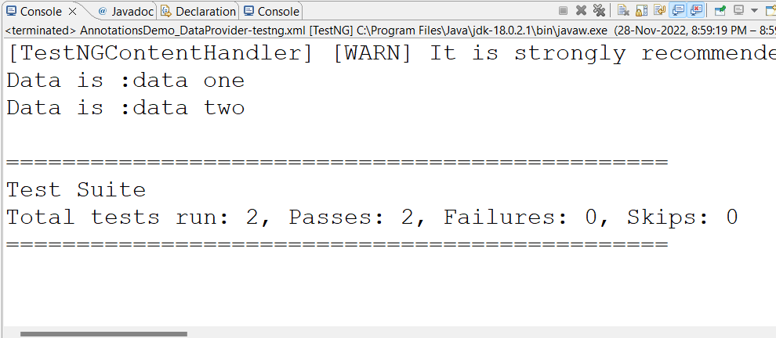

**Conclusion:** Understood how to use TestNG Annotations.

**After performing this Practical/lab, students are expected to answer following questions**

1. What are TestNG Annotations?
2. What is data provider?