1. Locate all elements with tagname “input” on the given website <http://demo.guru99.com/test/facebook.html>

**package** first_practical;

**import** java.util.List;

**import** org.openqa.selenium.By;

**import** org.openqa.selenium.WebDriver;

**import** org.openqa.selenium.WebElement;

**import** org.openqa.selenium.firefox.FirefoxDriver;

**public** **class** Exercise5 {

**public** **static** **void** main(String[] args) {

System.*setProperty*("webdriver.gecko.driver", "E:\\Selenium\\geckodriver.exe");

WebDriver driver=**new** FirefoxDriver();

driver.get("https://demo.guru99.com/test/facebook.html");

List<WebElement> inputs=driver.findElements(By.*tagName*("input"));

inputs.get(1).sendKeys("bob@gmail.com");

inputs.get(2).sendKeys("9561");

}

}

Output:

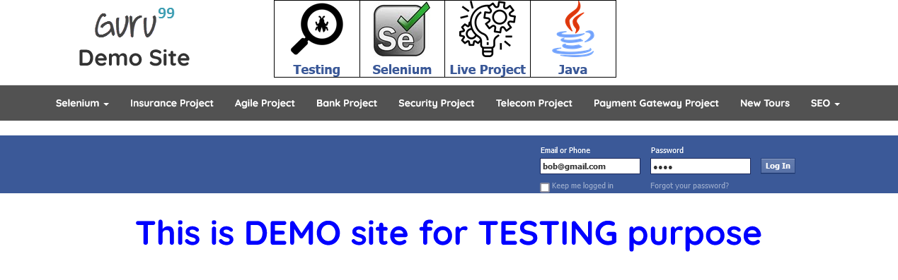

1. Locate all elements with classname “inputtext” on the given website <http://demo.guru99.com/test/facebook.html>

**package** first_practical;

**import** java.util.List;

**import** org.openqa.selenium.By;

**import** org.openqa.selenium.WebDriver;

**import** org.openqa.selenium.WebElement;

**import** org.openqa.selenium.firefox.FirefoxDriver;

**public** **class** Exercise6 {

**public** **static** **void** main(String[] args) {

System.*setProperty*("webdriver.gecko.driver", "E:\\Selenium\\geckodriver.exe");

WebDriver driver=**new** FirefoxDriver();

driver.get("https://demo.guru99.com/test/facebook.html");

List<WebElement> inputs=driver.findElements(By.*className*("inputtext"));

inputs.get(0).sendKeys("bob@gmail.com");

inputs.get(1).sendKeys("956131");

}

}

Output:

**Conclusion:** Learnt to find single as well as multiple elements using findElement() and findElements().