1. **Write a selenium script to navigate to https://**[**www.toolsqa.com/selenium-training/**](http://www.toolsqa.com/selenium-training/) **website and perform following actions-1)Click on Registration button link,2) Come back to Home page (Use 'Back' command), 3)Again goback to Registration page (This time use 'Forward' command), 4) Again come back to Home page (This time use 'To' command), 5) Refresh the Browser (Use 'Refresh' command)**

**package** first_practical;

**import** org.openqa.selenium.By;

**import** org.openqa.selenium.WebDriver;

**import** org.openqa.selenium.WebElement;

**import** org.openqa.selenium.firefox.FirefoxDriver;

**public** **class** Exercise8 {

**public** **static** **void** main(String[] args) **throws** InterruptedException {

System.*setProperty*("webdriver.gecko.driver", "E:\\Selenium\\geckodriver.exe");

WebDriver driver=**new** FirefoxDriver();

driver.get("http://google.com");

WebElement searchBox=driver.findElement(By.*name*("q"));

searchBox.sendKeys("toolsqa selenium training");

WebElement searchButton=driver.findElement(By.*name*("btnK"));

searchButton.submit();

driver.navigate().to("https://www.toolsqa.com/selenium-training/");

Thread.*sleep*(3000);

WebElement reg_link=driver.findElement(By.*cssSelector*("a[href='#enroll-form']"));

reg_link.click();

Thread.*sleep*(2000);

driver.navigate().back();

Thread.*sleep*(2000);

driver.navigate().forward();

Thread.*sleep*(2000);

driver.navigate().to("https://www.toolsqa.com/selenium-training/");

Thread.*sleep*(2000);

driver.navigate().refresh();

}

}

Output:



1. **Automate the following test scenarios:**
   1. **Invoke firefox Browser**
   2. **Open URL: https://**[**www.google.co.in/**](http://www.google.co.in/)
   3. **Get Page Title name and Title length**
   4. **Print Page Title and Title length on the Eclipse Console**
   5. **Get page URL and verify whether it is the desired page or not**
   6. **Get page Source and Page Source length**
   7. **Print page Length on Eclipse Console.**
   8. **Close the Browser**

**package** first_practical;

**import** org.openqa.selenium.WebDriver;

**import** org.openqa.selenium.firefox.FirefoxDriver;

**public** **class** Exercise7 {

**public** **static** **void** main(String[] args) {

System.*setProperty*("webdriver.gecko.driver", "E:\\Selenium\\geckodriver.exe");

WebDriver driver=**new** FirefoxDriver();

driver.get("https://www.google.co.in/");

String title = driver.getTitle();

System.***out***.println("Title of page: "+title);

System.***out***.println("Length of title: "+title.length());

String currentUrl = driver.getCurrentUrl();

System.***out***.println("Url of page: "+currentUrl);

String pageSource = driver.getPageSource();

System.***out***.println("Page length: "+pageSource.length());

driver.quit();

}

}

**Output:**

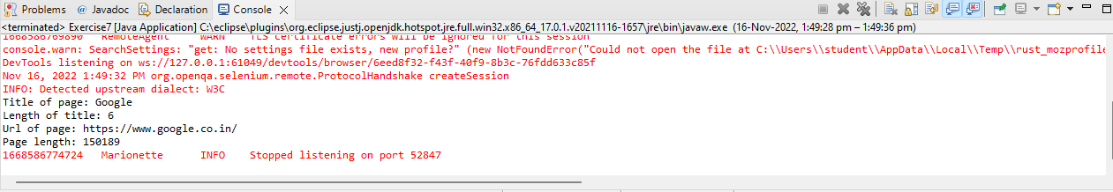

**Conclusion:** Learnt to use Browser command and navigation Commands in Selenium