1. **Open “flight_reservation.html” and write a script to handle frames and print heading of page in each frame.**

**package** first_practical;

**import** org.openqa.selenium.By;

**import** org.openqa.selenium.WebDriver;

**import** org.openqa.selenium.WebElement;

**import** org.openqa.selenium.firefox.FirefoxDriver;

**public** **class** Exercise8 {

**public** **static** **void** main(String[] args) {

System.*setProperty*("webdriver.gecko.driver", "E:\\Selenium\\geckodriver.exe");

WebDriver driver=**new** FirefoxDriver();

driver.get("file:///G:/imp/Flight_Reservation/flight_reservation.html");

//Switching to Frame1 using index

driver.switchTo().frame(0);

WebElement frame1_heading1=driver.findElement(By.*id*("heading1"));

System.***out***.println("Frame1 Heading: "+frame1_heading1.getText());

driver.switchTo().defaultContent();

System.***out***.println("Title of main window: "+driver.getTitle());

System.***out***.println("Switched to main window");

//Switching to frame 2

driver.switchTo().frame("IF2");

System.***out***.println("This is ifrmae 2");

WebElement frame2_heading1=driver.findElement(By.*id*("heading2"));

System.***out***.println("Frame2 Heading: "+frame2_heading1.getText());

//Switching to sub frmae

driver.switchTo().frame(0);

System.***out***.println("Switched to sub frame inside frame 2 ");

WebElement frame3_heading1=driver.findElement(By.*id*("heading3"));

System.***out***.println("Child Frame Heading: "+frame3_heading1.getText());

driver.switchTo().defaultContent();

System.***out***.println("Title of main window: "+driver.getTitle());

}

}

**Output:**

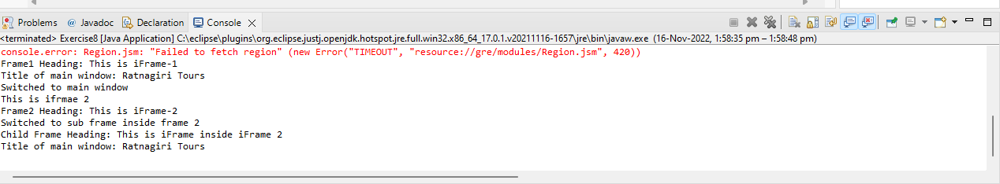

1. **Open *https://demoqa.com/browser-windows* and write a script to handle multiple windows that opens after clicking button “New Window” and print the heading on that new window.**

**package** first_practical;

**import** java.util.Iterator;

**import** java.util.Set;

**import** org.openqa.selenium.By;

**import** org.openqa.selenium.WebDriver;

**import** org.openqa.selenium.WebElement;

**import** org.openqa.selenium.firefox.FirefoxDriver;

**public** **class** Exercise9 {

**public** **static** **void** main(String[] args) {

System.*setProperty*("webdriver.gecko.driver", "E:\\Selenium\\geckodriver.exe");

WebDriver driver=**new** FirefoxDriver();

driver.get("https://demoqa.com/browser-windows");

WebElement newWindowBtn=driver.findElement(By.*id*("windowButton"));

newWindowBtn.click();

//Get handles of the windows

String mainWindowHandle = driver.getWindowHandle();

Set<String> allWindowHandles = driver.getWindowHandles();

Iterator<String> i1 = allWindowHandles.iterator();

**while** (i1.hasNext()) {

String ChildWindow = i1.next();

**if** (!mainWindowHandle.equalsIgnoreCase(ChildWindow)) {

driver.switchTo().window(ChildWindow);

WebElement text = driver.findElement(By.*id*("sampleHeading"));

System.***out***.println("Heading of child window is " + text.getText());

driver.close();

System.***out***.println("Child window closed");

}

}

}

}

**Output:**

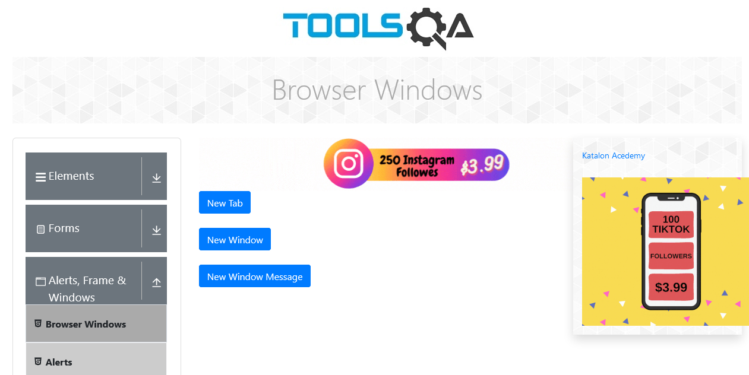

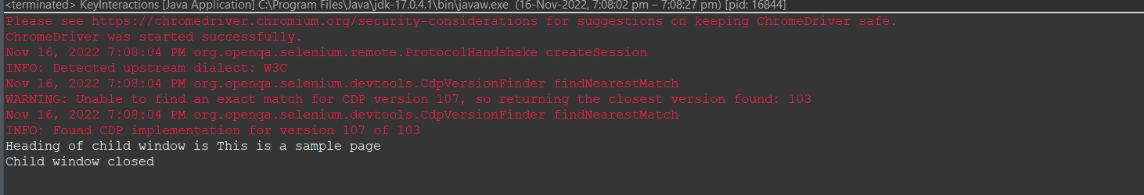

1. **Open “flight_reservation.html” and write a script to handle popup window that opens after clicking on “Hotels” Hyperlink and print title of the popup window and heading on that page.**

**package** first_practical;

**import** java.util.Set;

**import** org.openqa.selenium.By;

**import** org.openqa.selenium.WebDriver;

**import** org.openqa.selenium.WebElement;

**import** org.openqa.selenium.firefox.FirefoxDriver;

**public** **class** Exercise10 {

**public** **static** **void** main(String[] args) **throws** InterruptedException {

System.*setProperty*("webdriver.gecko.driver", "E:\\Selenium\\geckodriver.exe");

WebDriver driver=**new** FirefoxDriver();

driver.get("file:///G:/imp/Flight_Reservation/flight_reservation.html");

String mainWindow=driver.getWindowHandle();//retrieve the unique id of flight reservation window

System.***out***.println("Main Window Handle :"+mainWindow);

System.***out***.println("Title of main window is: "+driver.getTitle());

WebElement hotel_link=driver.findElement(By.*linkText*("Hotels"));

hotel_link.click();

Set<String> handles=driver.getWindowHandles();

**for**(String windowHandle:handles)

{

**if**(!windowHandle.equals(mainWindow))

{

driver.switchTo().window(windowHandle);

System.***out***.println("Title of child window is "+driver.getTitle());

WebElement heading1=driver.findElement(By.*id*("sampleHeading"));

System.***out***.println("Heading inside child window is "+heading1.getText());

Thread.*sleep*(4000);

driver.close();

}

}

driver.switchTo().window(mainWindow);

System.***out***.println("Title of main window: "+driver.getTitle());

}

}

**Output:**

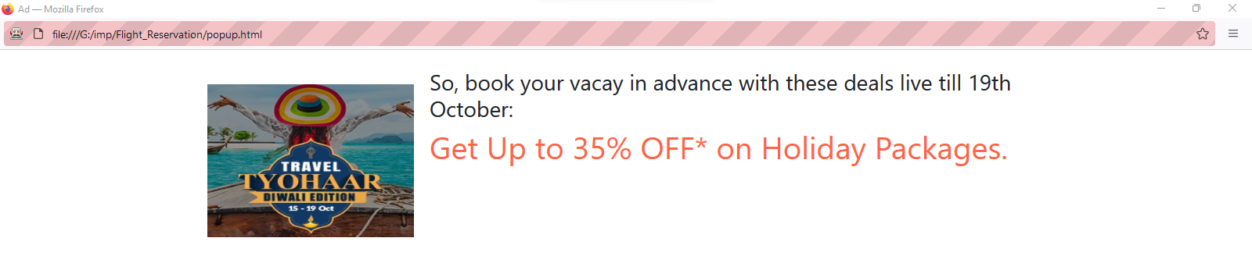

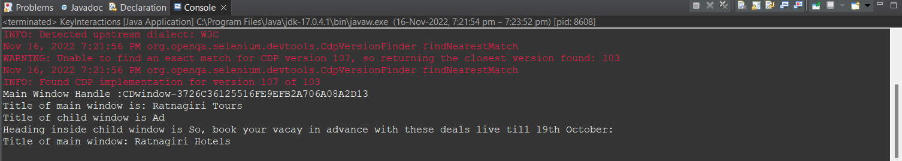

1. **Open “hotel_search.html” page and handle modals that appear after clicking on buttons on that webpage.**

package first_practical;

import java.util.Iterator;

import java.util.Set;

import org.openqa.selenium.By;

import org.openqa.selenium.WebDriver;

import org.openqa.selenium.WebElement;

import org.openqa.selenium.chrome.ChromeDriver;

public class KeyInteractions {

public static void main(String[] args) throws InterruptedException {

// **TODO** Auto-generated method stub

System.*setProperty*("webdriver.chrome.driver", "C:\\Users\\parun\\Desktop\\FAMT\\Cyber Security\\driver\\chromedriver.exe");

WebDriver driver=new ChromeDriver();

driver.get("file:///H:/imp/Flight_Reservation/hotel_search.html");

WebElement hotels=driver.findElement(By.*cssSelector*("button[data-target='#myModal']"));

hotels.click();

WebElement modal_title1=driver.findElement(By.*xpath*("//h4[@class='modal-title']"));

System.***out***.println("Title of modal is : "+modal_title1.getText());

Thread.*sleep*(3000);

WebElement ok_button=driver.findElement(By.*xpath*("//button[@data-dismiss='modal']"));

ok_button.click();

Thread.*sleep*(2000);

WebElement book_room_btn=driver.findElement(By.*xpath*("//button[@id='myBtn1']"));

book_room_btn.click();

WebElement hotelname=driver.findElement(By.*xpath*("//input[@id='htlname']"));

hotelname.sendKeys("Taj Hotel");

WebElement person=driver.findElement(By.*xpath*("//input[@id='prs']"));

person.sendKeys("1");

WebElement days=driver.findElement(By.*xpath*("//input[@id='days']"));

days.sendKeys("6");

Thread.*sleep*(3000);

WebElement cancelbtn=driver.findElement(By.*xpath*("//button[@type='submit'] //following::button"));

cancelbtn.click();

}

}

**Output:**

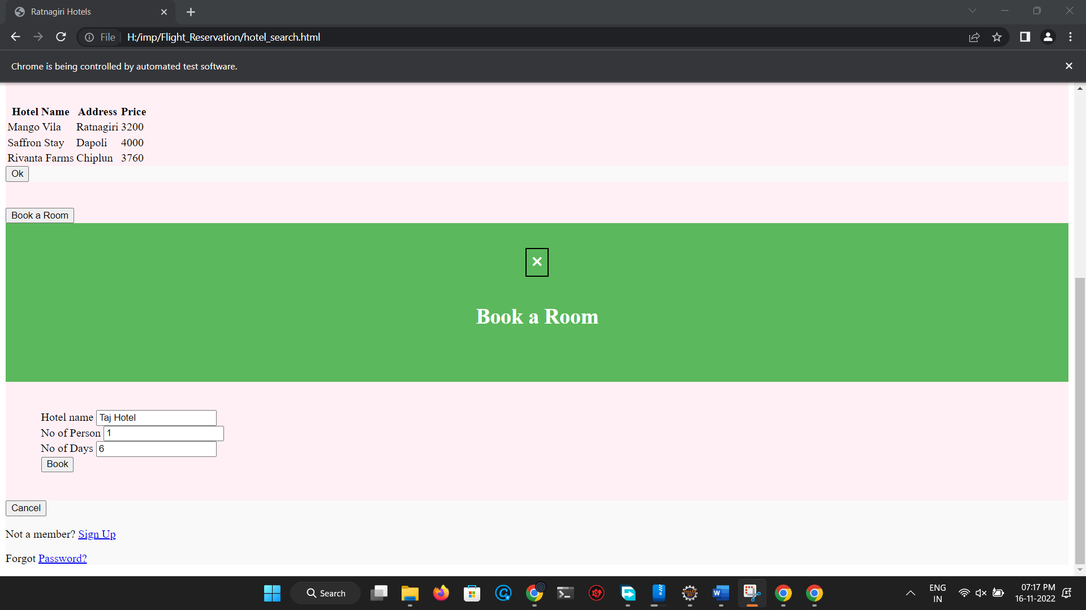

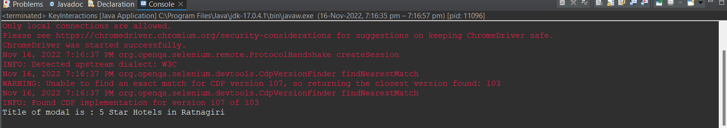

**Conclusion:** Learnt to handle multiple windows, frames and modals in Selenium.