* 1. **Write a selenium script to handle alert on** [**http://only-testing-blog.blogspot.com/2013/09/test.html**](http://only-testing-blog.blogspot.com/2013/09/test.html)

package first_practical;

import java.util.Iterator;

import java.util.Set;

import org.openqa.selenium.Alert;

import org.openqa.selenium.By;

import org.openqa.selenium.WebDriver;

import org.openqa.selenium.WebElement;

import org.openqa.selenium.chrome.ChromeDriver;

public class KeyInteractions {

public static void main(String[] args) throws InterruptedException {

// **TODO** Auto-generated method stub

System.*setProperty*("webdriver.chrome.driver", "C:\\Users\\parun\\Desktop\\FAMT\\Cyber Security\\driver\\chromedriver.exe");

WebDriver driver=new ChromeDriver();

driver.get("http://only-testing-blog.blogspot.com/2013/09/test.html");

WebElement alertBtn=driver.findElement(By.*cssSelector*("input[value='Show Me Alert']"));

alertBtn.click();

Alert simpleAlert=driver.switchTo().alert();

Thread.*sleep*(3000);

String alertText=simpleAlert.getText();

System.***out***.println("Alert Text is: "+alertText);

simpleAlert.accept();

Thread.*sleep*(3000);

WebElement confirmAlertBtn=driver.findElement(By.*cssSelector*("button[onclick='myFunction()']"));

confirmAlertBtn.click();

Alert ConfirmAlert=driver.switchTo().alert();

Thread.*sleep*(3000);

String confirmalertText=ConfirmAlert.getText();

System.***out***.println("Confirmation Alert Text is: "+confirmalertText);

simpleAlert.accept();

}

}

**Output:**

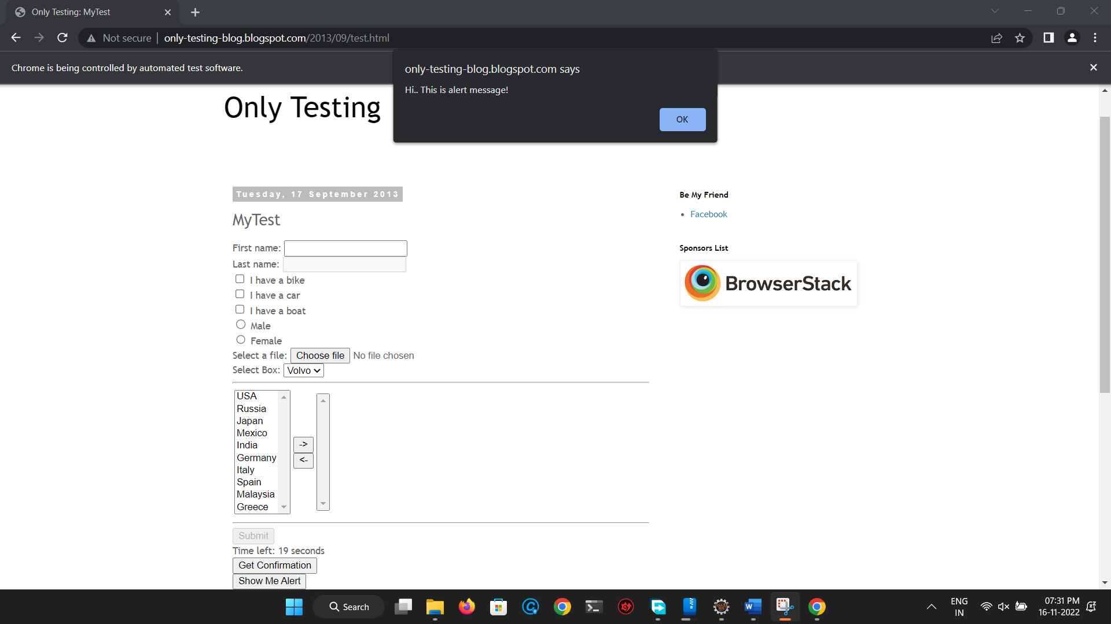

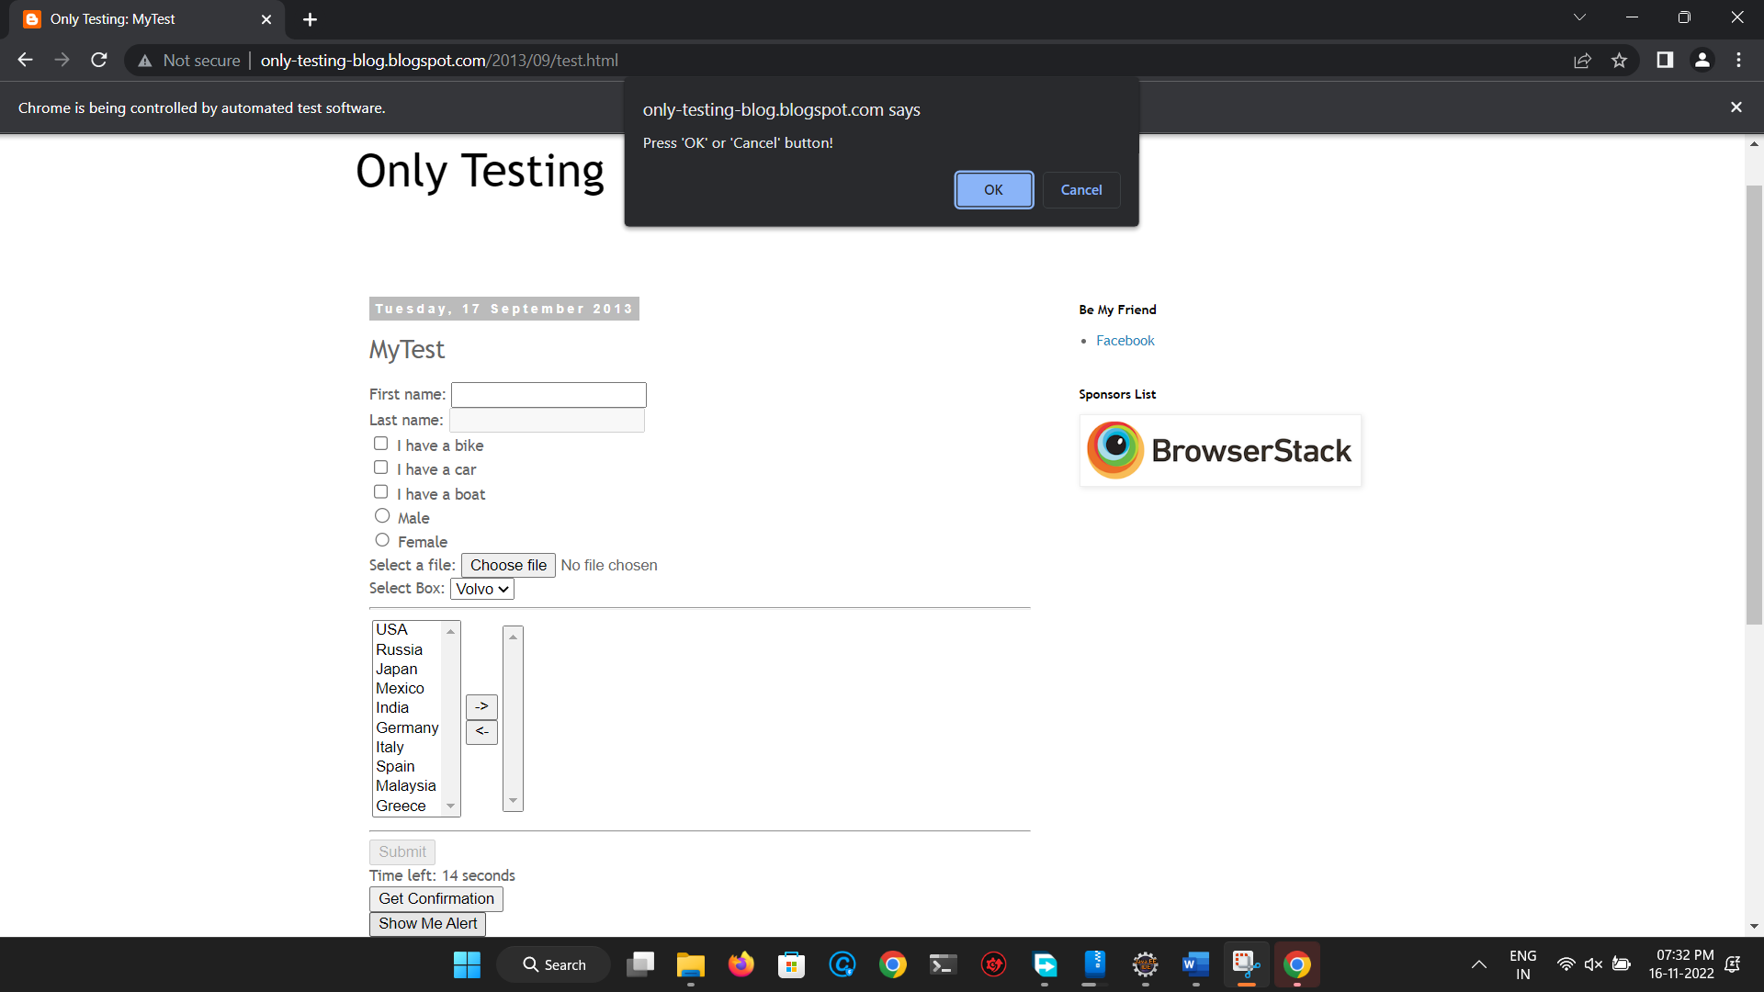

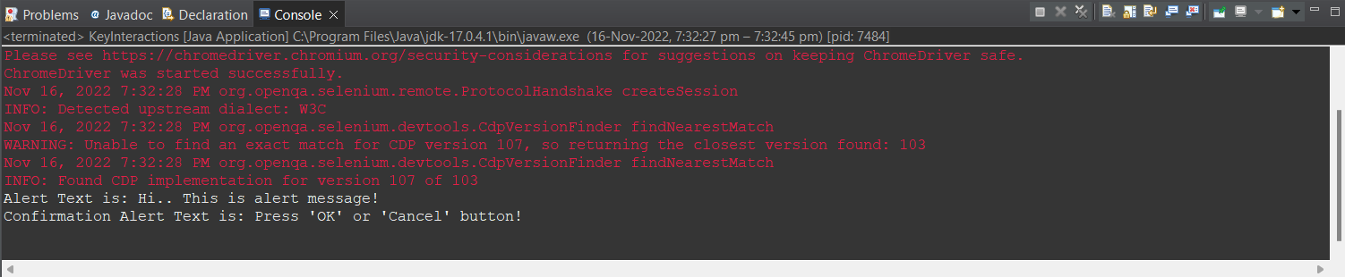

* 1. **Write a selenium script to handle alerts on** [**https://demoqa.com/alerts**](https://demoqa.com/alerts)

package first_practical;

import java.util.Iterator;

import java.util.Set;

import org.openqa.selenium.Alert;

import org.openqa.selenium.By;

import org.openqa.selenium.WebDriver;

import org.openqa.selenium.WebElement;

import org.openqa.selenium.chrome.ChromeDriver;

public class KeyInteractions {

public static void main(String[] args) throws InterruptedException {

// **TODO** Auto-generated method stub

System.*setProperty*("webdriver.chrome.driver", "C:\\Users\\parun\\Desktop\\FAMT\\Cyber Security\\driver\\chromedriver.exe");

WebDriver driver=new ChromeDriver();

driver.get("https://demoqa.com/alerts");

WebElement btn1=driver.findElement(By.*id*("alertButton"));

btn1.click();

Alert alert1=driver.switchTo().alert();

Thread.*sleep*(3000);

String alert1Text=alert1.getText();

System.***out***.println("Alert 1 Text is: "+alert1Text);

alert1.accept();

Thread.*sleep*(3000);

WebElement btn2=driver.findElement(By.*id*("timerAlertButton"));

btn2.click();

Thread.*sleep*(7000);

Alert alert2=driver.switchTo().alert();

Thread.*sleep*(3000);

String alert2Text=alert2.getText();

System.***out***.println("Alert 2 Text is: "+alert2Text);

alert2.accept();

Thread.*sleep*(3000);

WebElement btn3=driver.findElement(By.*id*("confirmButton"));

btn3.click();

Alert alert3=driver.switchTo().alert();

Thread.*sleep*(3000);

String alert3Text=alert2.getText();

System.***out***.println("Alert 3 Text is: "+alert3Text);

alert3.accept();

Thread.*sleep*(3000);

WebElement btn4=driver.findElement(By.*id*("promtButton"));

btn4.click();

Alert alert4=driver.switchTo().alert();

Thread.*sleep*(3000);

alert4.sendKeys("26");

Thread.*sleep*(3000);

alert3.accept();

}

}

**Output:**

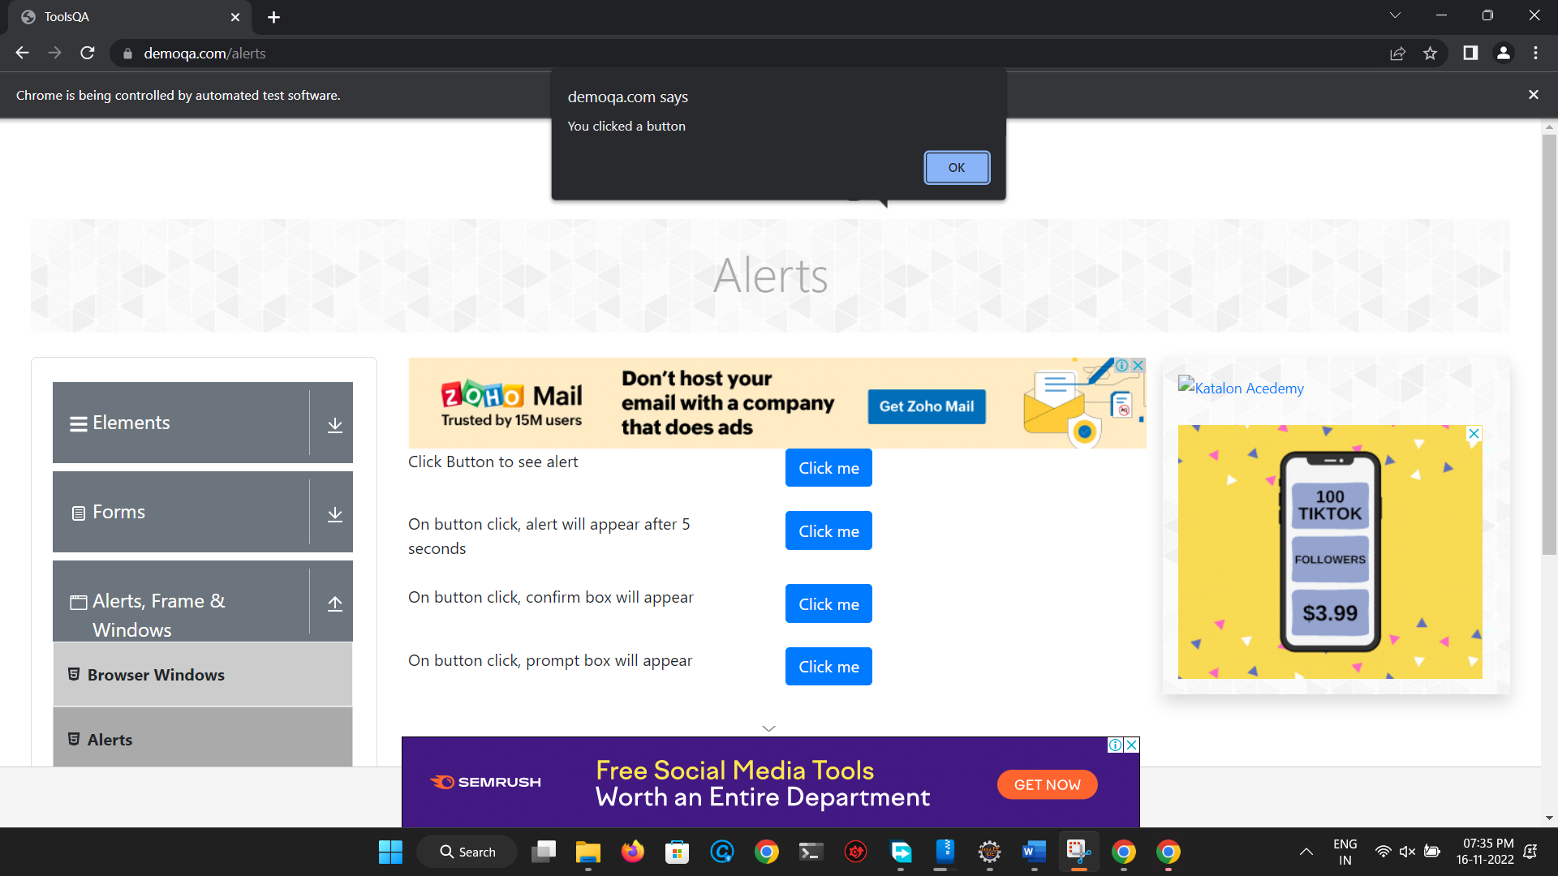

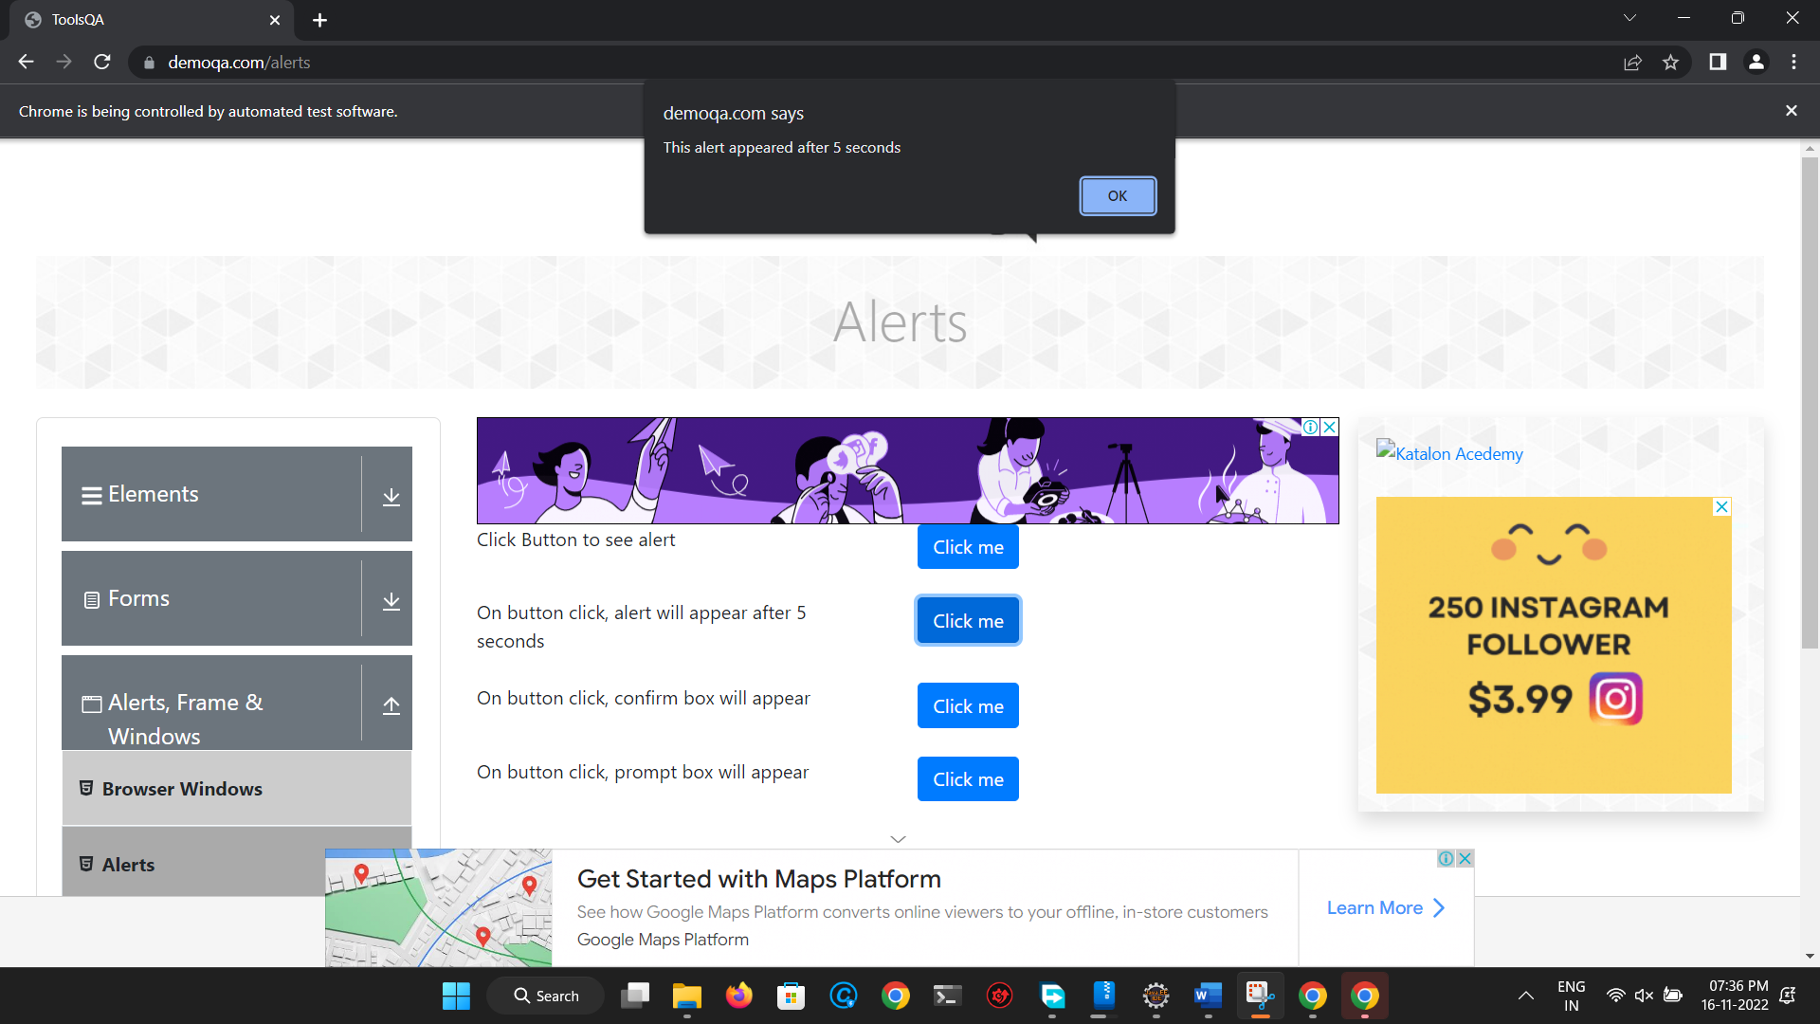

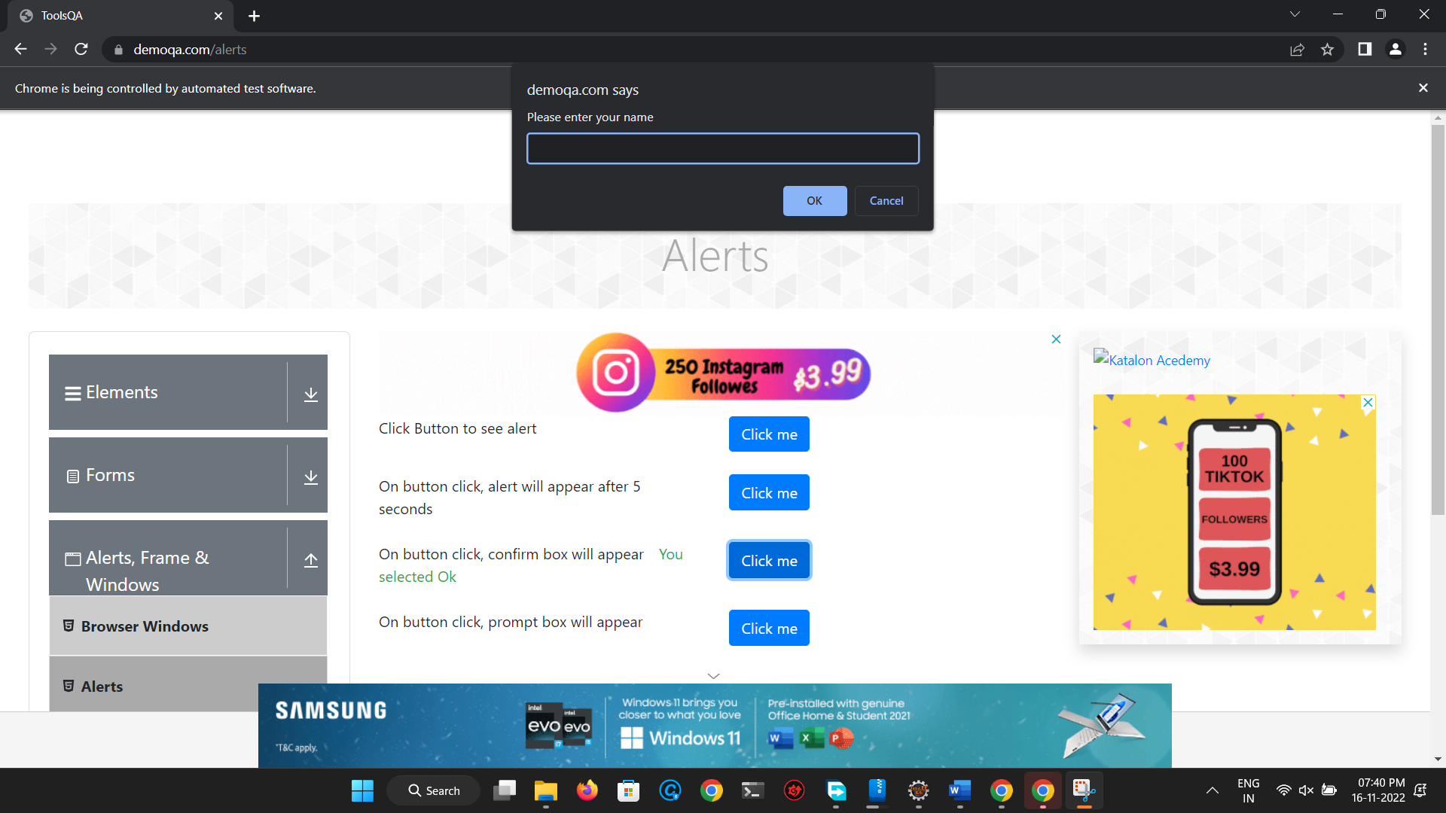

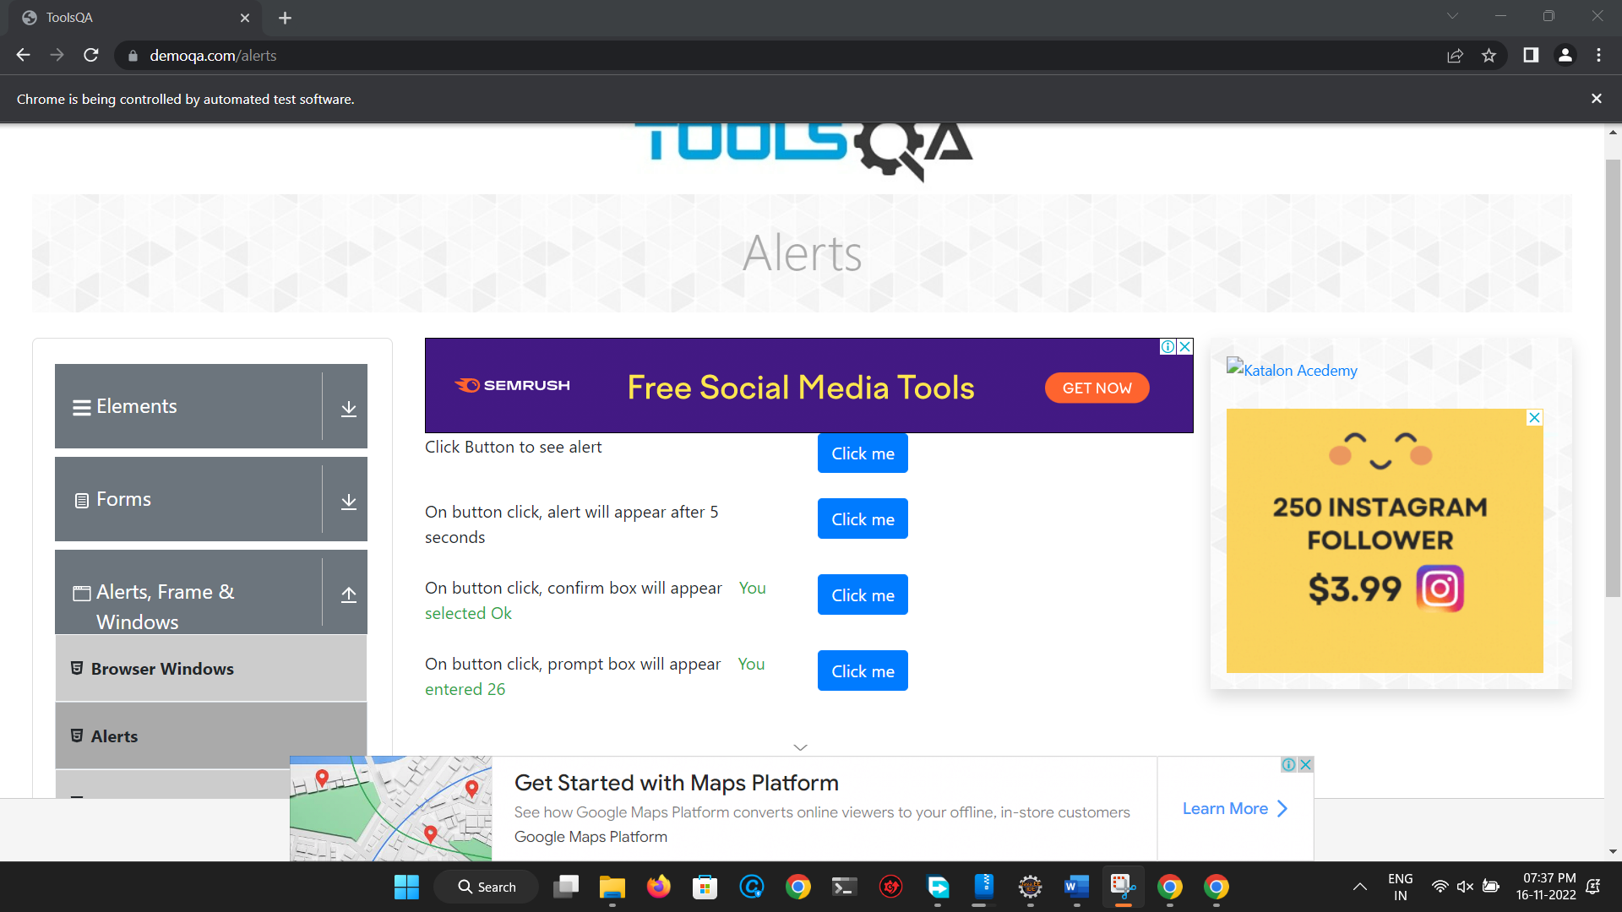

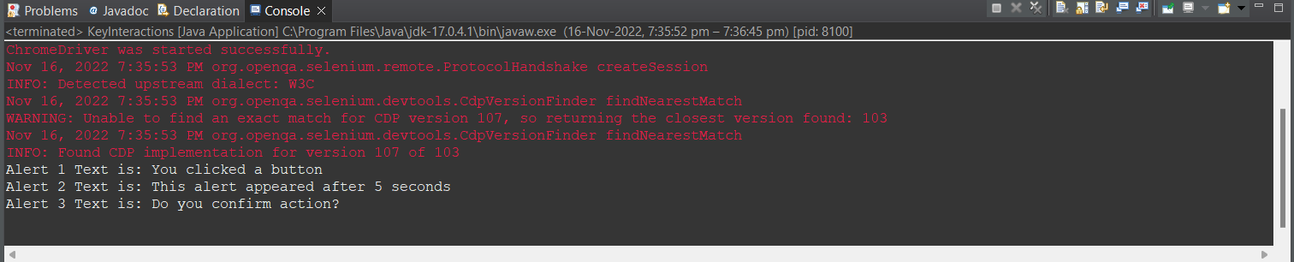

* 1. **Write a selenium script to handle alert on** [**http://demo.guru99.com/test/simple_context_menu.html**](http://demo.guru99.com/test/simple_context_menu.html)

**package first_practical;**

**import java.util.Iterator;**

**import java.util.Set;**

**import org.openqa.selenium.Alert;**

**import org.openqa.selenium.By;**

**import org.openqa.selenium.WebDriver;**

**import org.openqa.selenium.WebElement;**

**import org.openqa.selenium.chrome.ChromeDriver;**

**import org.openqa.selenium.interactions.Actions;**

**public class KeyInteractions {**

**public static void main(String[] args) throws InterruptedException {**

**// TODO Auto-generated method stub**

**System.setProperty("webdriver.chrome.driver", "C:\\Users\\parun\\Desktop\\FAMT\\Cyber Security\\driver\\chromedriver.exe");**

**WebDriver driver=new ChromeDriver();**

**driver.get("https://demo.guru99.com/test/simple_context_menu.html");**

**Actions action = new Actions(driver);**

**WebElement link =driver.findElement(By.xpath("//button[text()='Double-Click Me To See Alert']"));**

**action.doubleClick(link).perform();**

**//Switch to the alert box and click on OK button**

**Alert alert = driver.switchTo().alert();**

**System.out.println("Alert Text: " +alert.getText());**

**Thread.sleep(3000);**

**alert.accept();**

**}**

**}**

Output:

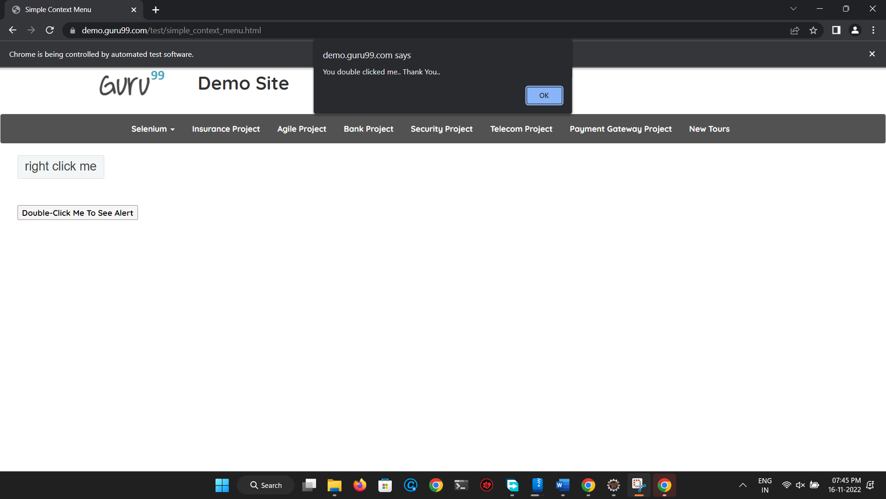

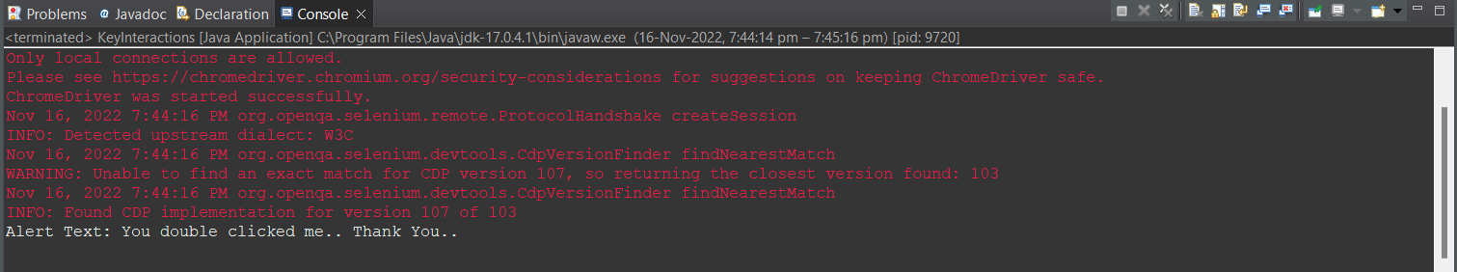

* 1. **Open “train_reservation.html” page and handle the alerts on that page.**

package first_practical;

import java.util.Iterator;

import java.util.Set;

import org.openqa.selenium.Alert;

import org.openqa.selenium.By;

import org.openqa.selenium.WebDriver;

import org.openqa.selenium.WebElement;

import org.openqa.selenium.chrome.ChromeDriver;

import org.openqa.selenium.interactions.Actions;

public class KeyInteractions {

public static void main(String[] args) throws InterruptedException {

// TODO Auto-generated method stub

System.setProperty("webdriver.chrome.driver", "C:\\Users\\parun\\Desktop\\FAMT\\Cyber Security\\driver\\chromedriver.exe");

WebDriver driver=new ChromeDriver();

driver.get("file:///H:/imp/Flight_Reservation/flight_reservation.html");

WebElement train_link=driver.findElement(By.linkText("Trains"));

train_link.click();

//Handling simple alert

Alert simpleAlert=driver.switchTo().alert();

Thread.sleep(5000);

String alertText=simpleAlert.getText();

System.out.println("Alert Text is: "+alertText);

simpleAlert.accept();

Thread.sleep(5000);

//Handling Prompt Alert

WebElement confirmButton=driver.findElement(By.cssSelector("input[value='Confirm Details']"));

confirmButton.click();

Alert promptAlert=driver.switchTo().alert();

promptAlert.sendKeys("3");

Thread.sleep(3000);

promptAlert.accept();

Thread.sleep(4000);

//Handling Confirmation Alert

WebElement bookButton=driver.findElement(By.cssSelector("input[value='Book Tickets']"));

bookButton.click();

Alert confirmAlert=driver.switchTo().alert();

System.out.println("Confirmation Alert Text is: "+confirmAlert.getText());

Thread.sleep(3000);

confirmAlert.accept();

}

}

Output:

