# Implementation

1. Write a selenium script for following scenario on [http://only-](http://only-testing-blog.blogspot.com/2013/09/test.html) [testingblog.blogspot.com/2013/09/test.html](http://only-testing-blog.blogspot.com/2013/09/test.html)
   1. Check whether firstname and lastname textboxes are enabled or not. Enter data only if they are enabled.
   2. Delete the data entered in first name textbox and enter another name.
   3. Select “I have a bike” and “I have a car” checkboxes
   4. Select gender
   5. Is car drop down list multi-select. Display message accordingly. And select “Opel” Car

Model.

* 1. Is countries list multi select. Display message accordingly. And select “Opel” Car

Model.

Select two or three countries and display all selected options.

# Code:

import org.openqa.selenium.By; import org.openqa.selenium.WebDriver; import org.openqa.selenium.WebElement; import org.openqa.selenium.firefox.FirefoxDriver; import org.openqa.selenium.support.ui.Select; public class Q1 {

public static void main(String[] args) throws InterruptedException { System.setProperty("webdriver.gecko.driver","C:\\Setup\\geckodriver- v0.31.0win64\\geckodriver.exe");

WebDriver driver=new FirefoxDriver();

driver.get("<http://only-testing-blog.blogspot.com/2013/09/test.html>"); WebElement firstName=driver.findElement(By.name("fname"));

WebElement lastName=driver.findElement(By.name("lname")); if(firstName.isEnabled()){

firstName.sendKeys("abc");}

else{

System.out.println("First Name Text Box is not Enabled");} if(lastName.isEnabled()){ lastName.sendKeys("xyz");}

else{

System.out.println("Last Name Text Box is not Enabled");} Thread.sleep(1000); firstName.clear();

firstName.sendKeys("abc xyz");

WebElement bike=driver.findElement(By.xpath("//input[@value='Bike']")); bike.click();

WebElement car=driver.findElement(By.xpath("//input[@value='Car']")); car.click();

WebElement female=driver.findElement(By.xpath("//input[@value='female']")); female.click();

Select vehicle = new Select(driver.findElement(By.xpath("//*[@class=\"post-body entry-content\"]/div[1]/select[1]")));

vehicle.selectByVisibleText("Opel"); if(vehicle.isMultiple()){

System.out.println("In country dropdown Multiple Value Selection

Allowed"); vehicle.selectByVisibleText("Opel"); vehicle.selectByIndex(0);

}

else

{

System.out.println("In Car dropdown Multiple Value Selection Not Allowed"); vehicle.selectByVisibleText("Opel");

}

Select country=new Select(driver.findElement(By.name("FromLB"))); if(country.isMultiple()) {

System.out.println("In country dropdown Multiple Value Selection Allowed"); country.selectByIndex(1);

country.selectByValue("IND"); country.selectByVisibleText("Mexico");

}

else {

System.out.println("In country dropdown Multiple Value Selection Not Allowed");

}}}

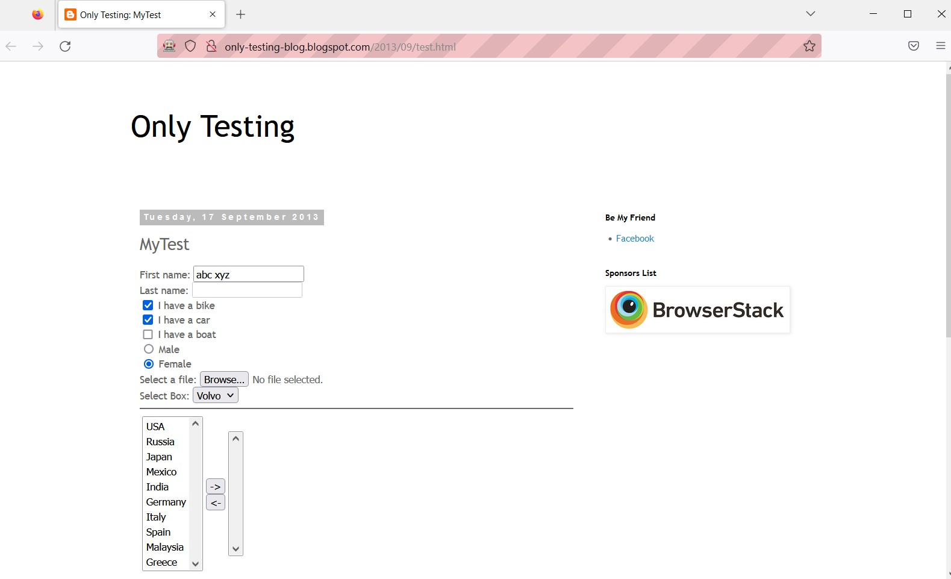

1. Write a selenium script to handle radio and checkboxes on following webpage [http://demo.guru99.com/test/radio.html.](http://demo.guru99.com/test/radio.html) Print the status of radio buttons i.e whether the radio button is selected or not. **Code:-** package selenium;

import org.openqa.selenium.By; import org.openqa.selenium.WebDriver; import org.openqa.selenium.WebElement; import org.openqa.selenium.firefox.FirefoxDriver; public class LocateRadioButtons {

public static void main(String[] args) throws InterruptedException {

// TODO Auto-generated method stub System.setProperty("webdriver.gecko.driver", "D:\\Finolex\\SEM 3\\Selenium-

Setup\\geckodriver.exe");

WebDriver driver=new FirefoxDriver(); //create driver instance driver.get("https://demo.guru99.com/test/radio.html"); WebElement option1=driver.findElement(By.id("vfb-7-1")); option1.click();

Thread.sleep(2000);

WebElement option2=driver.findElement(By.id("vfb-7-2")); option2.click();

Thread.sleep(2000);

WebElement option3=driver.findElement(By.id("vfb-7-3")); option3.click();

WebElement checkBox1=driver.findElement(By.id("vfb-6-1")); checkBox1.click();

Thread.sleep(2000);

WebElement checkBox2=driver.findElement(By.id("vfb-6-2")); checkBox2.click();

Thread.sleep(2000);

WebElement checkBox3=driver.findElement(By.id("vfb-6-3"));

checkBox3.click();

}}

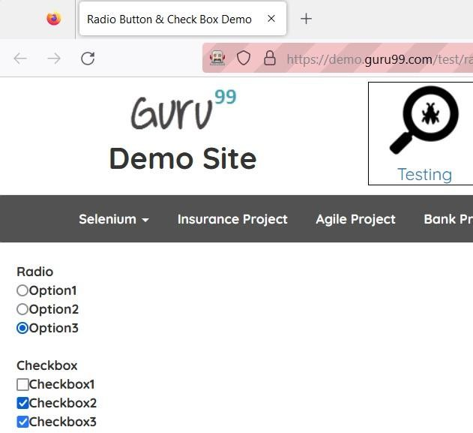

1. Write a selenium script to select options from dropdown list on <http://jsbin.com/osebed/2> using VisibleText, Value, Index and check whether you can select multiple options.

# Code:

package selenium; import java.util.List; import org.openqa.selenium.By; import org.openqa.selenium.WebDriver; import org.openqa.selenium.WebElement; import org.openqa.selenium.firefox.FirefoxDriver; import org.openqa.selenium.support.ui.Select; public class ActionOnDropdownList { public static void main(String[] args) {

// TODO Auto-generated method stu System.setProperty("webdriver.gecko.driver", "D:\\Finolex\\SEM 3\\Selenium-

Setup\\geckodriver.exe");

WebDriver driver=new FirefoxDriver(); //create driver instance driver.get("https://jsbin.com/osebed/2");

Select fruits=new Select(driver.findElement(By.id("fruits")));

//select a item by text fruits.selectByVisibleText("Banana"); //select a item by value fruits.selectByValue("apple");

//select a item by index fruits.selectByIndex(3);

System.out.println(fruits.getFirstSelectedOption().getText());

//deselect

/*fruits.deselectByIndex(0); fruits.deselectByVisibleText("Grape"); fruits.deselectByValue("apple");*/

List<WebElement> selected_items=fruits.getAllSelectedOptions(); for(int i=0;i<selected_items.size();i++) {

System.out.println(selected_items.get(i).getText());

}

System.out.println(fruits.isMultiple());

}}

# Output:

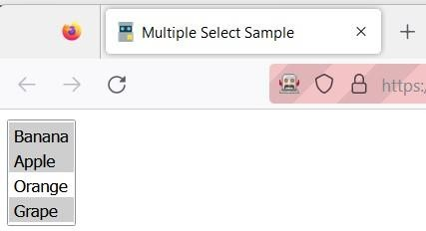

1. Write a selenium script to Browse to https://in.ebay.com/ website. Enter a product in the search box on the homepage (say Apple Watches). From categories dropdown, select category of your product (say Electronics). Click the Search button. Print the result of the product **Code:** package practical7; import java.util.List; import

org.openqa.selenium.By; import org.openqa.selenium.WebDriver; import org.openqa.selenium.WebElement; import org.openqa.selenium.chrome.ChromeDriver; import org.openqa.selenium.firefox.FirefoxDriver; import org.openqa.selenium.support.ui.Select; public class Q4 {

public static void main(String[] args) throws InterruptedException { System.setProperty("webdriver.chrome.driver", "D:\\Finolex\\SEM

3\\chromedriver_win32\\chromedriver.exe");

WebDriver driver=new ChromeDriver(); //create driver instance driver.get("https://[www.ebay.com/](http://www.ebay.com/)"); WebElement

inputBox,allCategories,cE,searchBtn; inputBox=driver.findElement(By.id("gh- ac")); inputBox.sendKeys("Apple Watches"); Thread.sleep(1000);

allCategories=driver.findElement(By.id("gh-cat-box")); allCategories.click(); Thread.sleep(1000);

cE = driver.findElement(By.xpath("//Select//option[@value='293']")); cE.click();

Thread.sleep(1000);

searchBtn=driver.findElement(By.id("gh-btn")); searchBtn.click();

//storing all items List<WebElement>

itemList=driver.findElements(By.xpath("//span[@role='heading']")); for(int i=1;i<=4;i++) {

# Output:

}}}

System.out.println(itemList.get(i).getText());

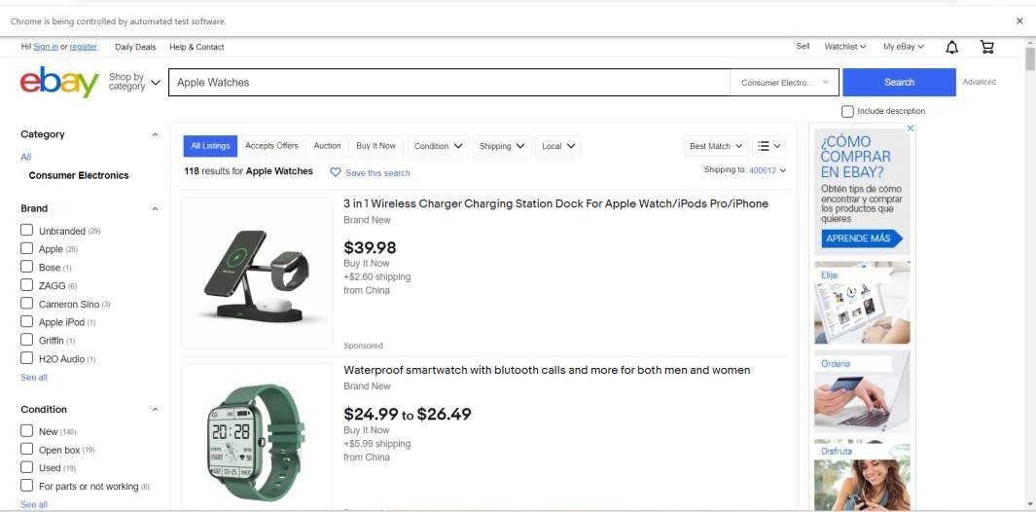

**Conclusion:** Learnt to handle Drop Down, List Boxes, Command Button, Radio buttons & text boxes using Selenium.

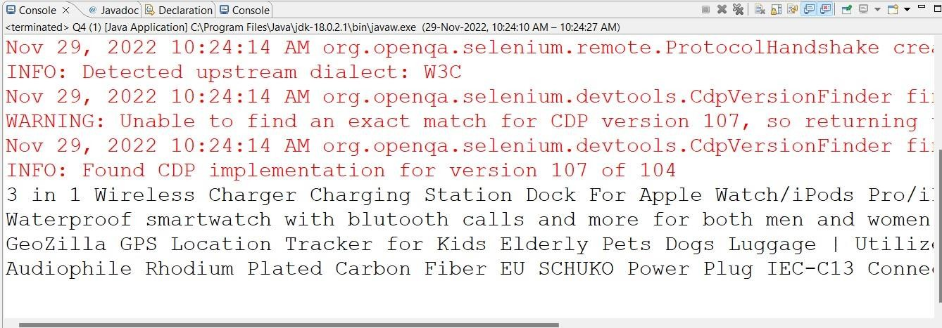

# After performing this Practical/lab, students are expected to answer following questions

* 1. Which Select methods are used to select options in dropdown in Selenium?
  2. Which method is used to cancel or close alert window?