**1. Write a selenium script to take screenshot of** <http://demo.guru99.com/test/newtours/index.php>**Program:**

package webDriver;

import java.io.File; import java.nio.file.Files; import java.io.IOException; import org.openqa.selenium.OutputType; import org.openqa.selenium.TakesScreenshot; import org.openqa.selenium.WebDriver; import org.openqa.selenium.chrome.ChromeDriver;

public class ScreenShot {

public static void main(String[] args) throws IOException {

System.setProperty("webdriver.chrome.driver","C:\\Setup\\chromedriver_win32\\chromedri ver.exe");

WebDriver driver=new ChromeDriver(); driver.get("http://www.google.com");

TakesScreenshot scrShot=((TakesScreenshot)driver);

File srcFile=scrShot.getScreenshotAs(OutputType.FILE);

System.out.println(srcFile.getAbsolutePath());

File DestFile=new File("D:/MCA/test.png");

//Files.copy(srcFile,DestFile);

Files.copy(srcFile.toPath(),DestFile.toPath());

}

}

**Output:**

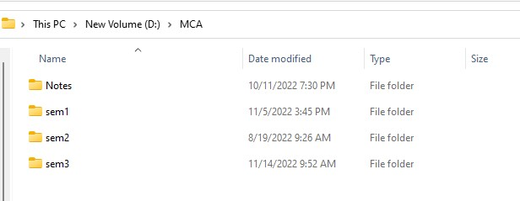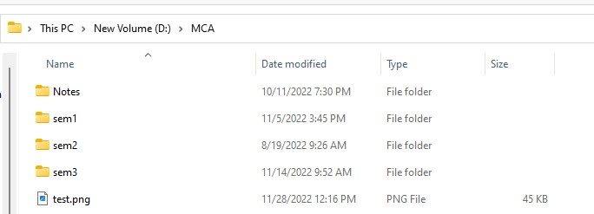

**2. Write a selenium script to demonstrate explicit and implicit waits on** [**https://demoqa.com/alerts**](https://demoqa.com/alerts) **Program:**

# ImplicitWaitTime.java: package webDriver;

import java.util.concurrent.TimeUnit; import org.openqa.selenium.WebDriver; import org.openqa.selenium.firefox.FirefoxDriver; public class ImplicitWaitTime { public static void main(String[] args) {

System.setProperty("webdriver.gecko.driver","C:\\Setup\\geckodriver-v0.31.0-win64\\geckod river.exe");

WebDriver driver=new FirefoxDriver(); //configure implicit wait time for webdriver

driver.manage().timeouts().implicitlyWait(10,TimeUnit.SECONDS); driver.get("http://demo.guru99.com/test/guru99home");

System.out.println("The title pf webpage is:"+driver.getTitle());

}

}

**ExplicitWaityTime.java:** package webDriver; import java.time.Duration; import org.openqa.selenium.Alert; import org.openqa.selenium.By; import org.openqa.selenium.WebDriver; import org.openqa.selenium.WebElement; import org.openqa.selenium.chrome.ChromeDriver; import org.openqa.selenium.support.ui.ExpectedConditions; import org.openqa.selenium.support.ui.WebDriverWait;

public class ExplicitWaitTime {

public static void main(String[] args) throws InterruptedException {

System.setProperty("webdriver.chrome.driver","C:\\Setup\\chromedriver_win32\\chromedri ver.exe");

WebDriver driver=new ChromeDriver(); driver.get("http://demoqa.com/alerts");

//configure explicit wait time for webdriver

WebElement btn=driver.findElement(By.id("timerAlertButton")); btn.click();

System.out.println("Alert button is click but alert window is yet

to open");

//create webdriver wait

WebDriverWait wait=new WebDriverWait(driver, Duration.ofSeconds(10)); Alert myAlert=wait.until(ExpectedConditions.alertIsPresent()); driver.switchTo().alert(); Thread.sleep(2000); myAlert.accept();

System.out.println("Alert is accepted"); driver.close();

}

}

**Output:**

**ExplicitWaityTime:**

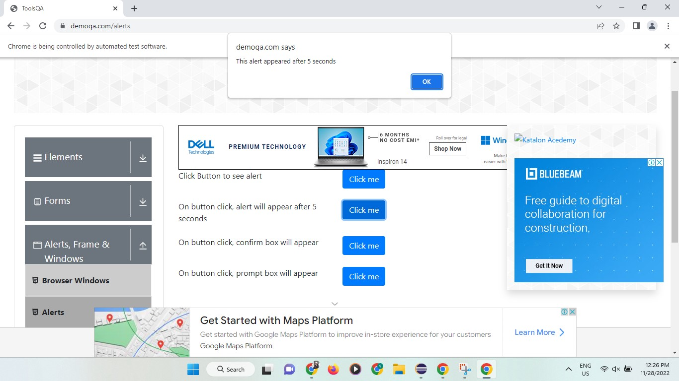

**ImplicitWaitTime:**

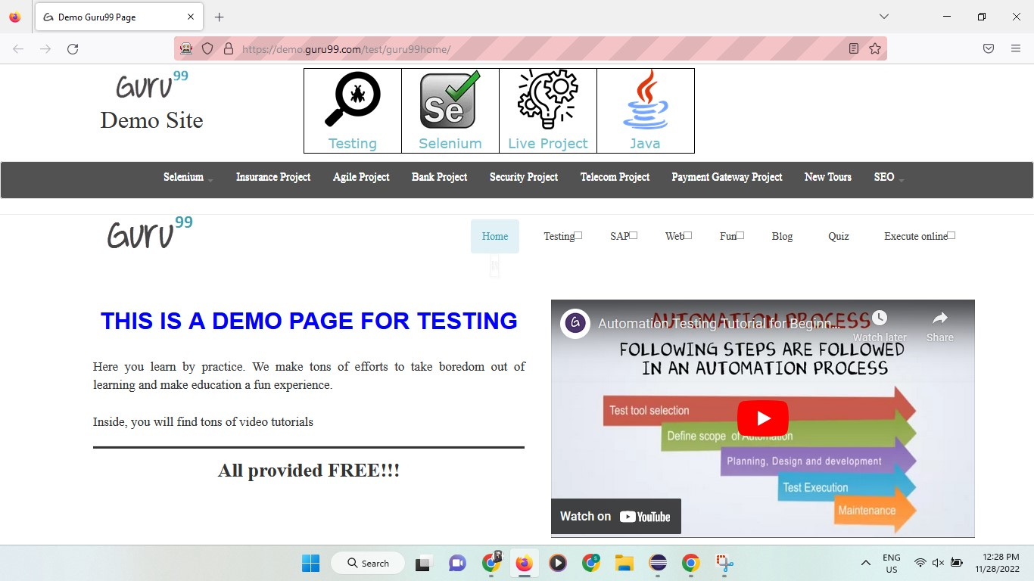

**Conclusion:** Learnt to take screenshot of webpage and manage waits in selenium.