# Implementation

1. Write a selenium script to move tile3 to the position of tile2 on Sortable.html **Code:** package webDriver; import org.openqa.selenium.By; import org.openqa.selenium.WebDriver; import org.openqa.selenium.WebElement; import org.openqa.selenium.firefox.FirefoxDriver; import org.openqa.selenium.interactions.Actions; public class MoveToElement {

public static void main(String[] args) {

System.setProperty("webdriver.gecko.driver","C:\\Setup\\geckodriver-v0.31.0win64\\geckodriver.exe");

WebDriver driver=new FirefoxDriver();

driver.get("file:///D:/MCA/sem3/STQA/Sample%20Testing%20Files/Sortable.ht ml");

WebElement tile3=driver.findElement(By.name("three"));

WebElement tile2=driver.findElement(By.name("two")); Actions builder=new Actions(driver);

builder.moveToElement(tile2).clickAndHold().release(tile3); builder.perform();

}

}

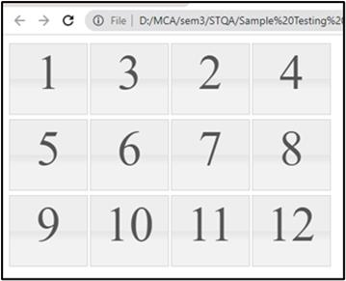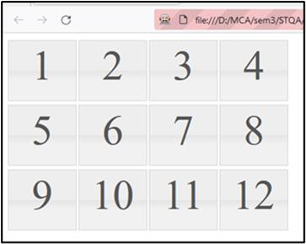

2. Write a selenium script to select tile 1, tile 5, tile 11 on Selectable.html **Code:**

package webDriver; import org.openqa.selenium.By; import org.openqa.selenium.WebDriver; import org.openqa.selenium.WebElement; import org.openqa.selenium.firefox.FirefoxDriver; import org.openqa.selenium.interactions.Actions; public class ClickOnElement {

public static void main(String[] args) throws InterruptedException { System.setProperty("webdriver.gecko.driver","C:\\Setup\\geckodriver-v0.31.0win64\\geckodriver.exe");

WebDriver driver=new FirefoxDriver(); driver.get("file:///D:/MCA/sem3/STQA/Sample%20Testing%20Files/Selectable.html");

WebElement btnOne=driver.findElement(By.name("one"));

WebElement btnEleven=driver.findElement(By.name("eleven"));

WebElement btnFive=driver.findElement(By.name("five")); Actions builder=new Actions(driver);

builder.click(btnOne).click(btnFive).click(btnEleven); builder.perform();

}

}

**Output:**

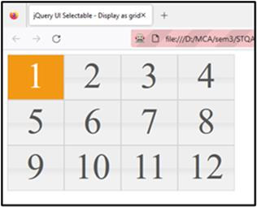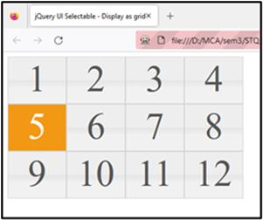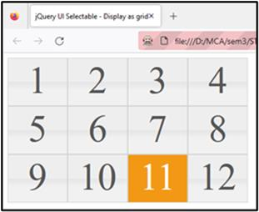

3. Write a selenium script to select tile 3 using moveByOffset() method and select tile 11 using click on web Element method click() on Selectable.html **Code:**

package webDriver; import org.openqa.selenium.By; import org.openqa.selenium.WebDriver; import org.openqa.selenium.WebElement; import org.openqa.selenium.firefox.FirefoxDriver; import org.openqa.selenium.interactions.Actions; public class MoveByOffset {

public static void main(String[] args) {

System.setProperty("webdriver.gecko.driver","C:\\Setup\\geckodriver-v0.31.0win64\\geckodriver.exe");

WebDriver driver=new FirefoxDriver(); driver.get("file:///D:/MCA/sem3/STQA/Sample%20Testing%20Files/Selectable.html");

WebElement tile11=driver.findElement(By.name("eleven"));

System.out.println("X Coordinate: "+tile11.getLocation().x+" Y Coordinate:

"+tile11.getLocation().y);

Actions builder = new Actions(driver);//instantiate action class objrct builder.moveByOffset(tile11.getLocation().x+1,tile11.getLocation().y+1).click(); builder.perform();

}

}

## Output:-

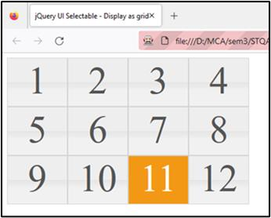

4. Write a selenium script to double click and right click the elements on

<http://demo.guru99.com/test/simple_context_menu.html>**Code:**

package Exercise;

import org.openqa.selenium.Alert; import org.openqa.selenium.By; import org.openqa.selenium.WebDriver; import org.openqa.selenium.WebElement; import org.openqa.selenium.chrome.ChromeDriver; import org.openqa.selenium.interactions.Actions;

public class Q4 {

public static void main(String[] args) throws InterruptedException { System.setProperty("webdriver.chrome.driver", "D:\\Finolex\\SEM

3\\chromedriver_win32\\chromedriver.exe");

WebDriver driver=new ChromeDriver(); //create driver instance driver.get("https://demo.guru99.com/test/simple_context_menu.html"); WebElement context=driver.findElement(By.xpath("//span[@class='contextmenu-one btn btn-neutral']"));

WebElement li=driver.findElement(By.xpath("//li[@class='context-menu-item context-menu-icon context-menu-icon-edit']"));

Actions builder=new Actions(driver); builder.contextClick(context).click(li).perform();

Alert simpleAlert=driver.switchTo().alert(); Thread.sleep(1000); simpleAlert.accept();

Thread.sleep(1000);

WebElement

dblClick=driver.findElement(By.xpath("//button[@ondblclick='myFunction()']")); builder.doubleClick(dblClick).perform(); Thread.sleep(1000); simpleAlert.accept();

}}

**Output:**

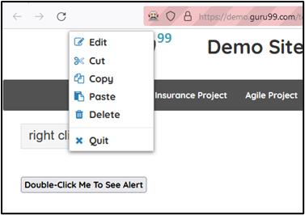

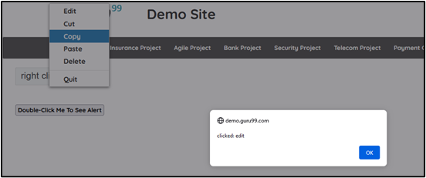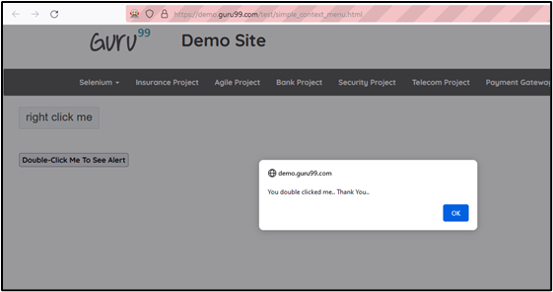

5. Write a selenium script to drag the BANK element and drop on the DEBIT SIDE block through dragAndDrop method on the following webpage http://demo.guru99.com/test/drag_drop.html. Use xpath to locate required elements.

**Code:**

package practical9; import org.openqa.selenium.By; import org.openqa.selenium.WebDriver; import org.openqa.selenium.WebElement; import org.openqa.selenium.firefox.FirefoxDriver; import org.openqa.selenium.interactions.Actions; public class Q5 {

public static void main(String args[]) throws InterruptedException {

System.setProperty("webdriver.gecko.driver", "D:\\Finolex\\SEM 3\\Selenium-

Setup\\geckodriver.exe");

WebDriver driver=new FirefoxDriver(); //create driver instance driver.get("https://demo.guru99.com/test/drag_drop.html"); WebElement bank=driver.findElement(By.xpath("//li[@data-id='5']//a")); Actions builder=new Actions(driver); builder.clickAndHold(bank);

WebElement dropOn=driver.findElement(By.xpath("//div[@class='ui-widgetcontent']//descendant::ol[@id='bank']"));

builder.moveToElement(dropOn); builder.release().perform();

}}

**Output:**

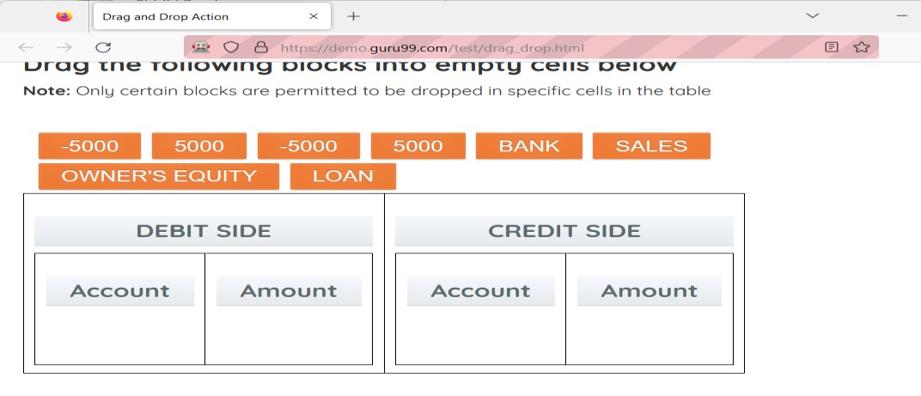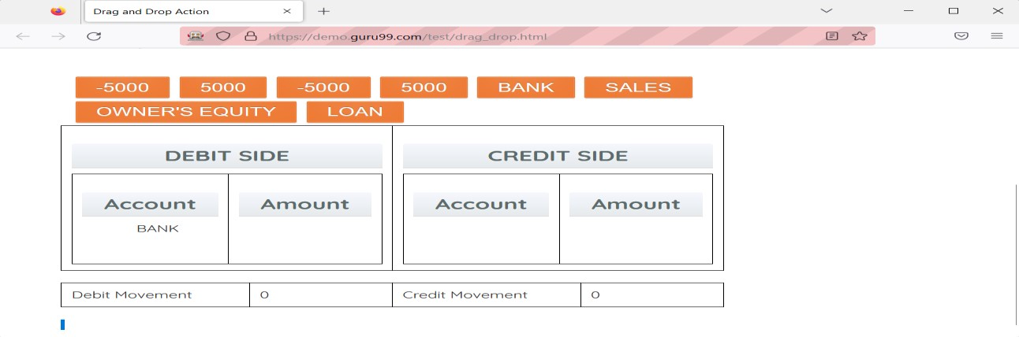

6. Write a selenium script to implement drag and drop action o[n https://demoqa.com/droppable/](https://demoqa.com/droppable/) **Code:** package practical9; import org.openqa.selenium.By; import org.openqa.selenium.WebDriver; import org.openqa.selenium.WebElement; import org.openqa.selenium.firefox.FirefoxDriver;

import org.openqa.selenium.interactions.Actions; public class Q6 {

public static void main(String[] args) {

System.setProperty("webdriver.gecko.driver","C:\\Setup\\geckodriver-v0.31.0win64\\geckodriver.exe");

WebDriver driver=new FirefoxDriver(); driver.get("https://demoqa.com/droppable/");

WebElement drag=driver.findElement(By.id("draggable"));

WebElement drop=driver.findElement(By.id("droppable")); Actions builder=new Actions(driver); builder.dragAndDrop(drag, drop); builder.perform();

}}

**Output:**

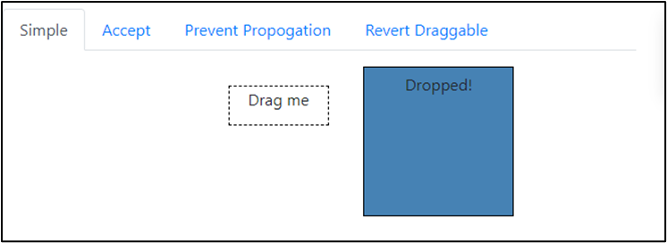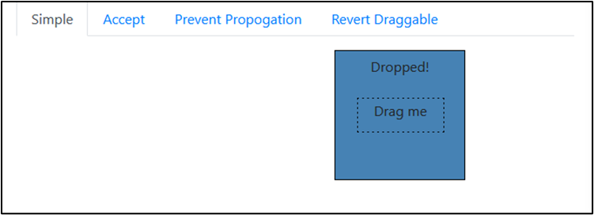

**Conclusion:** Learnt advance mouse and keyboard interactions using Selenium.

# After performing this Practical/lab, students are expected to answer following questions

Q.1 What is Actions class in Selenium?

Q.2 How to build a set of actions in a composite action to execute it in one pass?