Supplemental Materials

Evaluating cessation of the type 2 oral polio vaccine by modeling pre- and post-cessation detection rates

Steve J. Kroiss, Michael Famulare, Hil Lyons, Kevin A. McCarthy, Laina D. Mercer, Guillaume

Table of Contents
A Countries included in western Africa analysis 1
B Matched filtering for finding unlabeled bOPV campaigns in India 1
C Sensitivity analysis for incorrectly determining the unlabeled India bOPV campaign dates 2
D Possible sources of error in recorded campaign calendar 3
E Model sampling and priors 4
F Approach for generating pre-cessation prediction intervals 4
G Approach for generating post-cessation prediction intervals 5
References 5

A Countries included in western Africa analysis
We grouped 13 countries as western Africa (Benin, Burkina Faso, Côte d’Ivoire, Gambia, Ghana, Guinea, Guinea-Bissau, Mali, Mauritania, Niger, Senegal, Sierra Leone, and Togo) because their individual population sizes are small, the countries have similar vaccination campaign schedules, and similar age and dose distributions. We excluded Liberia from this analysis because no Sabin 2 detections were reported in the AFP data for this country. The starting dates of data and number of samples for each country are listed in Table A.

Fig A and B show the age and vaccination exposure for each region from the Acute Flaccid Paralysis (AFP) data we used in our analysis. The Sabin positive and negative cases show similar distributions and suggest the Sabin positive cases are a representative sample of non-polio AFP cases (NP-AFP). Approximately 0.01% of the age data was recorded as older than 80 years and is suggestive of data entry errors. As such, we omitted those samples from the age distributions. Likewise, 0.1% of the reported dose values were greater than 50 and we omitted those values from the dose distributions.

B Matched filtering for finding unlabeled bOPV campaigns in India
We were unable to definitively determine the date and location of three bOPV campaigns in India in 2014 based on information from the WHO and published records. To address this issue, we chose a conservative approach and filtered the India AFP data to only include Bihar and Uttar Pradesh provinces because these two provinces had clearly identifiable peaks in Sabin detection around the time of the unknown campaign dates, all districts within these provinces participated in the SIAs, and these provinces accounted for ~2/3 of the India AFP dataset. We then used pattern matching functions to identify likely campaign start dates which we describe below. We also conducted a sensitivity analysis to determine the impact of incorrectly determining the campaign dates for these three campaigns.

With the set of known campaign dates and template “pulses” of Sabin shedding observed in the stools of NP-AFP cases subsequent to these campaigns, a matched filtering [1] approach can be used to identify the presence of similar pulses without a nearby known campaign and to estimate the start date of these unlabeled campaigns. Given an observed series $x[t]$ containing some signals of interest $s[t]$ (the post-campaign “pulses”) in the presence of additive noise $n[t]$ (presumed to be detections due to routine immunization):
$$x[t]=s[t]+n[t]$$
The matched filter can be defined as the sequence $h[t]$ that minimizes the least-squared residual:
$$\sum_{t}{{\left(x\left[t\right]-c h\left[τ-t\right]\right)}^{2}}$$
For appropriate choices of arbitrary scaling and shifting parameters $c$ and $τ$. The time series model employed in the manuscript is:
$$y=βte^{-γt}+α$$
Identifying $s\left[t\right]=βte^{-γt}$ and $n\left[t\right]=α$, and noting that $n[t]$ then represents stationary, serially uncorrelated white noise (with non-zero mean, which can be subtracted away), the solution for the matched filter $h[t]$ will be simply:
$$h\left[t\right]=c s[τ-t]$$
where the scaling and shifting parameters are defined by minimization of the residual defined above. The least-squares estimator for the shifting parameter of the signal (the imputed date of the campaign) is
$$\hat{τ}=argmax\left(x\left[t\right]*h\left[t\right]\right)=argmax(x\left[t\right]⋆s\left[t\right])$$
Where $*$ and $⋆$ represent the convolution and cross-correlation operators, respectively.
With this estimator in hand, a filter template is derived by taking the mean of the observation sequence in the 30 days immediately subsequent to known campaigns in the Indian states of Bihar and Uttar Pradesh. An example template (for type 1 Sabin observations across both Bihar and Uttar Pradesh provinces) is presented in Fig C. This filter is then applied to the full observed time series, shown in Fig Da, providing the filtered output in Fig Db. Finally, Fig E presents a histogram of the difference between the estimated and known start dates of the campaigns present in the campaign calendar, demonstrating that the expected error on this estimator is small, of the order of one to three days.

C Sensitivity analysis for incorrectly determining the unlabeled India bOPV campaign dates
We examined the sensitivity of our models to errors in determining the dates of the three unlabeled India bOPV campaigns (out of a total of 12 bOPV campaigns in India). Examination of the differences between the estimated and known start dates of the campaigns were one to three days (Fig E). As such, we reran the models by shifting all of the unlabeled bOPV campaign dates three days earlier than estimated by the matched filter approach. We did not shift the campaigns date estimates later than estimated because Sabin detection rates had already begun to rise on the estimated days indicating campaigns had occurred (Fig D). We then reran our models using the earlier date estimates and present the summarized impacts on the results below. Since the unlabeled campaigns were bOPV campaigns (and didn’t contain Sabin 2, only 1 and 3), model results for Sabin 2 are unchanged.

Earlier dates than estimated by the matched filter did not qualitatively change the results for India (Fig F). The mean duration of the pulses in Sabin 1 and 3 detections were 2.07 and 2.26 days longer than the matched filter estimates, but these differences were not significantly different from the original matched filter estimates. Decay estimates for earlier dates were 0.03 and 0.01 smaller for Sabin 1 and 3 respectively, but again these differences were not significantly different from the original matched filter estimates. Differences in the rate of peak detection and baseline detection rates for both Sabin 1 and 3 were less than 0.001 and were not significantly different from the original matched filter estimates.

D Possible sources of error in recorded campaign calendar
Multiple factors could introduce errors into our estimates, but are unlikely to qualitatively affect our main conclusions. First, SIAs usually occur over three to five days, which will tend to extend the duration of peak Sabin detection. Campaign length also varied slightly among countries, but these differences were less than two days (Table 1). Misspecifications in country-reported campaign calendars may bias our analyses if campaigns occur earlier or later than reported. The degree to which this occurs is uncertain, but this effect may partially account for differences in baseline detection rates between the Sabin types. Within each country, baseline detection rates were slightly lower and less variable for Sabin 2 than for Sabin 1 & 3 (Fig 3a). The more frequent use of Sabin 1 & 3 than 2, could allow for more opportunities for secondary transmission and subsequent baseline detection, or allow for more frequent miss-specifications in the campaign calendars for Sabin 1 and 3 and erroneous time since SIA calculations (potentially categorizing cases as long times since SIAs thereby increasing baseline detection rates). Unfortunately, we are not able to distinguish between these possibilities.

To examine the extent to which campaigns started earlier than reported, we examined Sabin detection rates immediately prior to SIAs and compared them to model predictions. To do this, we filtered our data to AFP cases where the time since last campaign was ≥50 days after an SIA or zero (occurring on the same day as an SIA). We re-categorized these cases by the number of days prior to the next SIA (based on the SIA calendar). We then generated prediction intervals by drawing from the beta-binomial distribution based on the AFP sampling rate per day and model predictions for each of the 4000 posterior samples. However, we set time (time since SIA) in the Ricker function to either zero (for samples on the same day as an SIA) or 50 (for samples ≥50 days after last SIA). To determine if observed detection rates prior to SIAs were higher than predicted, we compared the observed rates to the 95% prediction intervals.

Inspection of Sabin detection rates prior to campaigns (Fig G) suggest that our campaign calendars are off by at most one to three days. Observed detection rates greater than three days prior to an SIA were not significantly different than predictions. However, observed detection rates one to two days prior to an SIA lay outside of the prediction intervals for India, Nigeria, Pakistan and western Africa suggesting some campaigns started earlier than reported. Furthermore, observed detection rates on the same day as an SIA were higher than predicted for every country. Detection of Sabin on the same day as an SIA could represent viral excretion since excretion is known to occur within 24 hours of infection [2]; detection of the actual OPV dose; or indicate the campaign started earlier than reported. Thus in total, we estimate the campaign calendars are off by at most one to three days.

E Model sampling and priors
We used uniform priors on all parameters with boundaries at zero and one for α, γ, and θ. Since we’re modeling probabilities, we needed to constrain our function to take values between zero and one.

To do this, instead of setting priors on beta, we set a uniform prior between zero and one on the peak detection rate ($\frac{α_{ij}}{β_{ij}}e^{-1}$). We then transformed back to β according to the following equation:
$$β_{ij}={(1-α}_{ij})*{peak_detection_rate}_{ij}*γ_{ij}*e^{1}$$
Here we index by country $i$, Sabin type $j$, $α$ captures baseline detection rates, and $β$ and $γ$ parameters to describe the shape of the curve.

Using these priors, we ran four sampler chains with a burn-in of 1000 and 2000 monitored iterations. We assessed model convergence by examining the effective number of samples and the point scale reduction statistics [3,4].

F Approach for generating pre-cessation prediction intervals
Prediction errors are useful to assess model fit to observed data. Our computation for pre-cessation intervals is largely for diagnostic and visualization purposes. For pre-cessation data, NP-AFP cases are grouped by country, Sabin type, and the number of days from stool collection the last SIA occurred.

Prediction intervals include model and parameter uncertainty. In order to incorporate both, we build Beta-Binomial simulation on top of the posterior samples. Let $Y_{ijt}^{*}|Y_{ij}$ be a hypothetical replication of the experiment for country $i$, type $j$, and at day $t$ conditional on the actual vector of observations $Y_{ij}$ across all times, i.e. the posterior predictive distribution [5]. This distribution arises from the conditional distribution
$$Y_{ijt}^{*}|n_{ijt},p_{ijt}∼BetaBinomial\left(n_{ijt},p_{ijt},λ_{ij}\right)$$
paired with the posterior $p_{ijt}|Y_{ij}$. Thus, an approximation for the $Y_{ijt}^{*},p_{ijt},λ_{ij}|Y_{ij}$ and subsequently $Y_{ijt}^{*}|Y_{ij}$ is

Step 1: generate $M$ posterior samples from $p_{ijt},λ_{ij}|Y_{ij}$.
Step 2: generate one sample from $Y_{ijt}^{*\left(m\right)}∼BetaBinomial\left(n_{ijt},p_{ijt}^{\left(m\right)},λ_{ij}^{\left(m\right)}\right)$ where $m$ indexes the posterior samples.

This results in $M$ posterior samples of the predictive distribution as desired. From these samples we produced 95% prediction intervals using the 2.5% and 97.5% quantiles. Note that the lower bound will often be 0 when $p_{ijt}$ is small and/or $n_{ijt}$ is small as $Y_{ijt}^{*}$ is discrete. In isolation, when $p_{ijt}$ is small an upper 95% prediction might make more sense (0 is a common outcome), but to accommodate larger $p_{ijt}$ we maintained the approach of using lower and upper quantiles.

G Approach for generating post-cessation prediction intervals
Post-cessation prediction intervals are useful to understand not only what might be expected for future Sabin isolates, but also to compare observations with these expectations. We are largely concerned with the latter: assessing what might be considered unusual in the post-cessation era.

The complication with post-cessation prediction intervals is that rather than grouping by the number of days since the last SIA we are interested in grouping by date since cessation. For a given country, due to subnational variety in SIA exposure, NP-AFP cases with the same first stool sample date may have different campaign dates. As such, we devise estimates and prediction intervals based on aggregating individual NP-AFP with potentially different exposures.

Let $x$ be the number of days since cessation. On this day, let the observed number of cases be $n_{ijx}$ for country $i$ and type $j$. Let the time since individual SIA exposure for NP-AFP case be $t_{k}$, $k=1,…,n_{ijx}$; then
$$p_{ijk}=\left\{\begin{matrix}α_{ij}e^{-γ_{ij}x}+β_{ij}t_{k}e^{-γ_{ij}t_{k}}, j=2; \\ α_{ij}+β_{ij}t_{k}e^{-γ_{ij}t_{k}}, j∈\left(1,3\right).\end{matrix}\right.$$
We then generate prediction intervals similar to the above procedure. Let $Y_{ijk}^{*}$ be a hypothetical replication of the binary outcome for NP-AFP case $k$ observed $x$ days after cessation.

Step 1: generate $M$ posterior samples from $p_{ijt},λ_{ij}|Y_{ij}$. Note that $Y_{ij}$ is pre-cessation data only.

Step 2: generate one sample from $Y_{ijk}^{*\left(m\right)}∼Bernoulli\left(p_{ijk}^{\left(m\right)},\right)$ where $m$ indexes the posterior samples.

Step 3: aggregate the individual samples to a composite sample to $Y_{ijx}^{*(m)}=\sum_{k=1}^{n_{ijx}}{Y_{ijk}^{*\left(m\right)}}$.

This results in $M$ posterior samples of the predictive distribution as desired. From these samples we produced 95% prediction intervals using the 2.5% and 97.5% quantiles, with the same caveat as above.

Note that a Bernoulli trial has no overdispersion, and the only heterogeneity is induced by possible differences in SIA exposure. The posterior distribution of the input parameters does reflect heterogeneity in pre-cessation observations, but there may be other individual-level heterogeneity that contributed to this overall overdispersion that is not reflected in the above procedure.

References
1. Turin G. An introduction to matched filters. IEEE Trans Inf Theory. 1960;6: 311–329. doi:10.1109/TIT.1960.1057571
2. Fine PEM, Carneiro IAM. Transmissibility and persistence of oral polio vaccine viruses: implications for the global poliomyelitis eradication initiative. Am J Epidemiol. 1999;150: 1001–1021. doi:10.1093/oxfordjournals.aje.a009924
3. Gelman A, Rubin DB. Inference from Iterative Simulation Using Multiple Sequences. Stat Sci. 1992;7: 457–511. doi:10.1214/ss/1177011136
4. Gelman A, Shalizi CR. Philosophy and the practice of Bayesian statistics. Br J Math Stat Psychol. 2013;66: 8–38. doi:10.1111/j.2044-8317.2011.02037.x
5. Gelman A, Goegebeur Y, Tuerlinckx F, Van Mechelen I. Diagnostic checks for discrete data regression models using posterior predictive simulations. J R Stat Soc Ser C (Applied Stat. 2000;49: 247–268. doi:10.1111/1467-9876.00190

Table A: Beginning dates and number of cases for NP-AFP data for each country.

Region | Country | Start date of data | Number of samples
Afghanistan | Afghanistan | 2011-01-01 | 10757
India | India | 2014-01-01 | 62358
Nigeria | Nigeria | 2010-01-01 | 54423
Pakistan | Pakistan | 2010-01-01 | 31288
Western Africa | Benin | 2012-01-01 | 717
Western Africa | Burkina Faso | 2011-01-01 | 1412
Western Africa | Côte d’Ivoire | 2012-01-01 | 1496
Western Africa | Gambia | 2012-01-01 | 108
Western Africa | Ghana | 2010-01-01 | 1813
Western Africa | Guinea | 2016-01-01 | 73
Western Africa | Guinea-Bissau | 2014-01-01 | 26
Western Africa | Mali | 2011-01-01 | 1241
Western Africa | Mauritania | 2012-01-01 | 247
Western Africa | Niger | 2011-01-01 | 1527
Western Africa | Senegal | 2011-01-01 | 909
Western Africa | Sierra Leone | 2012-01-01 | 456
Western Africa | Togo | 2012-01-01 | 488

Table B: Summary of model parameters posteriors. We list the mean with the 95% credible intervals in parentheses.

Region | Sabin | Time to baseline | γ | Peak detection | α
Afghanistan | 1 | 17.58  (13.688, 22.255) | 0.429  (0.333, 0.542) | 0.144  (0.116, 0.176) | 0.025  (0.021, 0.029)
Afghanistan | 2 | 32.377  (24.808, 40.895) | 0.236  (0.184, 0.303) | 0.119  (0.09, 0.152) | 0.011  (0.009, 0.013)
Afghanistan | 3 | 30.155  (21.541, 40.813) | 0.25  (0.18, 0.342) | 0.118  (0.094, 0.144) | 0.025  (0.021, 0.03)
India | 1 | 25.174  (22.591, 28.066) | 0.303  (0.27, 0.336) | 0.134  (0.116, 0.154) | 0.005  (0.004, 0.006)
India | 2 | 37.126  (34.282, 40.053) | 0.205  (0.19, 0.222) | 0.143  (0.129, 0.157) | 0.003  (0.003, 0.004)
India | 3 | 33.861  (30.511, 37.71) | 0.225  (0.201, 0.249) | 0.11  (0.096, 0.125) | 0.005  (0.004, 0.006)
Nigeria | 1 | 18.359  (15.283, 21.63) | 0.408  (0.343, 0.488) | 0.147  (0.124, 0.173) | 0.023  (0.021, 0.025)
Nigeria | 2 | 33.736  (29.641, 38.276) | 0.223  (0.195, 0.253) | 0.141  (0.125, 0.159) | 0.018  (0.016, 0.019)
Nigeria | 3 | 20.697  (17.785, 23.84) | 0.36  (0.31, 0.417) | 0.158  (0.138, 0.18) | 0.029  (0.027, 0.031)
Pakistan | 1 | 23.13  (18.801, 27.851) | 0.321  (0.263, 0.391) | 0.08  (0.067, 0.094) | 0.018  (0.016, 0.02)
Pakistan | 2 | 36.374  (29.794, 43.742) | 0.207  (0.17, 0.25) | 0.066  (0.055, 0.08) | 0.01  (0.009, 0.012)
Pakistan | 3 | 29.128  (23.87, 35.384) | 0.254  (0.207, 0.308) | 0.081  (0.069, 0.094) | 0.019  (0.016, 0.021)
Western Africa | 1 | 23.053  (17.052, 32.164) | 0.337  (0.234, 0.445) | 0.19  (0.136, 0.252) | 0.011  (0.008, 0.014)
Western Africa | 2 | 33.423  (24.046, 45.761) | 0.232  (0.165, 0.314) | 0.156  (0.119, 0.197) | 0.011  (0.008, 0.013)
Western Africa | 3 | 28.828  (21.13, 39.65) | 0.269  (0.191, 0.358) | 0.143  (0.106, 0.183) | 0.01  (0.007, 0.013)

Fig A: Age distributions of Sabin negative and positive NP-AFP cases by region. Peaks occur at 6 and 12 month intervals because child ages are often approximated by year or half a year intervals in AFP surveillance.

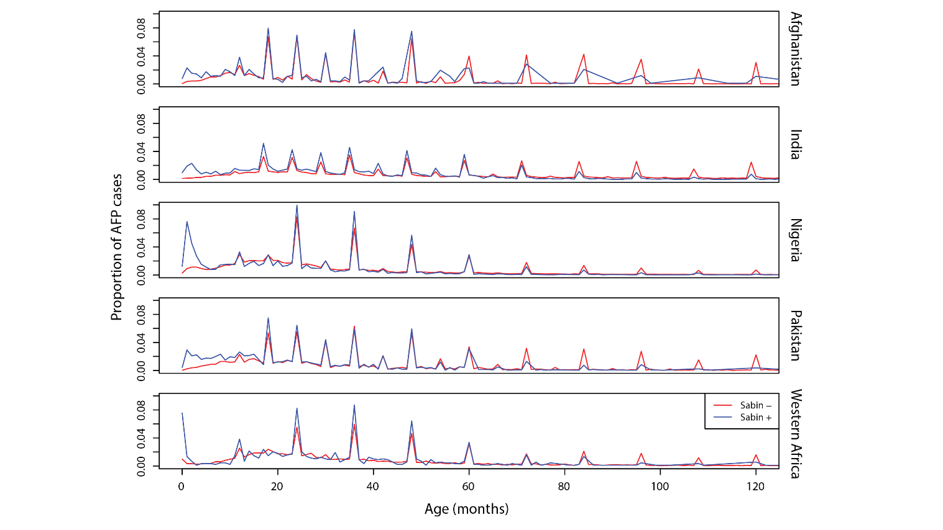
Fig B: Distributions of reported total number of doses for Sabin negative and positive NP-AFP cases by region.

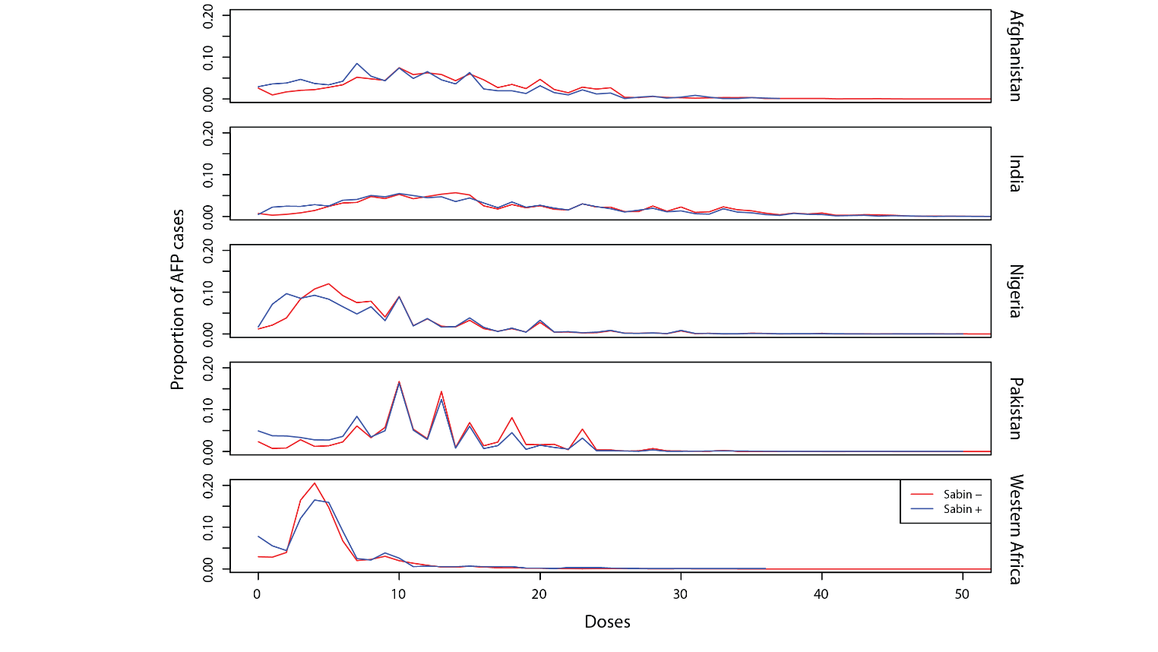
Fig C: Matched filter template for Sabin 1 across all known Sabin 1 campaigns in India.

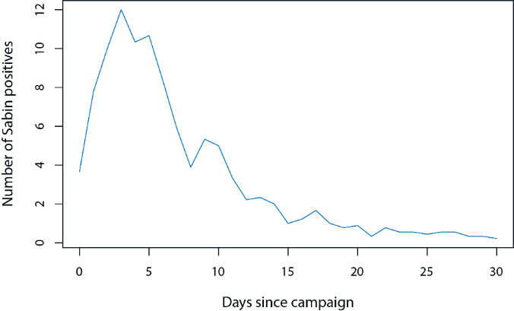
Fig D: Identification of unlabeled campaign dates in Bihar province in India. Sabin 1 case counts by day (A) and matched filter output (B). The exact scale of the y-axis panel B is not meaningful; as we are only interested in the estimate of the start date, the filtered output is unnormalized. The red x’s mark large local maxima in the filtered output, while the black dashed lines mark known campaign dates. The red x’s not accompanied by a black dashed line indicate the likely presence of a campaign not present in the calendar of known campaigns.

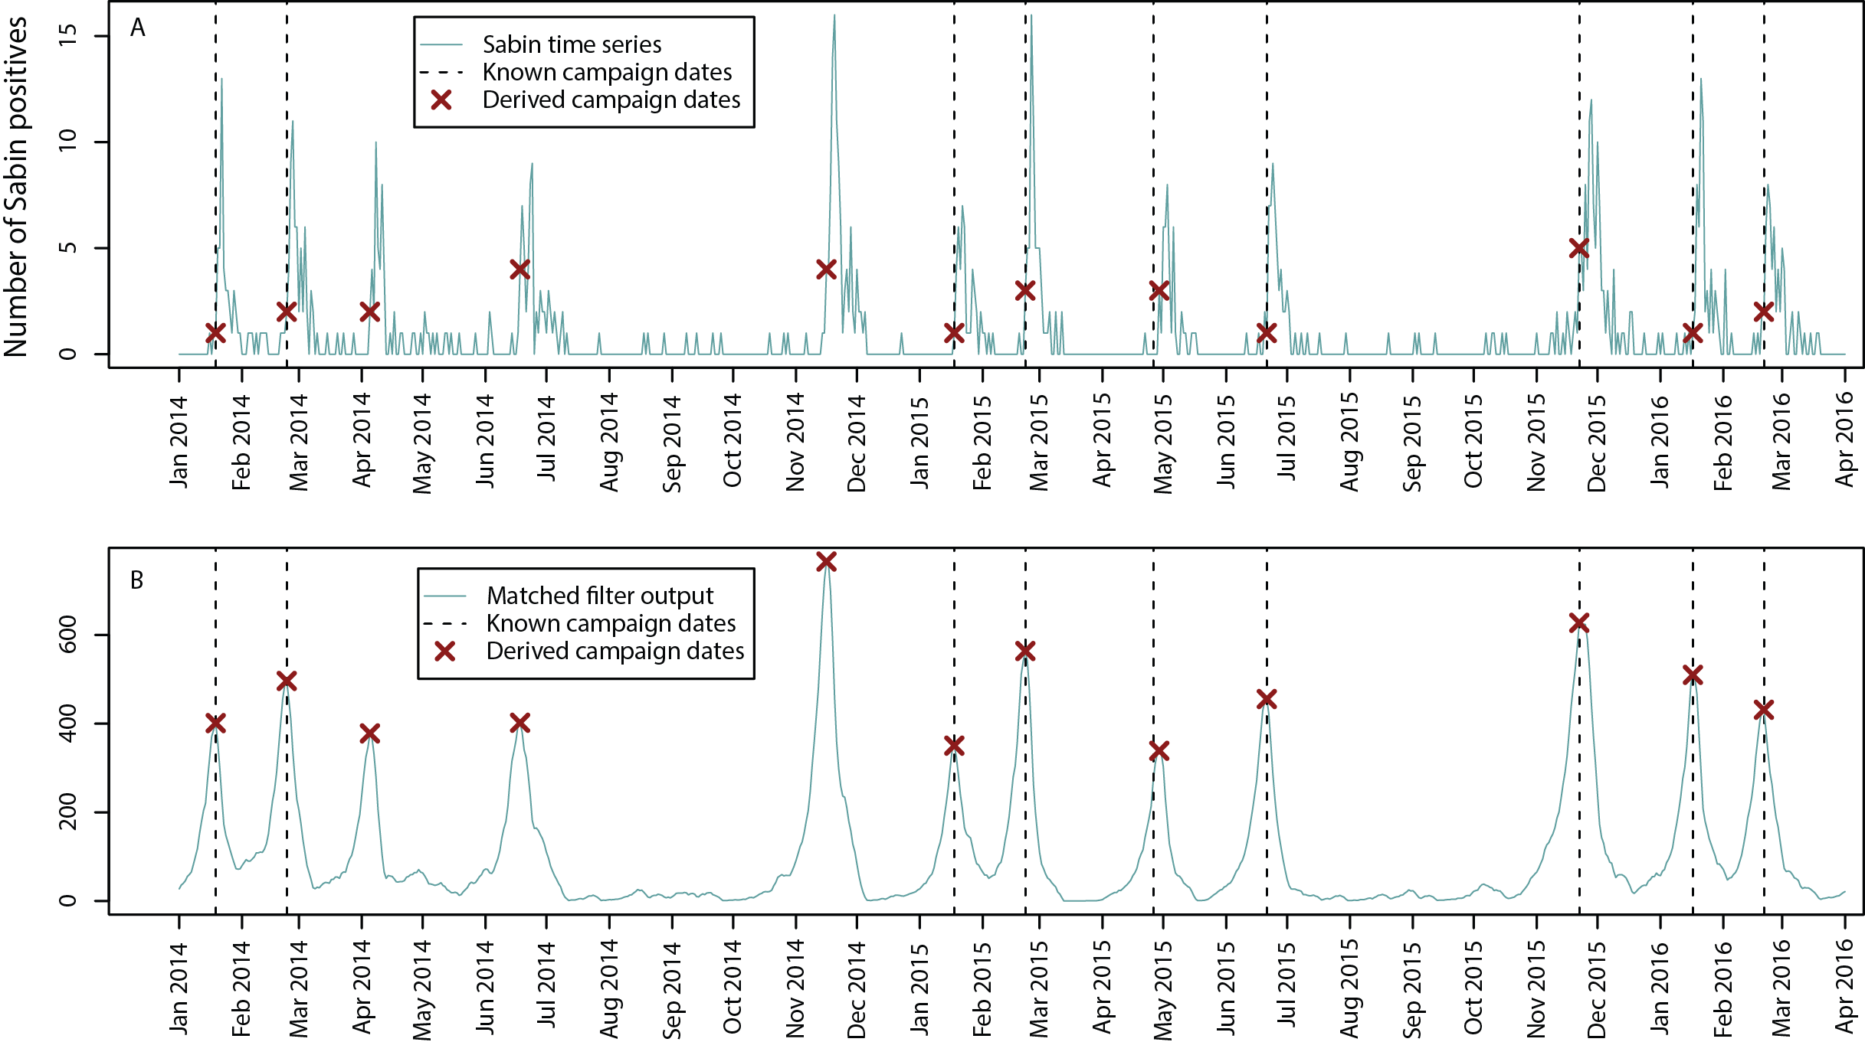

Fig E: Histogram of difference between estimated and known start dates of the Sabin 1 and 3 campaigns present in the campaign calendar for Bihar and Uttar Pradesh provinces.

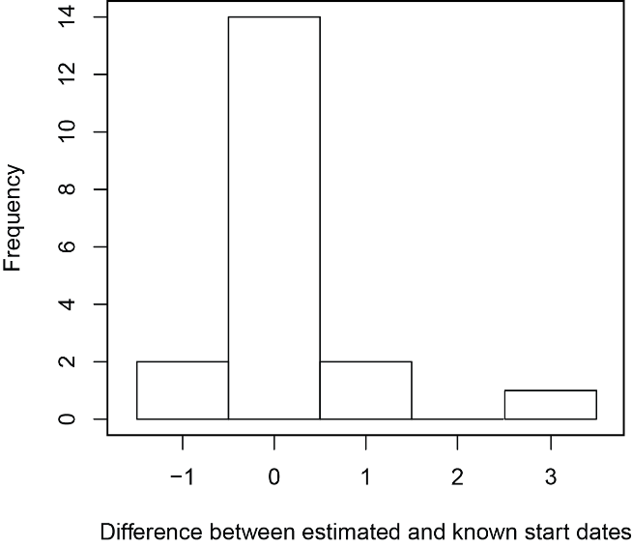

Fig F: Summary of parameters estimates for Sabin detection pre-cessation from the original matched filter date estimates and dates shifted three days earlier. Units and plotting ranges are the same as in Fig 3 for ease of comparison.

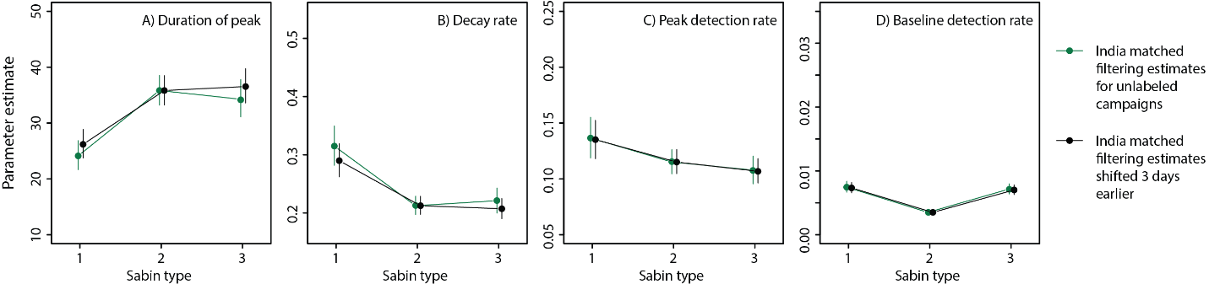

Fig G: Sabin detection rates prior to and on the day of SIAs. Observed Sabin detection rates up to 15 days prior to an SIA are indicated by gray circles and sized according to the number of NP-AFP samples. We only included data ≥50 days after an SIA, but reclassified cases by the number of days prior to the next SIA. The blue ribbons indicate 95% prediction intervals based on predictions assuming the time since the last campaign was either 0 (for samples on same day as SIA) or 50 (for those >50 days after last SIA and 1-15 days prior to next SIA). Observed values lying outside of the prediction intervals suggest that Sabin detection rates were higher than expected, likely because of misspecifications in the campaign calendar on the order of one to three days.

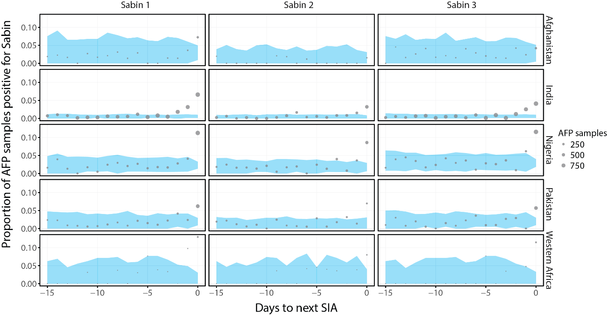

Fig H: Pre-cessation model estimates of Sabin detection rates by days since an SIA for each Sabin type and region. Observed rates of Sabin detection are represented by grey dots. The solid blue lines represent mean model predictions. The blue ribbon represents 95% prediction intervals. At long times after SIAs, data become sparse and some prediction intervals can extend above y limits. We clipped plots clipped at 180 days because data become extremely sparse beyond, except in Nigeria where the full data shown are in Fig 2.

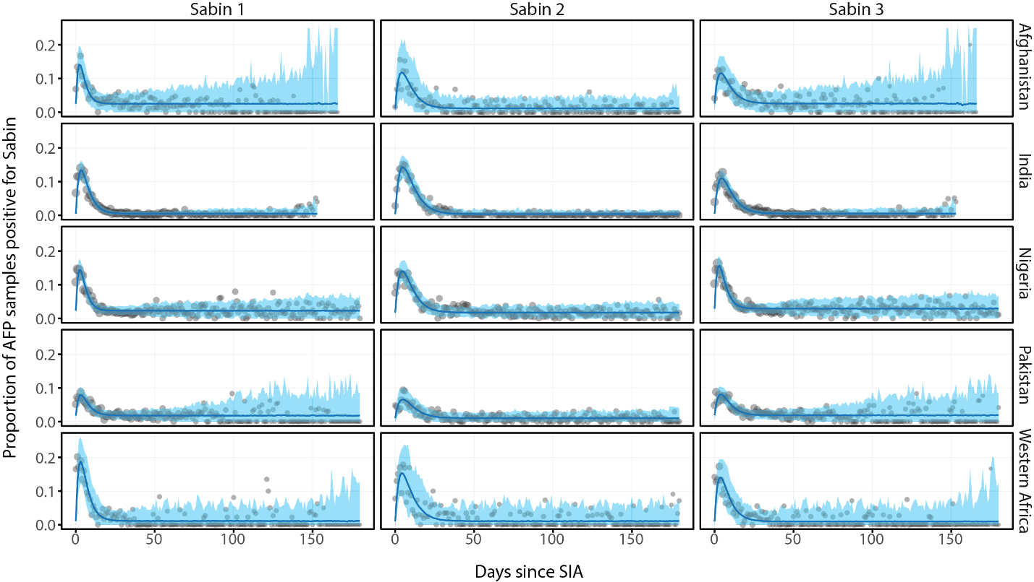
Fig I: Pairwise comparisons of model parameters between Sabin types within each country. Each point represents mean differences and the vertical lines indicate the 95% confidence intervals.

