数据结构-第02套

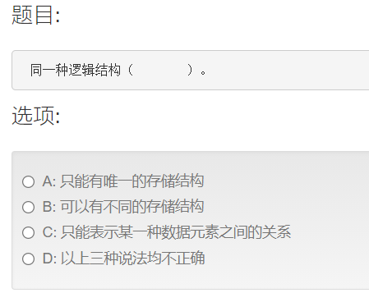B

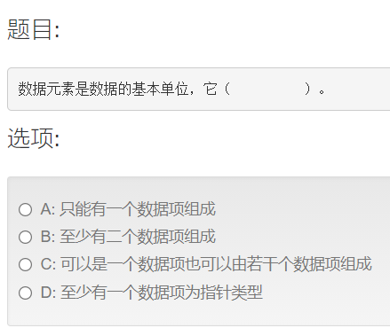C

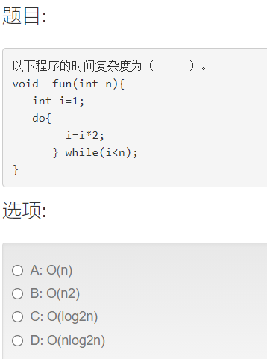

1

2

4

8

16

C

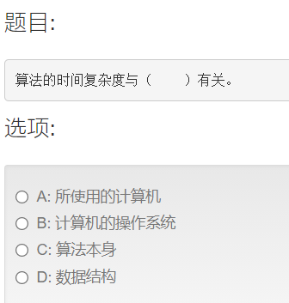C

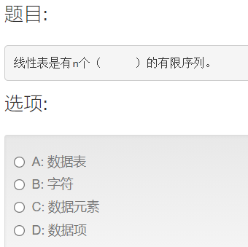C

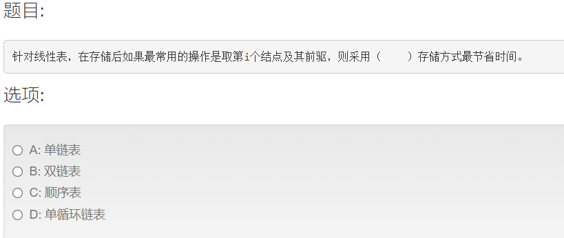C

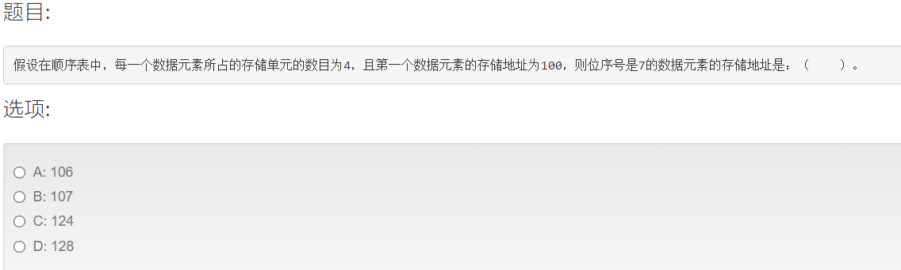D

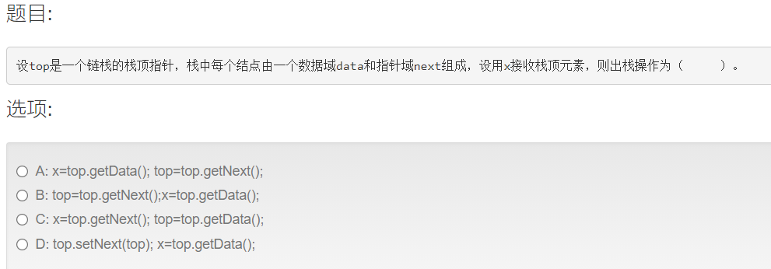A

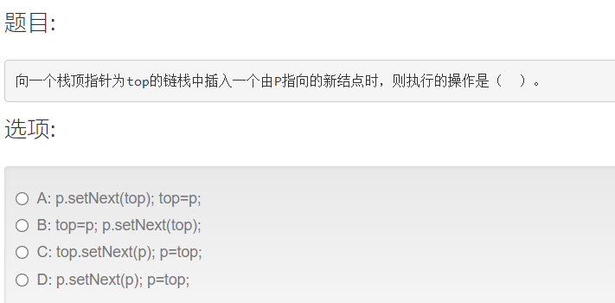A

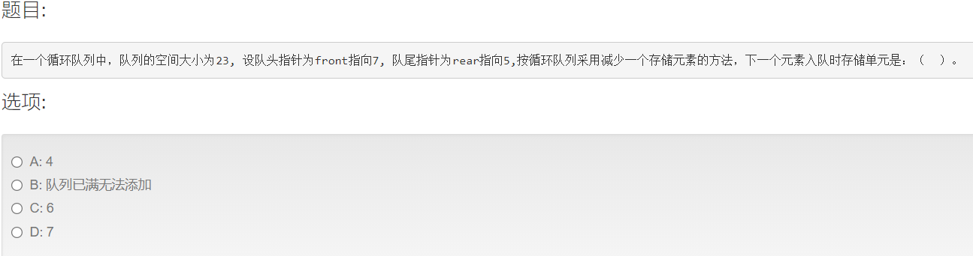C

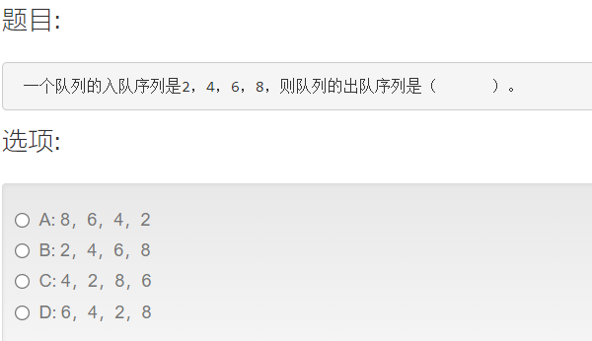B

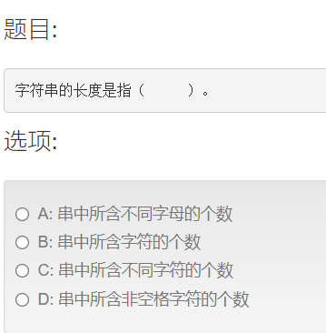B

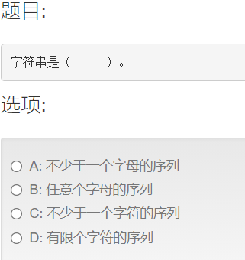D

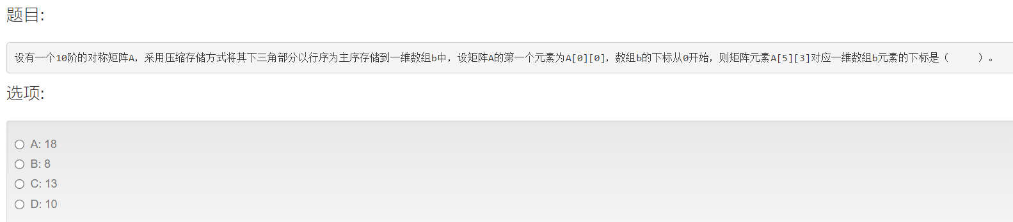A

5*6/2+3=18

|  |  |  |  |  |  |  |  |  |  |
| --- | --- | --- | --- | --- | --- | --- | --- | --- | --- |
| 0 |  |  |  |  |  |  |  |  |  |
| 1 | 2 |  |  |  |  |  |  |  |  |
| 3 | 4 | 5 |  |  |  |  |  |  |  |
| 6 | 7 | 8 | 9 |  |  |  |  |  |  |
| 10 | 11 | 12 | 13 | 14 |  |  |  |  |  |
| 15 | 16 | 17 | 18 | 19 | 20 |  |  |  |  |
|  |  |  |  |  |  |  |  |  |  |
|  |  |  |  |  |  |  |  |  |  |
|  |  |  |  |  |  |  |  |  |  |
|  |  |  |  |  |  |  |  |  |  |

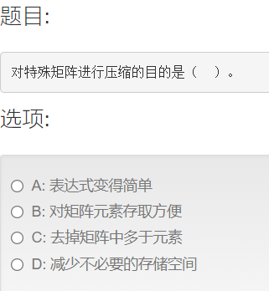D

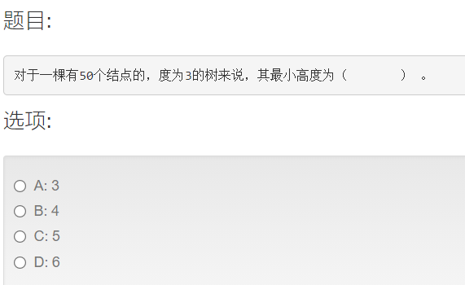C

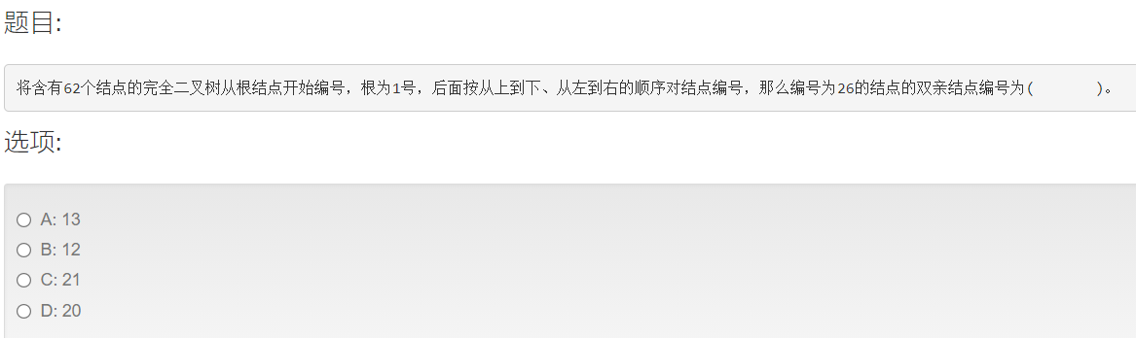A

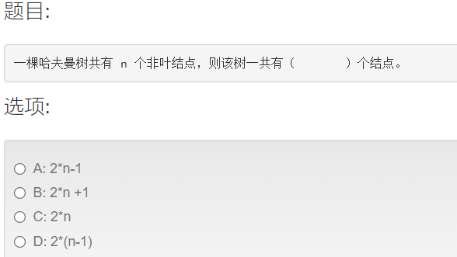B

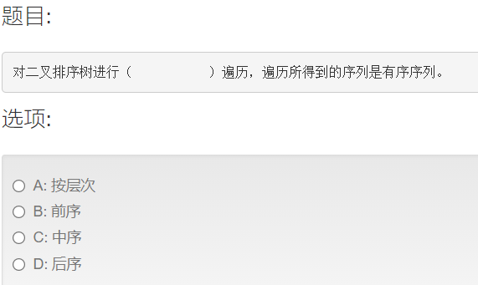C

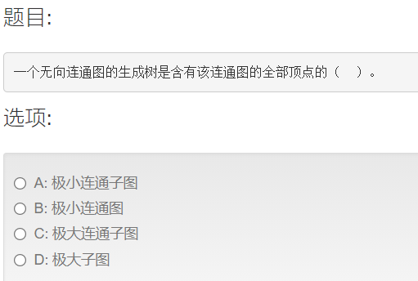A

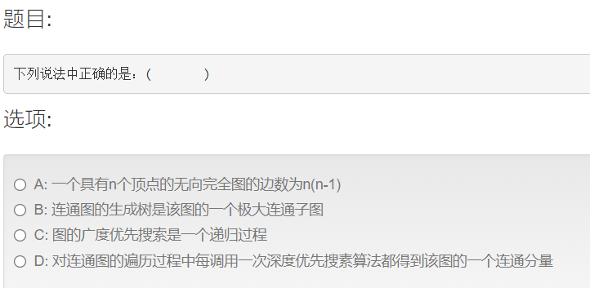D

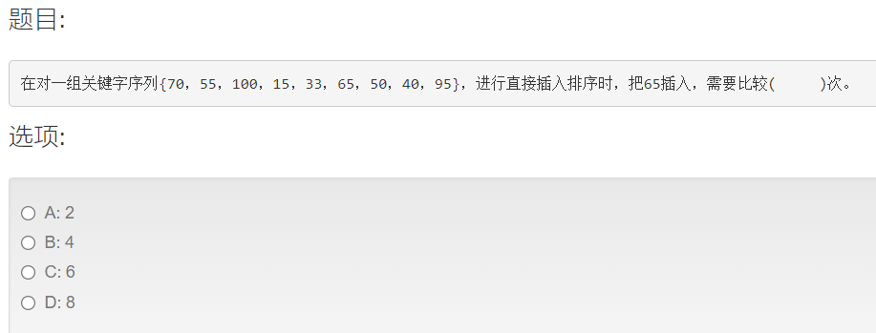3

15,33，55，65，70，100,

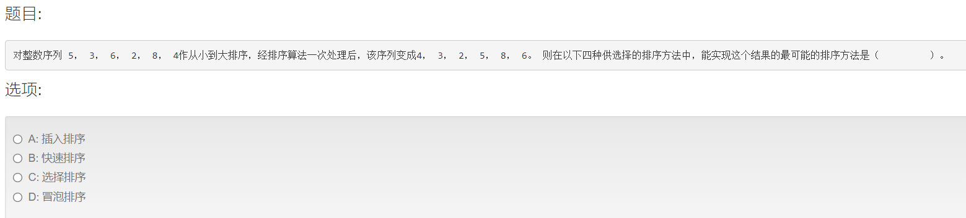B

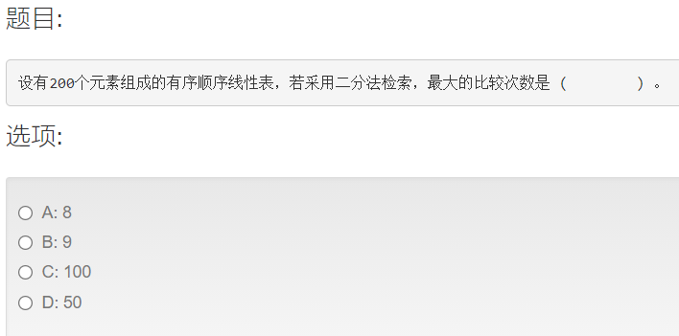A

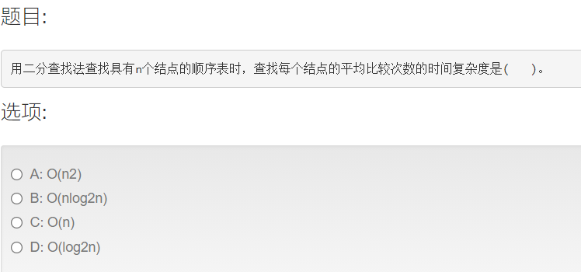D

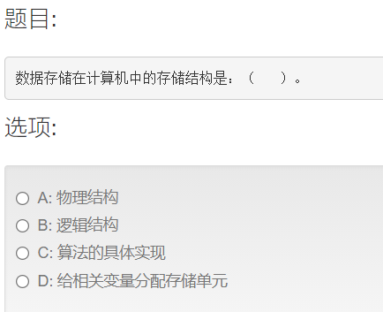A

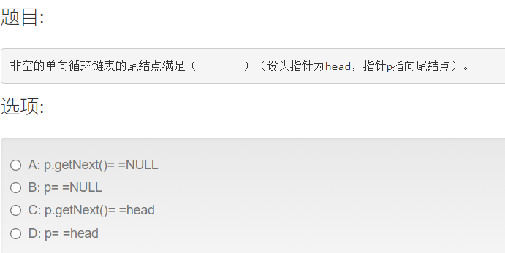C

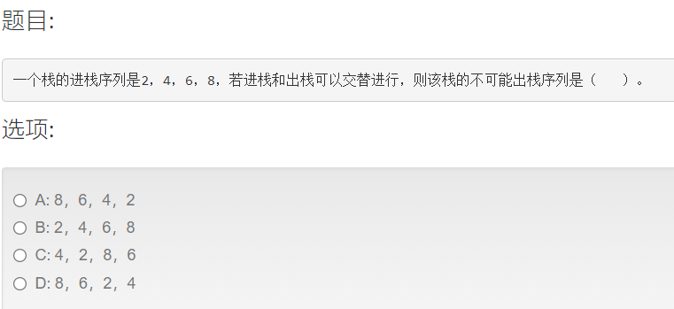D

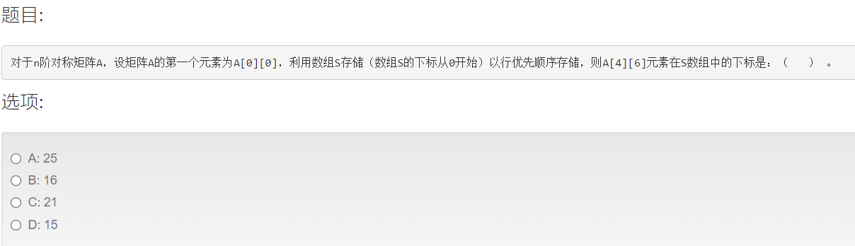A

|  |  |  |  |  |  |  |  |  |  |
| --- | --- | --- | --- | --- | --- | --- | --- | --- | --- |
| 0 |  |  |  |  |  |  |  |  |  |
| 1 | 2 |  |  |  |  |  |  |  |  |
| 3 | 4 | 5 |  |  |  |  |  |  |  |
| 6 | 7 | 8 | 9 |  |  |  |  |  |  |
| 10 | 11 | 12 | 13 | 14 |  | 46 |  |  |  |
| 15 | 16 | 17 | 18 | 19 | 20 |  |  |  |  |
|  |  |  |  | 64 |  |  |  |  |  |
|  |  |  |  |  |  |  |  |  |  |
|  |  |  |  |  |  |  |  |  |  |
|  |  |  |  |  |  |  |  |  |  |

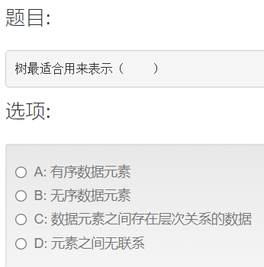C

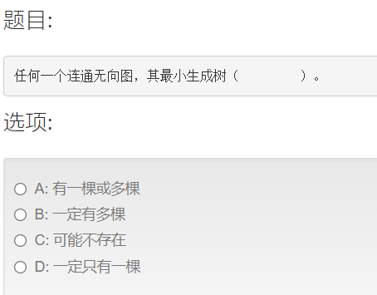a

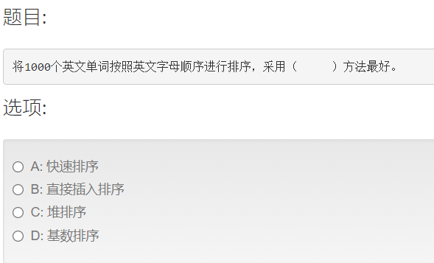D

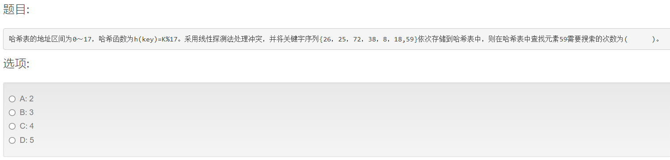C

