1.

Sol.

For this problem, we don’t know the exact bits number of each sample. Let x represents the bits number.

For the first question, "sampled every 1 msec" means that we can get 1000 samples per sec. So the maximum data rate is **1*x kbps = x kbps.**

For the second question, from the definition of signal-to-noise ratio we can know that $\frac{S}{N}={10}^{30/10}=1000$. According to Shannon Theorem, the maximum data rate is $4×\log_{2}\left(1+\frac{S}{N}\right)=4×\log_{2}{1001}=39.87$ **kbps**.

2.

Sol.

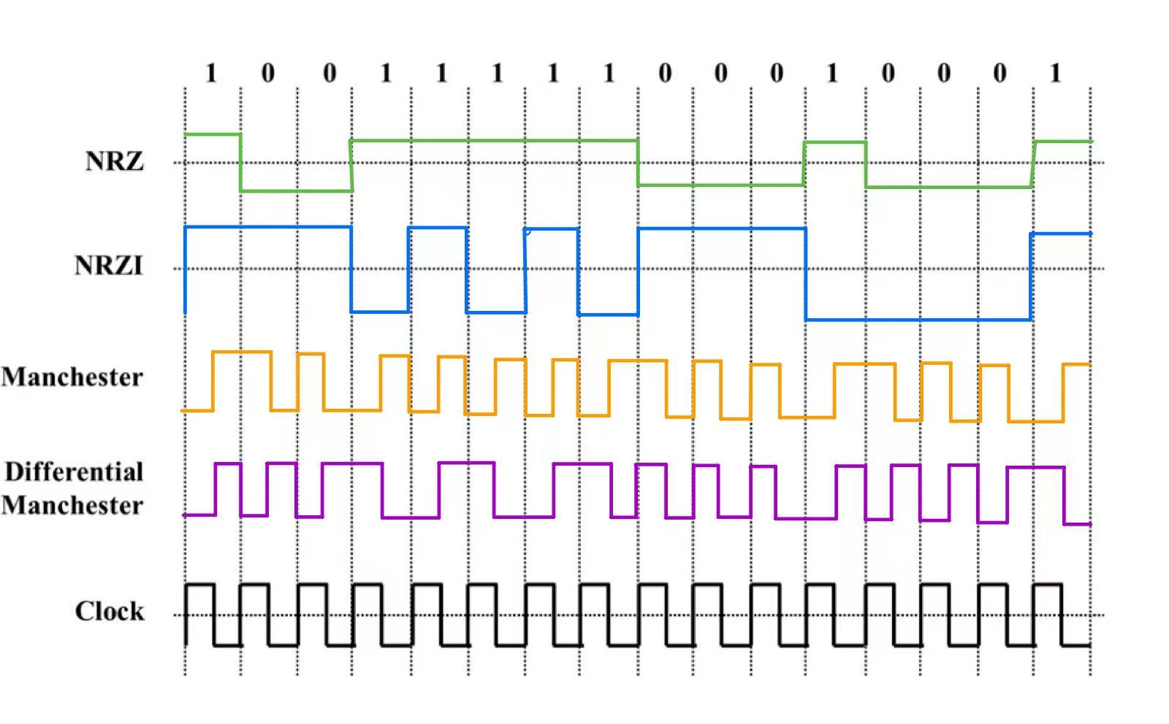

3.

Ans.

For Manchester Encoding, its disadvantage is that it requires more bits to be transmitted than the original digital signals. Thus, the data rate is only half of the bandwidth, since it needs two logic states to represent one digital signal.

4.

Sol.

For chip sequence A, the inner product of it and X is $\frac{1}{8}⋅\left(\left(-1\right)×\left(-1\right)+\left(-1\right)×1+…+1×1\right)=1$. So that A send bit 1.

By the same token, for chip sequence B, the inner product is -1. So that B send bit 0.

For chip sequence C, the inner product is 0, which means this station hasn't transmitted.

For chip sequence C, the inner product is 1, so D send bit 1.

To sum up, station A,B,D has transmitted and C hasn’t. In detail, A,D has sent bit 1 and B has sent bit 0.