1.

Sol.

For this problem, the frame is 10011101 and the generator G(x) is 1001. The dividing process is as shown.

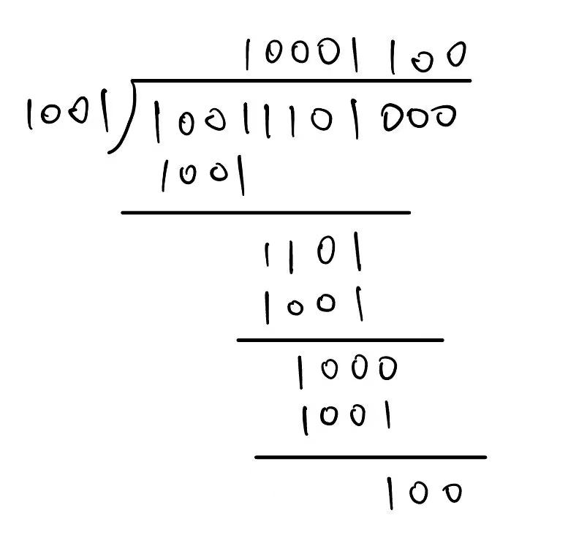

So the remainder is 100. Thus, the transmitted bit string is: **10011101100**.

Suppose the third bit from the left is inverted, that is, receiver gets 10111101100. Dividing this string by 1001, it is has a remainder of 100. So the receiver detects that it's not 0 and find the error.

If there are some errors during transmissions and the origin bit string change into a string that is multiple of 1001, the errors cannot be detected, since the remainder is 0, which is the same as the correct situations.

2.

Sol.

The efficiency can be calculated with the equation below.

$$U=\frac{T_{trans}}{T_{trans}+2×T_{prop}}=\frac{1}{2α+1}$$

where $α=\frac{T_{prop}}{T_{trans}}$.

Let $U=50\%$, so $T_{trans}=2T_{prop}=2×20=40$ msec.

So the least frame sizes is $4×40 = 160$ bits.

3.

Sol.

We can find that $T_{prop}=\frac{3×{10}^{4}×1000}{3×{10}^{8}}=0.1$ s. The bandwidth-delay product is $1Mbps×0.1s={10}^{5}b$, which is the bits size of 12.5 packets. So the **SWS = 13**.

1. If RWS = 1, $\left\lceil log_{2}\left(SWS+RWS\right)\right\rceil =4$. Thus we need 4 bits.
2. If RWS = SWS, $\left\lceil log_{2}\left(SWS+RWS\right)\right\rceil =5$. Thus we need 5 bits.

4.

Sol.

1. The smallest MaxSeqNum is 8. Any receive window that contains DATA[8] has already sent and sender has already gotten the ACK[6] or ACK[7], which means DATA[5] has already been sent. Combining the SWS is 5, so DATA[0] is not in the present sending window, that is, DATA[0] can no longer arrive.
2. MaxSeqNum – 1 = 7. At first sender sent DATA[0]~DATA[4] and receiver got it and changed receive window to DATA[5]~DATA[7]. But the ACK were all missing during propagation. So sender retransmitted DATA[0]~DATA[4]. Since 0 and 7 have the identical number under the mod with 7, receive accepted DATA[0] as DATA[7].

$MaxSeqNum≥SWS+RWS$