1.

Sol.

Routing: Determine routes taken by packets from source to destination. It needs routing algorithm to manage the packet transmitting. It operates on the network layer.

Forwarding: Move packets from router’s input to appropriate router output. It needs to check the forwarding table. It operates on the network layer.

Switching: Switch data packets between devices on the same network. It operates on the data link layer.

2.

Sol.

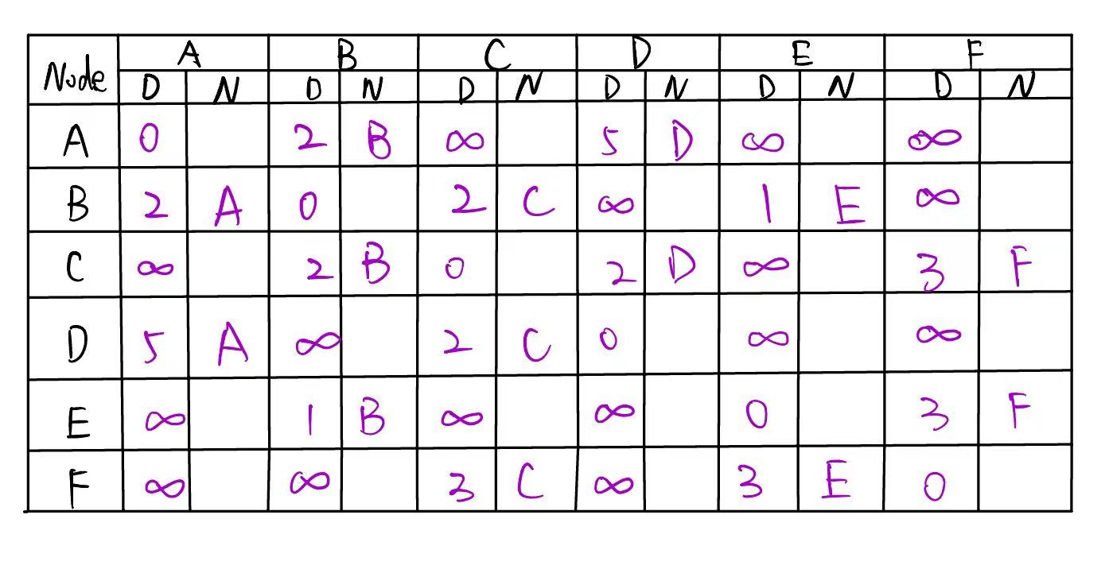 initial:

First time:

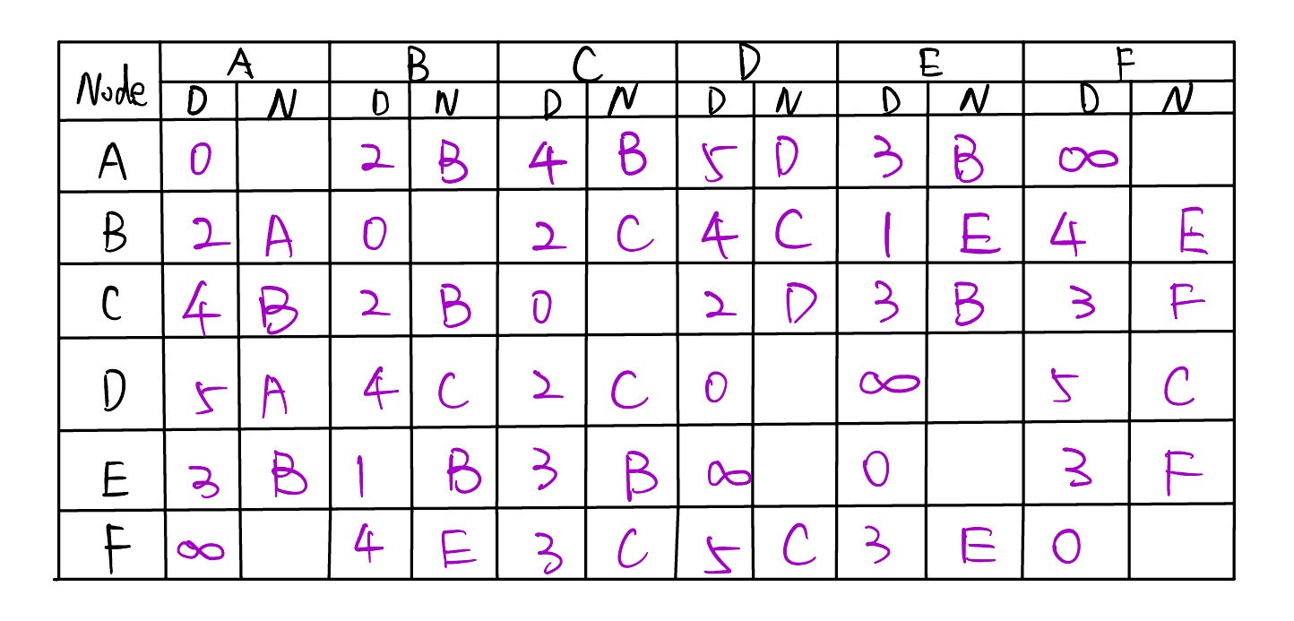

Second time:

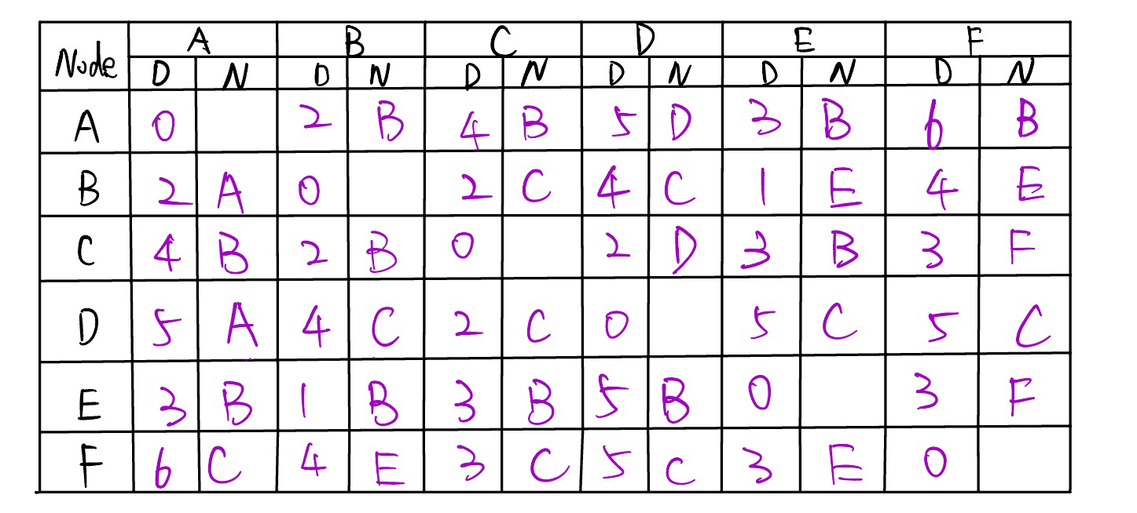

3.

Sol.

From the left part of the Table, we can find that, A connects to B and D; B connects to C and E.

From the right part of the Table, we can find that, F connects to C and E; C connects to B and D.

Above all, we can give an example network topology, shown as follows.

