4.

Sol.

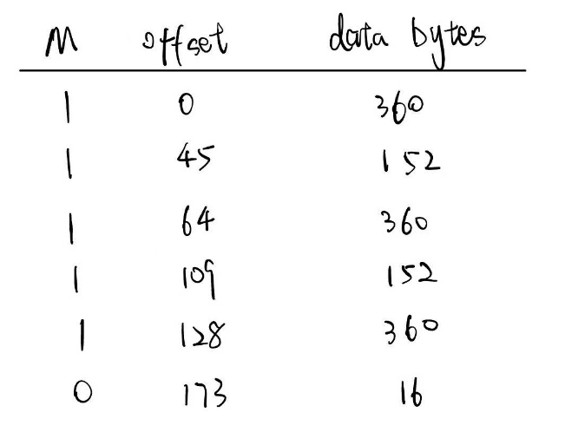(a)

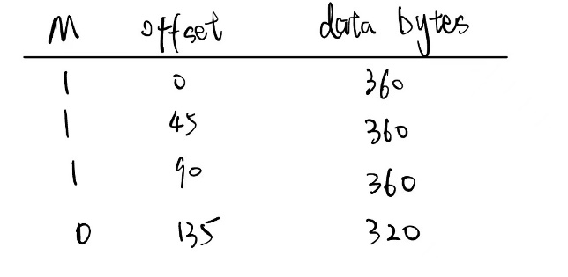(b)

5.

Sol.

The maximum bandwidth is $576×2^{16} ×8 / 60 = 4.8Mbps$.  
 If the bandwidth exceed, there will be two fragments of the different packets which share the same Ident value.

6.

Sol.

1. $\left\lceil log 75\right\rceil =7$, $\left\lceil log 35\right\rceil =6$, $\left\lceil log 20\right\rceil =5$, $\left\lceil log 18\right\rceil =5$

So Department A's subnet ID is ${\left(0\right)}_{2}$, so the IPv4 address segment is from 200.1.1.1 to 200.1.1.127

Similar to A, Department B's subnet ID is ${\left(10\right)}_{2}$, so the IPv4 address segment is from 200.1.1.128 to 200.1.1.191.

Department C's subnet ID is ${\left(110\right)}_{2}$, so the IPv4 address segment is from 200.1.1.192 to 200.1.1.223.

Department D's subnet ID is ${\left(111\right)}_{2}$, so the IPv4 address segment is from 200.1.1.224 to 200.1.1.254.

1. Because the changes, we need 6 bits to represent the Department D's hosts.

We can change Department A's hosts into 2 segments. So the solution is as follows:

A: 200.1.1.00xxxxxx and 200.1.1.111xxxxx

B: 200.1.1.01xxxxxx

C: 200.1.1.110xxxxx

D: 200.1.1.10xxxxxx

7.

Sol.

Yes.

$96={\left(01100000\right)}_{2}$

$104={\left(01101000\right)}_{2}$

$112={\left(01110000\right)}_{2}$

$120={\left(01111000\right)}_{2}$

So they can be aggregated to 57.6.96.0/19

8.

Sol.

|  |  |  |  |  |
| --- | --- | --- | --- | --- |
| Destination | Mask | Next-hop | Inter-face | Met-ric |
| 211.14.5.0 | 255.255.255.0 | 211.14.3.2 | S0 | 1 |
| 211.14.5.220 | 255.255.255.192 | 211.14.5.220 | E1 | 0 |
| 196.17.20.128 | 255.255.255.128 | 196.17.20.128 | E0 | 0 |
| 196.17.20.0 | 255.255.254.0 | 196.17.24.2 | S1 | 1 |