Algorithm of error correction
1．Kmer size and Kmer frequency
Kmer is a string of bases with specified length of K. We often use K = 17 bp, which represent all 4^17 (16 G) possible Kmers. For small genome, we can use smaller K size, and increase K size when the genome size grows. Limited by the computer memory to store Kmer frequency table, the practical Kmer size is 15, 16, 17, 18, and 19 bp, which corresponds to 1G, 4G, 16G, 64G and 256G possible Kmers and the same amount of memory (one byte for one Kmer), this can almost resolve all the genome sizes. As our main goal of error detection and correction is low-frequency Kmers, so both the odd and even Kmer size can be used, this is different from the de-bruijn-graph-method contig construction, which only use odd Kmer sizes.

Firstly, note that the memory size must be much larger than genome size, in order to represent the error Kmers, i.e, do not merge error Kmers with correct Kmers. For example, when the genome size is 3G, the maximum number of correct Kmers is 3G, considering the two strands, we need two times of memory (6G) to store these Kmer frequency, however, the number of error Kmers, which were caused by sequencing errors, will be much more than the correct Kmers, which exist in the genome. If you do not want the error Kmers to be merged significantly with the correct Kmers, this is the key factor, it is very important for the latter error correction step, we recommend at least 10 times larger memory than the number of correct Kmers. So we got a formula for choosing the memory size: Genome_size * 2 * 10, here for a mammal genome with 3G size, the required memory size should be >= 60G, so we’d better use Kmer size 18. Note that the larger the Kmer size (memory size), the better effect of the error correction function. For genome size > 12.8 Gb, we can always use Kmer size 19, however, the space to store error Kmers will be decreased, we should be very careful for these extreme huge genomes.

Genome size, range from | Kmer size selection (bp) | Memory Usage for Kmer frequency (G) | Memory Usage for error correction (G)
<= 50 Mb | 15 | 1 | 0.125
50 Mb - 200 Mb | 16 | 4 | 0.5
200 Mb - 800 Mb | 17 | 16 | 2
800 Mb - 3.2 Gb | 18 | 64 | 8
3.2 Gb - 12.8 Gb | 19 | 256 | 32

Kmer frequency, is the appearance number of Kmer in a given reads data set. The Kmer frequency distribution is possion disstribution (approximate to normal distribution). For example, if the average coverage depth is 40X, and read length 100 bp, then the peak of Kmer (K=17) frequency distribution will be 40 * (100 – 17 + 1) /100 = 33.6; This is the ideal condition. If there is sequencing errors such as 1% errors, then the peak of Kmer frequency distribution will be smaller, and we will see a lot of low-frequency Kmers (frequency < 3), which were mostly caused by the sequencing errors. The task of error correction is to remove the sequencing errors, or correct them with the help of high frequency Kmers information.

Each Kmer has two strand formats, the forward strand and the reverse strand. We take the two as one same Kmer, and store the one which has small value (convert sequence to 64-bits unsigned int value, uint64_t). We use one byte (8-bits) to store the frequency value of Kmer, range from 0~255. The Kmer-frequency-table is very large, 16G size when K=17, so we compress it by gz format to save disk space and IO time.

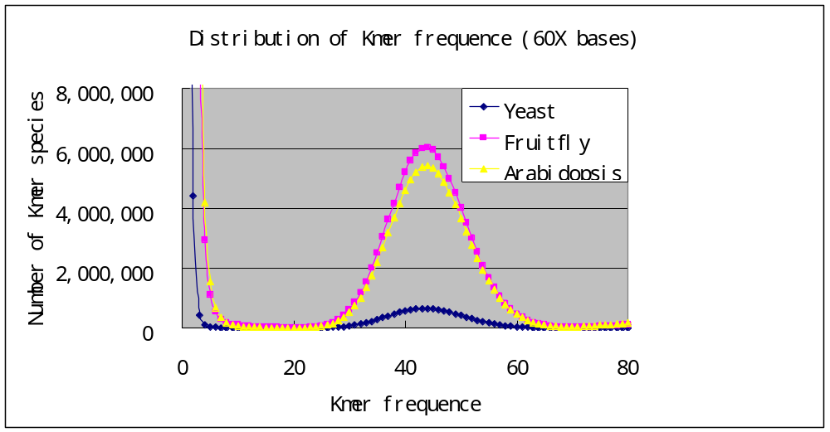
Figure. Distribution of Kmer frequency, using 60X simulated data (1% error rate) on yeast, fruitfly and Arabidopsis genome. The theoretic peak of Kmer frequency should be (L-K+1)/L*60=84/100*60=50.4; However, due to the sequencing errors, the peak moved leftward, and it is 44~45 in fact.

2. Low frequency and high frequency Kmers
The core spirit of the frequency-based error-correction method, is to identify low-frequency Kmers (mostly sequencing errors), and change them with high-frequency Kmers (mostly correct bases). A simple way is to set a cutoff, those frequency smaller than the cutoff were low-frequency Kmers, and those larger than the cutoff were high-frequency Kmers. The simple way is often the practical way. Then the most question is to choose the cutoff, for standard data set 40X depth, and with frequency peak 33.6, we can set the cutoff at 10, where is just the turning point.

In last step, we calculate the Kmer-frequency-table, one byte for a Kmer frequency, range from 0~255; To correct the sequencing errors, we only need the low-frequency and high-frequency information, and one bit is enough to represent this information, 0 for low-frequency and 1 for high-frequency. This will save much memory and also increase the speed. The low-frequency Kmers will be corrected by the high-frequency Kmers.

One question: is the low-frequency kmers always the error Kmers? In fact, there is indeed some genomic regions with low sequencing coverage depth, and so there are low-frequency Kmers, but they are real. To resolve this problem, and avoid to mis-change the base or exclude real reads, we should do some detailed works here, for example, calculate the average Kmer frequency on the whole read, or by checking the base quality given by illumine machine, to distinguish low coverage depth with sequencing errors.

Another question: is the error kmers always in low-frequency? The answer is absolutely not. One reason may be due to the limited memory (as described above), some error Kmers were randomly merged with correct Kmers, and then we see they are in high-frequency. The other reason is due to repeat sequences, error Kmers from one repeat region, tend to be merged with correct Kmers in other repeat copies. This problem get severe when the genome contains lots of repeats, for example, human and maize genome, the efficiency of error correction for reads from these repetitive genomes will be very low. However, if we consider the whole assembly process, this is not the key problem, because repeat regions are difficult to construct contig and scaffold, even if these reads do not contain sequencing errors. We have got some simulation results on model species, showing below. We simulate each mutation (as sequencing error) along the reference genome with distance 100 bp, one mutation will affect a set of Kmers crossed that site, the number of these Kmers is equal to the Kmer size. We defined low-frequency as a Kmer do not exist in the reference genome, then we calculate the ratio of low-frequency Kmers in each set, and make distribution statistics, to illustrate the difficulty of error correction for each type of genomes.

Table. Statistics of low-frequency Kmers ratio by simulation sequencing errors on the reference genomes (推荐选用K=16或17)
Genome of model species | Arabidopsis
Kmer size, (bp) | 15 | 16 | 17 | 18 | 19
Ratio of low-freq kmers in all kmers by muation | 0.60 | 0.81 | 0.92 | 0.96 | 0.98
Ratio of mutations with 100% low-freq kmers | 0.07 | 0.27 | 0.55 | 0.76 | 0.88
Ratio of mutations with >=80% low-freq kmers | 0.34 | 0.67 | 0.87 | 0.95 | 0.97
Ratio of mutations with >=50% low-freq kmers | 0.65 | 0.91 | 0.97 | 0.99 | 0.99
Ratio of mutations with >=20% low-freq kmers | 0.91 | 0.97 | 0.99 | 1.00 | 1.00
Ratio of mutations with >= 1 low-freq kmers | 0.97 | 0.99 | 1.00 | 1.00 | 1.00

Table. Statistics of low-frequency Kmers ratio by simulation sequencing errors on the reference genomes (推荐选用K=18或19)
Genome of model species | Maize
Kmer size, (bp) | 15 | 16 | 17 | 18 | 19
Ratio of low-freq kmers in all kmers by muation | 0.23 | 0.44 | 0.58 | 0.64 | 0.68
Ratio of mutations with 100% low-freq kmers | 0.00 | 0.03 | 0.14 | 0.29 | 0.39
Ratio of mutations with >=80% low-freq kmers | 0.02 | 0.19 | 0.41 | 0.51 | 0.55
Ratio of mutations with >=50% low-freq kmers | 0.15 | 0.50 | 0.63 | 0.69 | 0.70
Ratio of mutations with >=20% low-freq kmers | 0.50 | 0.68 | 0.75 | 0.78 | 0.80
Ratio of mutations with >= 1 low-freq kmers | 0.68 | 0.78 | 0.81 | 0.83 | 0.85

Table. Statistics of low-frequency Kmers ratio by simulation sequencing errors on the reference genomes (推荐选用K=17或18)
Genome of model species | Chicken
Kmer size, (bp) | 15 | 16 | 17 | 18 | 19
Ratio of low-freq kmers in all kmers by muation | 0.17 | 0.42 | 0.70 | 0.87 | 0.94
Ratio of mutations with 100% low-freq kmers | 0.00 | 0.02 | 0.11 | 0.35 | 0.65
Ratio of mutations with >=80% low-freq kmers | 0.03 | 0.14 | 0.43 | 0.78 | 0.92
Ratio of mutations with >=50% low-freq kmers | 0.12 | 0.41 | 0.81 | 0.96 | 0.98
Ratio of mutations with >=20% low-freq kmers | 0.32 | 0.71 | 0.96 | 0.99 | 0.99
Ratio of mutations with >= 1 low-freq kmers | 0.57 | 0.93 | 0.99 | 0.99 | 0.99

Table. Statistics of low-frequency Kmers ratio by simulation sequencing errors on the reference genomes (推荐选用K=18或19)
Genome of model species | Human
Kmer size, (bp) | 15 | 16 | 17 | 18 | 19
Ratio of low-freq kmers in all kmers by muation | 0.07 | 0.20 | 0.44 | 0.66 | 0.78
Ratio of mutations with 100% low-freq kmers | 0.00 | 0.00 | 0.03 | 0.13 | 0.34
Ratio of mutations with >=80% low-freq kmers | 0.01 | 0.05 | 0.16 | 0.43 | 0.66
Ratio of mutations with >=50% low-freq kmers | 0.04 | 0.16 | 0.44 | 0.75 | 0.83
Ratio of mutations with >=20% low-freq kmers | 0.15 | 0.33 | 0.73 | 0.87 | 0.90
Ratio of mutations with >= 1 low-freq kmers | 0.26 | 0.65 | 0.87 | 0.91 | 0.93

3. Read the reads and divide into continuous frequency regions
Each input raw reads file was parsed separately. For one input raw reads file, each reads was load into memory and corrected one by one. This does not require any other large memory consumption. Multiple threads can be paralleled by reading and parsing different reads sequentially in a given input file.

For a reads, we divide it into a set of continuous low-frequency Kmer region and high-frequency Kmer region, and store this information in a data structure, which have 3 elements, start position, end position, and status (0 for low-frequency and 1 for high-frequency).
typedef struct {
int start;
int end;
int status;
} FreqContReg;

4. Correct easy errors by a fast approach
The main purpose of this method is to increase the computation speed. Consider KmerSize = 17 bp, if a sequencing error occurs in middle of the reads, this will cause continuous 17 low-frequency Kmers ideally, a sequencing error in the front or back end of the reads will cause less than 17 low-frequency Kmers, and the error position can be easily and uniquely inferred. The program identified this character, and correct the errors on a specified position by testing the other 3 types of base, until get one base type that will change all the low-frequency Kmers into high-frequency Kmers.

This method is much faster than the bellowing Branch and Bound Tree method. For the sequencing errors in middle of the reads, we can always use this fast method. However, on the front and back ends of reads, this fast method will have relatively high error rates, so it is not suggested. The percent of errors that can be corrected by this method, depends on the Kmer size you chose and the repeat content in the genome. The larger Kmer size, and the less repeat content, the better effect of this fast correction method. If a continuous low-frequency Kmer region is corrected, then the status of FreqContReg is changed from 0 to 1.

5. Correct complicate errors by Branch and Bound Tree
After corrected by the above easy and fast method, the fragmental high-frequency Kmer regions were combined, and a length cutoff was set to choose confident high-frequency regions, which will be used as the start point to correct low-frequency regions. Note that the borders of the high-frequency must be accurate, else the following error correction will be failed. To achieve this, we cut out some bases (for example ~1/3 KmerSize bases) at each end of the high-frequency regions. This can increase some computation time, but it sis essential for accuracy considerations.

We correct each low-frequency regions between two high-frequency regions, if success, it was labeled, else also labeled. Then we combine the neighboring high-frequency regions whose middle low-frequency region have been corrected, and then find a max length high-frequency region to server as the starting point to correct/trim the read head and tail. The advantage here is to correct each low-frequency region separately, as read length grows day by day, this method will be more efficient.

The basic method used here is called branch and bound(分支定界) tree, not the dynamic programming (动态规划) as described in the previous program，to find a path of all high frequency Kmers with minimum changes on the raw reads. If there is alternative path with the minimum change, the program will return failure result and no correction action will be performed. There is a maximum base change allowed for one read, when the accumulated change number achieves the threshold, the program turns to trim the read at the front and back low-frequency ends. To increase the accuracy of final results, we further trimmed a Kmer/2 size length if the head or tail of read is found to have low-frequency regions and be hard to correct.

The node data structure of the branch and bound (BB) tree is showed below, with 4 elements: pointer, store the position of parental node; base, store the 2-bit base information, range 0~3; change, store the accumulated change number on the read, range 0~7; same, whether the changed base is equal or different to the raw base on the read. Each read position corresponds a layer in the BB tree, only the high-frequency Kmer is added into the tree, and path achieves maximum allowed changes were stopped. If the base is equal to the raw base, than the change value of TreeNode is not changed, else add one. In the end, we find the minimum change value node in the last layer, and trace back to the start nodes, the path of which is the corrected form.

typedef struct {
uint32_t pointer:26,base:2,change:3,same:1;
} TreeNode;

