Algorithm of scaffold linkage
1．Map PE reads onto contigs
When get the contig sequences on hand, which is generated by using the read overlap information, the next step we can do, is to link them into longer scaffolds with the pair-end (PE) information. This is the basic logic of scaffold linkage, to utilize the PE information of reads.

The ground work before scaffold linkage, is mapping pairs of reads onto contigs, and get those pairs crossing two contigs, i.e, the two reads in a pair mapped to two different contigs, which means that these two contigs may be neighbor on the same chromosome. There is various approaches to do this mapping work. You can either use the common alignment tools, such as BLAST, BLAT, MAQ, and SOAP, or develop your own pair-wise alignment softwares, based on fast suffix array and BWT algorithms. All of these algorithms and softwares are indeed workable, especially for longer and fewer reads mapping. However, currently, the illumina reads is still very short (100bp) and the amount is very large (~60X), to perform efficiently, assembly programs often use the hash and seed-extension method.

We decomposed the contig sequences into kmers, and stored the kmer and its associated contig id and position information in a hash, which uses the similar hash technology as building the kmer de bruijn graph. The data structure for a kmer node here, can be defined as below. Besides the contig id and position information for each kmer, we also use 1 bit to represent the frequency, and 1 bit to represent the strand information.

typedef struct {
uint64_t kmer;
uint64_t id:32;
uint64_t pos:30;
uint64_t freq:1; //1 unique, 0 non-unique
uint64_t direct:1; //1 forward; 0 reverse;

} KmerNode;

By this way, the memory stores the kmer hash, and the contig sequences. We compared kmers on each read against the kmers in the hash, in order to match the read to contigs. A simple and fast method used in grape, is to find a continuous exact-matching region of specified length (~35bp), if KmerSize=31, this alignment length include 5 Kmers. There is no need to compare all these 5 Kmers, but only need to compare the two border Kmers (must be overlapping), i.e. if the first and the last Kmer from a read mapped to the same contig and the distance is consistent between read and contig, we can decide the exact-matching alignment (seed-alignment). The heterozygousity and sequencing errors can be allowed automatically because the length of seed-alignment is small relative to the read length. After the seed step, we extends the alignment, calculate the alignment length and identity for the whole read, and set a cutoff to make sure effective mapping, by now, you have done an eligible alignment work. For the scaffolding purpose, only the reads in a pair that mapped to different contigs are needed to output. And read pairs with one read mapped on the contig, and the other end fall in gap (unmapped) can be used to do the gap-closure.

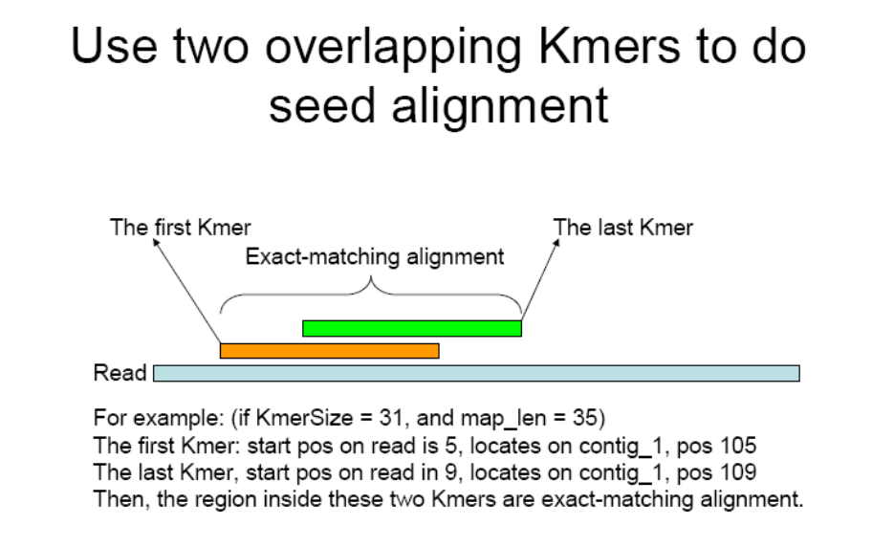

2. Build contig linkage graph
In this step, our purpose is to build a directed graph (contig graph), using contig as nodes, and the links between neighboring contigs as arcs. Then the scaffolding work will become finding a non-conflict path on this contig graph. If there are >= 3 pairs of reads crossed contig_1 and contig_2, then we set a link between contig_1 and contig_2, the direction is from 5’->3’, so we can also call this link as 3’-link. For easy, just think there is only one strand and one direction of DNA sequence, don’t consider the +/- strand problem here, discussion will be given in the next paragraph. The data structure of this directed graph is showed below, one neighboring-link(邻接链表) and one sequence array(序列数组).

vector <string> contig_seqs;

int contig_num = contig_seqs.size()

typedef struct CtgLink {
uint64_t id:30; //the 3’-linked contig id, range 1G
uint64_t freq:6; //the number of read pairs supported this link, range 63
uint64_t size:28; //the accumulated sum value of all estimated gap sizes, range 256M
CtgLink *pointer; //the pointer to next linked node
} CtgLink;

CtgLink **ctgLink = new CtgLink* [contig_num]; //二级指针，需要用两个*来定义
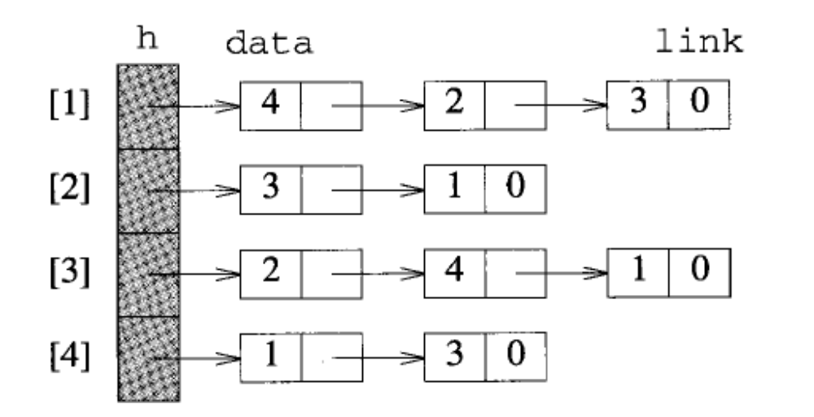
图示、邻接链表存储结构图

Now, let us calm down, and make a clear think of the strand problem. Each chromosome has two DNA strands, which has reverse and complementary relation. Note that there is only two DNA strands, all the contigs have 2 strand forms, and we can group all the contig forms into two set of sequences, each set represent one chromosome strand. If we only consider assembly on one strand, or on two strands independently, the assembly problem will become much easier. This is how we did here. We store both the forward and reverse strand contigs, set links to contigs that in the same strand. By this way, to get the scaffold sequence, you can retrieve from either one of the two strand paths, because they stored the same information.

Then, let us make clear of another question, the mapping direction of reads. This is the nature of illumina PE sequencing, read1 sequences from the forward strand, while reads sequences from the reverse strand. So when you mapped a pair of reads to the reference sequence, one read will be mapped forwardly (F), and the other read will be mapped reversely and complementarily (R). We use this character to decide the direction relations between two neighboring contigs. If the pair of reads mapped as direction F and R, then the two crossed contigs are in the same chromosome strand, else if both F or both R, the contigs are in different chromosome strands. So we can infer both the order and direction of contigs from the reads PE mapping result.
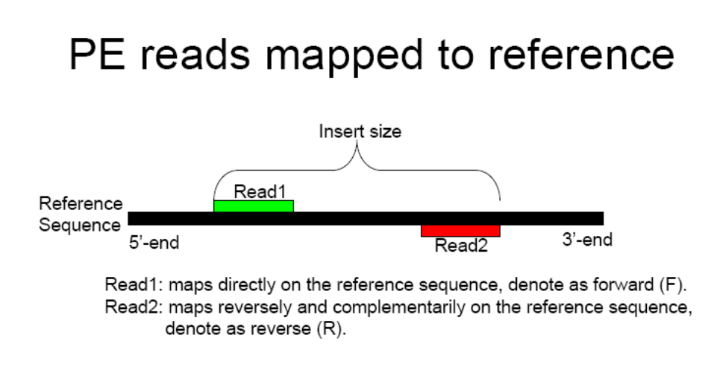
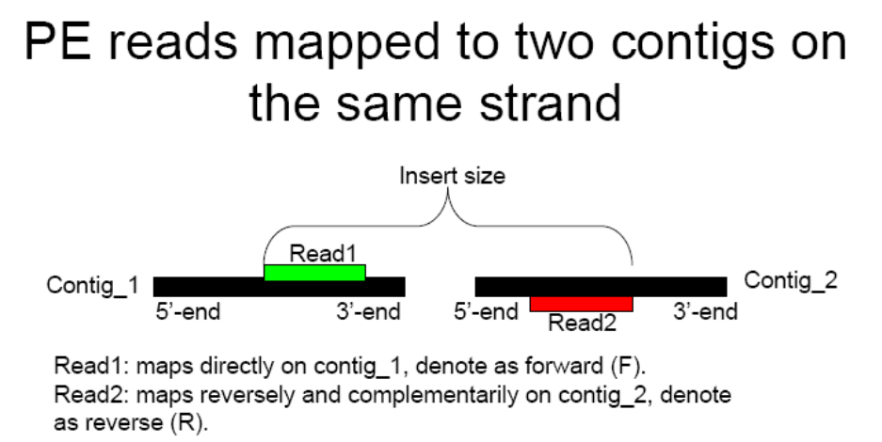

To simplify the +/- strand problem, we stored both the forward and revserse contig forms, using odd number for original contig ids, and even number for the reverse contig ids. We only set the 3’-end link for each contig node, and only contigs on the same chromosome strand will have links. The details of links and relations with PE reads mapping are showed below. Besides the links, the gap size can also be estimated from the insert size and mapping position of each read pair.

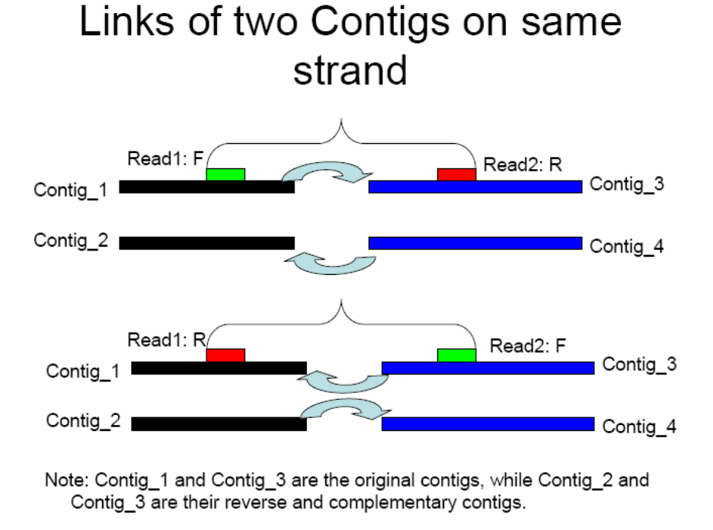

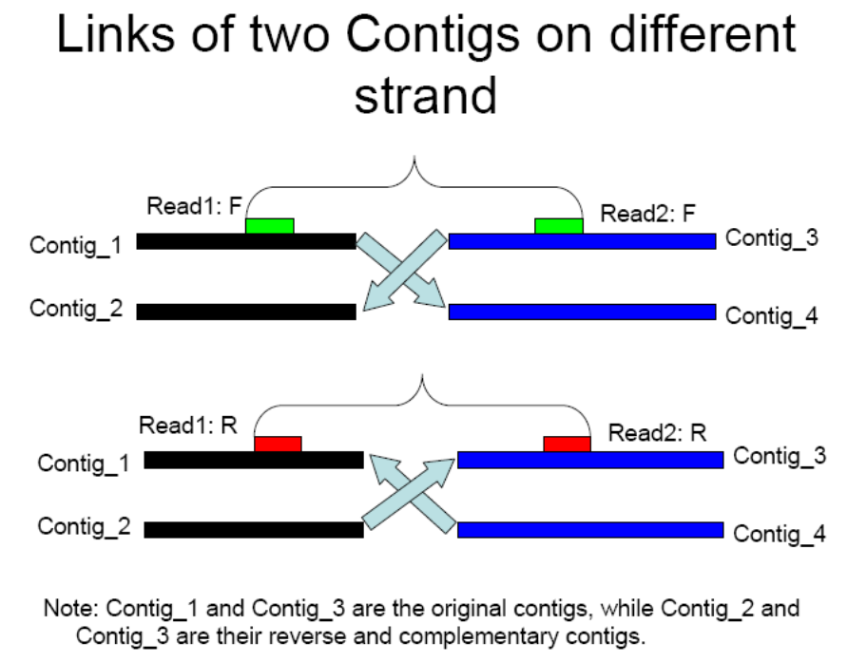
3. Get scaffold sequence
The last question, is how to get scaffold sequences from the contig graph. Before scaffolding, we should decide which links are trustable, some links will be non-real caused by random mistakes, we can remove them by requiring at least 3 or more pairs of reads support, and the insert size should be consistent with the mapped directions and positions. The pair number supporting a link should vary from insert sizes, and also related with the sequencing depth. This parameter affect the scaffold length significantly, from my experience, the larger insert size need larger pair supporting. The main purpose for choosing a suitable pair value, is to distinguish real and random links. After doing this, the graph becomes more clean, and the linear paths get longer.

In the most easy view, we may expect that the links among contigs are clean, and all the contigs are linear, with one ingoing arc and one outgoing arc, so we can conjoin the contigs along this linear path to get the final scaffold sequence. But things will never get so easy, there are two problems disturbed us, one problem is repeat sequences, which will result in branching node and links, i.e. one node have more than one ingoing or outgoing links, our approach to resolve this problem is removing (masking) the repeat contig nodes and links from scaffolding step, and at last output these single contigs as individual scaffolds. The other problem is interleaving, which will also result in branching nodes, we can solve this by iteratively scaffolding using PEs with insert size form smaller to longer. However, interleaving still can’t be avoid in any scaffolding rank, we can remove (mask) small contigs (length < 1/2 * Insert_size) firstly, and add them back in the last step.

The most simple way, is to break the scaffold at branching nodes, this will result in shorter but accurate scaffold sequences, else more complex algorithms need to be adopted to resolve the branching problem.

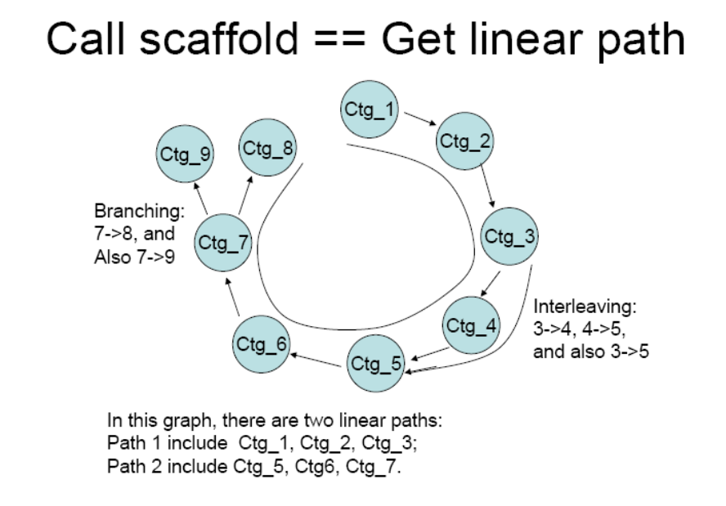

4. Compare Greedy and Optimization
Now let’s consider what is the nature of scaffolding. As the sequencing technology usually generate shorter read sequences (100-1000bp), the assembly process is often confused by repeats which length are larger than the read length. The pair-end sequencing provide a distance information between two reads, which extends the read length advantage from an alternative way, and this is greatly useful to distinguish repeats in assembly process.

Then what is the best standard of scaffolding, i.e. what result is the best scaffold result? No matter by what way you linked the contigs into scaffold, we can calculate the supported PE and conflict PE on the final scaffold sequences, the scaffold with most supported PEs and with least conflict PEs is the best scaffold result. Consider this nature, scaffolding is a optimization problem, which algorithms such as dynamic programming may be helpful. However, in reality, people often use simple algorithm such as the greedy algorithm to solve the scaffolding work, the above scaffolding method described in this document is often said to be the graph method, however, in fact, it can also be viewed as a type of greedy method, because we conjoins one contig into the scaffolds at one step, and never changed the previous decisions in latter steps. For large-scale task, this approach is practicable.

Then how about for a small task, such as BAC assembly, and extremely single gene assembly. The computing task is quite few, then complicate optimization algorithm may be used to find the best scaffold result. This is still an open question now, and hope you can contribute.

5. Use genetic or physical markers.
The pair-end (PE) reads, will provide order and direction relations of only two contigs each time. We will get more genetic and physical markers data in the future, which provide order and direction relations for several (>=2) contigs or scaffolds at a time. This is an extension of the pair-end scaffolding, and will be more powerful in constructing longer scaffold sequences.

This is still an open work now, and hope you can contribute.

