For Linux DBSCAN , the code is already in CSLINUX , and you just have to copy the commends in the commend.txt , one line by one line .

And you can see the final result here .

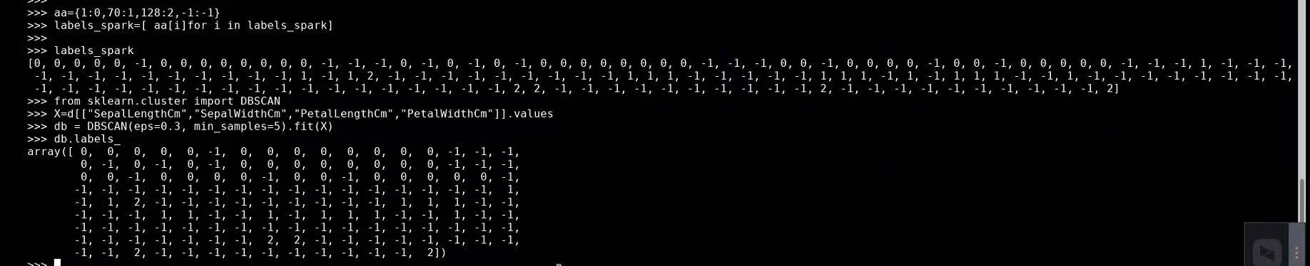

-1 means noise data (isolated points) , other numbers means cluster number . It is in a list order , from top to down .

For windows , you have to set up the environment .

The outputting process is look like this .

And the result is in the output folder , named output_1.0.csv

Open it up we can then see the result !

