# Written Section:

### 1.

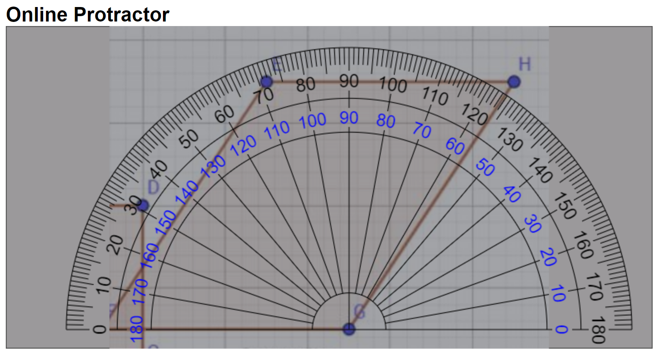

Measuring the sheared angle of the image I’ by online protractor, I find out the angle is roughly from 56.0 to 56.5 degree. So I select 56.3 degree as the sheared angle. Then the shear factor is equal to cot(56.3) (cotangent of 56.3 degree), which is roughly equal to 2/3.

Thus, the shear transformation matrix is $\left[\begin{matrix}1 & 2/3 & 0 \\ 0 & 1 & 0 \\ 0 & 0 & 1\end{matrix}\right]$

It is also easy to find out that both the width and height of the original image was scaled by 1.5, so the scale transformation matrix is $\left[\begin{matrix}1.5 & 0 & 0 \\ 0 & 1.5 & 0 \\ 0 & 0 & 1\end{matrix}\right]$

Finally, we find out the image I’ has moved in 1.5 in x-axis and 0.5 in y-axis, so the translation matrix is $\left[\begin{matrix}1 & 0 & 1.5 \\ 0 & 1 & 0.5 \\ 0 & 0 & 1\end{matrix}\right]$

Composing the three transformation matrices, we get:

$\left[\begin{matrix}1 & 2/3 & 0 \\ 0 & 1 & 0 \\ 0 & 0 & 1\end{matrix}\right]\left[\begin{matrix}1.5 & 0 & 0 \\ 0 & 1.5 & 0 \\ 0 & 0 & 1\end{matrix}\right]\left[\begin{matrix}1 & 0 & 1.5 \\ 0 & 1 & 0.5 \\ 0 & 0 & 1\end{matrix}\right]$ = $\left[\begin{matrix}1.5 & 1 & 1.5 \\ 0 & 1.5 & 0.5 \\ 0 & 0 & 1\end{matrix}\right]$ corresponds to $\left[\begin{matrix}a & b & 1.5 \\ c & d & 0.5 \\ 0 & 0 & 1\end{matrix}\right]$

Hence, we conclude:

$\left[\begin{matrix}a & b \\ c & d\end{matrix}\right]$ = $\left[\begin{matrix}1.5 & 1 \\ 0 & 1.5\end{matrix}\right]$

### 2.

Transforming J from Image I’ back to Image I, use the inverse of the above transformation matrix.

$${\left[\begin{matrix}1.5 & 1 \\ 0 & 1.5\end{matrix}\right]}^{−1}=\left[\begin{matrix}2/3 & −4/9 \\ 0 & 2/3\end{matrix}\right]$$

The original J in the Image I is:

$$\left[\begin{matrix}2/3 & −4/9 \\ 0 & 2/3\end{matrix}\right]\left[\begin{matrix}4 \\ 2\end{matrix}\right]=\left[\begin{matrix}16/9 \\ 4/3\end{matrix}\right]$$

The bilinear interpolation formula is g(x,y) = ax + by + cxy + d:

Plug M (1,1):

30=a+b+c+d

Plug L (2,1):

18=2a+b+2c+d

Plug K (2,2):

10=2a+2b+4c+d

Plug I (1,2):

4=a+2b+2c+d

Solve the above equation:

We get:

A=-30

B=-44

C=18

D=86

Finally, calculate the intensity of J as:

G(x,y) = $\frac{16}{9}$ a+ $\frac{4}{3}$ b+ $\frac{64}{27}$ c+d= $\frac{50}{3}$