AIWC(O): 26 AUG – 04 OCT 19

PROJECT REPORT: IDENTIFICATION OF STRIKE AND NON-STRIKE FORMATIONS (AIR FORCE AND NAVY) USING MACHINE LEARNING

Team Members

Flt Lt Ananya Tiwari
Sub Lt Ashwin Jayaprakash
Acknowledgements

- The project for Identification of strike and non-strike formations using machine learning (with python) is inspired from the need for an improved Early Warning System for defence forces to infer upon a conclusion for a strike formation. This will help higher authorities to take faster decisions for optimum utilization of military resources to ensure security of the nation.

2. We are thankful to Wg Cdr S Sivakumar, CO, IW School and all other faculty members of IW School for their extended support throughout the project. Our heartfelt gratitude to Wg Cdr Shubhendu, CI, for being our guiding light for the entire course of the project from the scratch. We are sincerely thankful to him for showing his confidence in us and thus teaching the values of hard work in principle.

3. Our special thanks to the entire faculty members for their untiring support and for making themselves available throughout the course during non-working hours at the cost of their personal commitments.

BRIEF CONTENTS

Sl No. | Subject | Page No.
1. | Introduction | 4
2. | Aim | 4
3. | Team Members | 4
4. | Scope | 4
5. | Analysis of problem statement | 4
6. | Methodology | 5
7. | Transfer Learning | 5
10. | Implementation | 6
11. | Limitations | 7
12. | Conclusions | 10
13. | References | 12

IDENTIFICATION OF STRIKE AND NON-STRIKE FORMATIONS (AIR FORCE AND NAVY) USING MACHINE LEARNING

1. Aim. The aim of our project is to classify images of satellite/radar based surveillance images for identification of strike formations using machine learning. The scope of this project includes preparation of a dataset of images for various strike and non-strike formations of Indian Air Force and Indian Navy, training the machine on this dataset and predicting the outcome whether it’s a strike formation or not. The project can be extended to include various other satellite images of drones, helicopters, mid-air and mid-ocean refuelling, oil rigging ships, missile systems and inputs from IACCS (Indian Air Force), marine and ocean surveillance systems (Indian Navy) and surveillance radars of Indian Army for training and prediction of desired results.

2. Members. The members of the project are:-
(a) Flt Lt Ananya Tiwari 48 Wg, IAF
(b) Sub Lt Ashwin Jayaprakash DIW IN

3. Scope. The automatic classification of ships and aircrafts from aerial images is a considerable challenge.Previous works have usually applied image processing and computer vision techniques to extract meaningful features from visible spectrum images in order to use them as the input for traditional supervised classifiers. We present a method for determining if an aerial image of visible spectrum is a strike formation or not for IAF and IN. The proposed architecture is based on Convolutional Neural Networks (CNN),and it combines neural codes extracted from a CNN with a k-Nearest Neighbor method so as to improve performance. Several CNN models have been configured and evaluated in order to seek the best hyperparameters,and the most suitable setting for this task was found by using MobileNet a small and versatile CNN model derived from the much larger ImageNet and then applying transfer learning on that model. A new dataset composed of images with more than 3000 samples derived from open source have also been created to train and evaluate our architecture. The experimentation shows a success rate of over 79% for our approach, which can be improved with an improved collection of high quality images in large numbers for our dataset. A dataset of images(MWPU VHR-10)used in previous works was additionally used to evaluate the proposed approach.Our best setup achieves a success ratio of 86% with these data, significantly outperforming previousstate-of-the-art ship classification methods

4. Analysis. Projects like classification of objects in optical remote sensing have been an active research field for decades and continues to attract increasing interest. These systems are important for surveillance in both civil and defence sector. In defence sector, these surveillance and security systems directly contribute to the enhanced security of the nation for both offensive and defensive strategic planning. A wide variety of sensors are already in use for these tasks like the Vessel Monitoring System (VMS) and the Synthetic Aperture Radar (SAR), images in a visible spectrum, as well as hyperspectral imaging acquired by Observation Satellites.

5. The technical advances of visible spectrum sensors have made it possible to obtain images with more spatial resolution than those obtained with SAR. In contrast to SAR, many satellites are equipped with them, such as SPOT, RedEye, LandSat, QuickBird, and CBERS, among others. The proposed work consequently focuses on researching how to improve the accuracy of the classification process, while the requirements of real-time object monitoring in satellite imagery are accomplished.

6. We present an approach based on Convolutional Neural Networks (CNN) for the automatic classification of aircraft and naval vessels in a strike formation from optical aerial imagery acquired in the visible spectrum. The proposed method can also be applied to the classification of images in a real time video acquired from different satellites and radars in order to increase prediction. This approach classifies ships as well as aircrafts in portions (224×224 pixels) of images (as of now downloaded form open source media ). Another contribution of this work is preparation of a dataset of optical aerial images that contains more than 3000 samples of correctly labeled and classified into four classes. In summary, the main contributions of this work are:

(a) A learning-driven architecture for detecting if an image contains a strike formation (of aircraft or ship) or not, trained to detect these type of objects in a generic way. In order to improve the performance, the proposed architecture uses a CNN for extracting features (neural codes) which are eventually classified using a kNN algorithm. Different fine-tuning strategies have also been evaluated for training several CNN models.

(b) A comparison between the proposed architecture, classical and state-of-the-art works, including some of the most common CNN topologies. The proposed method outperforms the performance of previous approaches, both using a reference database and the dataset compiled in this work.

7. Methology. The project involves the following steps:
- Dataset Preparation. One of the pivotal point of our project was creating a dataset for our project. Since the dataset required for our project includes confidential images, we had to prepare our own data set of open source relevant images. Even then preparing a model completely from scratch was not feasible as that would require training set in magnitude of thousands. Therefore, we used the technique of transfer learning in which the final layers of a created model is modified in order to cater for new, previously unseen categories. This approach helped us to reduce the requirement of images substantially and now each category of image requires only about 300 images each. These images were categorised into strike and non-strike formations for Indian Air Force and Indian Navy respectively. Our dataset was consequently divided into mutually exclusive sub-sets, maintaining the percentage of samples for each class. For each fold, we used one of the partitions for validation (20%of samples) andthe rest for training (80%). The classifier was trained epoch value as 10 (which indicates no. of traversals in the directory) using these sets, after which the averageresults were calculated.With all data science problems, formatting the data correctly will determine the success or failure of the project. I separated the data into training, validation, and testing sets with a 50%, 25%, 25% split and then structured the directories as follows:
/datadir
/train
/class1
/class2
.
.
/valid
/class1
/class2
.
.
/test
/class1
/class2
.
.
- Number of training images by category. We have used 4 categories for the categorization of our predictions ………………………………….
- As another bit of data exploration, we can also look at the size distribution.
- Distribution of average image sizes (in pixels) by category. Imagenet models need an input size of 224 x 224 so one of the preprocessing steps will be to resize the images. Preprocessing is also where we will implement data augmentation for our training data.

- Image Preprocessing. This is the most important step of working with image data. During image preprocessing, we simultaneously prepare the images for our network and apply data augmentation to the training set. Each model will have different input requirements. For our purpose, we figure out that our images need to be 224x224 and normalized to a range. To process an image in Python, we use transforms , simple operations applied to arrays. The validation (and testing) transforms are as follows:
- Resize
- Center crop to 224 x 224
- Convert to a tensor
- Normalize with mean and standard deviation
The end result of passing through these transforms are tensors that can go into our network. The training transformations are similar but with the addition of random augmentations.
- Pre-Trained Models for Image Recognition.
- Loading MobileNet. MobileNet was downloaded from Keras and the layers were enumerated. However the final layer was deactivated and our own defined layers were added which consist of a dense layer with 2 classes threat and non threat. This was carried out for both Air Force and Navy.

- Predicting labels. Then through directory traversal the testing images were run through a load_image() custo defined function and the resulting tensor was then used to make the prediction.

- Evaluation Metrics. In order to analyse the images the false positives were mapped to generate accuracy for prediction.

- Hyperparameters Evaluation. Both size and image quality may have an impact on the performance of the deep learning techniques used. In order to determine how the image size could affect our models, we performed exhaustive experimentation by means of rescaling the input images to sizes ranging from 32×32 pixels to 512×512 pixels. This scaling was used rather than square crop because cropping may remove information that is relevant to our task. This experiment allows us to verify that the optimal range of input size matches that of the other CNN topologies evaluated, which is set to 224×224 pixels. Furthermore, as previously mentioned, some images underwent transformations in order to generate new data and increase the training dataset. Data augmentation increases the performance.

- With our data in shape, we next turn our attention to the model. For this, we’ll use a pre-trained convolutional neural network. Python has a number of models that have already been trained on millions of images from 1000 classes in Imagenet. We have used a smaller version of ImageNet by the name of MobileNet.

- Then, we add on our own custom classifier with the following layers:

- Fully connected with ReLU activation, shape = (n_inputs, 256)
- Dropout with 40% chance of dropping
    - Fully connected with log softmax output, shape = (256, n_classes)
import torch.nn as nn# Add on classifier
model.classifier[6] = nn.Sequential(
nn.Linear(n_inputs, 256),
nn.ReLU(),
nn.Dropout(0.4),
nn.Linear(256, n_classes),
nn.LogSoftmax(dim=1))
When the extra layers are added to the model, they are set to trainable by default ( require_grad=True ). For the VGG-16, we’re only changing the very last original fully-connected layer. All of the weights in the convolutional layers and the the first 5 fully-connected layers are not trainable.
# Only training classifier[6]
model.classifierSequential(
(0): Linear(in_features=25088, out_features=4096, bias=True)
(1): ReLU(inplace)
(2): Dropout(p=0.5)
(3): Linear(in_features=4096, out_features=4096, bias=True)
(4): ReLU(inplace)
(5): Dropout(p=0.5)
(6): Sequential(
(0): Linear(in_features=4096, out_features=256, bias=True)
(1): ReLU()
(2): Dropout(p=0.4)
(3): Linear(in_features=256, out_features=100, bias=True)
(4): LogSoftmax()
)
)
The final outputs from the network are log probabilities for each of the 100 classes in our dataset. The model has a total of 135 million parameters, of which just over 1 million will be trained.
# Find total parameters and trainable parameters
total_params = sum(p.numel() for p in model.parameters())
print(f'{total_params:,} total parameters.')
total_trainable_params = sum(
p.numel() for p in model.parameters() if p.requires_grad)
print(f'{total_trainable_params:,} training parameters.')135,335,076 total parameters.
1,074,532 training parameters.
- Moving Model to GPU(s). One of the best aspects of PyTorch is the ease of moving different parts of a model to one or more gpus so you can make full use of your hardware. Since I’m using 2 gpus for training, I first move the model to cuda and then create a DataParallel model distributed over the gpus:
# Move to gpu
model = model.to('cuda')
# Distribute across 2 gpus
model = nn.DataParallel(model)
(This notebook should be run on a gpu to complete in a reasonable amount of time. The speedup over a cpu can easily by 10x or more.)
- Training Loss and Optimizer. The training loss (the error or difference between predictions and true values) is the negative log likelihood (NLL). (The NLL loss in PyTorch expects log probabilities, so we pass in the raw output from the model’s final layer.) PyTorch uses automatic differentiation which means that tensors keep track of not only their value, but also every operation (multiply, addition, activation, etc.) which contributes to the value. This means we can compute the gradient for any tensor in the network with respect to any prior tensor.What this means in practice is that the loss tracks not only the error, but also the contribution to the error by each weight and bias in the model. After we calculate the loss, we can then find the gradients of the loss with respect to each model parameter, a process known as backpropagation. Once we have the gradients, we use them to update the parameters with the optimizer. (If this doesn’t sink in at first, don’t worry, it takes a little while to grasp! This powerpoint helps to clarify some points.)The optimizer is Adam, an efficient variant of gradient descent that generally does not require hand-tuning the learning rate. During training, the optimizer uses the gradients of the loss to try and reduce the error (“optimize”) of the model output by adjusting the parameters. Only the parameters we added in the custom classifier will be optimized.
The loss and optimizer are initialized as follows:
from torch import optim# Loss and optimizer
criteration = nn.NLLLoss()
optimizer = optim.Adam(model.parameters())
With the pre-trained model, the custom classifier, the loss, the optimizer, and most importantly, the data, we’re ready for training.
- Training. Model training in python, the basic pseudo-code is as follows:
- Transforming input. Images were converted as a numpy array for processing in Keras. The images were converted to grayscale first for dimensionality reduction of the resulting tensor. The images were then assigned a numerical label based on the directory they were present in file.

- We can continue to iterate through the data until we reach a given number of epochs. However, one problem with this approach is that our model will eventually start overfitting to the training data. To prevent this, we use our validation data and early stopping.

- As expected, the training loss only continues to decrease with further training. The validation loss, on the other hand, reaches a minimum and plateaus. At a certain epoch, there is no return (or even a negative return) to further training. Our model will only start to memorize the training data and will not be able to generalize to testing data.

- Without early stopping, our model will train for longer than necessary and will overfit to the training data.

- Another point we can see from the training curves is that our model is not overfitting greatly. There is some overfitting as is always be the case, but the dropout after the first trainable fully connected layer prevents the training and validation losses from diverging too much.

- Making Predictions: Inference. In the notebook I take care of some boring — but necessary — details of saving and loading PyTorch models, but here we’ll move right to the best part: making predictions on new images. We know our model does well on training and even validation data, but the ultimate test is how it performs on a hold-out testing set it has not seen before. We saved 25% of the data for the purpose of determining if our model can generalize to new data.Predicting with a trained model is pretty simple. We use the same syntax as for training and validation. When diagnosing a network used for object recognition, it can be helpful to look at both overall performance on the test set and individual predictions.
for data, targets in testloader:
log_ps = model(data)
# Convert to probabilities
ps = torch.exp(log_ps)ps.shape()(128, 100)

# Find predictions and correct
pred = torch.max(ps, dim=1)
equals = pred == targets# Calculate accuracy
accuracy = torch.mean(equals)

- Model Results Here are two predictions the model nails:

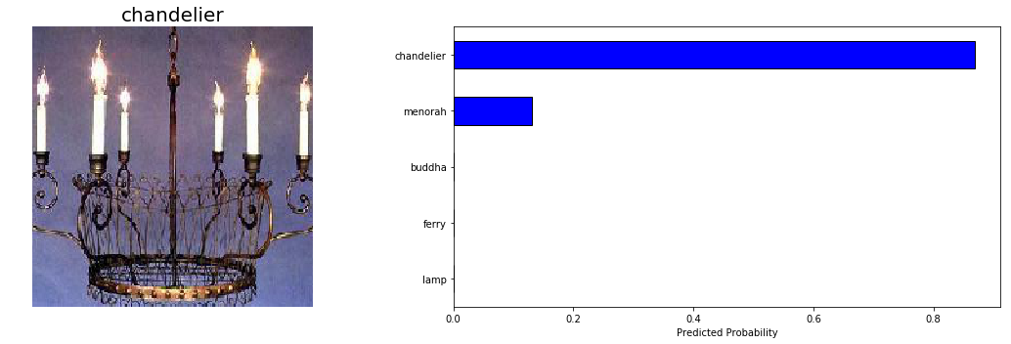

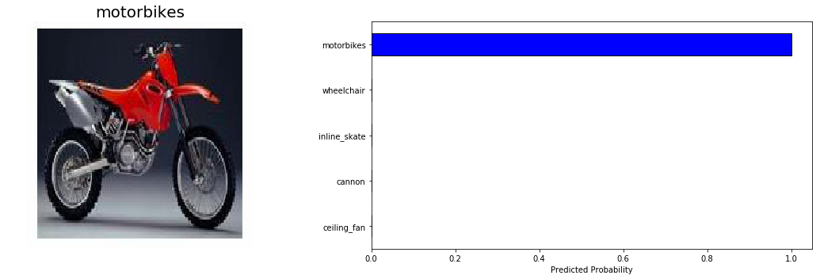

We don’t just want to focus on the correct predictions and we’ll take a look at some wrong outputs shortly. For now let’s evaluate the performance on the entire test set. For this, we want to iterate over the test DataLoader and calculate the loss and accuracy for every example.
Convolutional neural networks for object recognition are generally measured in terms of topk accuracy. This refers to the whether or not the real class was in the k most likely predicted classes. For example, top 5 accuracy is the % the right class was in the 5 highest probability predictions. You can get the topk most likely probabilities and classes from a PyTorch tensor as follows:
top_5_ps, top_5_classes = ps.topk(5, dim=1)
top_5_ps.shape(128, 5)
Evaluating the model on the entire testing set, we calculate the metrics:
Final test top 1 weighted accuracy = 88.65%
Final test top 5 weighted accuracy = 98.00%
Final test cross entropy per image = 0.3772.
These compare favorably to the near 90% top 1 accuracy on the validation data. Overall, we conclude our pre-trained model was able to successfully transfer its knowledge from Imagenet to our smaller dataset.

- Model Investigation. Although the model does well, there’s likely steps to take which can make it even better. Often, the best way to figure out how to improve a model is to investigate its errors (note: this is also an effective self-improvement method.)Our model isn’t great at identifying crocodiles, so let’s look at some test predictions from this category:

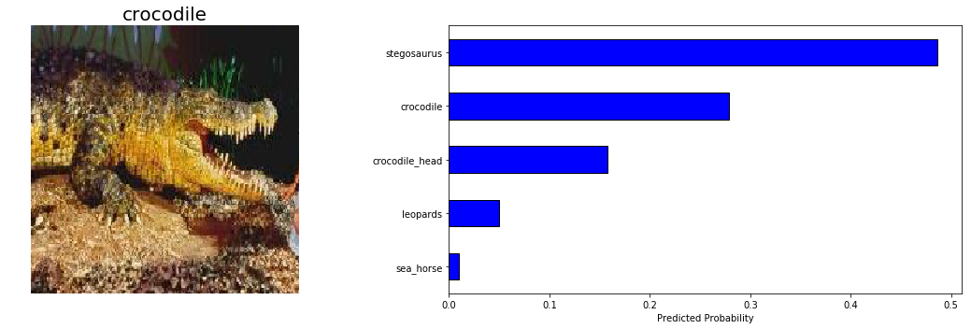

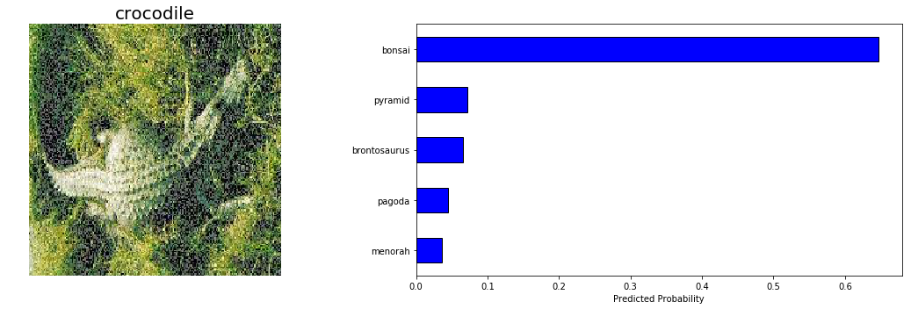

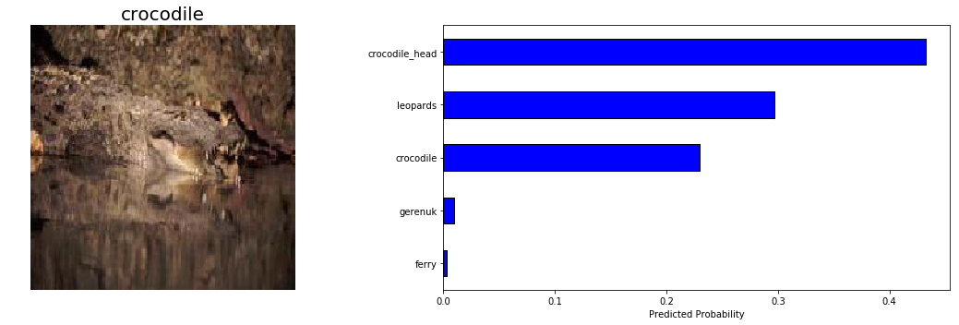
Given the subtle distinction between crocodile and crocodile_head , and the difficulty of the second image, I’d say our model is not entirely unreasonable in these predictions. The ultimate goal in image recognition is to exceed human capabilities, and our model is nearly there!
Finally, we’d expect the model to perform better on categories with more images, so we can look at a graph of accuracy in a given category versus the number of training images in that category:
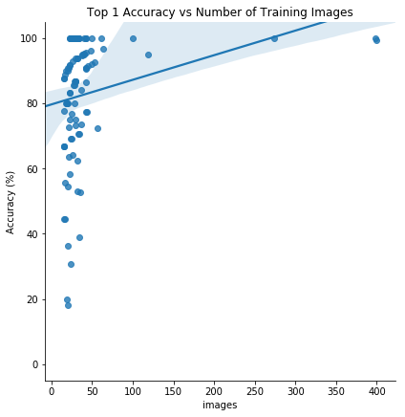
There does appear to be a positive correlation between the number of training images and the top 1 test accuracy. This indicates that more training data augmentation could be helpful, or, even that we should use test time augmentation. We could also try a different pre-trained model, or build another custom classifier. At the moment, deep learning is still an empirical field meaning experimentation is often required!

8. Transfer Learning with Machine Learning. The basic premise of transfer learning is to take a model trained on a large dataset and transfer its knowledge to a smaller dataset. For object recognition with a CNN, we freeze the early convolutional layers of the network and only train the last few layers which make a prediction. The idea is the convolutional layers extract general, low-level features that are applicable across images — such as edges, patterns, gradients — and the later layers identify specific features within an image such as eyes or wheels. Thus, we are using a network trained on unrelated categories in a massive dataset (MobileNet) and apply it to our own problem because there are universal, low-level features shared between images.
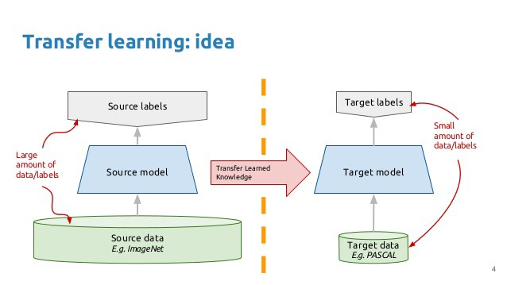
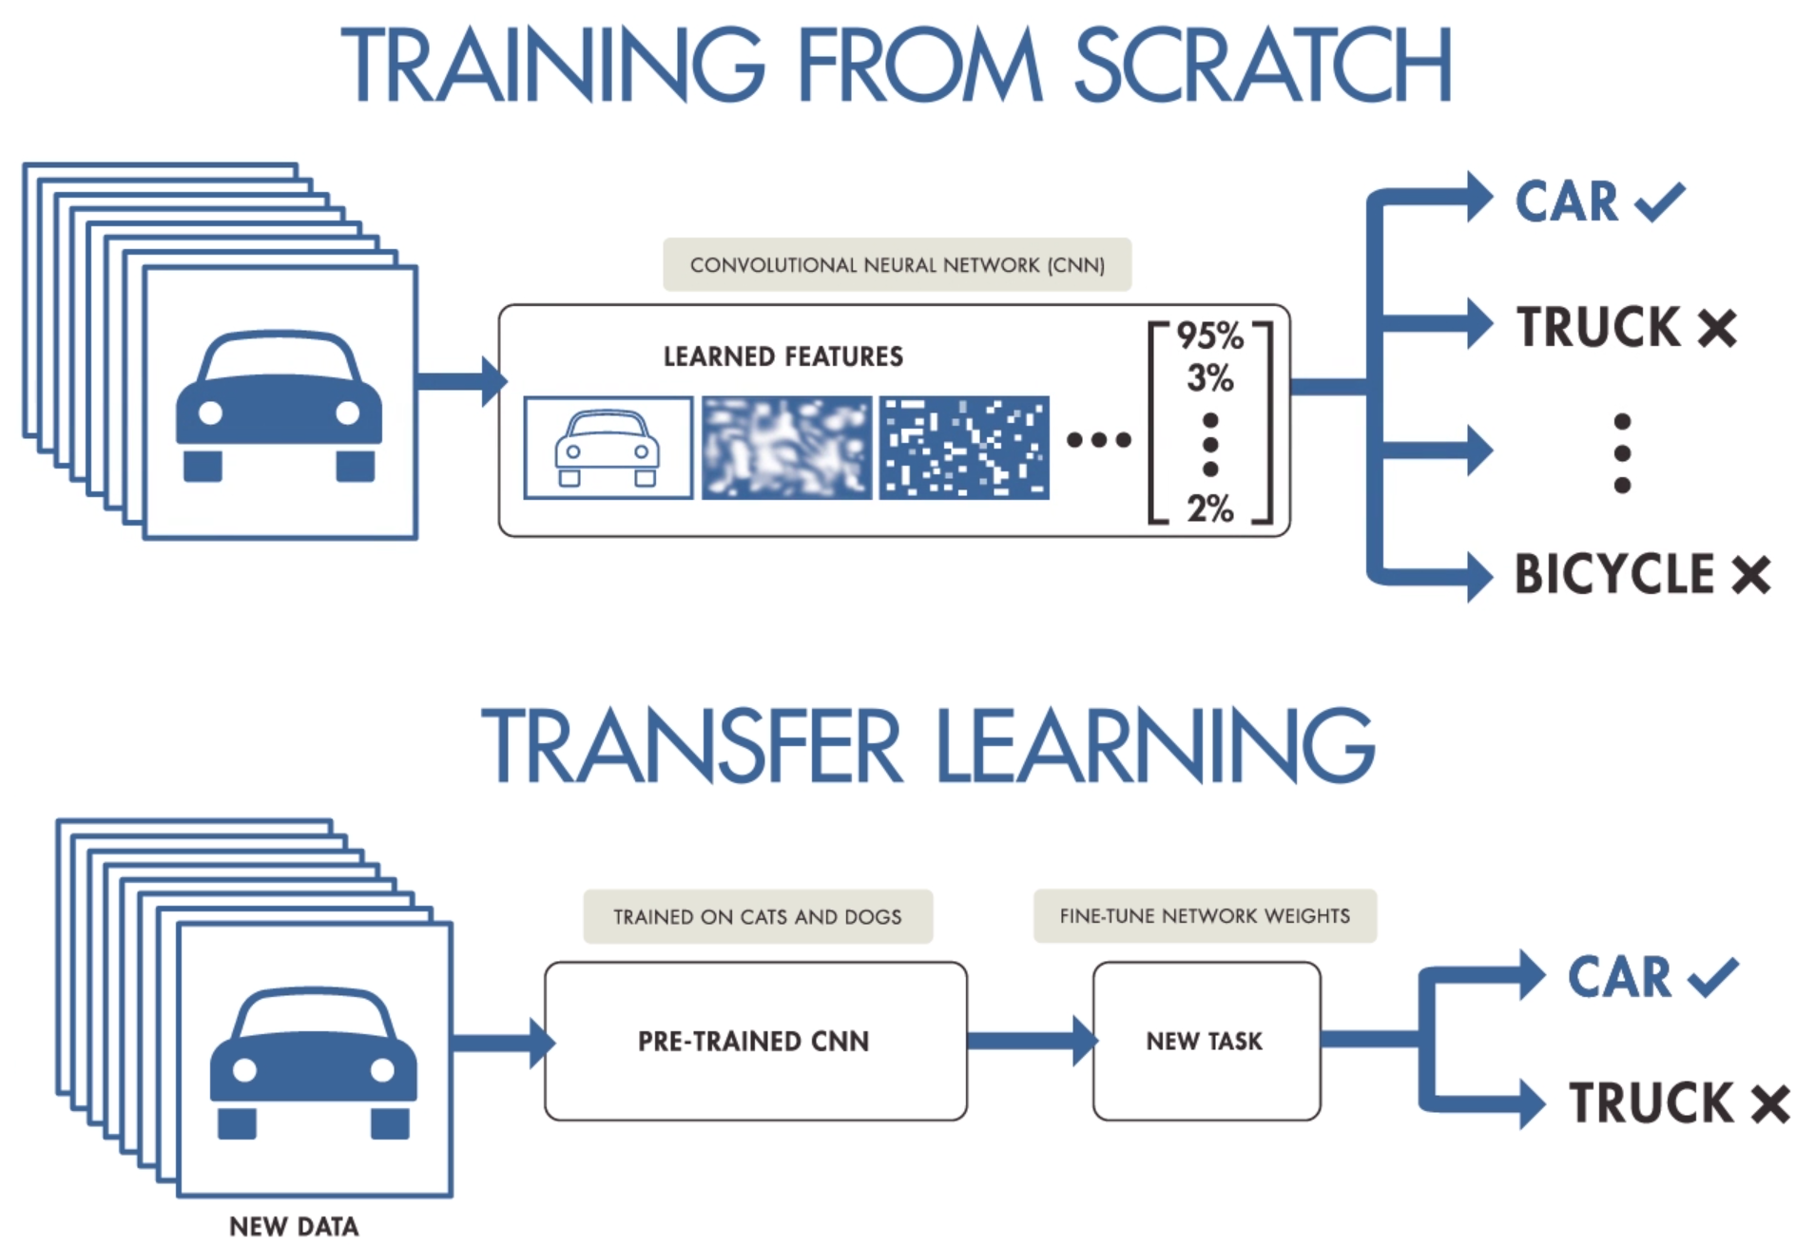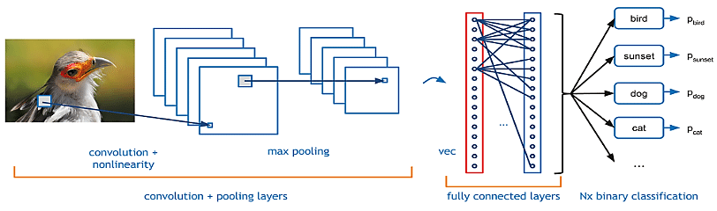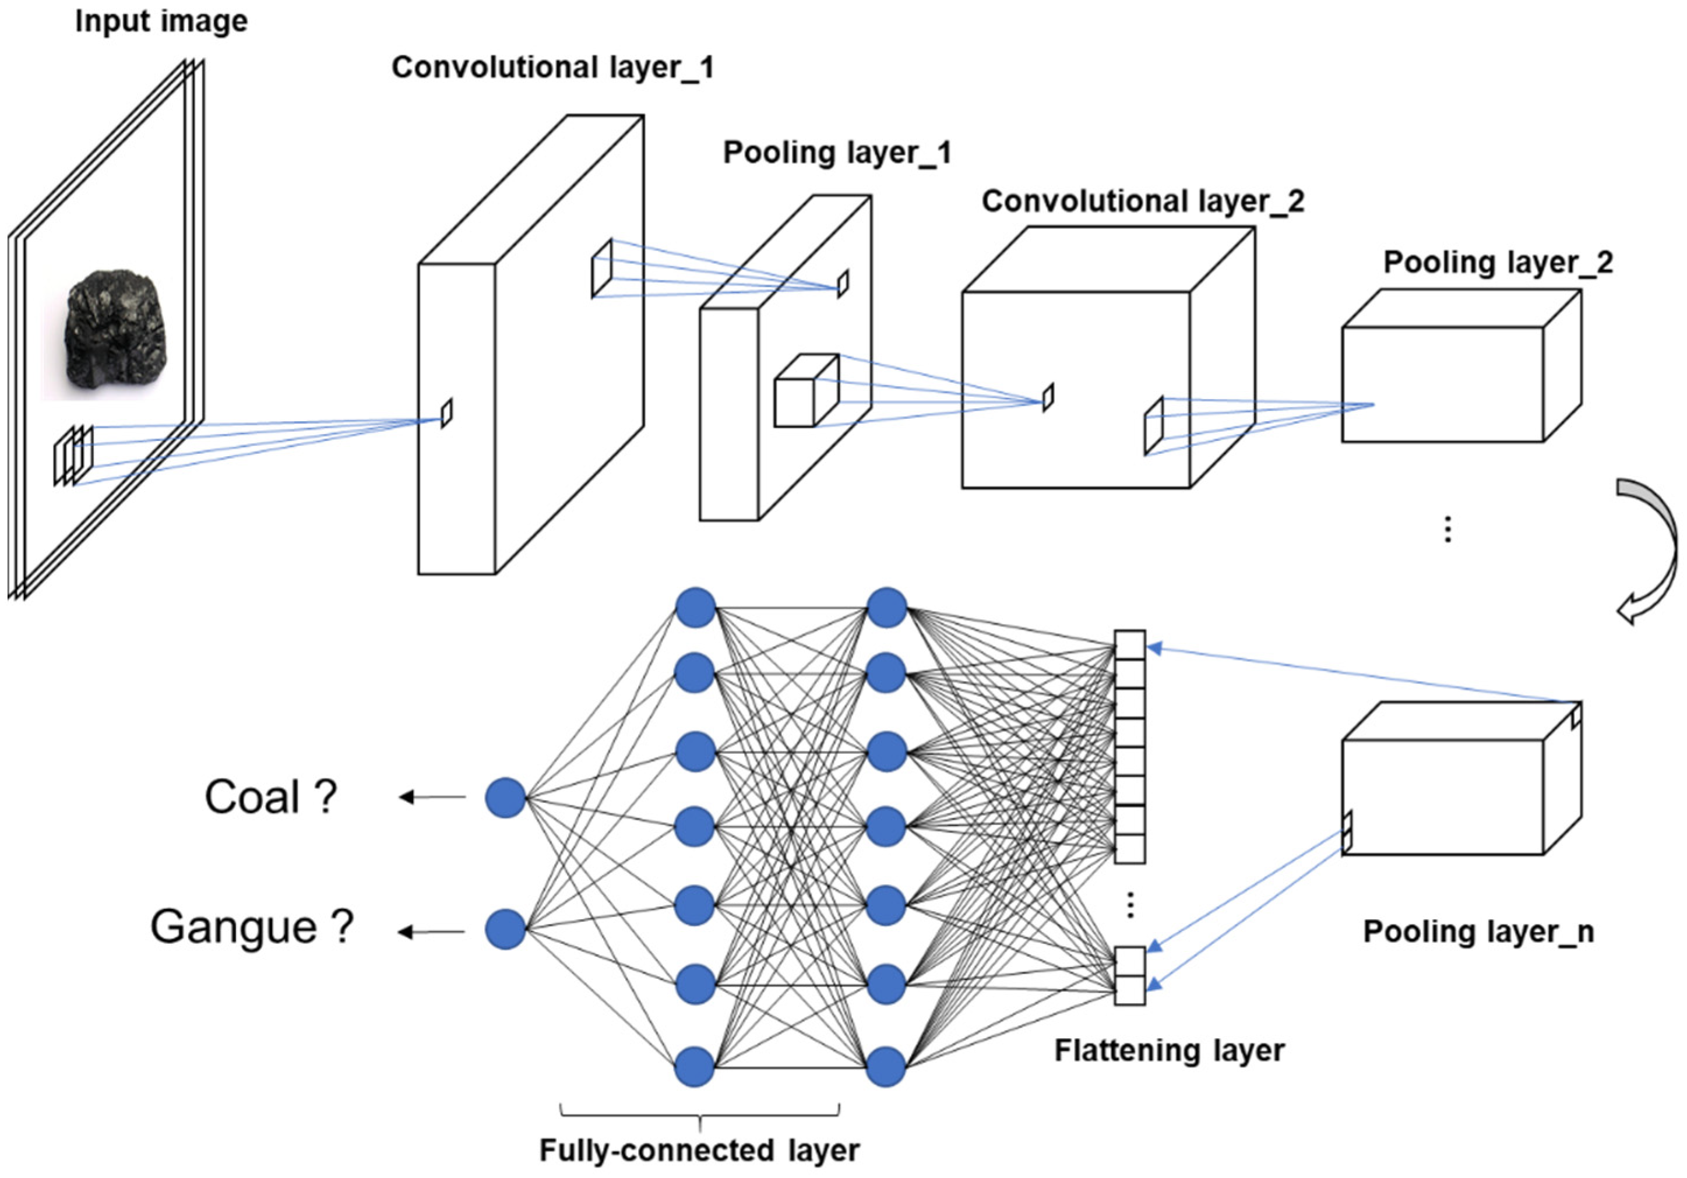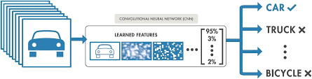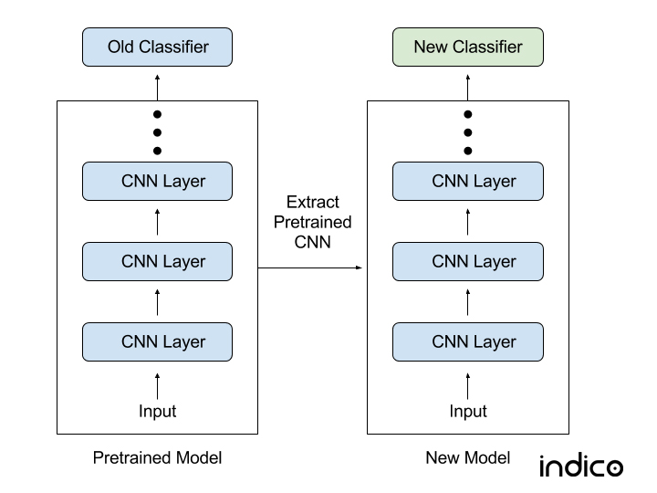
9. Implementation. The project can be used to predict various situations apart from strike and non stike formations. The project can be extended to include various other satellite images of drones, helicopters, mid-air and mid-ocean refuelling, oil rigging ships, missile systems and inputs from IACCS (Indian Air Force), marine and ocean surveillance systems (Indian Navy) and surveillance radars of Indian Army for training and prediction of desired results.

10. Limitations. The major limitation in good predication outcomes for machine learning is the collection of data set. The set needs to be constantly updated and maintained in different categories for different types of classifications.

11. Conclusion.
While there are easier deep learning libraries to use, the benefits of PyTorch are speed, control over every aspect of model architecture / training, efficient implementation of backpropagation with tensor auto differentiation, and ease of debugging code due to the dynamic nature of PyTorch graphs. For production code or your own projects, I’m not sure there is yet a compelling argument for using PyTorch instead of a library with a gentler learning curve such as Keras, but it’s helpful to know how to use different options.
Through this project, we were able to see the basics of using PyTorch as well as the concept of transfer learning, an effective method for object recognition. Instead of training a model from scratch, we can use existing architectures that have been trained on a large dataset and then tune them for our task. This reduces the time to train and often results in better overall performance. The outcome of this project is some knowledge of transfer learning and PyTorch that we can build on to build more complex applications.
We truly live in an incredible age for deep learning, where anyone can build deep learning models with easily available resources! Now get out there and take advantage of these resources by building your own project.

As always, I welcome feedback and constructive criticism. I can be reached on Twitter @koehrsen_will or through my personal website willk.online.

12. References

