Class: [C1]

Computer Science/Software Engineering Programme

Sino-British Collaborative Education

CDUT

**Web Application Development Final Project**

Date: [2022/1/2]

Student number: [201918010407]

**List** **of** **Contents**

i. Cover Page

ii. List of Contents

1. Introduction

1.1. Purpose of the project

2. Accessibility measures

2.1. Accessibility measures

2.2. Intended users

2.3. Any additional accessibility features

3. Mobile phone user adaptation 3.1. Changes

3.2. The means

4. Test for both of functionality and accessibility

4.1. Test plan

4.2. Results

4.3. Fixes

5. JavaScript Framework Implementation

5.1. How to modify the site to work within this framework

5.2. What difference it would make to implementation ofthe site

6. Conclusion

7. Reference

1. **Introduction**

**1.1.Purpose of the project**

The project is a platform for discussion and debate. The platform allows users to discuss topics of interest and respond to their claims. Users register and log in to use the site, express their opinions on the site, and enhance their debating and expression skills. This article will cover the student forum in terms of accessibility measures, changes to the mobile user adaptation program,and tests the project with test records, as well as the implementation of the JavaScript framework.

1. **Accessibility measures**

**2.1.Accessibility measures**

There are 25 ways to improve accessibility( Lembree,D.,2016). Eleven have been completed in this project. The first is consistent layout and structure. The banner, navigation and sidebar sidebar should appear in the same place throughout the site. They should also be labeled identically, such as using the same heading structure. The second is to use page titles to provide a consistent structure for HTML documents. The third is the correct use of headings, confusion without headings and skipping titles. The fourth is that linked content still makes sense out of context.

The fourth is to use the title attribute sparingly. The fifth is to highlight links (visually) as they gain focus. This indicates to the eye keyboard user where they are on the page. The sixth is to make progressive enhancement (PE) more feasible by separating content, style (or presentation) and behavior through the use of HTML, CSS and JavaScript. Progressive enhancement allows websites to elegantly degrade over older browsers and technologies. The seventh is the list using the list element. Number eight is not using only color to pass color. The ninth is the correctly labeled data table. Number 10 is the use of easy-to-understand language for cognitively impaired and non-native speakers. Number eleven is to use a variety of methods to test the usability of your website.

**2.2.Intended users**

The site is designed to provide a platform for any user who wants to debate and discuss. It can not be accepted by the majority of disabled people, but users with mobility difficulties, cognitive impairment, color blindness and other users can use it.

**2.3.Any additional accessibility features**

There are nine accessibility features that can be attached

The first is to add alternative text to images,The Alt attribute of the image element provides a literal description of the image. Alt text can be used to access the "content" of images when they are not visible, such as blind users, search engines, disabled images, and broken links.

The second is that you can skip links. For example, a "skip" link is a special type of anchor link that moves the cursor from one area of the page to another. It is very beneficial to keyboard users, allowing them to skip chunks of content and links.

The third is to inform the user if a link is not opened in the default way, that is, outside of a web page in the same browser window. Includes links to open in a new window, links to non-HTML files such as PDF and video files. One or more methods should also be used depending on the type of disability and browser support.

The fourth is to keep the underline, mainly because such links are still visible to color-blind users.

The fifth is to make the Web form accessible by labeling the field. Most sections are already marked, so simply append the label element to the associated text. Give the field a unique ID and reference that ID through the for attribute of the label element.

The sixth is that many people don't use a mouse. Some assistive technologies rely on keyboard input or virtual keyboards rather than mouse or pointer devices. For this reason, links should not be required to be mouse-only. To comply with the standards, the link should be an A element with an href attribute.

The seventh is to add ARIA Landmark Roles. Barrier-free Rich Internet Applications (ARIA) is a relatively new W3C specification that provides a way to make modern applications accessible to assistive technologies

The eighth is to add enough color contrast to ensure benefits for low vision and color blind users. The ninth is to use ARIA Live Regions to alert users to dynamic changes in content on a web page.

The ninth is to provide text for all audio, and simultaneous captions should also be provided for video and multimedia content to help users who are deaf or hard of hearing.

1. **Mobile phone user adaptation**

**3.1.Changes**

The adaptive system of this project is not perfect, which means that the system cannot adjust itself according to the changes of the environment to achieve the best or at least the allowable characteristics and functions in the new or changed environment. It does not have such adaptive ability to environmental changes. This can be done either by changing the hardware (processing circuits) or the software (program control). The former designs the circuit according to the mathematical model of the algorithm, while the latter makes the mathematical model of the algorithm into a program and realizes it by computer.

**3.2. The means**

Commonly used adaptive algorithms are zeroing algorithm, steepest descent algorithm, LMS algorithm, RLS algorithm and various blind equalization algorithm. There are many ways to do this. Give two examples. In the first case, the mobile phone and computer are on the same server, and the Wlan connection address of the mobile phone is changed to the IP address of the computer. The second can install the computer with its own IIS, IIS and then fill in and select the site name, the default application pool, will "start 32-bit application Settings" is true, and finally turn off the firewall

1. **Test for both of functionality and accessibility**

**4.1.Test plan**

This test plan is to test the functions of the web page several times, and record the test results in the form of table and text. The final goal is to find the problems in the project and modify the existing problems to achieve the perfect use of the website

**4.2. Results**

**4.2.1. login and register**

To register, users need to enter username and password, and confirm password.

If the entered password is different from the confirmed password, an error message is displayed.

Table1:register page

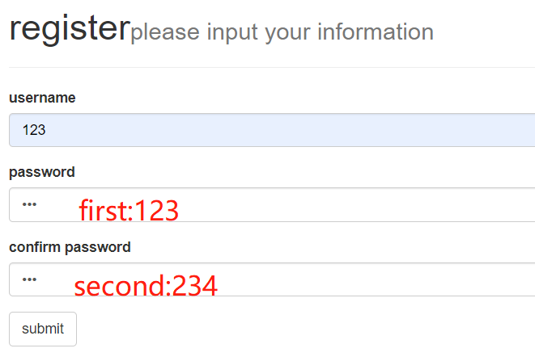

Table 2 : error message is displayed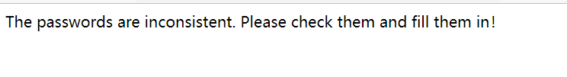

To log in, users need to enter a user name and password that exists in the database.

Five data store in database

|  |  |  |  |
| --- | --- | --- | --- |
| id | username | password | Successful? |
| 1 | Username1 | 123 | yes |
| 2 | Username2 | 123a | yes |
| 3 | Username3 | @123 | yes |
| 4 | Username4 | Cjm20080901 | yes |
| 5 | Username5 | 123A | yes |

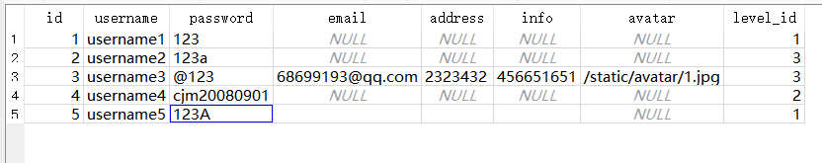Table 2.database page about user information

If input password or username not in the database,an error message is displayed.

Table 3:If put wrong username in login page.

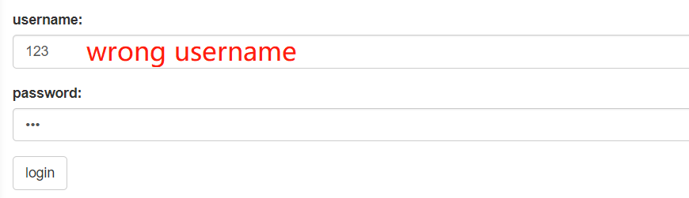

Table 4: error message is displayed

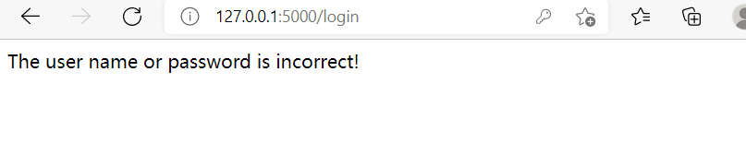**4.2.2.Functions about topics claims and replies**

Users can view other users' Topics and claims on the page and successfully create their own topics and claims

Table5:Create a new topic

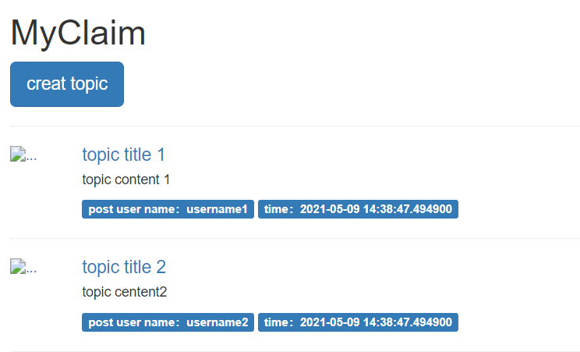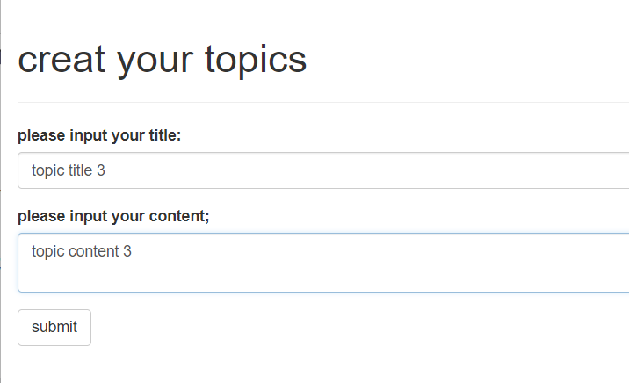

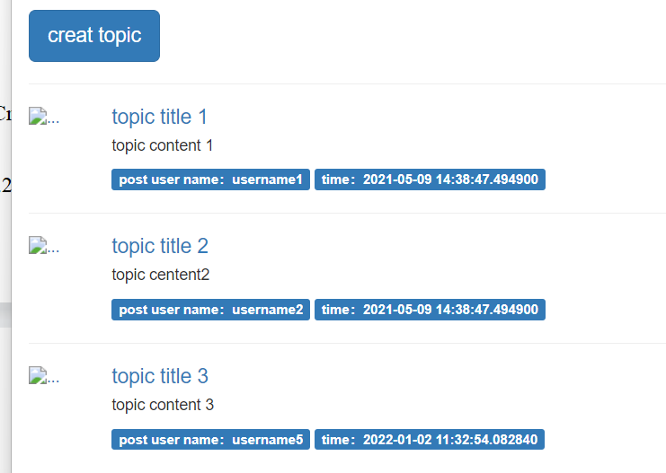

Table6:Create a new claim

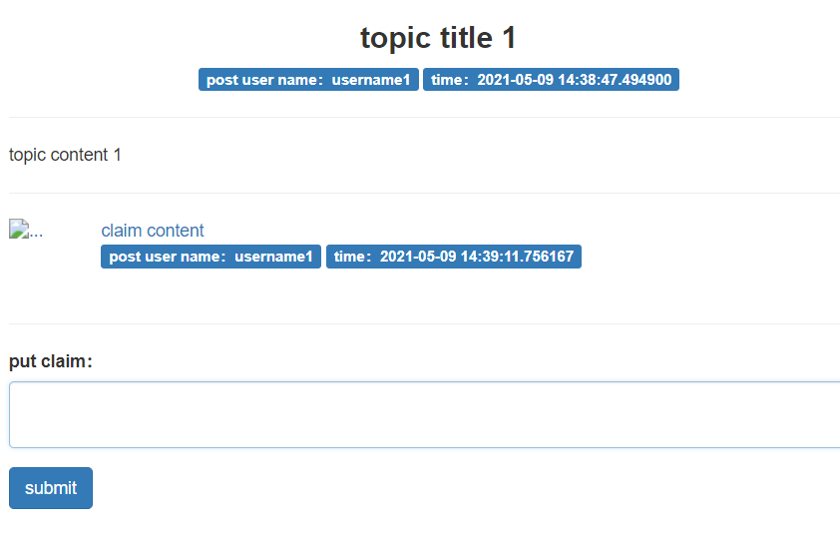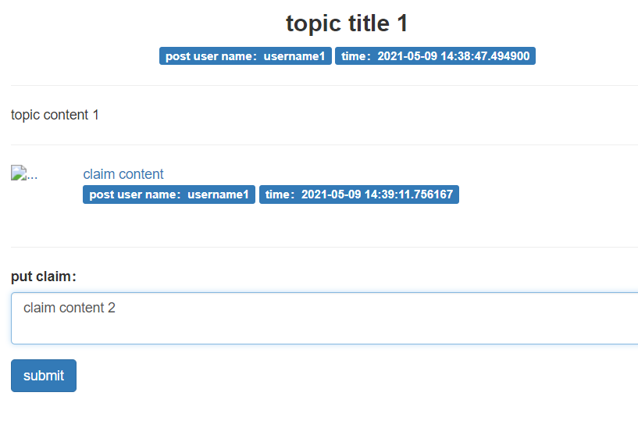

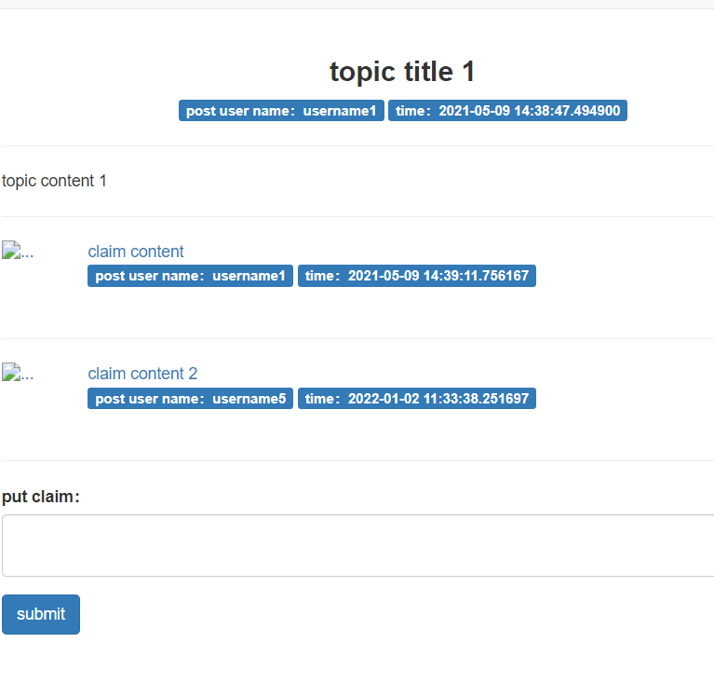

If user click claims , can go to reply page .But can’t create a reply to claim page .

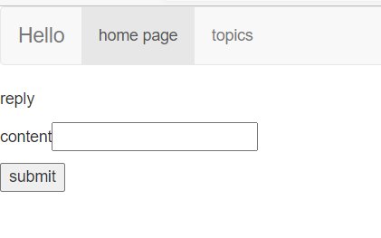Table7:Reply page is not complete success. 

**4.2.3.As the page size changes, the banner and navigation in the page can adapt to the size**

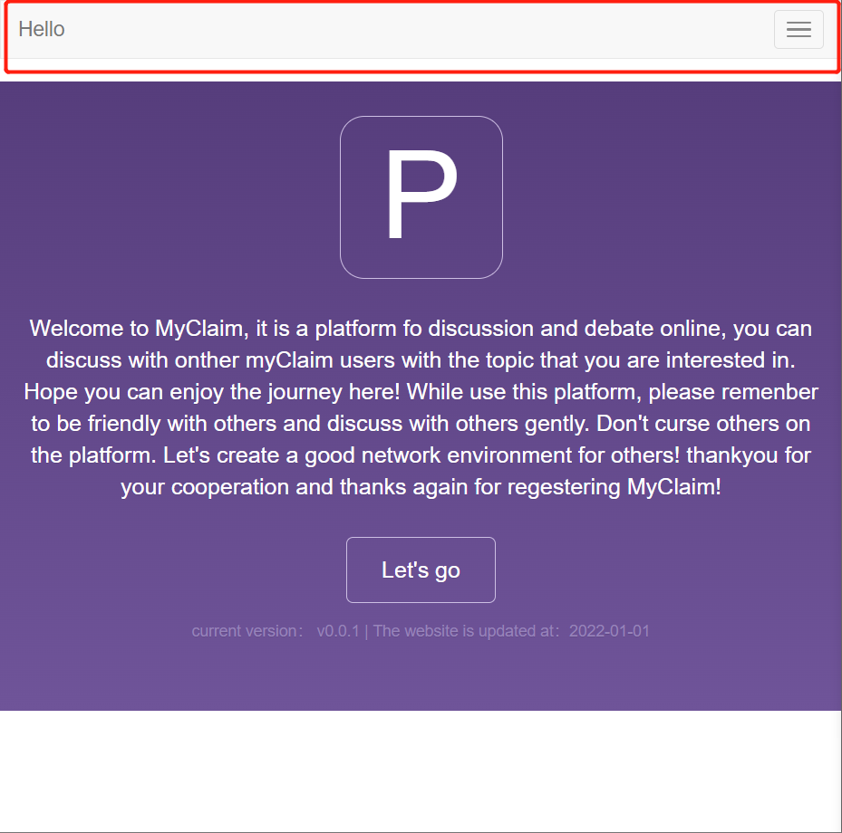Table8:Different size of web page

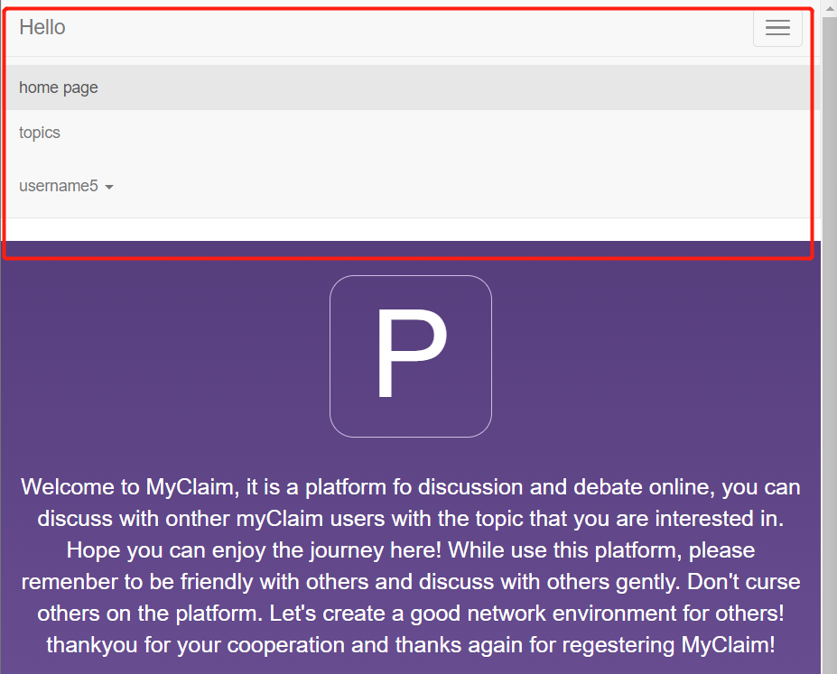

**4.2.4.The administrator has the right to delete topics published by other users and conduct a collation.**

Table9:Administrator successfully deleted topics posted by other users

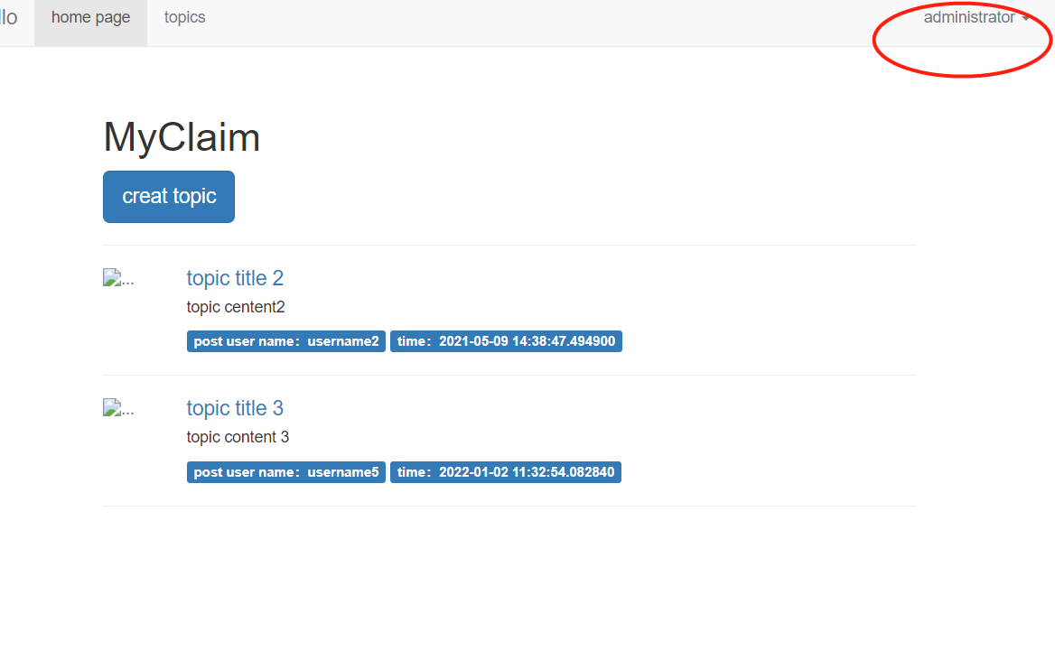

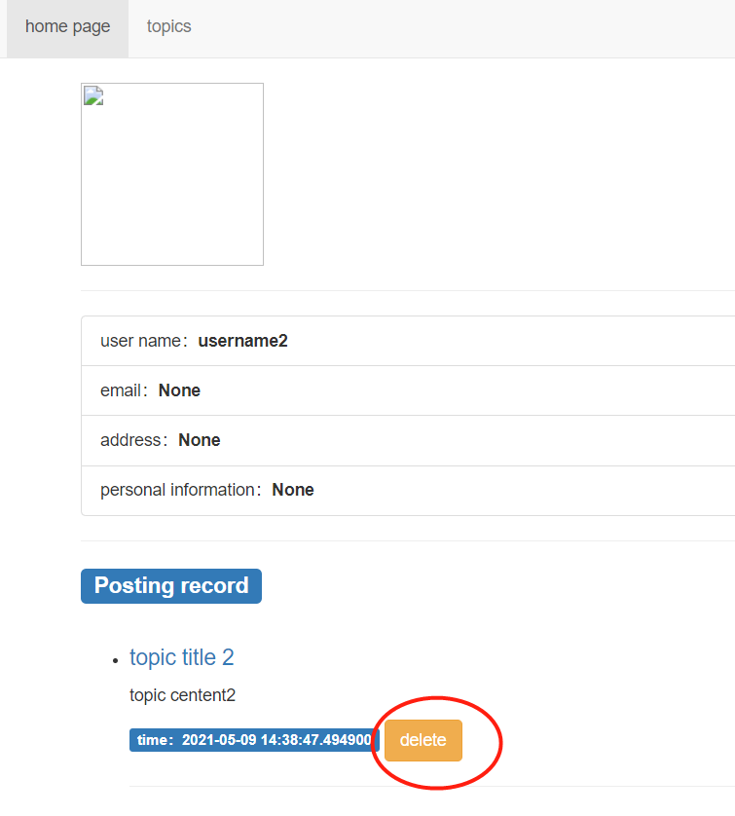

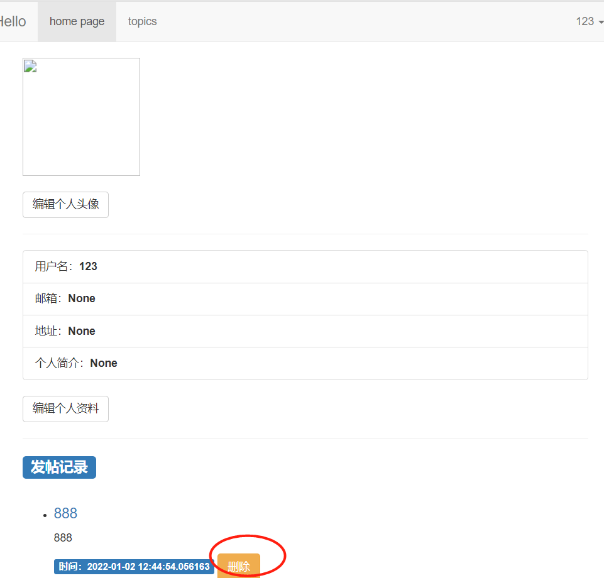However, a bug was found in the verification process. If users who did not publish this topic log in, the function of deleting this topic can also be realized.

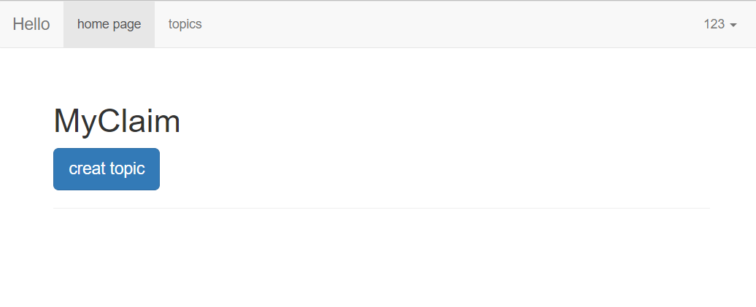Table 10:User successfully deleted topics posted by other users

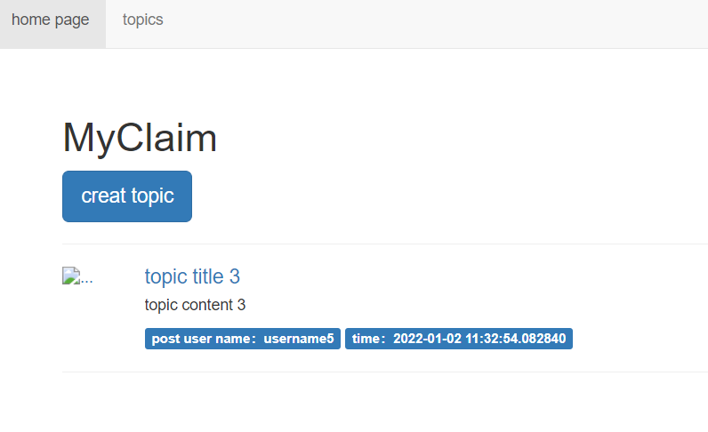

**4.3. Fixes**

The content in the input tag in Reply has always been None. Modify it later and check the assignment carefully so that the function can be used normally.The second bug is probably due to the fact that the front end user_detail. HTML is written properly so that only publishers can see the deleted A tag and the administrator can delete it, but the administrator can't see the delete button

1. **JavaScript Framework Implementation**
   1. **How to modify the site to work within this framework**

Serialized data is returned in the view method of the /homepageRecommend route, and json is deserialized in the front end using Jquary. The front-end sends requests using.get() or.get() or.post() methods. The back-end returns JSON data using json.dumps(dict) and converts json data into JS objects using eval() in JS.

* 1. **What difference it would make to implementation of the site**

Bootstrap, for example, has many templates that can be directly called for beautification. For example, in a homepage, you can reference the drop-down list in the homepage and put everything in the navigation bar in the drop-down list. This saves space occupied by many pages and increases the utilization rate of page space

1. **Conclusion**

This report focuses on Accessibility measures, Mobile phone user adaptation, Test for both of Functionality and accessibility and JavaScript Framework Implementation introduce the existing functions of this project. Accessibility and adaptability and room for improvement. In the future, this project can focus on mobile phone and continue to improve compatibility functions, fix existing bugs, and realize the expectation of compatibility between web pages and mobile phones

**7. Reference**

Dennis E. Lembree. (2016)*25 Ways To Make Your Website Accessible.*

Available at: https://www.webhostingsearch.com/articles/25-ways-to-make-your-site-more-accessible.php. (Accessed: 1 January 2021).