Assignment 2

As a student at the University of Windsor, I pledge to pursue all endeavours with honour and integrity and will not tolerate or engage in academic or personal dishonesty. I confirm that I have not received any unauthorized assistance in preparing for or writing this assignment. I acknowledge that a mark of 0 may be assigned for copied work.

Wen Dong #110057395

**Task #1 and #2**

1. The source code

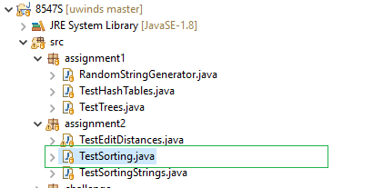

1. Output of the java file looks as below:

Testing sorting 100,000 random numbers for 100 times:

Algorithsm Avg time(ms)

Mergesort 71

Quicksort 50

Heapsort 75

dual-pivot 70

1. Comments:

From the results, we can see all the four sort algorithms perform at a same decent time complexity level, compliant with the time complexity we learned form class, which is O(n log n)

**Task #3 and #4**

1. The corresponding source code as below

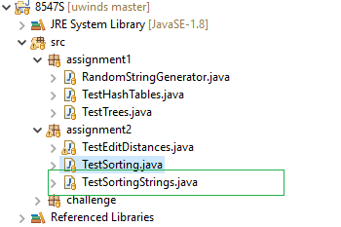

1. Output of the java file looks like the table below:

Testing sorting 100000 random strings for 100 times:

Avg time(ms) | 4 6 8 10

------------------------------------------------------

Mergesort | 148 134 131 126

Quicksort | 104 101 101 106

Heapsort | 175 186 220 190

dual-pivot | 109 117 129 121

Radixsort | 96 126 233 212

It shows each algorithm’s average time of sorting 100000 random strings respectively of length 4, 6, 8, and 10.

1. Comment:

According to the results, I will choose Radix sort for sorting strings of small length (<=4), as its performance excels in that case. On the other hand, for lengthy strings sorting I prefer Quick sort and Dual-pivot quick sort, as they outperform in that scenario, moreover, they conduct the sorting process in place while Merge sort requires additional space.

**Task #5**

1. The corresponding source code as below

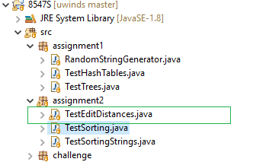

1. Output of the java file looks like the table below:

Calculating Edit Distance for 1000 pairs of random strings:

Pairs StrLen Avg time(ns)

1000 10 18275

1000 20 43044

1000 50 63136

1000 100 168248

1. Comments:

The implementation of the Edit Distance solution is of time complexity O(nm) according to what we learnt from the class, and the testing results can roughly reflect that, it will be more clear if we increase the testing times to a larger number, like 100,000

Calculating Edit Distance for 100000 pairs of random strings:

Pairs StrLen Avg time(ns)

100000 10 3715

100000 20 9052

100000 50 35039

100000 100 141366