Assignment 2

As a student at the University of Windsor, I pledge to pursue all endeavours with honour and integrity and will not tolerate or engage in academic or personal dishonesty. I confirm that I have not received any unauthorized assistance in preparing for or writing this assignment. I acknowledge that a mark of 0 may be assigned for copied work.

Wen Dong #110057395

**Task #1**

1. Source code

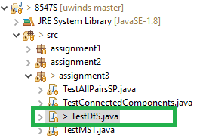

1. Output of the java file looks as below:

Task #1 - Run DFS on mediumDG.txt. Time spent:

Creating DG from mediumDG.txt - 178 ms

DFS - 6 ms

Pre-order: 0 34 40 15 49 22 6 28 44 39 42 31 32 47 30 37 35 46 16 9 11 21 5 43 38 23 13 18 29 8 48 33 19 2 25 12 26 7 41 1 45 14 3 36 20 27 24 4 17 10

Post-order: 21 11 9 16 46 35 38 43 5 37 23 30 47 13 32 18 31 42 39 44 29 28 6 22 49 19 25 2 33 26 12 48 8 15 40 34 41 7 0 14 45 1 20 36 17 4 24 27 3 10

1. The CPU time for DFS is 6 ms as per the output.
2. The Worst-case complexity of DFS is Running time of DFS is O(|V|+|E|), if it happens to be the last node visited as the worst case, it will need to traverse the entire graph, i.e. traversing all vertexes and edges which is of time complexity O(|V|+|E|)

**Task #2 - a**

1. Source code

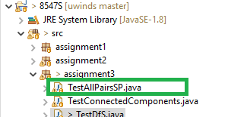

1. Output of the java file looks as below:

Task #2 - Find shortest path for all pairs in mediumEWG.txt

Total time spent: 126 ms.

Here is a snippet of Shortest paths matrix (10 X 10), see full results in sp_all_pairs.txt

0.00 N N N N N N N N N

N 0.00 N N N N N N N N

N N 0.00 N N N N N N N

N N N 0.00 N N N N N N

N N N N 0.00 0.11 N N N N

N N N N N 0.00 N N N N

N N N N N N 0.00 N N N

N N N N N N N 0.00 N N

N N N N N N N N 0.00 N

N N N N N N N N N 0.00

1. Report entire time complexity

The time complexity of my algorithm is O(E**²** + |E||V| log |V|), as it apply Dijkstra search to all vertexes as source to calculate shortest paths to all the rest. As we learned from class, Dijstra’s time complexity is O(E + |V| log |V|), so the entire cost is O(E**²** + |E||V| log |V|).

**Task #2 – b**

1. Source code

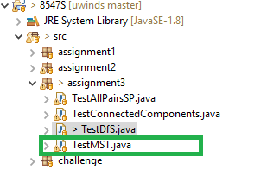

1. Output of the java file looks as below:

Finds MST in mediumEWG.txt, time spent:

loading EWG from mediumEWG.txt: 136 ms

finding MST: **17 ms**

1. The algorithm in my code is Kruskal which is of time complexity (worst-case) O(|E| log |E|).

**Task #3 and #4**

1. Source code

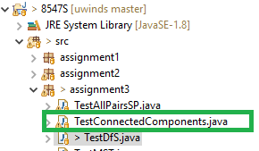

1. Output of the java file looks as below:

33 connected components found in movies.txt

Task #3 - It took **49 ms** to use DFS identifying the components and 33 connected components identified in movies.txt.

Task #4 -

**Movies starred by DiCaprio, Leonardo:**

What's Eating Gilbert Grape (1993)

Total Eclipse (1995)

Titanic (1997)

This Boy's Life (1993)

Romeo + Juliet (1996)

Quick and the Dead, The (1995)

Poison Ivy (1992)

Marvin's Room (1996)

Man in the Iron Mask, The (1998 I)

Gangs of New York (2002)

Departed, The (2006)

Celebrity (1998)

Catch Me If You Can (2002)

Beach, The (2000 I)

Basketball Diaries, The (1995)

Aviator, The (2004)

**Movies starred by Roberts, Julia (I):**

Stepmom (1998)

Steel Magnolias (1989)

Something to Talk About (1995)

Sleeping with the Enemy (1991)

Runaway Bride (1999)

Prêt-à-Porter (1994)

Pretty Woman (1990)

Player, The (1992)

Pelican Brief, The (1993)

Ocean's Twelve (2004)

Ocean's Eleven (2001)

Notting Hill (1999)

Mystic Pizza (1988)

My Best Friend's Wedding (1997)

Mona Lisa Smile (2003)

Michael Collins (1996)

Mexican, The (2001)

Mary Reilly (1996)

I Love Trouble (1994)

Hook (1991)

Full Frontal (2002)

Flatliners (1990)

Everyone Says I Love You (1996)

Erin Brockovich (2000)

Dying Young (1991)

Conspiracy Theory (1997)

Confessions of a Dangerous Mind (2002)

Closer (2004 I)

America's Sweethearts (2001)

**Movies starred by Grant, Hugh (I):**

Two Weeks Notice (2002)

Small Time Crooks (2000)

Sirens (1994)

Sense and Sensibility (1995)

Restoration (1995)

Remains of the Day, The (1993)

Notting Hill (1999)

Nine Months (1995)

Mickey Blue Eyes (1999)

Maurice (1987)

Love Actually (2003)

Lair of the White Worm, The (1988)

Four Weddings and a Funeral (1994)

Extreme Measures (1996)

Englishman Who Went Up a Hill But Came Down a Mountain, The (1995)

Bridget Jones: The Edge of Reason (2004)

Bridget Jones's Diary (2001)

Bitter Moon (1992)

American Dreamz (2006)

About a Boy (2002)

Movies starred by both Roberts, Julia (I) and Grant, Hugh (I):

Notting Hill (1999)

1. According to the output, the CPU time is 49 ms for DFS identify the connected components, while the time complexity of the algorithm DFS which is in my implementation is O(|V|+|E|) as we learned from the class. worst-case is the case O(|V|+|E|) as well.
2. From the output, we can see the movies starred by the given actors respectively.