Assignment 2

Wen Dong #110057395

COMP 8700 Fall 2019 Assignment 2

Due: Nov. 25@ Bb, 11:59pm

**4.1** Give the name of the algorithm that results from each of the following special cases:

**a**. Local beam search with k = 1.

Answer: Hill Climbing Search

**c**. Simulated annealing with T = 0 at all times (and omitting the termination test).

Answer: Hill Climbing Search

**d**. Simulated annealing with T = ∞at all times.

Answer: Random-restart Hill Climbing

**e**. Genetic algorithm with population size N = 1.

Answer: Local beam search

4.4 no simulated annealing.

**4.4** Generate a large number of 8-puzzle and 8-queens instances and solve them (where possible)

by hill climbing (steepest-ascent and first-choice variants), hill climbing with random

restart, and simulated annealing. Measure the search cost and percentage of solved problems

and graph these against the optimal solution cost. Comment on your results.

**4.10** Consider the sensorless version of the erratic vacuum world. Draw the belief-state

space reachable from the initial belief state {1, 2, 3, 4, 5, 6, 7, 8}, and explain why the problem

is unsolvable.

Answer: if it is deterministic, belief state is as below for the sensorless version.

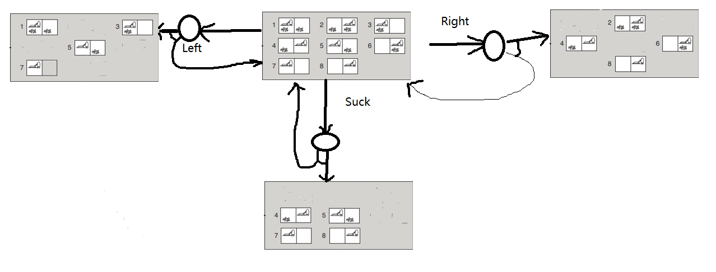

Since it is erratic, belief state is as below after combine two belief-state spaces for each step:

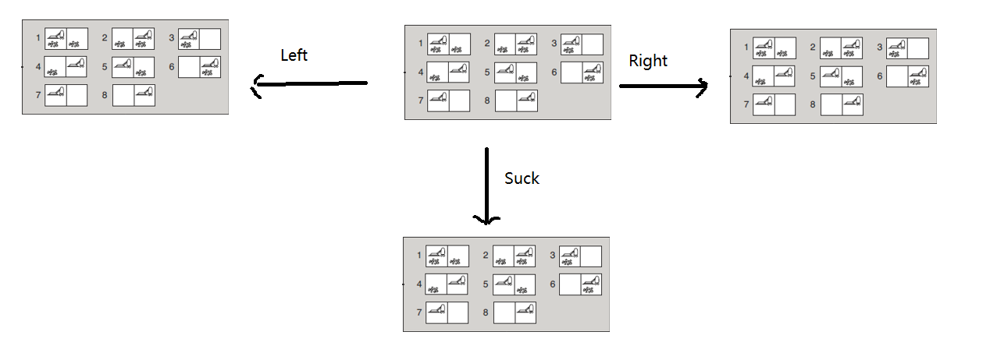

From the belief-state space above we can see, any step from the initial belief-state space leads to the same belief state space, which is the initial belief-state itself, it cannot reach any goal state, so it’s unresolvable.