1. a) Created a MongoDB database “wendong”

b) added four recipes to collection “wenfavorite” and all displayed as below

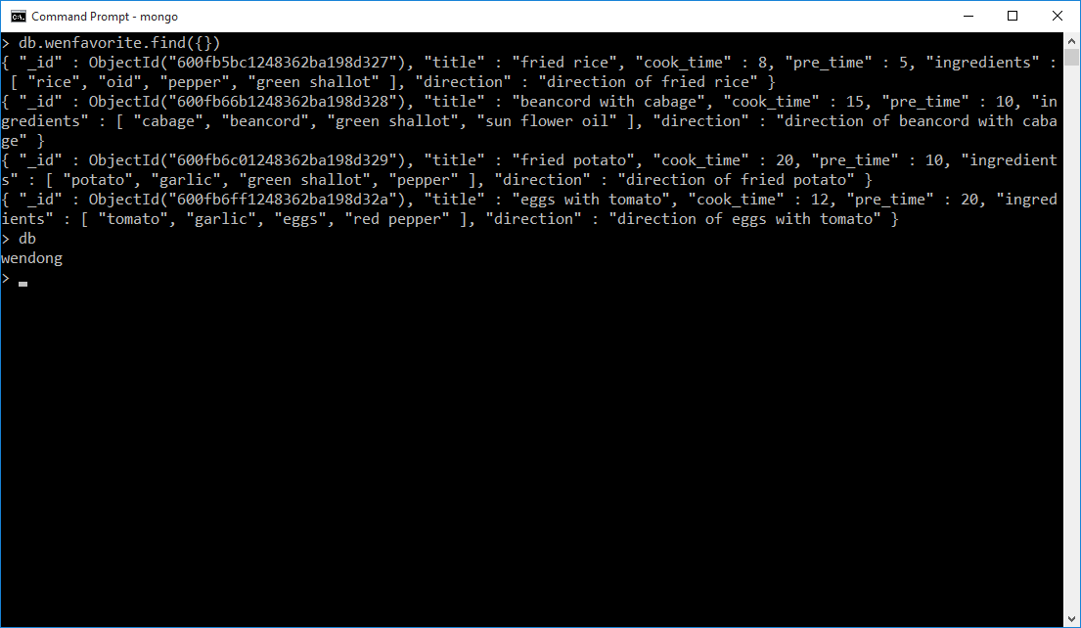

1. display title and direction

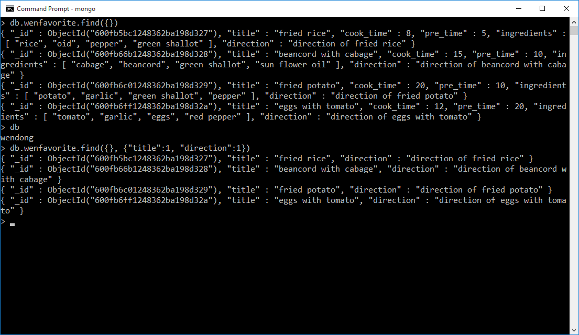

1. skip the first 2 with sugar as ingredient and display the next 2

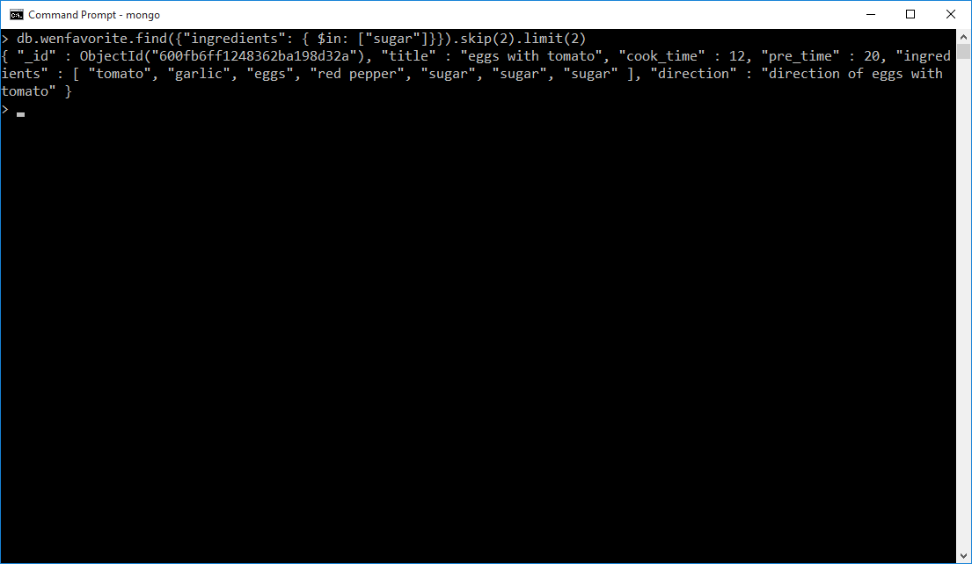

Since there is only one after skipping the first two with sugar, so only one record displayed.

1. Display the recipe with lowest pre_time

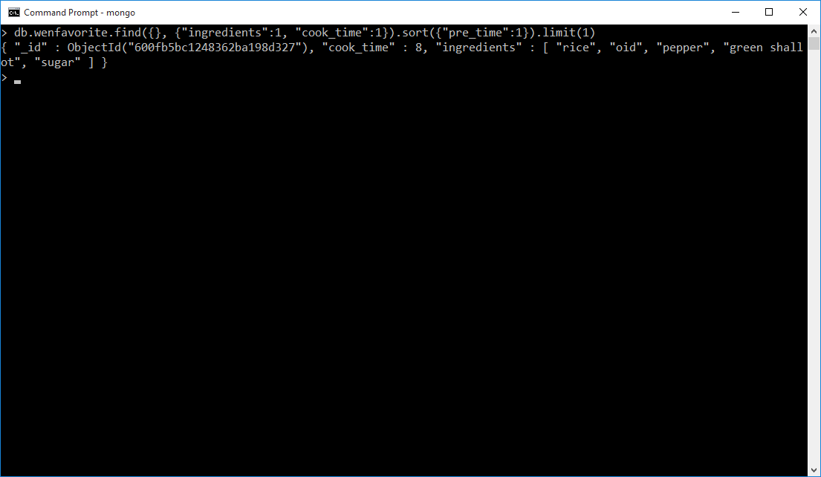

d.

