1.

a. source IP address is 15.122.123.56, destination IP address is 23.2.132.117

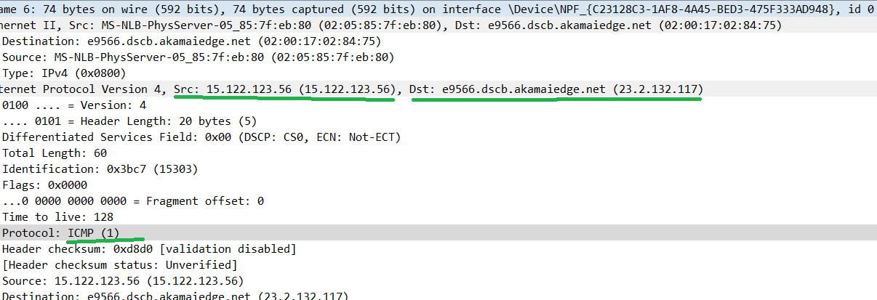

b. the upper-layer protocol is ICMP.

c. IP header length is 20 bytes.

d. payload length for IP packet is total length 60 – header length 20 = 40

e. TTL is acronym of Time To Live, value is 128 in the IP packet. The TTL value is set by sender, reduced by every router on the route to the destination, if the value is reduced to zero before it reach the destination, the packet is discarded.

f. the source IP and destination IP addresses shows whether the packet is if IPv4 or IPv6 format.