Q1

md5um

Hash_comp.py

2.

Generate private RSA key

Extract public key

Display private key

Display public key

3. encrypt & decrypt with RSA

Encrypt

Decrypt

4.

RSA signature sign - $2000

RSA signature sign - $3000

The experiment shows that signatures are different for messages of slightly different.

Verify the signature

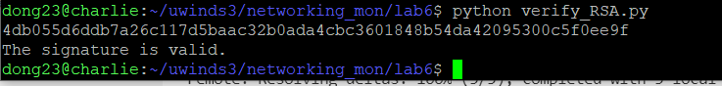

5.

