INTRODUCTION:

This document guide to check the AP55 hardware configure, it focus on the ST STM8L052C6T6 MCU IO interface.

PCBA Testing Procedure:

- Download File “ap55_ver0.20_20200415_8422.hex ” to AP55 PCBA board by using “ST Visual Programmer.exe” PC Tool, here ap55_ver0.20_20200415_8422.hex is example, last 8422 is checksum digit, different version will be different name and checksum.

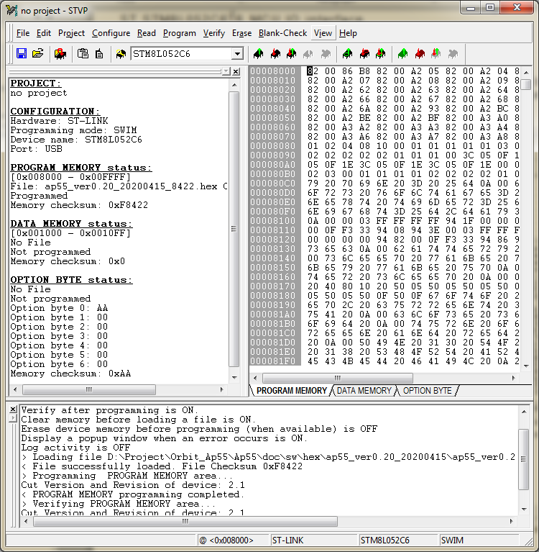

- Open the PC tools (Ultra Serial Port Monitor) or other tools to control the Serial Port.

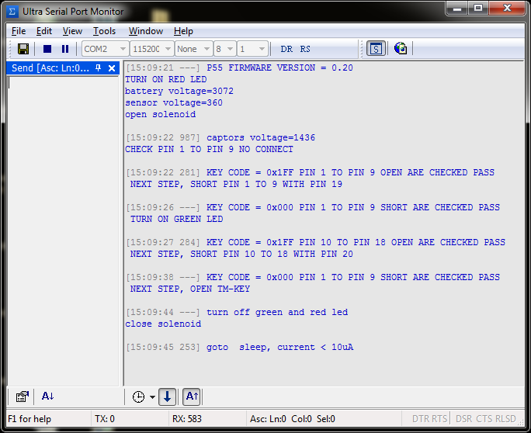

- Connect RX and TX by USB2COM USB Dongle with 115200 bps, 8bits, Parity (none), 1 and Connect TM-KEY to LOW

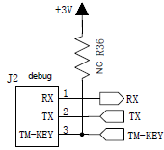

- Power up AP55 to start the test items.

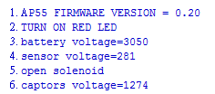

Item 1: Check firmware version? Here should be 0.18.

Item 2 : Test the RED LED ON and GREEN LED OFF.

Item 3: If Supply Voltage = 3.0v, the battery measure acceptance range is +/- 4%, that range is 2880 to 3120.

Item 4: Photo Sensor test, product need to setup a stable environment, and use the golden sample to check the value, for example golden sample value is 500, then the acceptable range is +/- 8%,that mean 460 to 540.

Item 5: Test JIG should connect to Solenoid, here the solenoid should open.

Item 6: Check the Charge voltage, the charge voltage must between 1200 to 1300.

- Item 7 , Switch Pin Position Testing

  - Open Pin 1 to Pin 9, if PASS it will show below message.

KEY CODE = 0x1FF PIN 1 TO PIN 9 OPEN ARE CHECKED PASS
NEXT STEP, SHORT PIN 1 TO 9 WITH PIN 19

  - Short Pin 1 to Pin 9 with Pin 19, if PASS it will show below message,and GREEN LED will turn ON.

KEY CODE = 0x000 PIN 1 TO PIN 9 SHORT ARE CHECKED PASS
TURN ON GREEN LED

  - Open Pin 10 to Pin 18, if PASS it will show below message

KEY CODE = 0x1FF PIN 10 TO PIN 18 OPEN ARE CHECKED PASS
NEXT STEP, SHORT PIN 10 TO 18 WITH PIN 20

  - Short Pin 10 to Pin 18 with Pin 20, if PASS it will show below message

KEY CODE = 0x000 PIN 1 TO PIN 9 SHORT ARE CHECKED PASS
NEXT STEP, OPEN TM-KEY

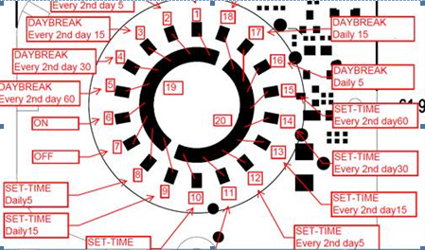

- Remove TM-KEY, let TM-KEY is HIGH, then check below items
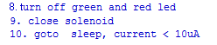
Item 8: RED and GREEN LED is OFF
Item 9. The Solenoid is closed
Item 10. The sleep current < 10uA.

FG Testing Procedure:
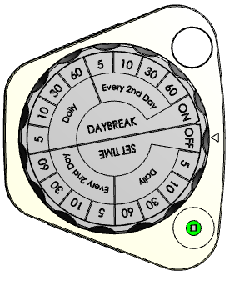

LED Light >500Lux

Air Flow
50PSI
Flow Meter#1
Flow Meter#2

Testing Step:

- Turn the Dial to OFF “position”
- Insert Battery with 3V
- Confirm Valve Turn Off Twice
- Check Flow Meter#1 >50PSI and Flow Meter #2 <20PSI
- Turn Dial Counter Clockwise and check LED blinking along each setting point until DayBreak Daily 5mins condition.
- Confirm status set and “Green” and “Red” LED both light on
- Turn Dial Counter Clockwise and check LED blinking along each setting point until position “ON”
- Confirm Valve Turn On with Flow Meter#2 =>50PSI
- Turn Dial Counter Clockwise to OFF “position and the Valve turn off nicely with no Air Flow on Meter#2.
Checking

>> OFF Location

>> Battery Compartment

>> OFF Function

>> Valve no Leakage

>> Each position contact

>> Light Sensor & LED

>> Each position contact

>> ON Function

>> OFF Function with pressure.

