**Daybreak Timer**

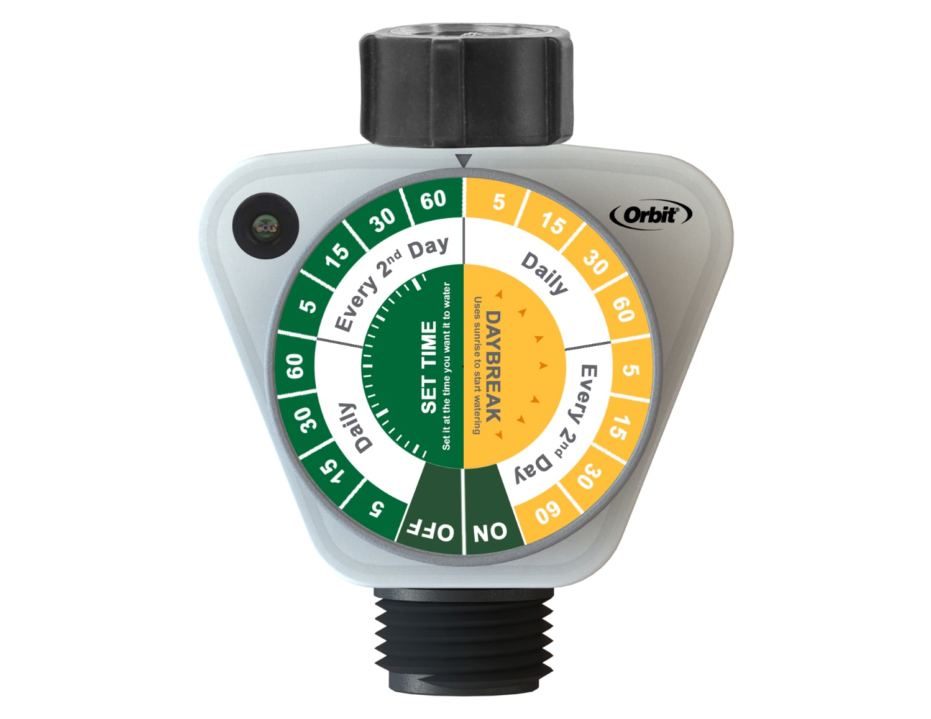

CONTENTS

1 General Specification 3

1.1 Description - Timer 3

2 Physical Specification 3

2.1 Body 3

2.2 Dial Specifications 3

3 Electrical Specification 4

3.1 Timer 4

3.2 Standards 4

4 Environmental Specification 4

4.1 Working temperature: 4

4.2 Storage temperature: 4

4.3 Humidity: 4

4.4 IP Rating: 4

5 Functional Requirements (EVT/DVT) 4

5.1 Manifold Inlet / Outlet Threads: 4

6 Performance Requirements (EVT/DVT) 4

6.1 Working Pressure Testing 4

6.2 Full Cycle Function Testing 5

6.3 Life Cycle Testing 5

6.4 Temperature Testing 5

6.5 Proof Pressure Testing 5

6.6 Swivel Strength Testing 5

6.7 Impact Testing 5

7 Incoming Inspection Requirements (IQA) 5

7.1 Lot acceptance shall be determined by the evaluation of samples taken from each shipment per ANSI/ASQC Z1.4-2003. 5

7.2 Thread Specification Testing 5

*Note: Damage to threads in shipping and handling should not necessarily constitute failure of the entire shipment, but do present a possible opportunity for continuous improvement in packaging or handling this should be evaluated on a case by case basis.* 6

8 Safety Requirements (EVT/DVT) 6

8.1 Product Finish 6

9 Regulatory Requirements (EVT/DVT) 6

9.1 Plastic Materials and Packaging 6

9.2 ROHS 6

10 Environmental Requirements (EVT/DVT) 6

10.1 UV Resistance 6

10.2 Corrosion Resistance 6

11 Significant Modifications to the General Specification 6

1. General Specification
   1. Description - Timer
      1. A non-programmable timer with preset duration/interval cycles for watering.
      2. Two methods to begin watering cycle.
         1. One method to begin at certain light threshold
         2. One method to begin after duration is set
      3. One physical dial to select the duration/interval cycle as well as starting method.
      4. Timer will have a photo sensor to detect ambient light level.
2. Physical Specification
   1. Body
      1. Dimensions: TBD
      2. Housing made of ABS + UV inhibitor
   2. Dial Specifications
      1. One 18 position rotary knob. Will contain the following modes:
         1. Off – No watering, will send “OFF” pulse and reinforcement “OFF” pulse when selected
         2. On – Valve remains open, safety shutoff after 1 hour has elapsed. After one hour, an “OFF” pulse and reinforcement “OFF” pulse will be sent to the valve. No more watering events will occur once the valve shuts off until the dial is moved.
         3. Daybreak functionality – Will turn on at ambient light threshold
            1. Daily – will water every day

5, 15, 30 and 60 minute durations

* + - * 1. Every 2nd day – will water on an every other day interval.

5, 15, 30 and 60 minute durations

* + - 1. Interval functionality – Will turn on at the time the dial is set.
         1. Daily – will water every day

5, 15, 30 and 60 minute durations

* + - * 1. Every 2nd day – will water on an every other day interval.

5, 15, 30 and 60 minute durations

* + - 1. Free to rotate 360 degrees either clockwise or counter clockwise.
      2. Physical detent at each position.

1. Electrical Specification
   1. Power Management
      1. Battery: two 1.5V AA batteries. Assume battery capacity is 2600 mAh.
      2. Battery life: minimum one year for 2 new alkaline batteries
      3. Low battery detection below 2.4 ± 0.2V
      4. Timer will not begin any watering cycles or open the valve when the voltage is lower than 2.3 V.
   2. Programming
      1. Daybreak Mode
         1. The timer will activate after 30 minutes of light above the determined threshold.
         2. After watering, while the dial remains in position the timer will not activate again until a minimum of 23 hours have passed.
      2. Interval mode
         1. The timer will begin watering approximately 5 seconds after the dial is set.
         2. Once the watering cycle is complete, the next cycle will start approximately 24 hours later for the “Daily” section, or 48 hours for the “Every 2nd day” section.
   3. Valve pulse
      1. Any “OFF” pulse will have a reinforcement off pulse that will occur no less than 7 seconds after the first “OFF” pulse is sent.
   4. Time Keeping
      1. Timer will be able to keep the passage of time with drift under 2 seconds per day.
   5. Standards
      1. Unit to pass EMI/EMC test according to CE.
      2. C-Tick
2. Environmental Specification
   1. Working temperature:
      1. 0°C to 70°C (32F to 158F)
   2. Storage temperature:
      1. -20°C to 70°C (-4F to 158F)
   3. Humidity:
      1. 90%RH
   4. IP Rating:
      1. IP45
3. Functional Requirements (EVT/DVT)
   1. Manifold Inlet / Outlet Threads:
      1. Inlet/Swivel threads shall be 3/4” FHT female threads sized as per the SKU specification.
         1. Inlet/Swivel to made of ABS
      2. Outlet threads shall be ¾” MHT male threads sized as per the SKU specification.

*Note: All units being tested must pass using the appropriate thread gauge*

1. Performance Requirements (EVT/DVT)
   1. Working Pressure Testing
      1. Valves must function properly at pressures from 10 to 100 psi (static) without leakage from internal components and no degradation of performance.
      2. Valves must perform adequately with no hose or sprinkler attached as well with a sprinkler or drip nozzle(s) attached.
      3. Test for proper operation of the automatic valves while attached to the manifold at the following pressures. Valve must open and close cleanly with no leakage through the valve or through the internal components. Repeat the test a minimum of 5 times at each pressure.
         1. 10 psi
         2. 20 psi
         3. 40 psi
         4. 60 psi
         5. 80 psi
         6. 100 psi
   2. Full Cycle Function Testing
      1. The timer must operate properly through the full range of programs. The unit will be tested three times at each dial position for full functionality.
   3. Life Cycle Testing
      1. A minimum of 3 timers shall be tested as a variety of cycles over an extended period of time.
      2. Valves will be tested for 1,200 cycles by means of actuation at a water temperature range of 40°F - 80°F (4.4°C – 21.1°C) supply water at 90 psi.
      3. At the conclusion of the 1,200 cycles the Working Pressure Test and the Full Function tests will be repeated.
      4. This testing may use data accumulated from the Working Pressure Test, the Full Cycle Function Test, and the Timer Repeatability test.
   4. Temperature Testing
      1. A minimum of 2 timer assemblies shall be heated in an oven at 135 F for 2 hours.
      2. After the temperature test, the timers shall be placed on water and shall open and close at 10psi and 90 psi.
   5. Proof Pressure Testing
      1. Timer will meet 150 PSI proof pressure.
   6. Burst Pressure Testing
      1. Units will meet a minimum of 700 PSI burst pressure.
   7. Swivel Strength Testing
      1. Timer swivel will withstand 200 in-lbs of force.
   8. Impact Testing
      1. A sample set shall be tested as follows: The product must withstand 3 drops from a 3-foot height onto a concrete surface without breaking or suffering a loss of serviceability.
2. Device Functionality
   1. Power up/Battery installation
      1. When device first powers on, an “OFF” pulse will be sent to the valve.
      2. The timer will begin to operate as if the current dial selection has just been set.
   2. LED indications
      1. The LED will begin to flash green (.5 s on and .5 s off) when dial position is changed. It will continue to flash until a position is selected.
      2. When a dial position is selected, the LED will turn green for 10 seconds.
      3. When a watering cycle begins, the LED will turn green for 10 seconds.
      4. When the battery is low, the LED will flash red for approximately .25 s every 10 seconds.
   3. Program Selection
      1. Programs will be selected by rotating the dial.
      2. Program selection will not be instantaneous but will have a 3 second delay. When a dial remains in a position for 3 seconds, the program is selected. Watering will begin immediately for a “Set Time” selection or at the next daybreak event for a “Daybreak” selection.
      3. Any rotation of the dial will immediately stop any current watering cycle. An “OFF” pulse as well as a reinforcement “OFF” pulse will be sent to the valve.
3. Incoming Inspection Requirements (IQA)
   1. Lot acceptance shall be determined by the evaluation of samples taken from each shipment per ANSI/ASQC Z1.4-2003.
      1. Timer: Test timer for proper operation in both manual and Auto modes.
      2. Manifold: Test the manifold on water at 100 psi.
         * 1. Look for from the valve while between the “ON” and “OFF” position.
           2. Automatic Valves: Test for proper operation. Open/Close a minimum of 10 times.

* 1. Thread Specification Testing
     1. The threads for a randomly selected sample set shall meet the thread specification requirements of section 5 of this general specification.

*Note: Damage to threads in shipping and handling should not necessarily constitute failure of the entire shipment, but do present a possible opportunity for continuous improvement in packaging or handling this should be evaluated on a case by case basis.*

1. Safety Requirements (EVT/DVT)
   1. Product Finish
      1. There shall be no sharp edges, points, or features on the product or packaging that will present a hazard to the user.

1. Regulatory Requirements (EVT/DVT)
   1. Plastic Materials and Packaging
      1. All plastic and packaging materials must be free of formaldehyde.
   2. ROHS
      1. All components must conform to ROHS requirements.
2. Environmental Requirements (EVT/DVT)
   1. UV Resistance
      1. All materials with external surfaces shall be UV resistant to withstand outdoor / sunlight exposure without fading or material degradation,
   2. Corrosion Resistance
      1. Timer must withstand 24 hours in a 5% salt (NaCl) spray (fog) with no major corrosion or visual – including tarnishing or discoloration – of the components. Reference: ASTM B117 G85 Modified
3. Significant Modifications to the General Specification

|  |  |  |
| --- | --- | --- |
| Date | Events |  |
| 08/26/19 | Initial draft |  |
| 09/11/19 | Updated program and LED logic |  |
| 09/27/19 | Added Burst pressure specification |  |
| 10/15/19 | Updated LED logic, added power requirements |  |
|  |  |  |

* END *