Tittle {Style : Title. Times New Roman 13 pt Bold, Justify, Single Spacing}

Author 11, Author 22, … {Style : Author. Times New Roman 10 pt Bold, left, single spacing}

1 Author 1 Affiliation **{Style Affiliation**. Times New Roman 10 pt, left , single spacing**}**

2 Author 2 Affiliation

Email : email1@xxx.com, email2@xxx.com, email3@gmail.com **{Style : email.** Times New Roman 10 pt, left, single spacing}

**Abstract {Style : Abstract. }**

The abstract must not exceed 200 words. Write it in Times New Roman 10pt, line spacing 1. Keywords must be carefully selected to facilitate reader’s search and can be written up to five words.The abstract should outline the purpose of the paper and the main results, conclusions and recommendations, using clear, factual statements.A concise and factual abstract is required. The abstract should also state briefly the principal results and major message. The abstract is often presented separately from the article, so it must be able to stand alone. For this reason, References should be avoided, but if essential, they must be cited in full, without reference to the reference list. Also, abbreviations should be avoided, but if essential they must be defined at their first mention in the abstract it self.

**Keywords**: keyword1, keyword2, keyword3, up to six words ordered alphabetically **{style : keywords}**

Submited: Revised: Accepted Publication: Published:

# iNTRODUCTION {style : Heading 1. Times New Roman, 11 pt, bold, space after paragraph 8 pt, space before paragraph 8 pt }

{**Style : Content**. Times New Roman, 11 pt, justify, single spacing, first line: 1.27 cm}. The introduction should clearly state the purpose of the study. It should include key references of appropriate works but **SHOULD NOT** be a historical or literature review. The contents of the paper include **Introduction (Pendahuluan)**, **Method (Metode)** (for research-based articles), **Results and Discussions (Hasil dan Pembahasan)**, **Conclusion (Penutup)**, and **References (Daftar Rujukan)**. The content of non-research based article may include some sub-chapters (Heading 2 and Heading 3).

Articles are original reports whose conclusions represent a substantial advance in understanding of an important problem and have immediate far-reaching implications.

**Essential information**

***Title***. Concise and informative. Titles are often used in information-retrieval systems. Avoid abbreviations and formulae where possible.

***Author names and affiliations***. Please clearly indicate the given name(s) and family name(s) of each author and check that all names are accurately spelled. Present the authors' affiliation addresses (where the actual work was done) below the names. Indicate all affiliations with a lower-case superscript letter immediately after the author's name and in front of the appropriate address. Provide the full postal address of each affiliation, including the country name and, if available, the e-mail address of each author.

***Corresponding author***. Clearly indicate who will handle correspondence at all stages of refereeing and publication, also post-publication. Ensure that the e-mail address is given and that contact details are kept up to date by the corresponding author.

***Abbreviations***. Define abbreviations that are not standard in this field in a footnote to be placed on the first page of the article. Such abbreviations that are unavoidable in the abstract must be defined at their first mention there, as well as in the footnote. Ensure consistency of abbreviations throughout the article.

***Math formulae***. Please submit math equations as editable text and not as images. Present simple formulae in line with normal text where possible and use the default Microsoft Word Equation Editor, not other third party equation editors. In principle, variables are to be presented in italics. Number consecutively any equations that have to be displayed separately from the text (if referred to explicitly in the text).

***Tables***. Please submit tables as editable text and not as images. Tables can be placed either next to the relevant text in the article, or on separate page(s) at the end. Number tables consecutively in accordance with their appearance in the text and place any table notes below the table body. Be sparing in the use of tables and ensure that the data presented in them do not duplicate results described elsewhere in the article. Please avoid using vertical rules.

***Keywords***. Immediately after the abstract, provide a maximum of 6 keywords, avoid general and plural terms and multiple concepts (avoid, for example, "and", "of"). Be sparing with abbreviations: only abbreviations firmly established in the field may be eligible. These keywords will be used for indexing purposes. Use keywords that make your paper easy detectable for interested readers in literature databases. Repeating terms in the title is usually not needed.

***Figure captions***. Ensure that each illustration has a caption. Submit each caption directly below each figure. A caption should comprise a brief title (not on the figure itself) and a description of the illustration. Keep text in the illustrations themselves to a minimum but explain all symbols and abbreviations used. The figure caption should be understandable independent of the text and abbreviations should be avoided.

# METHOD {style : Heading 1. Times New Roman, 11 pt, bold, space after paragraph 8 pt, space before paragraph 8 pt }

{**Style : Content**. Times New Roman, 11 pt, justify, single spacing, first line: 1.27 cm}. Donec hendrerit, felis et imperdiet euismod, purus ipsum pretium metus, in lacinia nulla nisl eget sapien. Donec ut est in lectus consequat consequat. Etiam eget dui. Aliquam erat volutpat. Sed at lorem in nunc porta tristique. Proin nec augue. Quisque aliquam tempor magna. Pellentesque habitant morbi tristique senectus et netus et malesuada fames ac turpis egestas. Nunc ac magna. Maecenas odio dolor, vulputate vel, auctor ac, accumsan id, felis. Pellentesque cursus sagittis felis. Pellentesque porttitor, velit lacinia egestas auctor, diam eros tempus arcu, nec vulputate augue magna vel risus. Cras non magna vel ante adipiscing rhoncus. Vivamus a mi. Morbi neque. Aliquam erat volutpat. Integer ultrices lobortis eros. Pellentesque habitant morbi tristique senectus et netus et malesuada fames ac turpis egestas. Proin semper, ante vitae sollicitudin posuere, metus quam iaculis nibh, vitae scelerisque nunc massa eget pede. Sed velit urna, interdum vel, ultricies vel, faucibus at, quam.

Donec elit est, consectetuer eget, consequat quis, tempus quis, wisi. In in nunc. Class aptent taciti sociosqu ad litora torquent per conubia nostra, per inceptos hymenaeos. Donec ullamcorper fringilla eros. Fusce in sapien eu purus dapibus commodo. Cum sociis natoque penatibus et magnis dis parturient montes, nascetur ridiculus mus. Cras faucibus condimentum odio. Sed ac ligula. Aliquam at eros. Etiam at ligula et tellus ullamcorper ultrices. In fermentum, lorem non cursus porttitor, diam urna accumsan lacus, sed interdum wisi nibh nec nisl. Ut tincidunt volutpat urna. Mauris eleifend nulla eget mauris. Sed cursus quam id felis. Curabitur posuere quam vel nibh. Cras dapibus dapibus nisl. Vestibulum quis dolor a felis congue vehicula. Maecenas pede purus, tristique ac, tempus eget, egestas quis, mauris. Curabitur non eros. Nullam hendrerit bibendum justo.

# RESULT AND DISCUSSION {style : Heading 1. Times New Roman, 11 pt, bold, space after paragraph 8 pt, space before paragraph 8 pt}

{**Style : Content**. Times New Roman, 11 pt, justify, single spacing, first line: 1.27 cm}. Fusce iaculis, est quis lacinia pretium, pede metus molestie lacus, at gravida wisi ante at libero. Quisque ornare placerat risus. Ut molestie magna at mi. Integer aliquet mauris et nibh. Ut mattis ligula posuere velit. Nunc sagittis. Curabitur varius fringilla nisl. Duis pretium mi euismod erat. Maecenas id augue. Nam vulputate. Duis a quam non neque lobortis malesuada. Praesent euismod. Donec nulla augue, venenatis scelerisque, dapibus a, consequat at, leo. Pellentesque libero lectus, tristique ac, consectetuer sit amet, imperdiet ut, justo. Sed aliquam odio vitae tortor. Proin hendrerit tempus arcu. In hac habitasse platea dictumst. Suspendisse potenti. Vivamus vitae massa adipiscing est lacinia sodales (Giganti, 2007). Donec metus massa, mollis vel, tempus placerat, vestibulum condimentum, ligula.

## Sub Discussion {Style: Heading 2. Times New Roman, 11 pt, bold, space after paragraph 8 pt, space before paragraph 8 pt }

Nunc lacus metus, posuere eget, lacinia eu, varius quis, libero. Aliquam nonummy adipiscing augue. Lorem ipsum dolor sit amet, consectetuer adipiscing elit. Maecenas porttitor congue massa. c, sit amet commodo magna eros quis urna. Nunc viverra imperdiet enim. Fusce est. Vivamus a tellus. Pellentesque habitant morbi tristique senectus et netus et malesuada fames ac turpis egestas. Proin pharetra nonummy pede. Mauris et orci. Aenean nec lorem. In porttitor. Donec laoreet nonummy augue. Suspendisse dui purus, scelerisque at, vulputate vitae, pretium mattis, nunc. Mauris eget neque at sem venenatis eleifend. Ut nonummy. Fusce aliquet pede non pede. Suspendisse dapibus lorem pellentesque magna. Integer nulla.

### Sub- Sub Discussion{Style: Heading 3. Times New Roman, 11 pt, bold, italic, space after paragraph 8 pt, space before paragraph 8 pt }

Nunc lacus metus, posuere eget, lacinia eu, varius quis, libero. Aliquam nonummy adipiscing augue. Lorem ipsum dolor sit amet, consectetuer adipiscing elit. Maecenas porttitor congue massa. c, sit amet commodo magna eros quis urna. Nunc viverra imperdiet enim. Fusce est. Vivamus a tellus. Pellentesque habitant morbi tristique senectus et netus et malesuada fames ac turpis egestas. Proin pharetra nonummy pede. Mauris et orci. Aenean nec lorem. In porttitor. Donec laoreet nonummy augue. Suspendisse dui purus, scelerisque at, vulputate vitae, pretium mattis, nunc. Mauris eget neque at sem venenatis eleifend. Ut nonummy. Fusce aliquet pede non pede. Suspendisse dapibus lorem pellentesque magna. Integer nulla.

Table 1. Pellentesque habitant morbi tristique senectus et netus et malesuada **{Style: Caption}**

|  |  |  |
| --- | --- | --- |
| No | opustie | restuie |
| 1 | Nunc lacus metus, posuere eget, lacinia eu, | Nunc lacus metus, posuere eget, lacinia eu, varius quis, libero. Aliquam nonummy adipiscing augue |
| 2 | Nunc lacus metus, posuere eget, lacinia eu, | Nunc lacus metus, posuere eget, lacinia eu, varius quis, libero. Aliquam nonummy adipiscing augue |
| 3 | Nunc lacus metus, posuere eget, lacinia eu, | Nunc lacus metus, posuere eget, lacinia eu, varius quis, libero. Aliquam nonummy adipiscing augue |

Nunc lacus metus, posuere eget, lacinia eu, varius quis, libero. Aliquam nonummy adipiscing augue. Lorem ipsum dolor sit amet, consectetuer adipiscing elit. Maecenas porttitor congue massa. c, sit amet commodo magna eros quis urna. Nunc viverra imperdiet enim. Fusce est. Vivamus a tellus. Pellentesque habitant morbi tristique senectus et netus et malesuada fames ac turpis egestas.

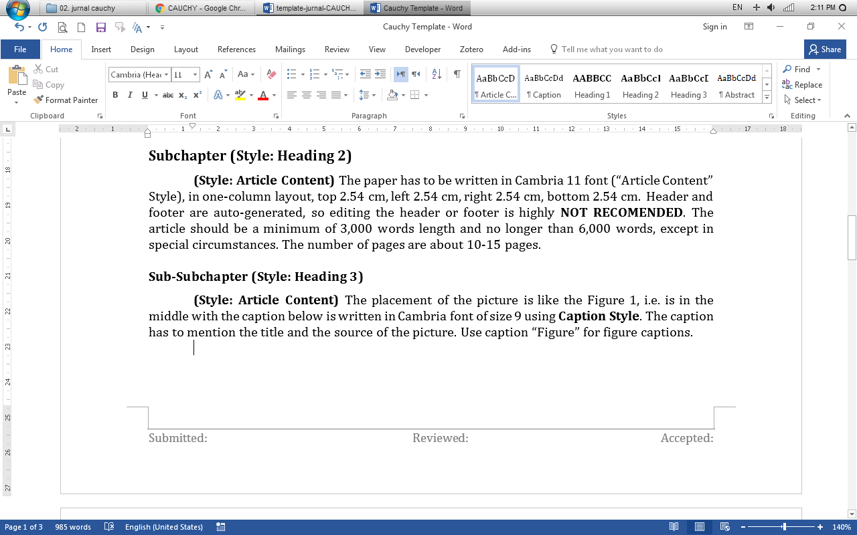

Figure 1. Style.**{Style : Caption}**

Nunc lacus metus, posuere eget, lacinia eu, varius quis, libero. Aliquam nonummy adipiscing augue. Lorem ipsum dolor sit amet, consectetuer adipiscing elit. Maecenas porttitor congue massa. c, sit amet commodo magna eros quis urna. Nunc viverra imperdiet enim. Fusce est. Vivamus a tellus. Pellentesque habitant morbi tristique senectus et netus et malesuada fames ac turpis egestas.

Nunc lacus metus, posuere eget, lacinia eu, varius quis, libero. Aliquam nonummy adipiscing augue. Lorem ipsum dolor sit amet, consectetuer adipiscing elit. Maecenas porttitor congue massa. c, sit amet commodo magna eros quis urna. Nunc viverra imperdiet enim. Fusce est. Vivamus a tellus. Pellentesque habitant morbi tristique senectus et netus et malesuada fames ac turpis egestas.

# Conclusion {style : Heading 1. Times New Roman, 11 pt, bold, space after paragraph 8 pt, space before paragraph 8 pt }

{**Style : Content**. Times New Roman, 11 pt, justify, single spacing, first line: 1.27 cm}. Nunc lacus metus, posuere eget, lacinia eu, varius quis, libero. Aliquam nonummy adipiscing augue. Lorem ipsum dolor sit amet, consectetuer adipiscing elit. Maecenas porttitor congue massa. c, sit amet commodo magna eros quis urna. Nunc viverra imperdiet enim. Fusce est. Vivamus a tellus. Pellentesque habitant morbi tristique senectus et netus et malesuada fames ac turpis egestas.

Nunc lacus metus, posuere eget, lacinia eu, varius quis, libero. Aliquam nonummy adipiscing augue. Lorem ipsum dolor sit amet, consectetuer adipiscing elit. Maecenas porttitor congue massa. c, sit amet commodo magna eros quis urna. Nunc viverra imperdiet enim. Fusce est. Vivamus a tellus. Pellentesque habitant morbi tristique senectus et netus et malesuada fames ac turpis egestas.Nunc lacus metus, posuere eget, lacinia eu, varius quis, libero. Aliquam nonummy adipiscing augue. Lorem ipsum dolor sit amet, consectetuer adipiscing elit. Maecenas porttitor congue massa. c, sit amet commodo magna eros quis urna. Nunc viverra imperdiet enim. Fusce est. Vivamus a tellus. Pellentesque habitant morbi tristique senectus et netus et malesuada fames ac turpis egestas.

Nunc lacus metus, posuere eget, lacinia eu, varius quis, libero. Aliquam nonummy adipiscing augue. Lorem ipsum dolor sit amet, consectetuer adipiscing elit. Maecenas porttitor congue massa. c, sit amet commodo magna eros quis urna. Nunc viverra imperdiet enim. Fusce est. Vivamus a tellus. Pellentesque habitant morbi tristique senectus et netus et malesuada fames ac turpis egestas.

# Bibliography

{Style : **Bibliography**. APA (American Psychological Association Sixth Edition}

Dewiyani, S. (2015). Improving Students Soft Skills using Thinking Process Profile Based on Personality Types. *International Journal of Evaluation and Research in Education (IJERE)*, pp 118-129.

Giganti, P. (2007). Why Teach Problem Solving, Part I: The World Needs Good Problem Solvers!. *ComMuniCator, 31*(4), 15-16.