# 2) Tustin Integrator

Model: ‘integrator_12B.mdl’

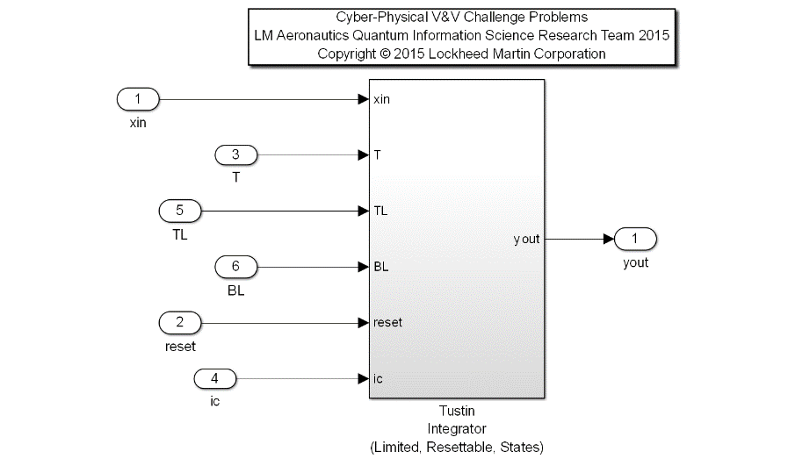Description: A common flight control utility for computing the Tustin Integration of a signal yout = T/2*(xin + xinpv)+ ypv. The algorithm bounds the allowable integration range with a position limiter, with TL as the Top Limit, and BL as the Bottom Limit. Other inputs are the signal to be integrated (xin), the time step (dt), a Boolean reset flag (reset), and the initial condition upon a reset condition (ic). A provision has been implemented for the limiter functionality in the algorithm. If the user plumbs a TL value that is less than BL, the algorithm will swap these numerical values to correctly bound the signal.

|  |  |  |  |  |
| --- | --- | --- | --- | --- |
| **Input Scope** | **Name** | **#** | **Type** | **Description** |
| Global | xin | 1 | Double | Input Signal to be integrated with the Tustin method |
| Global | T | 2 | Double | Time step quantified by rate of execution |
| Global | TL | 3 | Double | Top Limit bounding the output, yout. |
| Global | BL | 4 | Double | Bottom Limit bounding the output, yout. |
| Global | reset | 5 | Boolean | Reset control, initializes output to ic value. |
| Global | ic | 6 | Double | Initial Condition for yout when in reset mode. |

|  |  |  |  |  |
| --- | --- | --- | --- | --- |
| **Output Scope** | **Name** | **#** | **Type** | **Description** |
| Global | yout | 1 | Double | Output Signal result of Tustin integration method on xin |

Definitions:

* Normal operation: the integrator is not in reset mode, and the output is within the specified limits (TL and BL).
* ypv: prior yout value
* xinpv: prior xin input value
* SP: Saturation Point

Requirements:

1. When Reset is True and the Initial Condition (ic) is bounded by the provided Top and Bottom Limits (BL <= ic <= TL), the Output (yout) shall equal the Initial Condition (ic).
2. The Output (yout) shall be bounded by the provided Top and Bottom limits (TL and BL)
3. When in normal operation, the output shall be the result of the equation, yout = T/2*(xin + xinpv)+ ypv
4. The Output of this function shall approximate the integration of the value of the input signal over time within a specified tolerance, defined in subtests below:
   1. After 10 seconds of Computation at an execution frequency of 10 hz, the Output should equal 10 within a +/- 0.1 tolerance, for a Constant Input (xin = 1.0), and the sample delta time T = 0.1 seconds when in normal mode of operation.

Detailed Formal Property Derivation:

# 1. When Reset is True and the Initial Condition (ic) is

# bounded by the provided Top and Bottom Limits (BL<=ic<=TL),

# the Output (yout) shall equal the Initial Condition (ic).

# If the Initial Condition is not bound by the Limits

# during a Reset, the Output shall equal the saturation

# point (nominally with TL>=BL, ic>=TL impl SP==TL and ic<=BL impl SP==BL.

# Off-nominally with TL<BL, ic, ic>=BL impl SP==BL and ic<=TL impl SP==TL.

((reset and ic<=TL and ic>=BL) impl yout == ic); #1a

((reset and ic>=TL and ic>=BL and TL>=BL) impl yout == TL); #1b

((reset and ic<=BL and ic>=BL and TL>=BL) impl yout == BL); #1c

((reset and ic>=BL and ic<=TL and TL<BL) impl yout == BL); #1d

((reset and ic<=TL and ic>=BL and TL<BL) impl yout == TL); #1e

# 2. The Output (yout) shall be bounded by the provided Top

# and Bottom Limits (TL and BL).

(TL>=BL) impl (BL<=yout and yout<=TL); #2a

(TL<BL) impl (TL<=yout and yout<=BL); #2b

# 3. When in normal operation (as defined in reqs document), the Output

# (yout) shall be the result of the equation, yout = T/2*(xin + xinpv)+ypv.

#(not reset and ((TL{all}==10 and BL{all}==-10) and yout{all} <= 1*TL and yout{all} >= 1*BL) and abs(xin{all})<10.0 and T{all}==0.1 and ic{all}==0.0) impl (yout==0.5*T*(xin{t}+xin{t-1})+yout{t-1});

(not reset and (TL>=BL) and (0.5*T*(xin{t}+xin{t-1})+yout{t-1}>=BL) and (0.5*T*(xin{t}+xin{t-1})+yout{t-1}<=TL)) impl (yout==0.5*T*(xin{t}+xin{t-1})+yout{t-1});

#?(not reset and (TL>=BL) and (yout>=BL) and (yout<=TL)) impl (yout==0.5*T*(xin{t}+xin{t-1})+yout{t-1});

# 4. The Output (yout) of this function shall approximate the Tustin

# integration of the value of the input signal (xin) over time within

# a specified tolerance, defined in the following subtests:

# a) After 10 seconds of normal operation, the function computation

# at an execution frequency of 10 hz, yout should equal 10.0 within

# a +/- 0.1 tolerance, for a constant xin equal to 1.0, and sample

# delta time T equal to 0.1 seconds.

# b) After 10 seconds of normal operation, the function computation

# at an execution frequency of 10 hz, yout should equal the sine

# of time t, sin(t), within a +/- 0.1 tolerance, for an input xin

# equal to the cosine of time t, cos(t), and sample

# delta time T equal to 0.1 seconds.