C:\Users\Larry\AppData\Local\Microsoft\Windows\Temporary Internet Files\Content.IE5\BGD58BDB\MCj04323310000[1].wmfDate: WED 28 JAN 2015

CISC 193 – C#

Professor Larry Forman

Telephone: 619.388.3666

E-Mail: [LForman@sdccd.edu](mailto:lforman@sdccd.net)

Mail Box: A-8

Office: BT-210-G

**TRAINING ASSIGNMENT #1.1Q: QUIRKY PROGRAMMING**

**=== DUE MON 9 FEB ===**

**==============**

**TASKS:**

**0 –** First, read this Task Sheet!

Second, put a check mark by each Task number **and** letter when you complete it. Third, hand in your “hard-copy” and completed Green Grade Sheet in your folder when you demo this TA.

**1 –** **READ**: **Handout #1.0, #1.0A, 1.1GUIFun, Websites for Media**

**2 –** **TA OBJECTIVES**

* Design and develop a basic Visual C# program to display information using a GUI Windows application with a form, label, textbox, picture box, buttons, event-handling, string constants, concatenation, comments and effective Michelangelo program documentation
* Identify 2 “quirky” items about yourself and 2 about one colleague from class

**3 – SPECIFICATIONS (For ALL programs, use your name in the project name)**

Create a project called LarrysQuirks with all of the 9 following items:

1. Change the (Name) property of each control – label, textbox, picture box, button – to a self-descriptive name, like myQuirkyPictureBox or pictureBoxOfMyQuirk
2. Insert into the title bar of your form: “Larry’s GUI Quirky Program”
3. Include a "Welcome" message – centered near the top of the form – with **your name** to greet user in a label in a big, beautiful, bold, colorful font.
4. Display in a label the current date and time

**STAR: Add a button for displaying the elapsed time of your application**

1. A button with text property of “Larry’s Quirk #1” for displaying

* One label for your heading of LARRY'S QUIRK #1
* One "quirky" item about yourself in either a label or in a multiline TextBox
* A graphic in a PictureBox that connects with your quirk.

1. Another button with text of “Larry’s Quirk #2” to display the information about your second quirk via two labels and one picture box as described in TASK #3E.

**STAR: Re-use the same two labels and one picture box of TASK 3E.**

1. Two additional buttons for displaying two "quirky" items about a colleague from our class. Follow the structure of the previous TASK #3.E and F with a label and a PictureBox, along with a title like JOEL'S QUIRK #1 and JOEL'S QUIRK #2
2. An "Exit" button to display a MessageBox with a friendly farewell message that incorporates your name **through a const**

**STAR: Also play an engaging farewell sound or music**

1. After farewell message, display in another MessageBox (or more) all of your **ID INFO**, **CREDITS** (of whom you helped, who helped you), **MEDIA** (what resources – graphics, sounds, etc. – you used with a brief description and where you obtained them, e.g., the URLs of any web sites use, titles of music, etc.) and describe in a numbered list your **STARS** along with the **TOTAL NUMBER OF STARS** like this:

**STARS**

1. **Added two quirks for each of two additional people**
2. **Added pizzazz by using animated gifs for all quirks**
3. **Play scintillating music by Queen**

**TOTAL STARS = 3**

**NOTE: You only can earn STARS for those which are listed in this MessageBox.** Then, close the application.

**4 – SCREEN OUTPUT**

Display the following information and associated controls of labels, buttons, etc. in an aesthetically pleasing and user-friendly way on the screen AND use lots of screen real estate (like up to 1920 x 1080):

1. Welcome to Larry's Quirky Program
2. The current date and time
3. Click on a button to display:

LARRY'S QUIRK #1

Describe your first quirk with >= 3 lines

Display a graphic that depicts your quirk

1. Click on a button to display:

LARRY'S QUIRK #2

Describe your second quirk with >= 3 lines

Display a graphic that depicts your quirk

1. Click on a button to display:

JOEL’S QUIRK #1

Describe your colleague’s first quirk with >= 3 lines

Display a graphic that depicts the quirk

1. Click on a button to display:

JOEL’S QUIRK #2

Describe your colleague’s second quirk with >= 3 lines

Display a graphic that depicts the quirk

1. Via a button, display a farewell message with your name via a const
2. Display your complete ID INFO, CREDITS, MEDIA and STARS

Position all your controls for the information above, e.g., Larry’s Quirk #1, Exit buttons, etc. in a pleasing and user-friendly way.

**5** – **SAVE** your file early and often -- like every 5 minutes. And, use your backup "disk"

**6** – **TEST** your file early and often -- like every 5 minutes -- How do you eat an apple?

**7** – **”MICHELANGELO” PROGRAM DOCUMENTATION**

1. First, include in your C# code via comments your complete **ID INFORMATION, PROGRAM DESCRIPTION,** **EVENT-DRIVEN METHOD LIST**, **CREDITS** (to those who helped you and whom you helped as well as “tutorial” websites used) and **MEDIA** of all graphics and audio used with brief description and specific URL or where obtained.
2. **Include "inline credits" to acknowledge specifically where you were helped.**
3. Add a “banner” at the start and at the end of the event-driven methods section.
4. Also, just before each method is declared (signature), put a “banner” of comments with the method **name** and a brief **description** of the purpose of the method and what it does.
5. Make all method and constant (and variable) names self-descriptive as well as clear and fully formed (no abbreviations or secret code names). Use verbs for or in method names like “buttonDisplayLarrysQuirk_1”, etc. and nouns for constants (and variables).
6. Add a banner for your constants!
7. Add comments within a method immediately before each important segment of your code – the Welcome, each QUIRK#1, each QUIRK#2, your Farewell and your ID INFO/CREDITS – to describe "highlights" of coming attractions. Insert at least one blank line before each of these comments.

For instance, here is the initial Michelangelo structure **required for every C# program**:

/**************************************************************

***************************************************************

***************************************************************

*** ***

*** **ID INFORMATION** ***

*** ***

*** Programmer : Your name ***

*** Assignment # : TA #1.1Q ***

*** Assignment Name : Quirky Programming ***

*** Course # and Title : CISC 193 – C# ***

*** Class Meeting Time : MW 9:35 - 12:45 ***

*** Instructor : Professor Forman ***

*** Hours : 6.5 ***

*** Difficulty : 4 ***

*** Completion Date : Month/Day/Year ***

*** Program Name : LarrysQuirks ***

*** ***

***************************************************************

***************************************************************

*** ***

*** **PROGRAM DESCRIPTION** ***

*** ***

*** In your own words, describe with non-technical terms what your ***

*** program does. Learn how to KISS (Keep It Simple and Sweet) ***

*** BTW: Be sure to indicate how many people and how many quirks ***

*** ***

***************************************************************

***************************************************************

*** ***

*** ***

*** **EVENT-DRIVEN METHOD LIST** ***

*** ***

*** Alphabetically list only the **name** of ***

*** each method you created ***

*** ***

***************************************************************

***************************************************************

*** ***

*** **CREDITS** ***

*** ***

*** Acknowledge those who helped you and whom you helped ***

*** Remember the “triangle of learning”: ***

*** ***

*** Thanks for assistance and inspiration from: ***

*** ***

*** Jenay, Professor Forman ***

*** ***

*** Thanks for the opportunity to assist and inspire: ***

*** ***

*** Joel, Professor Forman ***

*** ***

***************************************************************

***************************************************************

*** ***

*** **MEDIA** ***

*** ***

*** GRAPHICS USED ***

*** ***

*** City College Logo -- www.sdcity.edu ***

*** ***

*** AUDIO USED ***

*** ***

*** Rawhide -- www.televisiontunes.com/Rawhide.html ***

*** ***

***************************************************************

***************************************************************

**************************************************************/

**.**

**.**

/**************************************************************

***************************************************************

*** ***

*** EVENT-DRIVEN METHOD DECLARATIONS AND DEFINITIONS ***

*** ***

***************************************************************

**************************************************************/

///////////////////////////////////////////////////////////////////////

//

// NAME: buttonLarrys1stQuirk_Click

//

// DESCRIPTION: -- Display Larry’s first quirk and associated graphic

//

///////////////////////////////////////////////////////////////////////

private void buttonLarrys1stQuirk_Click(object sender, EventArgs e)

{

///////////////////////////////////////////////////////////////////////////////////////////////////////////

// CONSTANT DECLARATIONS AND DEFINITIONS

///////////////////////////////////////////////////////////////////////////////////////////////////////////

(Insert your constants here)

///////////////////////////////////////////////////////////////////////////////////////////////////////////

**.**

**.**

**.**

//Larry’s First Quirk Info -- About Walking

(Insert the C# code here)

//Larry’s First Quirk Graphic -- The Matterhorn

(Insert the C# code here)

**.**

**.**

**.**

}

And continue with the rest of your C# code and comments

.

.

.

/**************************************************************

***************************************************************

*** ***

*** END METHOD DECLARATIONS AND DEFINITIONS ***

*** ***

***************************************************************

**************************************************************/

**8** – **DEMO (= beta testing)** your program in the Lab with a completed TASK SHEET

**9** – **HAND IN HARDCOPY** of your TASK SHEET and your TIME SHEET

**STAR**: **Also include hardcopy of your directly coded source code with line numbers AND your screen output using ALT-PrtScn -- with output header of:**

**Your name CISC 193 – C# TA#1.1Q date**

**10** – **STARS (One for each item)**

1. Work in a 2-4 person team to write and demo one program together that contains all the required information, EXCEPT ONLY ONE QUIRK PER PERSON. Additionally, include the names of all the team members in the welcome and as constants in the farewell **(1 easy STAR per teammate). NOTE: You only need to hand in ONE program per team.**
2. Add extra buttons to display information – names, 2 quirks and the associated graphics – for two other colleagues from class so you will have 3 people plus you with 8 quirks in total.
3. Expand B. by adding another two additional colleagues from class.
4. Include an additional PictureBox to display a recent photo of you only when your quirks are displayed AND display a recent photo of your colleague only when the colleague’s quirks are displayed
5. In an engaging and legible way, add color to foreground and background of labels, textboxes and buttons and use big, bold and beautifully harmonious fonts.
6. Add extra pizzazz. Briefly explain in your STARs output section
7. Effectively use three "Advanced" features (= not yet introduced). List them in your STARs output section
8. Demo before the due-date (N.B.: You still can do more STARS on the due-date)

**“Every artist was first an amateur.”**

**Ralph Waldo Emerson**



**TO GIVE YOU A START ON ONE WAY TO START . . .**

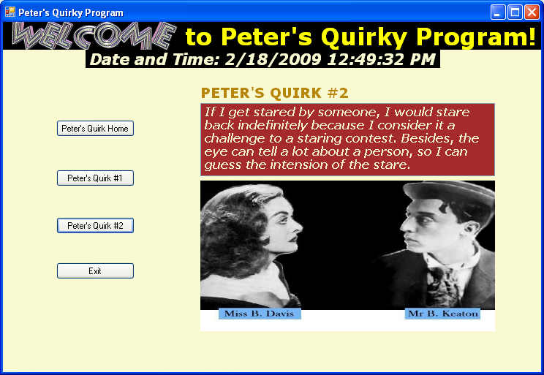

**NOTE: OUR TA #1.1Q HAS SOME DIFFERENT REQUIREMENTS FROM THIS EXAMPLE ABOVE. NAMELY, WE NEED TO ADD TWO MORE BUTTONS FOR THE TWO QUIRKS OF A COLLEAGUE FROM CLASS!! LIKE HERE:**

