Date: MON 4 FEB 2015

CISC 193 – C#

Professor Larry Forman

Telephone: 619.388.3666

E-Mail: [LForman@sdccd.edu](mailto:lforman@sdccd.net)

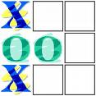 Mail Box: A-8

Office: BT-210-G

**TRAINING ASSIGNMENT #1.3: TICKEE-TACKEE-TOE**

**=== DUE WED 18 FEB ===**

**==============**

TASKS:

**0 –** First, read this Task Sheet!

Second, put a check mark by each Task number **and** letter when you **complete** it. Third, hand in your “hard-copy” and completed Green Grade Sheet in your folder when you demo this TA.

**1 –** **READ**: **Handout #1.2 GUI Mess**

**2 –** **TA OBJECTIVES**

* Develop a basic C# program with picture boxes, message boxes, radio buttons, check boxes, links, date/time, visible and properties to start to play tic-tac-toe
* Incorporate non-event driven methods
* Use effective Michelangelo program documentation

**3 – SPECIFICATIONS / SCREEN OUTPUT**

**For ALL programs, use your name in the project name!**

Create a project called LarrysTickeeTackeeToe that includes the following:

1. A message box to welcome the user to Larry’s Tickee-Tackee-Toe by using a **const** for your name
2. A form with a title, “TA #1.3 – Larry’s Tickee-Tackee-Toe”, along with a pleasing background color
3. 12 picture boxes – 9 for the game-play area, 1 to show the current player’s symbol and 2 that show the symbols used by each player.
4. 2 radio buttons to indicate which player is about to move.
5. 3 check boxes for:
6. Displaying the current player’s symbol in a picture box along with a descriptive label
7. With a label saying, “One of Larry’s Favorite Websites”, that displays a link to one of your favorite websites. Use a **const** for your name.
8. Calling a **non-event driven method** to display the current date and time in a label
9. 2 buttons:
   * One button displays a MessageBox with the **instructions** for playing
   * The second button calls a non-event driven method to display a **farewell** message – with your name via a const – in a MessageBox followed by another MesageBox (or more) with all of your **ID INFO, CREDITS** (of whom you helped, who helped you), **MEDIA** (what resources – graphics, sounds, etc. – you used with a brief description and where you obtained them, e.g., the URLs of any web sites use, titles of music, etc.) and describe in a numbered list your **STARS** along with the **TOTAL NUMBER OF STARS** like this:

**STARS**

1. **Added two quirks for each of two additional people**
2. **Added pizzazz by using animated gifs for all quirks**
3. **Play scintillating music by Queen**

**TOTAL STARS = 3**

**NOTE: You only can earn STARS for those which are listed in this MessageBox.** Then, close the application

1. Have the player use the radio button to select which player goes first (#1 or #2)
2. When a player successfully selects an unoccupied “square”, insert the player’s symbol into the square. Then, play a unique (for each player), short .wav file sound. Use a **non-event driven method** to play each sound. Then, have the player use the radio button to select which player goes next (so, the default has the same player move again . . .)
3. Should a player select a “square” already occupied, do nothing

The following is meant to guide you in thinking about how your form might start to look:

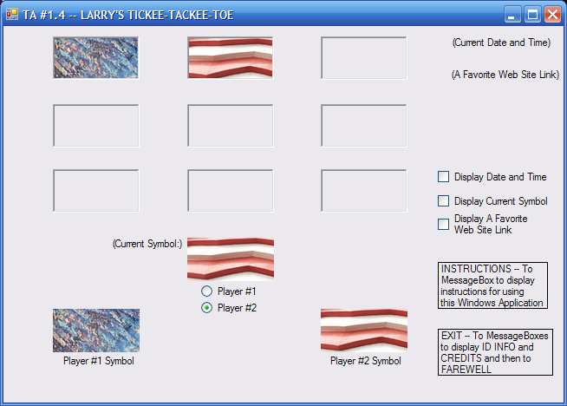

**4 – SAVE** your file early and often -- like every 5 minutes. And, use your backup "disk"

**5** – **TEST** your file early and often -- like every 5 minutes -- How do you eat an apple?

**6** – **”MICHELANGELO” PROGRAM DOCUMENTATION**

1. First, include in your C# code via comments your complete **ID INFORMATION, PROGRAM DESCRIPTION, EVENT-DRIVEN METHODS LIST, NON- EVENT-DRIVEN METHODS LIST, CREDITS** (to those who helped you and whom you helped as well as “tutorial” websites used) and **MEDIA** of all graphics and audio used with brief description and specific URL or where obtained.
2. **Include "inline credits" to acknowledge specifically where you were helped.**
3. For event-driven methods add a **“START CUSTOMIZED EVENT-DRIVEN METHODS**” banner at the beginning of these methods.
4. For nonevent-driven methods add a **“START CUSTOMIZED NON-EVENT DRIVEN METHODS”** banner at the beginning of these methods
5. Add **“END CUSTOMIZED METHODS”** banner at the end of all the methods.
6. Just before each method is declared (signature), put a “banner” of comments with the method **name** and a brief **description** of the purpose of the method and what it accomplishes.
7. Make all method and constant (and variable) names self-descriptive as well as clear and fully formed (no abbreviations or secret code names). Use verbs for or in method names like “buttonDisplayLarrysQuirk_1”, etc. and nouns for constants (and variables).
8. Add a banner for your constants!
9. Add a banner for your variables!
10. Add comments within a method immediately before each important segment of your code – like your ID INFO/CREDITS, your Farewell, etc. – to describe "highlights" of coming attractions. Insert at least one blank line before each of these comments.

**7** – **DEMO** your program in the Lab with a completed TASK SHEET

**8** – **HAND IN HARDCOPY** of your completed TIME SHEET

**9** – **STARS (One for each item)**

1. Add extra pizzazz by maximizing the size of your form and by using the Properties Window of all your picture boxes, labels, buttons, etc. to add big, bold and beautiful fonts and foreground and background colors to all your controls along with nice alignment and “centering” of all controls. BTW: Plan to request to install on the Instructor station any special fonts you have been using at home.
2. Add another check box to display a recent photo of yourself and of two people whom you admire
3. Expand the check box for your favorite web site to display links that go to three of your favorite web sites
4. Make the “game” automatically alternate between the two players’ radio buttons
5. Create five check boxes and the associated picture boxes to display a player’s symbol using the five SizeMode options for a picture box.
6. Expand the previous STAR to include five radio buttons so each player can select at “run time” which SizeMode to use when playing.
7. Effectively use tool tips on every control throughout the application.
8. Add 8 “counters” for each player to count and display how many of each symbol are used in each of the 8 possible directions ( 3 columns + 3 rows + 2 diagonals)
9. Add “pizzazz” (like actually announcing who won the game, etc.) and describe here what you did (**1 or more STARS)**:
10. Effectively use three new "Advanced" features (= not yet introduced) and identify them here:
11. Hand in and demo before the due-date

"The great successful men [and women] of the world have used their imagination…they think ahead and create their mental picture in all its details, filling in here, adding a little there, altering this a bit and that a bit, but steadily building - steadily building."

**Robert Collier**

MCj03076560000%5b1%5d