**Name: Fan Feng**

**Assignment: 1**

**Course: CPSC 433/533**

**P1.**

a). Based on geological distance, likely some domain in East Asia or South Africa will have large hops from the Zoo.

I tried the government website of Japan and South Africa, with 12 and 20 hops respectively.

[ff242@rattlesnake ~]$ traceroute -m 255 www.japan.go.jp

traceroute to www.japan.go.jp (202.214.194.147), 255 hops max, 60 byte packets

1 anger.net.yale.edu (128.36.232.1) 3.746 ms 3.723 ms 3.716 ms

2 10.1.2.81 (10.1.2.81) 0.382 ms 0.429 ms 0.682 ms

3 10.1.1.113 (10.1.1.113) 0.360 ms 0.667 ms 0.726 ms

4 asr-level3.net.yale.internal (10.1.4.40) 1.894 ms 2.216 ms 2.407 ms

5 2-2-7.bear2.Stamford1.Level3.net (4.26.48.81) 2.586 ms 2.977 ms 2.781 ms

6 * * *

7 133.106.98.216.sta.iij-america.net (216.98.106.133) 3.560 ms 3.582 ms 3.573 ms

8 nyc002bb00.IIJ.Net (58.138.81.53) 7.081 ms 5.909 ms nyc002bb00.IIJ.Net (58.138.81.49) 3.595 ms

9 sea001bb00.IIJ.Net (58.138.81.210) 76.835 ms 76.786 ms 76.790 ms

10 tky008bb00.IIJ.Net (58.138.88.137) 159.104 ms 159.023 ms tky009bb01.IIJ.Net (58.138.88.229) 182.497 ms

11 ykh002bb00.IIJ.Net (58.138.89.145) 159.416 ms ykh002bb01.IIJ.Net (58.138.89.149) 189.616 ms 189.602 ms

12 ykh002ip61.IIJ.Net (58.138.120.230) 159.373 ms 159.357 ms ykh002ip61.IIJ.Net (58.138.120.246) 159.470 ms

13 210.130.163.146 (210.130.163.146) 186.176 ms 159.588 ms 186.215 ms

[ff242@rattlesnake ~]$ traceroute -m 255 nationalgovernment.co.za

traceroute to nationalgovernment.co.za (197.221.14.107), 255 hops max, 60 byte packets

1 anger.net.yale.edu (128.36.232.1) 3.412 ms 3.388 ms 3.380 ms

2 10.1.2.81 (10.1.2.81) 0.382 ms 0.449 ms 0.709 ms

3 10.1.2.113 (10.1.2.113) 0.768 ms 0.825 ms 0.881 ms

4 CEN10G-ASR.net.yale.internal (10.1.4.30) 2.024 ms 4.817 ms 2.378 ms

5 jfk2-edge-02.inet.qwest.net (65.124.208.93) 2.820 ms * 2.807 ms

6 jfk-brdr-04.inet.qwest.net (67.14.5.98) 2.985 ms 4.385 ms *

7 enrt064hhh-mx-lo0-1.net.cen.ct.gov (67.218.84.5) 2.929 ms ae3.cr5-nyc2.ip4.gtt.net (199.229.229.205) 3.099 ms 3.037 ms

8 xe-1-0-2.cr0-lon1.ip4.gtt.net (89.149.137.105) 71.395 ms be4161.nr13.b006633-1.hpn04.atlas.cogentco.com (38.88.242.217) 5.717 ms 5.426 ms

9 te0-2-0-3.rcr21.hpn04.atlas.cogentco.com (154.24.15.89) 5.602 ms te0-3-0-3.rcr21.hpn04.atlas.cogentco.com (154.24.15.133) 5.534 ms ip4.gtt.net (46.33.86.78) 78.527 ms

10 be2120.ccr32.bos01.atlas.cogentco.com (154.54.47.145) 9.949 ms 9.938 ms *

11 be2982.ccr41.lon13.atlas.cogentco.com (154.54.1.118) 72.072 ms 41-66-132-179-b3.HET001-CPE-2-to-WC-RO-DCE-2.africainx.net (41.66.132.179) 218.548 ms be2982.ccr41.lon13.atlas.cogentco.com (154.54.1.118) 72.452 ms

12 be12194.ccr41.ams03.atlas.cogentco.com (154.54.56.94) 79.473 ms core-access-switch1-vlan1001.cpt.host-h.net (196.40.102.70) 220.028 ms 219.209 ms

13 * be2447.rcr21.b021535-1.ams03.atlas.cogentco.com (130.117.50.250) 79.752 ms be2322.rcr21.b021535-1.ams03.atlas.cogentco.com (130.117.50.82) 79.848 ms

14 * 149.11.65.22 (149.11.65.22) 80.128 ms *

15 * * *

16 xe-0-0-8.cr-01-lhr.uk.seacomnet.com (105.16.11.113) 250.579 ms * xe-0-0-0-0.cr-02-lhr.uk.seacomnet.com (105.16.9.2) 249.408 ms

17 xe-0-0-0-0.cr-02-cpt-za-seacomnet.com (105.16.10.201) 250.221 ms * xe-0-1-0-3.cr-02-cpt.za.seacomnet.com (105.16.11.26) 251.546 ms

18 xe-1-0-0-0.er-01-cpt.za.seacomnet.com (105.16.31.9) 248.131 ms * *

19 105.22.64.78 (105.22.64.78) 248.227 ms * 247.864 ms

b). Using <https://www.whoismyisp.org/>, from Zoo to the government website of South Africa, the ISPs are as follows:

Yale University

CentryLink (Qwest Communications Company, LLC)

Connecticut Education Network

Tinet­­

Cogent Communications

GTT Communications Inc.

HETZNER (Pty) Ltd

Seacom

Metrofibre-networx

**P2.**

The total number of students and faculties is 16,722.

According to the equations on page 38 of lecture 2, we can write the following program to determine $k$ such that $P_{k}$ < 1%.

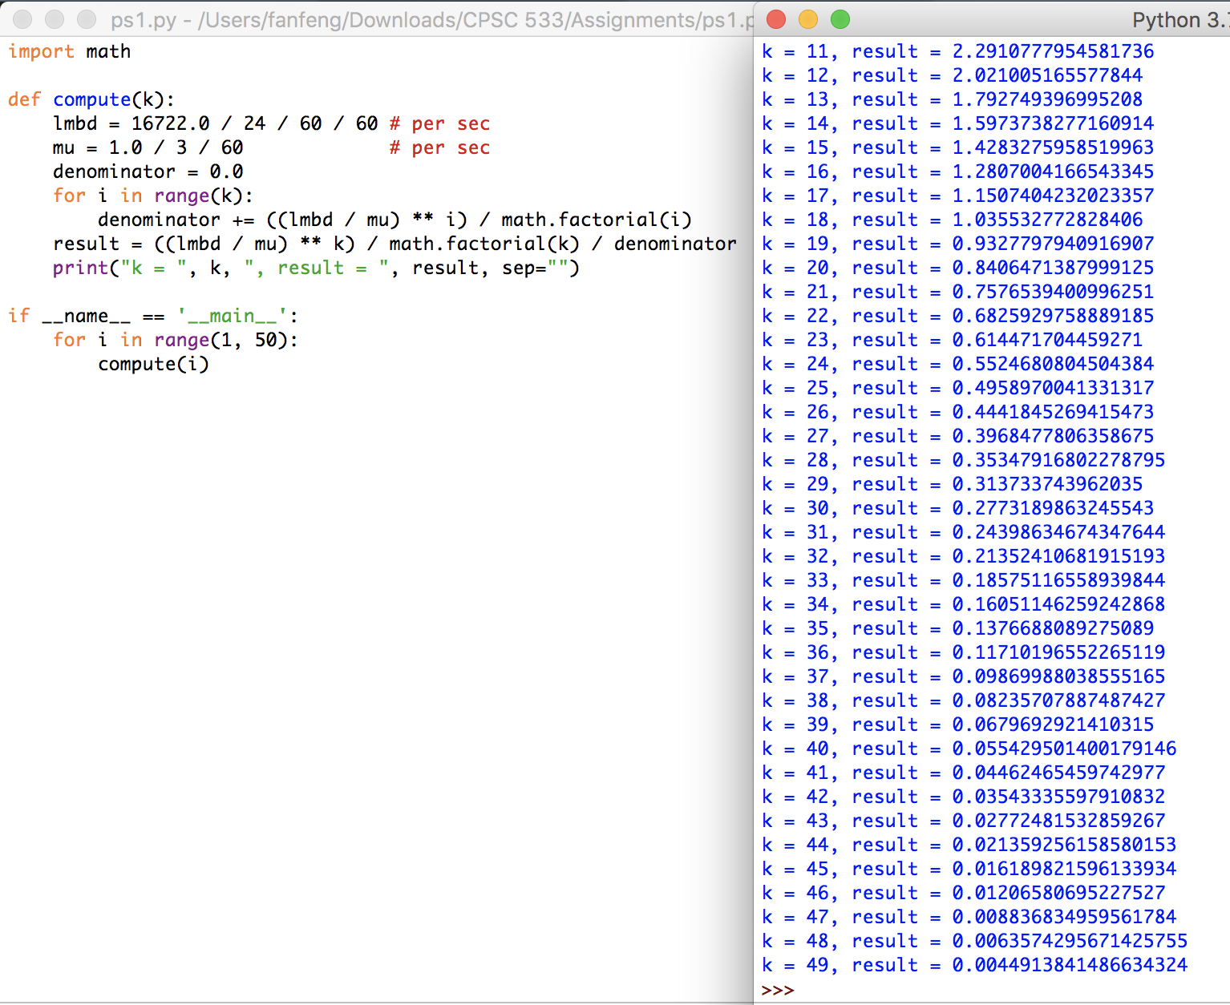

The number of external phone lines needed is 47.

**P3.**

$λ=15$, $μ=5$, c = 4, $ρ= \frac{λ}{μ}=3$

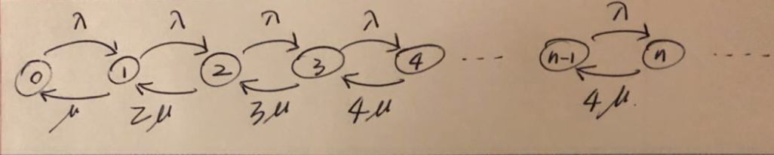

$$\sum_{i=0}^{∞}{P_{i}}= P_{0}\left(1+ρ + \frac{ρ^{2}}{2}+ \frac{ρ^{3}}{6}+ \frac{64}{6}\sum_{i=4}^{∞}{{\left(\frac{ρ}{4}\right)}^{i}}\right)=1$$

$$P_{0}= \frac{2}{53}$$

$P_{4}=\frac{9}{2}{*P}_{0}*(\frac{ρ}{4})$, $P_{5}=\frac{9}{2}{*P}_{0}*{(\frac{ρ}{4})}^{2}$, …

average queueing delay =

$$P_{4}*\frac{1}{μ}+ P_{5}*\frac{2}{μ}+ P_{6}*\frac{3}{μ}+…$$

$$=\frac{9*P_{0}}{2* μ} \sum_{i=1}^{∞}{{(\frac{ρ}{4})}^{i}*i}$$

$$=408 ms$$

Therefore, average service time = 408 + 200 = 608 ms.

If it is a dual-core processor, $P_{i}$ does not converge, thus average service time is infinity.

**P4.**

a). Propagation delay is the delay for the first bit to go from a source to a destination. Thus, $d_{prop}$ = m/s.

b). Transmission delay is the time to pump data onto link at line rate. $d_{trans}$ = L/R.

c). $d_{end-to-end}$ = $d_{prop}$ + $d_{trans}$ = (m/s) + (L/R).

d). The last bit just leaves host A.

e). The first bit is in the link and hasn’t arrived at host B. It is (L/R)*s away from host A.

f). The first bit has already arrived at host B.

g). m = (L/R)*s = (120/56000)*2.5 ${10}^{8}$* = 536 km

**P5.**

a). ${R*d}_{prop}$ = $2 * {10}^{6} * \frac{2 * {10}^{7}}{2.5 * {10}^{8}}$ = 160,000 bits

b). Since 160,000 < 800,000, the maximum number of bits that will be in the link at any given time is 160,000 bits.

c). The bandwidth-delay product is the maximum number of bits that can be in the link at any given time.

d). width of a bit = $\frac{2 * {10}^{7}}{1.6 * {10}^{5}}$ = 125 m

According to <https://en.wikipedia.org/wiki/American_football_field>, an American football field is 91.44 m. Thus, the width of a bit is longer than a football field.

e). width of a bit = m/(R*m/s) = s/R

**P6.**

The packet grouping of the stream takes $\frac{56 * 8}{64 * {10}^{3}}$ = 7 ms.

The transmission takes $\frac{56 * 8}{2 * {10}^{6}}$ = 0.224 ms.

Total elapse time = 7 + 0.224 + 10 = 17.224 ms.

**P7.**

$T_{trans}$ = $\frac{40 * {10}^{12} * 8}{1 * {10}^{8}}$ = 3,200,000 s = 37 days.

Therefore, FedEx over-night delivery is preferred over transmitting the date via the given link.

**P8.**

a). Circuit switching network is more appropriate, since the transmission lasts for a long period of time at a steady rate. Therefore, a particular bandwidth can be set to accommodate the transmission rate, and the overhead is not significant compared with the long duration of time.

b). No. Since the application is the only source of traffic and each link has a capacity greater than the sum of the application data rates, no congestion will happen.

**P9.**

a). ($3*{10}^{6}$) / ($1.5*{10}^{5}$) = 20 users can be supported.

b). The probability that a given use is transmitting is 0.1.

c). $P_{n}= C_{120}^{n}*{0.1}^{n}*{0.9}^{(120-n)}$

d). $P\left(N≥21\right)=1-P\left(N≤20\right)= 1-\sum_{i=0}^{20}{C_{120}^{i}}*{0.1}^{i}*{0.9}^{(120-i)}$ = 0.00794

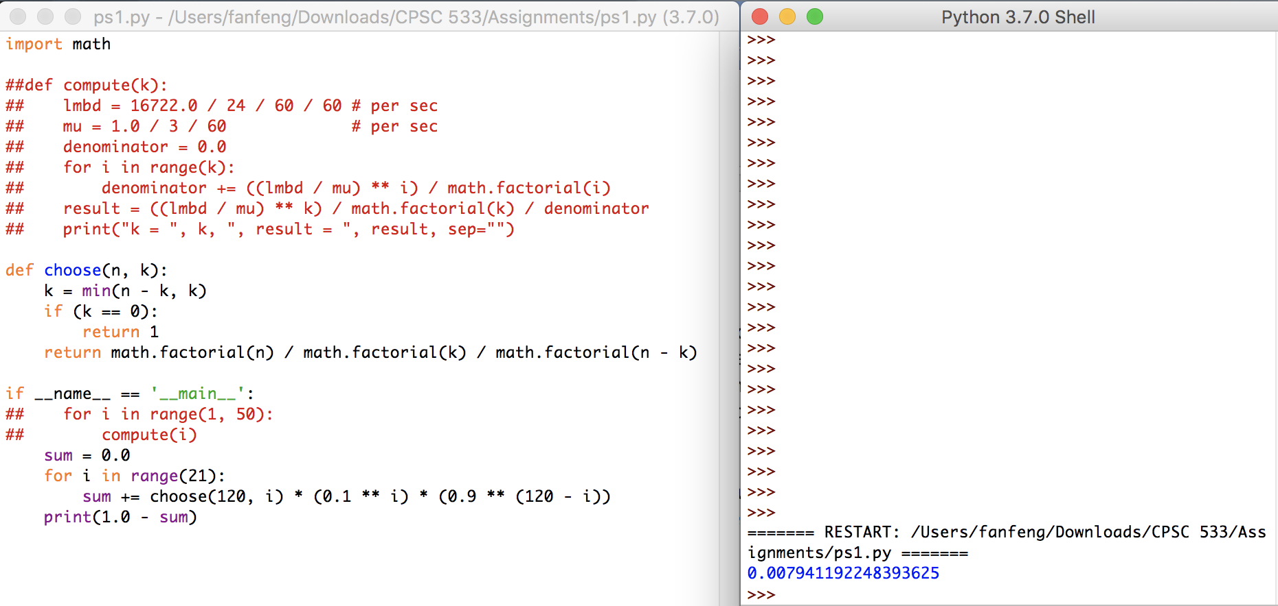

**P10.**

a). Moving the message from the source host to the first packet switch takes $\frac{8 * {10}^{6}}{2 * {10}^{6}}$ = 4 s.

Moving the message from source host to destination host takes 4 * 3 = 12 s.

b). Moving the message from the source host to the first packet switch takes $\frac{1 * {10}^{4}}{2 * {10}^{6}}$ = 0.005 s.

When the first packet is moved from the first switch to the second switch, simultaneously the second packet is moved from source host to the first switch. Thus, at 2*0.005 = 0.01 s, the second packet is fully received at the first switch.

c). The first packet takes 3*0.005 = 0.015 s to arrive at destination host. Each of the remaining packet takes 0.005 s to arrive at destination host. Thus, total time is 0.015+799*0.005 = 4.01 s.

We can conclude that with message segmentation, transmission takes much less time (about one third) than that without message segmentation.

d). Fault Tolerance. Without message segmentation, if some error happens during the transmission, the entire message has to be retransmitted, whereas with message segmentation, only that particular packet needs to be retransmitted.

Capacity. Without message segmentation, devices (e.g., routers) need to be able to handle the size of the entire message, whereas with message segmentation, the capacity only needs to be of the size of each segmented packet.

e). Overhead. Since each packet needs to have a header, the overhead of message segmentation is greater.

**P11.**

The first packet takes 3*(S+80)/R to arrive at host B. Each of the remaining packet takes (S+80)/R to arrive at host B, and there are F/S-1 of them.

Thus, total time is $\frac{(S+80)}{R}*\left(\frac{F}{S}+2\right)$.

Take derivative with respect to S, and set it equal to 0.

$$\frac{2}{R}-\frac{80F}{RS^{2}}=0$$

Thus $S= \sqrt{40F}$.

**P12.**

To be able to pass voice calls through both the Internet and through a telephone network, there must exist some equipment that converts packet data to circuit data, and vice versa.

Below is an excerpt from <https://www.explainthatstuff.com/how-voip-works.html>:

Making a telephone call from a computer to a traditional landline phone (or vice-versa) is more complex because it involves making a link from the Internet to the ordinary phone network (which is technically referred to as the **PSTN** or **Public Switched Telephone Network**). That complicates both aspects of VoIP that we discussed above. Call signaling is more complex, because the phone you're calling might be on either the PSTN or somewhere on the Internet—and it has to be located first. (One solution to this is to assign a special, nongeographical "area code" to VoIP numbers so they can be instantly identified and routed to the Internet.) Sending and receiving a phone call is also more complex because if you're calling from a VoIP phone to an ordinary landline handset, there's nothing at the receiving end to convert the digital data back into analog sound. So the data has to be converted before it reaches its destination.

What makes phone calls like this work is an extra piece of equipment known as a **gateway**, which acts as a bridge between the Internet (on one hand) and the PSTN (on the other). You can think of a gateway as a kind of translator that converts telephone calls in IP-format into traditional signals that ordinary phones can understand (and vice versa). It's also involved in call signaling, so when you dial a landline from a VoIP phone, the gateway converts the call-signaling data into a format that the PSTN can understand (and rings the landline the old-fashioned way).