Вебер

Лабораторная работа №2. Настройка VLAN на коммутаторах

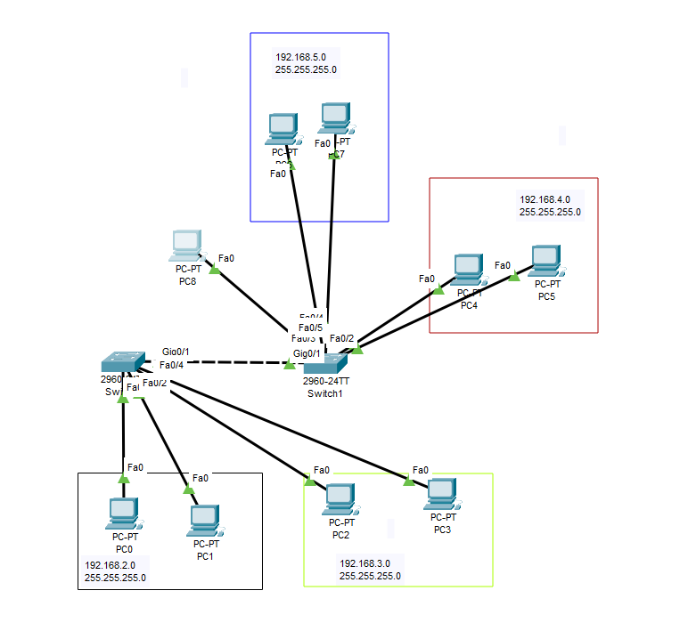

Рисунок 1. Топология сети с VLAN

1. Добавление VLAN в базу.

interface Vlan1

no ip address

shutdown

!

interface Vlan2

ip address 192.168.2.240 255.255.255.0

!

interface Vlan3

ip address 192.168.3.240 255.255.255.0

!

interface Vlan4

ip address 192.168.4.240 255.255.255.0

!

interface Vlan5

ip address 192.168.5.240 255.255.255.0

1. Настройка физических портов.

interface FastEthernet0/1

switchport access vlan 2

switchport mode access

!

interface FastEthernet0/2

switchport access vlan 2

switchport mode access

!

interface FastEthernet0/3

switchport access vlan 3

switchport mode access

!

interface FastEthernet0/4

switchport access vlan 3

switchport mode access

1. Настройка trunk

interface GigabitEthernet0/1

switchport trunk allowed vlan 1-1001

switchport mode trunk