Remotely sensing cities

2021-01-07

# 1 Introduction

You can label chapter and section titles using {#label} after them, e.g., we can reference Chapter 1. If you do not manually label them, there will be automatic labels anyway, e.g., Chapter 3.

Figures and tables with captions will be placed in figure and table environments, respectively.

par(mar = c(4, 4, .1, .1))  
plot(pressure, type = 'b', pch = 19)

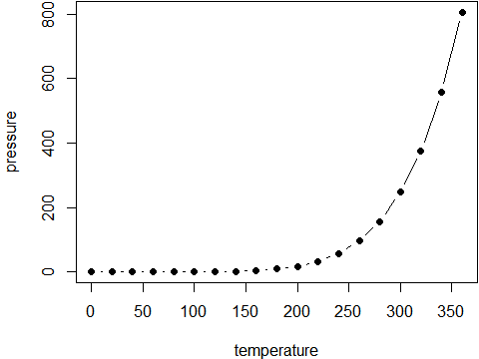

Figure 1.1: Here is a nice figure!

Reference a figure by its code chunk label with the fig: prefix, e.g., see Figure 1.1. Similarly, you can reference tables generated from knitr::kable(), e.g., see Table 1.1.

knitr::kable(  
 head(iris, 20), caption = 'Here is a nice table!',  
 booktabs = TRUE  
)

Table 1.1: Here is a nice table!

|  |  |  |  |  |
| --- | --- | --- | --- | --- |
| Sepal.Length | Sepal.Width | Petal.Length | Petal.Width | Species |
| 5.1 | 3.5 | 1.4 | 0.2 | setosa |
| 4.9 | 3.0 | 1.4 | 0.2 | setosa |
| 4.7 | 3.2 | 1.3 | 0.2 | setosa |
| 4.6 | 3.1 | 1.5 | 0.2 | setosa |
| 5.0 | 3.6 | 1.4 | 0.2 | setosa |
| 5.4 | 3.9 | 1.7 | 0.4 | setosa |
| 4.6 | 3.4 | 1.4 | 0.3 | setosa |
| 5.0 | 3.4 | 1.5 | 0.2 | setosa |
| 4.4 | 2.9 | 1.4 | 0.2 | setosa |
| 4.9 | 3.1 | 1.5 | 0.1 | setosa |
| 5.4 | 3.7 | 1.5 | 0.2 | setosa |
| 4.8 | 3.4 | 1.6 | 0.2 | setosa |
| 4.8 | 3.0 | 1.4 | 0.1 | setosa |
| 4.3 | 3.0 | 1.1 | 0.1 | setosa |
| 5.8 | 4.0 | 1.2 | 0.2 | setosa |
| 5.7 | 4.4 | 1.5 | 0.4 | setosa |
| 5.4 | 3.9 | 1.3 | 0.4 | setosa |
| 5.1 | 3.5 | 1.4 | 0.3 | setosa |
| 5.7 | 3.8 | 1.7 | 0.3 | setosa |
| 5.1 | 3.8 | 1.5 | 0.3 | setosa |

You can write citations, too. For example, we are using the **bookdown** package (Xie 2021) in this sample book, which was built on top of R Markdown and **knitr** (Xie 2015).

# 2 Literature Review

Here is a review of existing methods.

# 3 Methods

We describe our methods in this chapter.

# 4 Applications

Some *significant* applications are demonstrated in this chapter.

## 4.1 Example one

## 4.2 Example two

# 5 Final Words

We have finished a nice book.

# 6 Conclusion

Xie, Yihui. 2015. *Dynamic Documents with R and Knitr*. 2nd ed. Boca Raton, Florida: Chapman; Hall/CRC. <http://yihui.name/knitr/>.

———. 2021. *Bookdown: Authoring Books and Technical Documents with r Markdown*. <https://github.com/rstudio/bookdown>.