1. 剔除模式

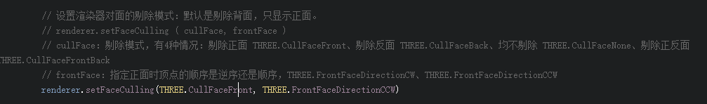

1. 自定义形状？出来了，但不是我想要的效果

var vertices = [  
 new **THREE**.Vector3(0,0,0),  
 new **THREE**.Vector3(5,0,0),  
 new **THREE**.Vector3(5,5,0),  
 new **THREE**.Vector3(0,5,0),  
 new **THREE**.Vector3(0,5,5),  
 new **THREE**.Vector3(5,5,5),  
 new **THREE**.Vector3(5,0,5),  
 new **THREE**.Vector3(0,0,5)  
]  
  
var faces = [  
 //1  
 new **THREE**.Face3(0,1,2),  
 new **THREE**.Face3(0,3,2),  
  
 //2  
 new **THREE**.Face3(0,1,7),  
 new **THREE**.Face3(1,6,7),  
 //3  
 new **THREE**.Face3(1,2,6),  
 new **THREE**.Face3(2,5,6),  
  
 //4  
 new **THREE**.Face3(3,5,2),  
 new **THREE**.Face3(3,4,5),  
 //5  
 new **THREE**.Face3(0,3,7),  
 new **THREE**.Face3(3,4,7),  
 //6  
 new **THREE**.Face3(5,6,7),  
 new **THREE**.Face3(4,5,7)  
]  
var geometry = new **THREE**.Geometry() // 形状  
geometry.**vertices** = vertices  
geometry.**faces** = faces;  
  
var defindMyself = new **THREE**.Mesh(geometry,planeMaterial); // 把它转化成一个物体，记住

4、computeFaceNormals 重新计算三角面对象的法线向量,计算法线向量，影响的是face数组中每个元素的normal属性，一个face只有1个 (可能是自定义的物体，比较把这个加上？)

var geom = new THREE.Geometry();  
geom.**vertices** = vertices;  
geom.**faces** = faces;  
geom.computeFaceNormals();

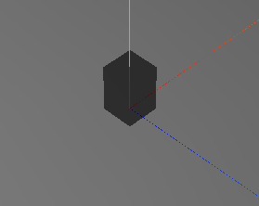 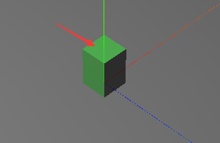

1. 如果想动态改变定义好的目标，需要添加这2个属性；（dfindMyself 是一个物体对象）

function render() {  
 stats.update();  
 defindMyself.**geometry**.**vertices**[0].**y** = controls.**v1**;  
 defindMyself.**geometry**.**verticesNeedUpdate** = true;// 这个属性  
 defindMyself.**geometry**.computeFaceNormals(); //和这个属性  
 requestAnimationFrame(render);  
 renderer.render(scene,camera);  
}

1. 多种材质 和添加阴影效果

