1、PerspectiveCamera



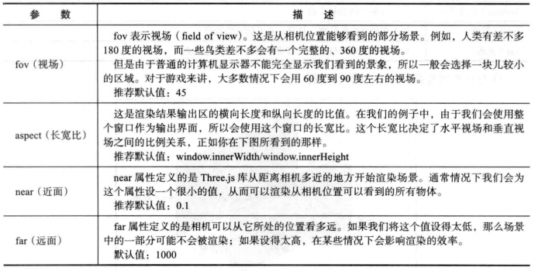

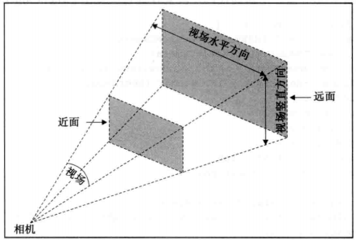

1. OrthographicCamera

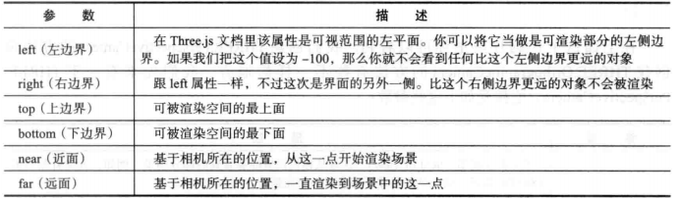

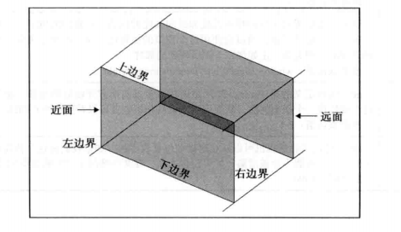

1. 获取物体（planeGeometry）的宽和高

var planeGeometry = new THREE.PlaneGeometry(180, 180);  
var planeMaterial = new THREE.MeshLambertMaterial({**color**: 0xffffff});  
var plane = new THREE.Mesh(planeGeometry, planeMaterial);  
  
**console**.log(planeGeometry.**parameters**.**width**)

4、lookAtMesh.**position**.copy 是什么鬼？？？

5、