1、光源
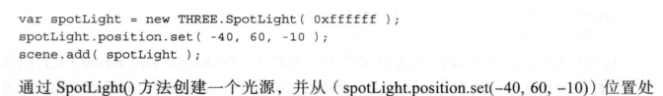
2、
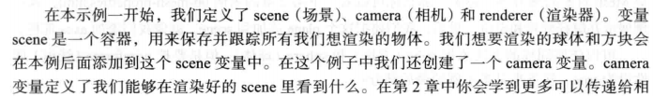

- 轴
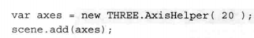

- 线框显示？

- 主要的模型对象
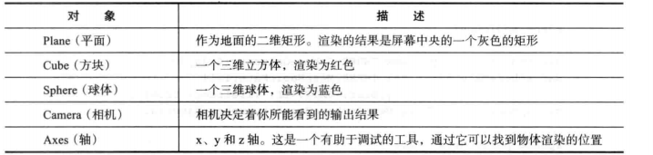

- 添加材质、灯光和阴影
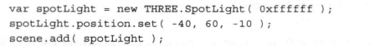

- 阴影
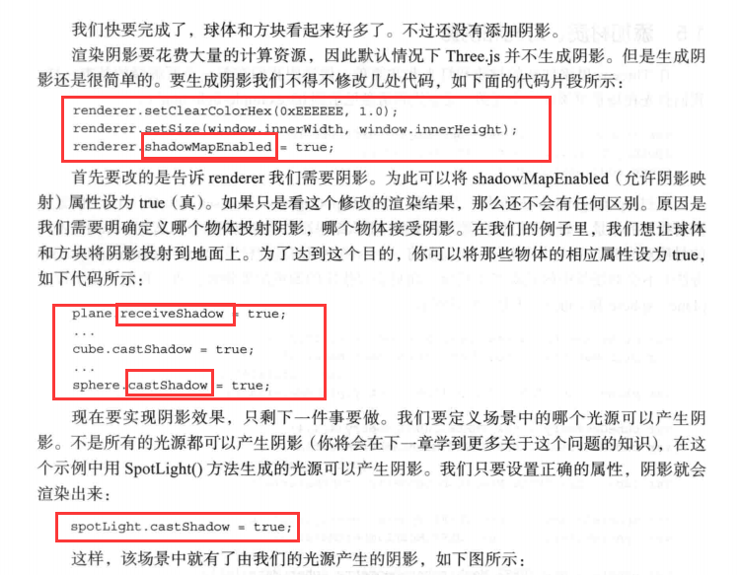

- 动画、帧
var stats = initStats();
function renderScene() {
stats.update();
requestAnimationFrame(renderScene);
renderer.render(scene,camera)
}
function initStats() {
var stats = new Stats;
stats.setMode(0);
stats.domElement.style.position = "absolute";
stats.domElement.style.left = "0px";
stats.domElement.style.top = "0px";
$("#web").append(stats.domElement);
return stats;
}
renderScene()

- 转动的方块 跳跳球
var step = 0;
var stats = initStats();
function renderScene() {
stats.update();
cube.rotation.x += .01;
cube.rotation.y += .01;
cube.rotation.z += .01;
step += 0.04;
sphere.position.x = 20 + (10 * (Math.cos(step)));
sphere.position.y = 2 + (10 * Math.abs((Math.sin(step))));
requestAnimationFrame(renderScene);
renderer.render(scene,camera)
}

- dat.gui
//dat-gui
var controls = new function () {
this.rotationSpeed = 0.02;
this.bouncingSpeed = 0.03;
}
var gui = new dat.GUI();
gui.add(controls,"rotationSpeed",0,0.5);
gui.add(controls,"bouncingSpeed",0,0.5);
function renderScene() {
stats.update();
cube.rotation.x += controls.rotationSpeed;
cube.rotation.y += controls.rotationSpeed;
cube.rotation.z += controls.rotationSpeed;
step += controls.bouncingSpeed;
sphere.position.x = 20 + (10 * (Math.cos(step)));
sphere.position.y = 2 + (10 * Math.abs((Math.sin(step))));
requestAnimationFrame(renderScene);
renderer.render(scene,camera)
}

- AsciiEffect
