ConvexGeometry

1、new THREE.Vector3

会转化成
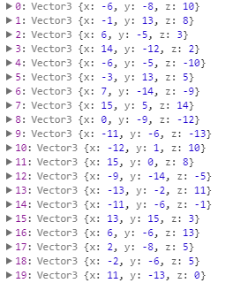
2、Object3D
不用position.copy 和用，最好用
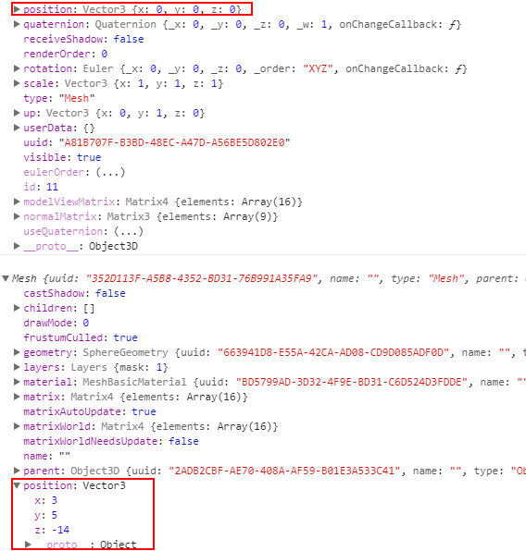

- createMesh
function createMesh(geom) {
// assign two materials
var meshMaterial = new THREE.MeshBasicMaterial({color: 0x00ff00, transparent: true, opacity: 0.2});
meshMaterial.side = THREE.DoubleSide;
var wireFrameMat = new THREE.MeshBasicMaterial();
wireFrameMat.wireframe = true;
// create a multimaterial
var mesh = THREE.SceneUtils.createMultiMaterialObject(geom, [meshMaterial, wireFrameMat]);
return mesh;
}

4、MeshNormalMaterial 根据法向量自己计算材质

5、ParametricGeometry
