南京林业大学


汇编语言上机实验
任务书

实验七 寻址方式在结构化数据访问中的应用
代码：
assume cs:codesg

data segment
db '1975','1976','1977','1978','1979','1980','1981','1982','1983'
db '1984','1985','1986','1987','1988','1989','1990','1991','1992'
db '1993','1994','1995'
dd 16,22,382,1356,2390,8000,16000,24486,50065,97479
dd 140417,197514,345980,590827,803530,1183000,1843000
dd 2759000,3753000,4649000,5937000
dw 3,7,9,13,28,38,130,220,476,778,1001,1442,2258
dw 2793,4037,5635,8226,11542,14430,15257,17800
data ends

table segment
db 21 dup('year summ ne ?? ')
table ends

codesg segment
start:
mov ax, data
mov ds, ax
mov ax, table
mov es, ax
mov bx, 0
mov di, 21*4*2
mov bp, 0
mov cx, 21

s:
mov ax, [bx]
mov es:[bp], ax
mov ax, [bx+2]
mov es:[bp+2], ax
mov ax, [bx+21*4]
mov es:[bp+5], ax
mov dx, [bx+21*4+2]
mov es:[bp+7], dx
div word ptr [di]
mov dx, [di]
mov es:[bp+0Ah], dx
mov es:[bp+0Dh], ax
add bx, 4
add di, 2
add bp, 16
loop s

mov ax, 4C00h
int 21h
codesg ends
end start
输入代码：
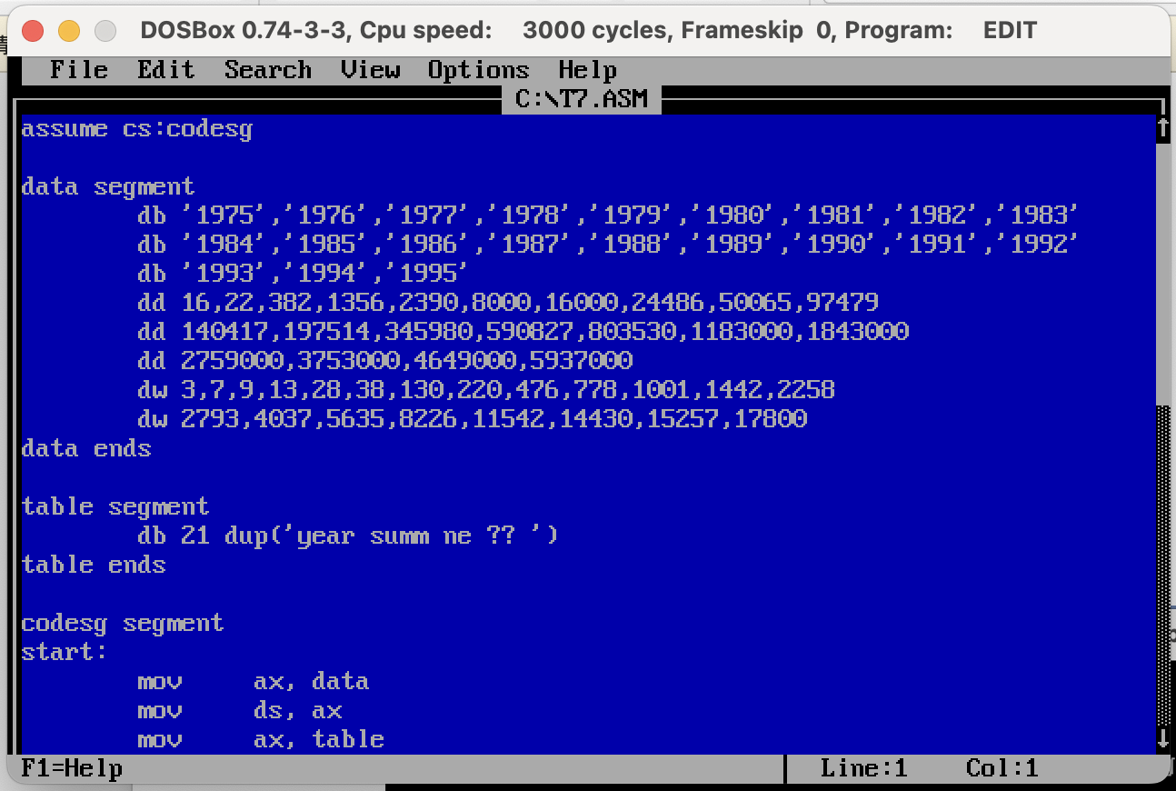
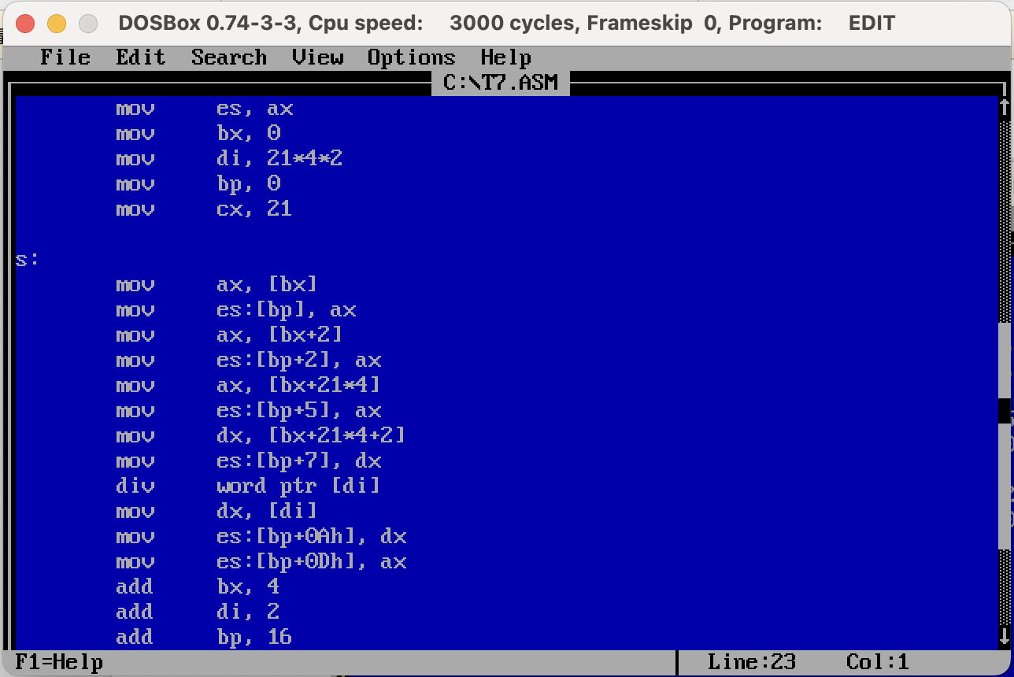
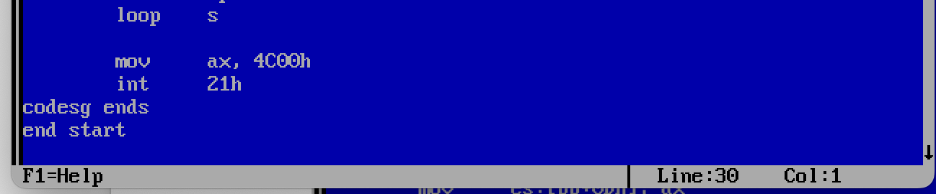
编译、链接：
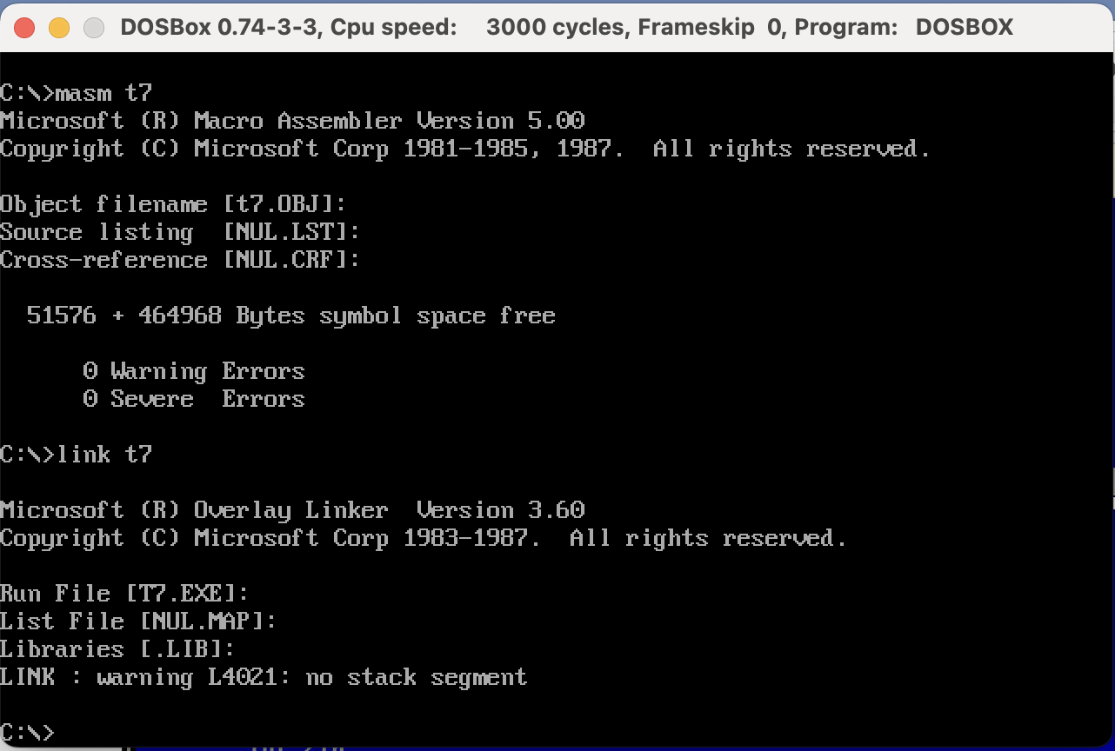
运行：
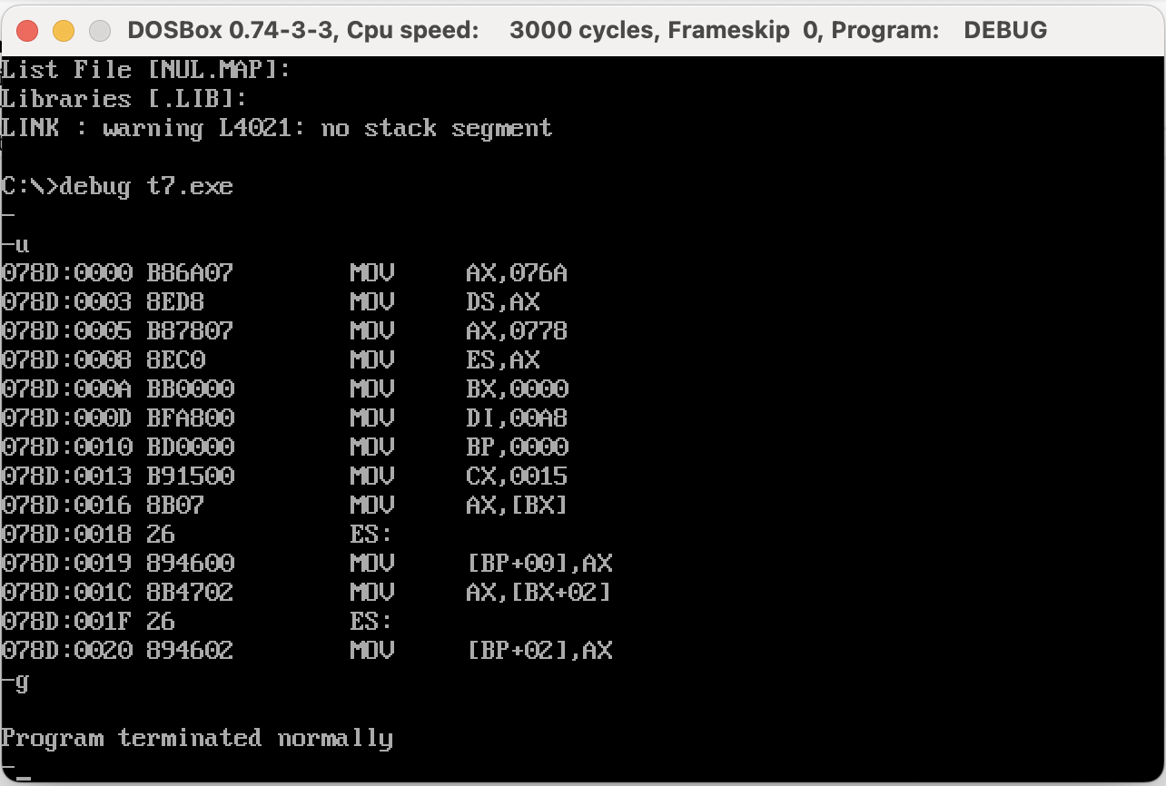
查看运行结果：
