Under your home directory (`~`), create a `labs` directory if it doesn't exist, and then create `lab1` inside `labs` as your lab directory for this assignment:
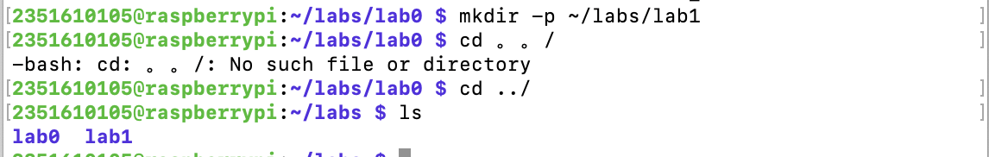
2351610105@raspberrypi:~/labs/lab0 $ mkdir -p ~/labs/lab1
2351610105@raspberrypi:~/labs/lab0 $ cd ../
2351610105@raspberrypi:~/labs $ ls
lab0 lab1

Part1: Extract and Sort Usernames
2351610105@raspberrypi:~/labs $ cd lab1
2351610105@raspberrypi:~/labs/lab1 $ echo "cut -d: -f1 /etc/passwd | sort">task1.sh
2351610105@raspberrypi:~/labs/lab1 $ cat task1.sh
cut -d: -f1 /etc/passwd | sort
2351610105@raspberrypi:~/labs/lab1 $ chmod +x task1.sh
2351610105@raspberrypi:~/labs/lab1 $ bash ./task1.sh

201760310
201760310
2110810306
2110810306
2111110220
2150810516
2210801102
2210806201
2250610205
2250801118
2250801124
2250801127
2250801201
2250801204
2250801223
2250801226
2250801227
2250801228
2250801301
2250801303
2250801309
2250801325
2250801403
2250801406
2250801425
2250802231
2310103129
2310602209
2310801101
2310801102
2310801103
2310801104
2310801105
2310801106
2310801107
2310801108
2310801109
2310801110
2310801111
2310801112
2310801113
2310801114
2310801115
2310801116
2310801117
2310801118
2310801119
2310801120
2310801121
2310801122
2310801123
2310801124
2310801125
2310801126
2310801127
2310801128
2310801129
2310801130
2310801131
2310801132
2310801201
2310801203
2310801206
2310801210
2310801212
2310801214
2310801216
2310801218
2310801221
2310801222
2310801223
2310801224
2310801225
2310801230
2311003205
2311403104
2311403204
2311403205
2311403220
2311610505
2350102130
2350203213
2350302315
2350403322
2350501126
2350501219
2350501234
2350507217
2350509332
2350610219
2350801101
2350801102
2350801103
2350801104
2350801105
2350801106
2350801107
2350801108
2350801109
2350801110
2350801111
2350801112
2350801113
2350801114
2350801115
2350801116
2350801117
2350801118
2350801119
2350801120
2350801122
2350801123
2350801124
2350801126
2350801127
2350801129
2350801130
2350801131
2350801132
2350801133
2350801134
2350801135
2350801202
2350801203
2350801204
2350801205
2350801206
2350801207
2350801208
2350801209
2350801210
2350801211
2350801212
2350801213
2350801214
2350801215
2350801216
2350801217
2350801218
2350801219
2350801220
2350801221
2350801223
2350801224
2350801225
2350801226
2350801227
2350801228
2350801229
2350801230
2350801231
2350801232
2350801233
2350801234
2350801235
2350801301
2350801302
2350801303
2350801304
2350801305
2350801306
2350801307
2350801308
2350801309
2350801310
2350801311
2350801312
2350801313
2350801314
2350801315
2350801316
2350801317
2350801318
2350801320
2350801323
2350801324
2350801325
2350801326
2350801327
2350801329
2350801330
2350801331
2350801332
2350801334
2350801335
2350801401
2350801402
2350801403
2350801404
2350801406
2350801407
2350801408
2350801409
2350801411
2350801412
2350801413
2350801415
2350801416
2350801418
2350801419
2350801420
2350801422
2350801424
2350801425
2350801426
2350801427
2350801428
2350801429
2350801430
2350801431
2350801432
2350801433
2350801435
2351501132
2351501217
2351501231
2351610105
2511803101
2511803101
2511803102
2511803103
2511803104
2511803105
2511803106
2511803107
2511803108
2511803109
2511803110
2511803111
2511803112
2511803113
2511803114
2511803115
2511803116
2511803117
2511803118
2511803120
2511803121
2511803122
2511803123
2511803124
2511803125
2511803126
2511803127
2511803128
2511803129
2511803130
2511803201
2511803202
2511803203
2511803204
2511803205
2511803206
2511803207
2511803208
2511803209
2511803210
2511803211
2511803212
2511803213
2511803214
2511803215
2511803216
2511803217
2511803218
2511803219
2511803220
2511803221
2511803223
2511803224
2511803225
2511803226
2511803227
2511803228
2511803229
2511803230
_apt
avahi
backup
bin
colord
daemon
games
gnats
hplip
irc
lightdm
list
lp
mail
man
messagebus
news
nobody
pi
proxy
pulse
root
_rpc
rtkit
saned
sshd
statd
sync
sys
systemd-coredump
systemd-network
systemd-resolve
systemd-timesync
uucp
wangli
www-data

Task2：Filter Users
2351610105@raspberrypi:~/labs/lab1 $ echo "grep -i root /etc/passwd | cut -d: -f1" >task2.sh
2351610105@raspberrypi:~/labs/lab1 $ chmod +x task2.sh
2351610105@raspberrypi:~/labs/lab1 $ bash ./task2.sh
root
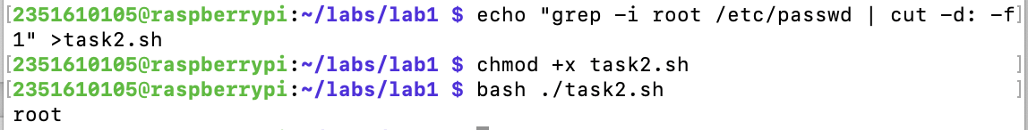

Task 3：Count Users
2351610105@raspberrypi:~/labs/lab1 $ echo "wc -l < /etc/passwd">task3.sh
2351610105@raspberrypi:~/labs/lab1 $ chmod +x task3.sh
2351610105@raspberrypi:~/labs/lab1 $ cat task3.sh
wc -l < /etc/passwd
2351610105@raspberrypi:~/labs/lab1 $ bash ./task3.sh
312
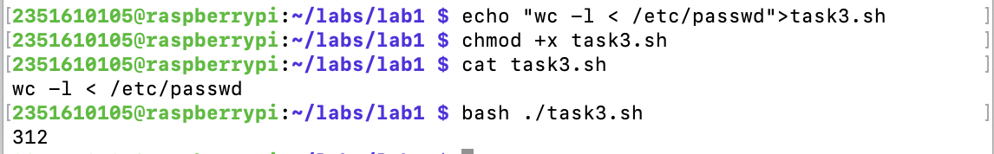

Task4: Handle the errors
2351610105@raspberrypi:~/labs/lab1 $ echo "cat non_existing_file.txt 2> error.txt">task4.sh
2351610105@raspberrypi:~/labs/lab1 $ cat task4.sh
cat non_existing_file.txt 2> error.txt
2351610105@raspberrypi:~/labs/lab1 $ chmod +x task4.sh
2351610105@raspberrypi:~/labs/lab1 $ bash ./task4.sh
2351610105@raspberrypi:~/labs/lab1 $ ls
error.txt task1.sh task2.sh task3.sh task4.sh
2351610105@raspberrypi:~/labs/lab1 $ cat error.txt
cat: non_existing_file.txt: No such file or directory
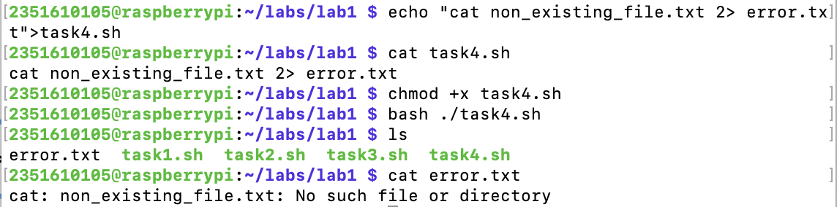

Task5: Pipeline Task
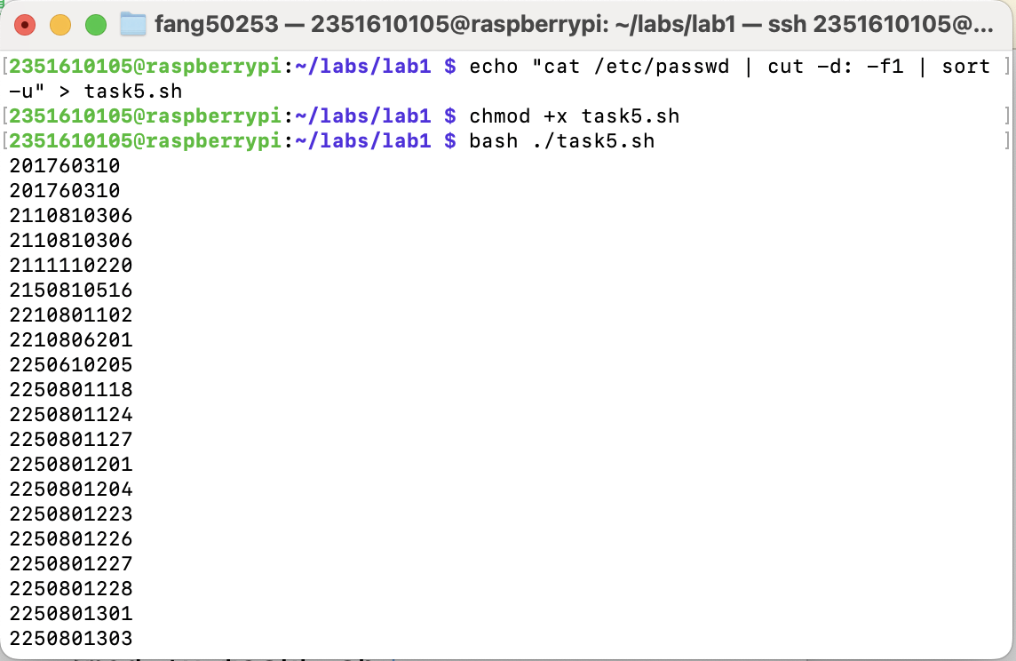
2351610105@raspberrypi:~/labs/lab1 $ echo "cat /etc/passwd | cut -d: -f1 | sort -u" > task5.sh
2351610105@raspberrypi:~/labs/lab1 $ chmod +x task5.sh
2351610105@raspberrypi:~/labs/lab1 $ bash ./task5.sh

201760310
201760310
2110810306
2110810306
2111110220
2150810516
2210801102
2210806201
2250610205
2250801118
2250801124
2250801127
2250801201
2250801204
2250801223
2250801226
2250801227
2250801228
2250801301
2250801303
2250801309
2250801325
2250801403
2250801406
2250801425
2250802231
2310103129
2310602209
2310801101
2310801102
2310801103
2310801104
2310801105
2310801106
2310801107
2310801108
2310801109
2310801110
2310801111
2310801112
2310801113
2310801114
2310801115
2310801116
2310801117
2310801118
2310801119
2310801120
2310801121
2310801122
2310801123
2310801124
2310801125
2310801126
2310801127
2310801128
2310801129
2310801130
2310801131
2310801132
2310801201
2310801203
2310801206
2310801210
2310801212
2310801214
2310801216
2310801218
2310801221
2310801222
2310801223
2310801224
2310801225
2310801230
2311003205
2311403104
2311403204
2311403205
2311403220
2311610505
2350102130
2350203213
2350302315
2350403322
2350501126
2350501219
2350501234
2350507217
2350509332
2350610219
2350801101
2350801102
2350801103
2350801104
2350801105
2350801106
2350801107
2350801108
2350801109
2350801110
2350801111
2350801112
2350801113
2350801114
2350801115
2350801116
2350801117
2350801118
2350801119
2350801120
2350801122
2350801123
2350801124
2350801126
2350801127
2350801129
2350801130
2350801131
2350801132
2350801133
2350801134
2350801135
2350801202
2350801203
2350801204
2350801205
2350801206
2350801207
2350801208
2350801209
2350801210
2350801211
2350801212
2350801213
2350801214
2350801215
2350801216
2350801217
2350801218
2350801219
2350801220
2350801221
2350801223
2350801224
2350801225
2350801226
2350801227
2350801228
2350801229
2350801230
2350801231
2350801232
2350801233
2350801234
2350801235
2350801301
2350801302
2350801303
2350801304
2350801305
2350801306
2350801307
2350801308
2350801309
2350801310
2350801311
2350801312
2350801313
2350801314
2350801315
2350801316
2350801317
2350801318
2350801320
2350801323
2350801324
2350801325
2350801326
2350801327
2350801329
2350801330
2350801331
2350801332
2350801334
2350801335
2350801401
2350801402
2350801403
2350801404
2350801406
2350801407
2350801408
2350801409
2350801411
2350801412
2350801413
2350801415
2350801416
2350801418
2350801419
2350801420
2350801422
2350801424
2350801425
2350801426
2350801427
2350801428
2350801429
2350801430
2350801431
2350801432
2350801433
2350801435
2351501132
2351501217
2351501231
2351610105
2511803101
2511803101
2511803102
2511803103
2511803104
2511803105
2511803106
2511803107
2511803108
2511803109
2511803110
2511803111
2511803112
2511803113
2511803114
2511803115
2511803116
2511803117
2511803118
2511803120
2511803121
2511803122
2511803123
2511803124
2511803125
2511803126
2511803127
2511803128
2511803129
2511803130
2511803201
2511803202
2511803203
2511803204
2511803205
2511803206
2511803207
2511803208
2511803209
2511803210
2511803211
2511803212
2511803213
2511803214
2511803215
2511803216
2511803217
2511803218
2511803219
2511803220
2511803221
2511803223
2511803224
2511803225
2511803226
2511803227
2511803228
2511803229
2511803230
_apt
avahi
backup
bin
colord
daemon
games
gnats
hplip
irc
lightdm
list
lp
mail
man
messagebus
news
nobody
pi
proxy
pulse
root
_rpc
rtkit
saned
sshd
statd
sync
sys
systemd-coredump
systemd-network
systemd-resolve
systemd-timesync
uucp
wangli
www-data

